L1 SignalFabric — Design Document
Layer: L1 SignalFabric
Engineers: Sreekumar M K, Sruthy
Status: Prototype design (for async review, due Jun 12, 2026)
Prod target: Jun 15, 2026
Source: L1SignalFabric/ (new standalone module — extends the upstream batch pipeline without modifying it)
────────────────────────────────────────

1. Purpose & Scope
L1 SignalFabric is the continuous event-ingestion layer. It converts real-world activity
(Slack, Gmail, ERP/operational databases) into a single canonical event stream that the **L2
knowledge graph consumes to build OrgMap** (tribal knowledge) and workflow nodes such as
SignOffEvent.
It extends the upstream medallion pipeline from *batch snapshots* to *continuous streams*.
The upstream pipeline ships file/batch adapters today: SourceAdapter → FileExtractor is live (Phase 1);
APIExtractor (Phase 2) and CDCExtractor (Phase 3) are stubbed for the future.
L1 SignalFabric realizes Phase 3: push connectors emitting the same canonical Record
shape as continuous DELTA operations.

1.1 In scope (prototype, build-first order)
# | Connector | Upstream source(s) | Feeds | Ingestion
1 | Slack Events API | Slack | OrgMap (tribal knowledge only) | webhook push
2 | Gmail API (Workspace) | email sign-off events | OrgMap + SignOffEvent | Pub/Sub push, metadata only
3 | ERP Integration | Crew DB · Contract (CLM) · Vessel/Port DB | L2 entities | CDC / outbox stream

1.2 Out of scope (prototype)
- Email body content (Gmail = metadata only: sender, recipient, thread, timestamp).
- Backfill/historical batch import (that is the upstream pipeline's existing file path).
- L2 graph internals (we publish events; L2 owns graph mutation semantics beyond the sink).
- Multi-tenant fan-out tuning (single tenant for proto; tenantId carried on every event).

1.3 Design goals (traceable to exit criteria)
Goal | Exit criterion
Continuous streams, never batch | All 5 sources streaming (not batch)
Sign-off email materializes a node fast | Sign-off email → L2 SignOffEvent < 5 min
Lossless under restart/failure | 50 crew records, 0 data loss
Low end-to-end latency | Changes propagate downstream < 5 min

────────────────────────────────────────

2. Connector Architecture

2.1 Component overview
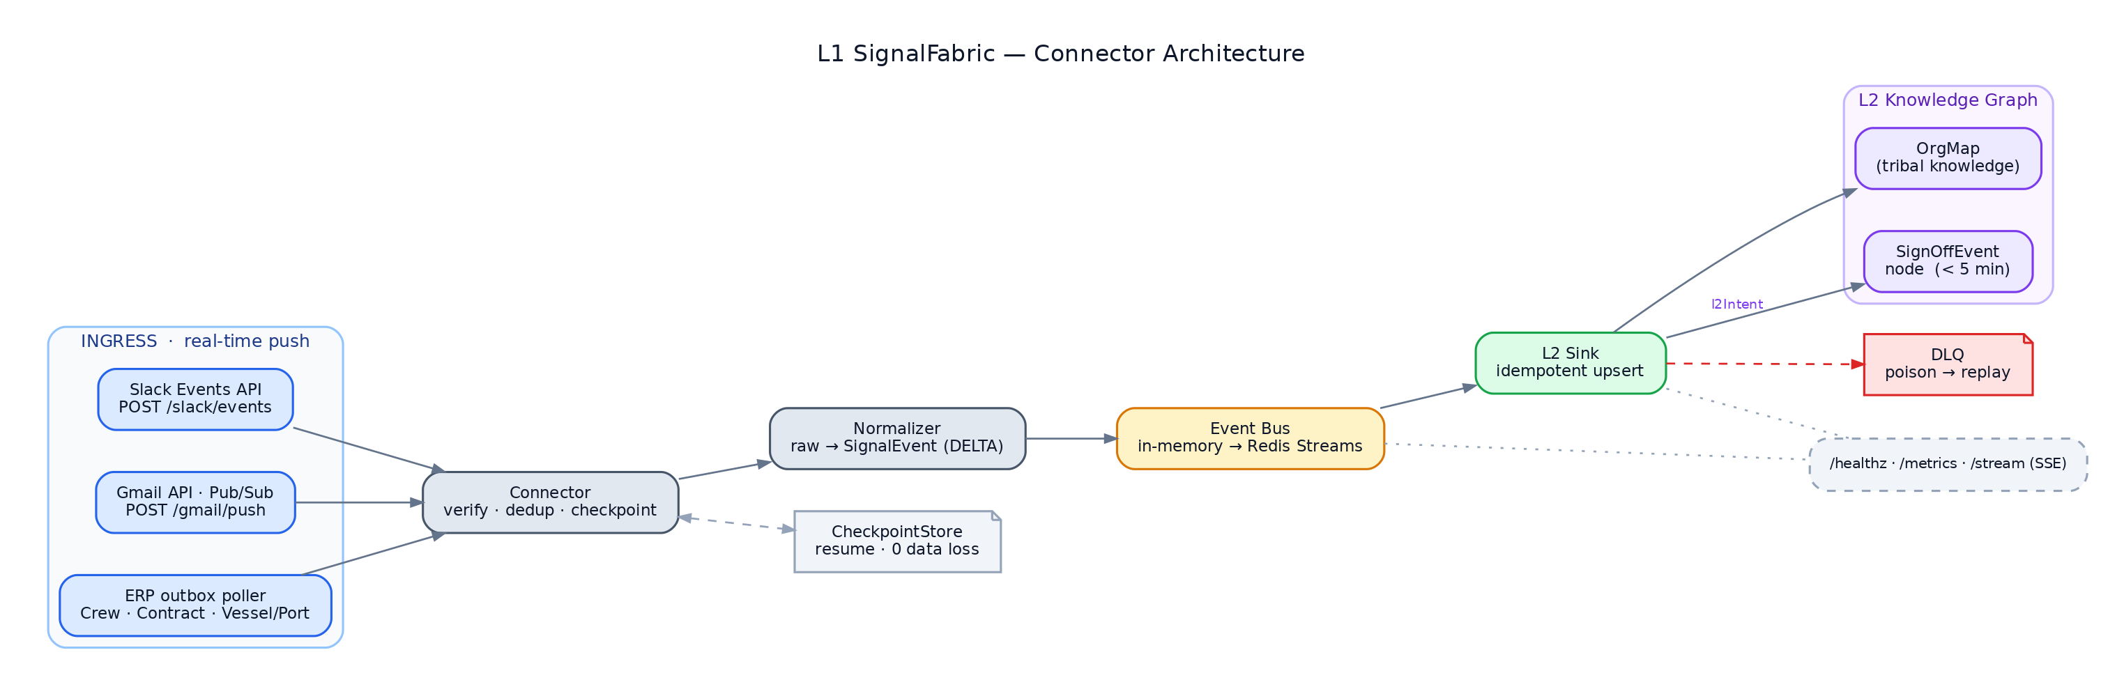
Figure 1 — Component overview. Push connectors (Slack, Gmail) and the ERP poller share one connector contract feeding normalizer → event bus → L2 sink, with CheckpointStore, DLQ, and observability cross-cutting.

2.2 The connector contract (EventStreamConnector)
Phase-3 analogue of the upstream stubbed CDCExtractor interface. Every connector implements the
same lifecycle so the core treats all sources uniformly.
class EventStreamConnector(Protocol):
name: str # "slack" | "gmail" | "erp.crew_db" | ...
source_system: SourceSystem # SLACK | EMAIL | CREW_DB | CONTRACT_CLM | VESSEL_PORT_DB
def verify(self, request) -> VerifyResult:
"""Validate authenticity of an inbound push (HMAC / JWT) or a poll cycle.
Returns CHALLENGE (echo handshake), OK, or REJECT."""
async def ingest(self, raw) -> list[RawEvent]:
"""Turn one inbound payload (or poll batch) into 0..N RawEvents,
applying idempotent de-duplication on the source's native id."""
def position(self) -> Checkpoint: # resume watermark (history_id / ts / updated_at)
def commit(self, ckpt: Checkpoint): ... # persist position after successful sink
Two ingestion modes, one contract:
- Push connectors (Slack, Gmail) — FastAPI route calls verify() then ingest().
- Pull/CDC connectors (ERP) — a background task polls an outbox/watermark, calls
ingest(), advances position(). Still emits `DELTA` (continuous), not SNAPSHOT.

2.3 Per-connector design

Slack Events API (Sreekumar)
- Transport: Slack Events API HTTP push → POST /slack/events. Socket Mode supported as
a no-public-URL fallback for demos.
- Auth: X-Slack-Signature HMAC-SHA256 over v0:{timestamp}:{body}, with a ±5-min
timestamp window to block replay. url_verification challenge handled in verify().
- Events handled: message, reaction_added, member_joined_channel.
- Dedup: Slack event_id (X-Slack-Retry-Num retries are idempotent).
- OrgMap mapping: person ↔ channel membership, message authorship, reaction edges =
tribal-knowledge signal. Field shape reuses the existing batch Slack scraper model.

Gmail API — Workspace (Sruthy)
- Transport: users.watch() → Google Cloud Pub/Sub topic → push subscription →
POST /gmail/push.
- Auth: verify the Pub/Sub OIDC JWT (audience + Google signing keys).
- Fetch: push gives only a historyId; we call users.history.list then
users.messages.get with `format=metadata` and an explicit metadataHeaders allow-list
(From,To,Cc,Subject,Date,Message-Id,References,In-Reply-To). Body is never requested.
- Mapping: participants → OrgMap interaction edges; References/In-Reply-To →
thread linkage.
- Sign-off detection: rule-based classifier (subject/label/sender allow-list, e.g.
label crew/sign-off or subject matches a sign-off pattern) → emits a SignOffEvent
intent on the canonical event (see §3.3).

ERP Integration (Sreekumar)
- Sources: Crew DB, Contract (CLM), Vessel/Port DB — modeled as Postgres (the project
already runs Postgres, `README.md`).
- CDC strategy (proto): transactional outbox table (signal_outbox) populated by
triggers on each tracked table, polled on a short interval; fallback is an updated_at
high-watermark scan. Each change emits a `DELTA` record. (Prod path can swap to logical
replication / Debezium behind the same connector contract.)
- Watermark: last consumed outbox.id (monotonic) stored in CheckpointStore → crash-safe
resume with no gap and no replay duplication.
────────────────────────────────────────

3. Stream Schema

3.1 SignalEvent — the canonical record
1:1 with the upstream Record so downstream stays batch-compatible. Difference from the
upstream file path: operation is always `DELTA`.
{
"entity": "message", // message | reaction | channel_join | email | crew | contract | vessel_port
"key": { "channel_id": "C005", "ts": "1719980964.000100" }, // source-natural primary key
"sourceSystem": "SLACK", // SLACK | EMAIL | CREW_DB | CONTRACT_CLM | VESSEL_PORT_DB
"tenantId": "maritime-acme",
"operation": "DELTA", // always DELTA in L1 (continuous)
"data": { /* normalized, source-specific fields (metadata only for Gmail) */ },
"timestamp": "2026-06-10T14:30:52Z", // when the event was valid at source
"extractedAt": "2026-06-10T14:30:53Z", // when L1 received it (latency start)
"lineage": {
"extractionId": "slack-evt-20260610-143052-a1b2",
"sourceEndpoint": "/slack/events", // or "/gmail/push", "erp.outbox"
"sourceSequence": 10432, // outbox id / gmail historyId
"checksum": "sha256:…" // integrity of raw payload
},
"metadata": {
"schemaVersion": "1.0",
"custom": { "eventId": "Ev0xx", "deliveryAttempt": "1", "sinkAt": "2026-06-10T14:30:54Z" }
}
}
metadata.custom.sinkAt − extractedAt = the propagation latency measured against the
< 5-min SLO.

3.2 Per-source data payloads
sourceSystem | entity | data fields (normalized)
SLACK | message | channel, user{id,name,email}, text, thread_ts, reply_count
SLACK | reaction | channel, user, target_ts, reaction
SLACK | channel_join | channel, user, inviter?
EMAIL | email | from, to[], cc[], subject, thread_id, references[], sent_at — no body
CREW_DB | crew | crew_id, name, rank, vessel_id, status, updated_at
CONTRACT_CLM | contract | contract_id, crew_id, type, state, effective_from/to
VESSEL_PORT_DB | vessel_port | vessel_id, port, eta, status

3.3 SignOffEvent envelope (the < 5-min trigger)
When the Gmail connector classifies a message as a sign-off, the SignalEvent carries a
materialization intent the L2 sink acts on:
{
"entity": "email", "sourceSystem": "EMAIL", "operation": "DELTA",
"data": { "from": "captain@…", "to": ["crewops@…"], "subject": "Sign-off: …",
"thread_id": "…", "sent_at": "…" },
"metadata": { "custom": {
"l2Intent": "CREATE_SIGNOFF_EVENT",
"crewRef": "<resolved crew_id or email>",
"vesselRef": "<resolved vessel_id?>" } }
}
The L2 sink, on seeing l2Intent=CREATE_SIGNOFF_EVENT, upserts a SignOffEvent node
(idempotent on thread_id+crewRef) — satisfying the exit criterion.
────────────────────────────────────────

4. Event Bus & Delivery Semantics
- Bus: InMemoryBus for Day-1 demo → `RedisStreamsBus` for durability + replay
(consumer groups, XACK, pending-entry reclaim).
- Delivery: at-least-once. The L2 sink is idempotent (upsert on canonical key +
sourceSequence), so at-least-once is safe end-to-end.
- Ordering: per-key ordering preserved by routing a key to a single stream partition;
global ordering not required (events are independently keyed).
- Backpressure: bounded stream length; producers block/spill to checkpoint rather than drop.
- DLQ: after N retries a message moves to signal.dlq with the failure reason; a replay
tool re-injects after fix.
- Checkpointing: commit() runs only after the sink acks → guarantees 0 loss across
restart (the connector resumes from the last committed position()).
────────────────────────────────────────

5. Data Flow

5.1 End-to-end (push: Slack / Gmail)
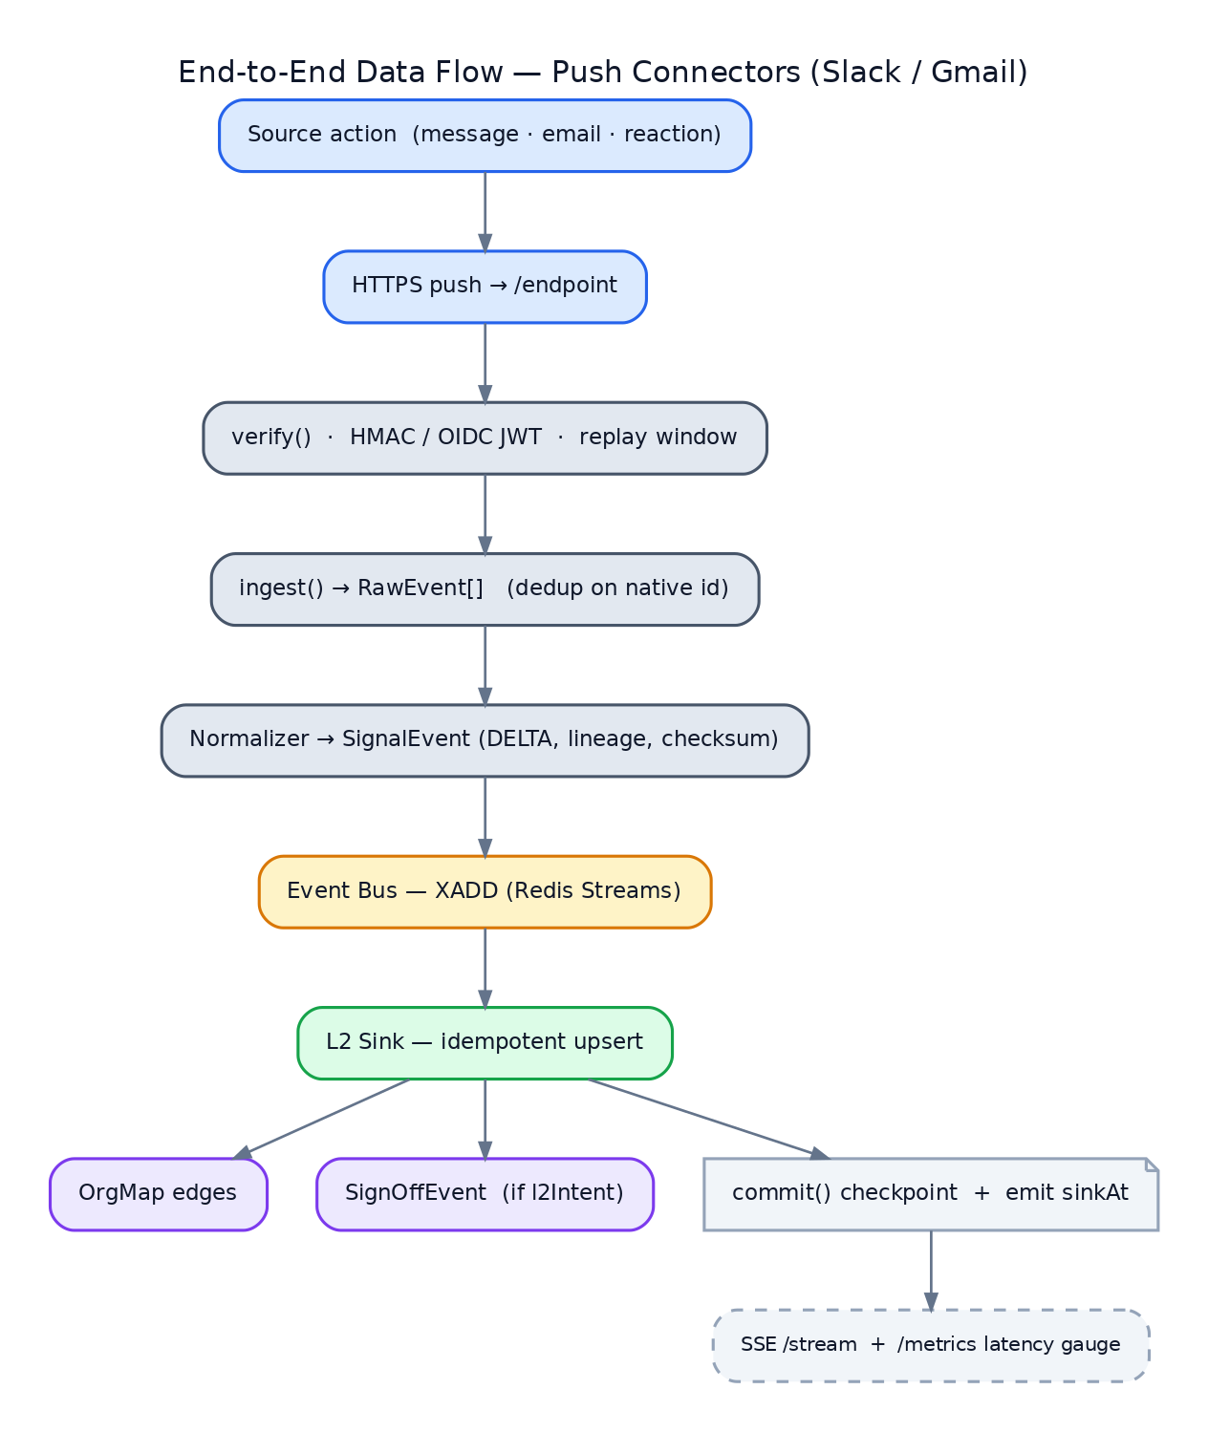
Figure 2 — End-to-end push flow (Slack / Gmail): verify → ingest/dedup → normalize → bus → idempotent sink, fanning out to OrgMap edges, SignOffEvent, checkpoint commit, and latency metrics.

5.2 ERP (pull/CDC)
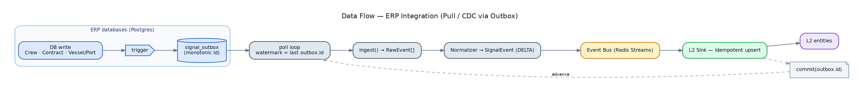
Figure 3 — ERP pull/CDC flow: DB write → trigger → outbox; a watermarked poll loop emits DELTAs through the bus to the sink, then commits the outbox id to advance.

5.3 Latency budget (target < 5 min; expected « 1 s for push)
Hop | Push (Slack/Gmail) | ERP (poll)
source → L1 ingress | network (~ms) | ≤ poll interval (≤ 5 s)
verify + normalize | ~ms | ~ms
bus → sink | ~ms–s | ~ms–s
observed E2E | sub-second | < 6 s

Headroom against the 5-min SLO is large; the SLO mainly guards Gmail's Pub/Sub delivery and
history.list pagination under load.
────────────────────────────────────────

6. Upstream Extension Approach
Upstream concept | L1 SignalFabric realization
CDCExtractor (Phase 3, stubbed) | EventStreamConnector — verify/ingest/position/commit
SubscribeChanges() | push routes (/slack/events, /gmail/push) + ERP outbox poller
GetCDCPosition() | position() + CheckpointStore
Record | SignalEvent (same fields; operation=DELTA)
SourceSystem enum (SLACK,EMAIL,…) | extended with CREW_DB,CONTRACT_CLM,VESSEL_PORT_DB
DataStream / RecordStream | EventBus (in-mem → Redis Streams)
Bronze JSONL sink | L2Sink (OrgMap upsert + SignOffEvent)
Batch Slack scraper | replaced by push connectors (history → real-time)

Why a separate service: L1 SignalFabric lives in its own L1SignalFabric/ module without
modifying the existing upstream codebase. We vendor the contract (Record/SourceSystem
shapes) into L1SignalFabric/core/ and keep wire compatibility, so this folds back into
the upstream pipeline later as its real Phase-3 CDCExtractor implementations.
────────────────────────────────────────

7. Technology & Module Layout
- Runtime: Python 3.12, FastAPI, asyncio (matches project stack, `README.md`).
- Bus/state: Redis (Streams + checkpoints); Postgres for ERP sources + outbox.
- Observability: Prometheus /metrics, structured JSON logs, SSE /stream live tail.
- External SDKs: slack_sdk, Google API client (google-api-python-client,
google-cloud-pubsub).
L1SignalFabric/
├── core/ # SignalEvent, SourceSystem, EventStreamConnector, EventBus, CheckpointStore
├── connectors/
│ ├── slack/ # events receiver, signature verify, normalizer
│ ├── gmail/ # pubsub push, watch(), metadata fetch, sign-off classifier
│ └── erp/ # outbox poller, crew/contract/vessel_port normalizers
├── sink/ # L2Sink (OrgMap upsert + SignOffEvent), DLQ
├── api/ # FastAPI routes: /slack/events /gmail/push /healthz /metrics /stream
├── scripts/ # inject_mock.py, replay.py, seed_erp.py
├── tests/ # see Test Doc
├── docs/ # PLAN.md, DESIGN.md, TEST.md (+ .docx)
└── docker-compose.yml / Makefile # make demo-day1..5
────────────────────────────────────────

8. Security & Privacy
- Inbound authenticity: Slack HMAC + timestamp window; Gmail Pub/Sub OIDC JWT verification.
- Least data: Gmail metadata-only (header allow-list); no message body ever fetched/stored.
- Secrets: tokens via env/secret manager; never logged. Mirrors the managed-agents
boundary — no source bodies/secrets enter hosted containers (`ARCHITECTURE.md` §0).
- Idempotency keys double as replay protection (Slack event_id, Pub/Sub messageId,
outbox id).
- PII: OrgMap stores identities/edges; access controlled at L2. L1 carries tenantId on
every event for isolation.
────────────────────────────────────────

9. Risks & Mitigations
Risk | Mitigation
No public URL for webhooks during dev/demo | Slack Socket Mode; ngrok/Cloud Run tunnel; replay.py recorded payloads
Pub/Sub or Workspace not provisioned in time | Pub/Sub emulator + recorded push payloads on the same /gmail/push code path
Duplicate deliveries (Slack retries, Pub/Sub redelivery) | idempotent sink + native-id dedup
Connector crash mid-stream | checkpoint-after-ack → resume with 0 loss/0 dup
Poison message stalls a stream | retry budget → DLQ + alert
Gmail body accidentally fetched | hard-coded format=metadata + header allow-list; unit test asserts no body field

────────────────────────────────────────

10. Open Questions (for async review)
1. L2 sink interface — does L2 expose a direct API/SDK, or do we publish to a topic L2 consumes?
2. SignOffEvent identity — canonical on thread_id+crewRef, or an L2-issued id?
3. ERP CDC in prod — outbox+triggers (proto) vs logical replication/Debezium (prod)?
4. Tenant model — single tenant for proto; confirm prod multi-tenant routing on tenantId.
</content>

