L1 SignalFabric — Implementation Details
Layer: L1 SignalFabric (continuous event ingestion for the Maritime Crew Orchestrator)
Module: L1SignalFabric/
Audience: engineers integrating with, extending, or reviewing the ingress layer
This document is the component-by-component implementation map. For each building
block it states the Role & Responsibility (what it owns) and **Where it is
implemented in code** (the exact file, class, and function). Companion docs:
`DESIGN.md` (the why), `PLAN.md` (the build order),
`TEST.md` (the test strategy), and `COMPONENTS.md` (the
six-component status map).
────────────────────────────────────────

0. The pipe at a glance
Every source event takes the same path. The components below are the stations on it:
raw source event
│ (Slack webhook · ERP outbox row · Gmail-style email)
▼
[ verify ] ── signature / handshake / authenticity
▼
[ ingest / normalize ] ── raw payload → canonical SignalEvent(s)
▼
[ dedup ] ── stable dedup_id drops at-least-once duplicates
▼
[ event bus ] ── publish + fan-out to subscribers
▼
[ L2 sink ] ── project SignalEvent → OrgMap edge / node / SignOffEvent
▼
[ dashboard / SSE ] ── live per-stage view in the browser
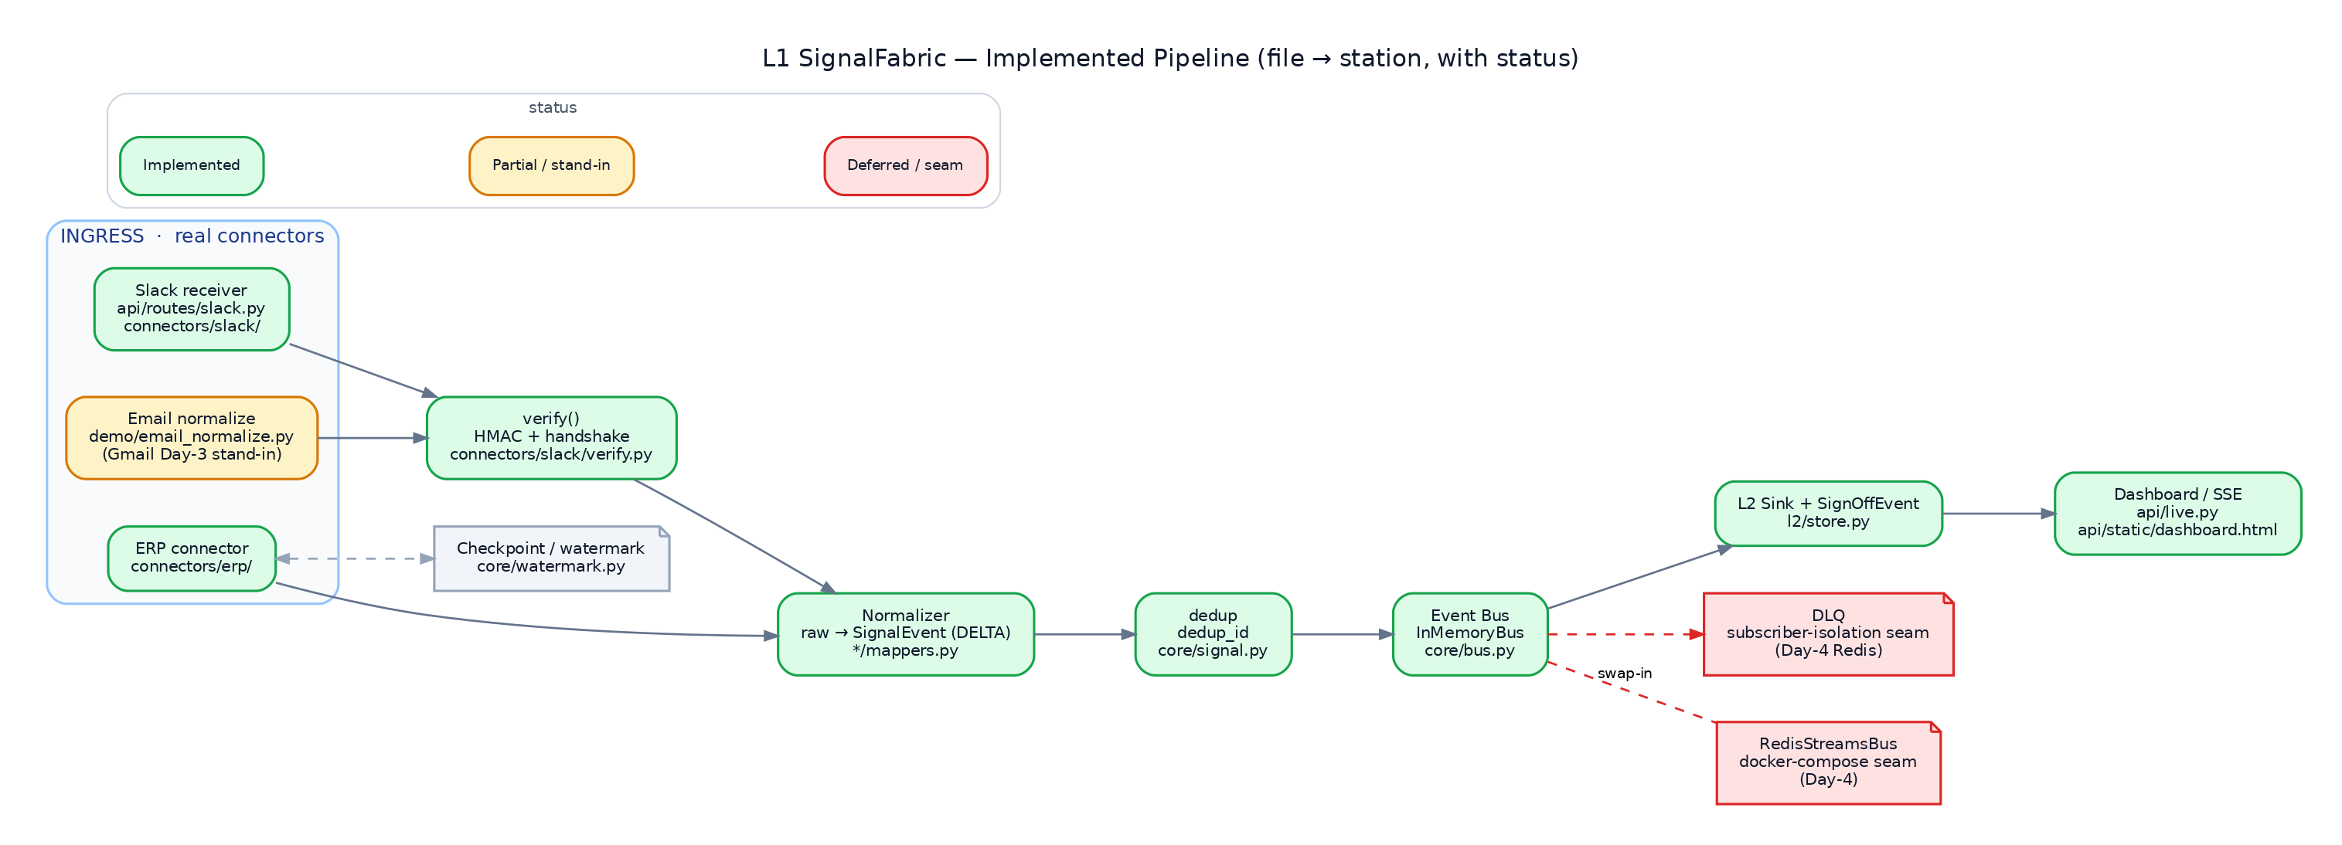
Implemented pipeline — each station mapped to its source file, coloured by status (green = implemented, amber = partial/stand-in, red = deferred/seam).
Two design invariants thread through every component:
1. One canonical shape. Every connector emits SignalEvent (core/signal.py) and
nothing downstream knows the source's native format.
2. One seam. Connectors and routes depend only on the EventBus Protocol
(core/bus.py); concrete buses (LoggingEventBus, InMemoryBus, BroadcastBus,
the Day-4 RedisStreamsBus) drop in with no change to any connector or route.
────────────────────────────────────────

0.1 Implementation status
The whole Day-1 scope is implemented and tested (35 passing tests). Two
components are intentionally partial (a labelled stand-in or a documented seam),
and three are deferred to later days behind the same Protocols. The map below is
colour-coded; the table that follows is the authoritative per-component status.
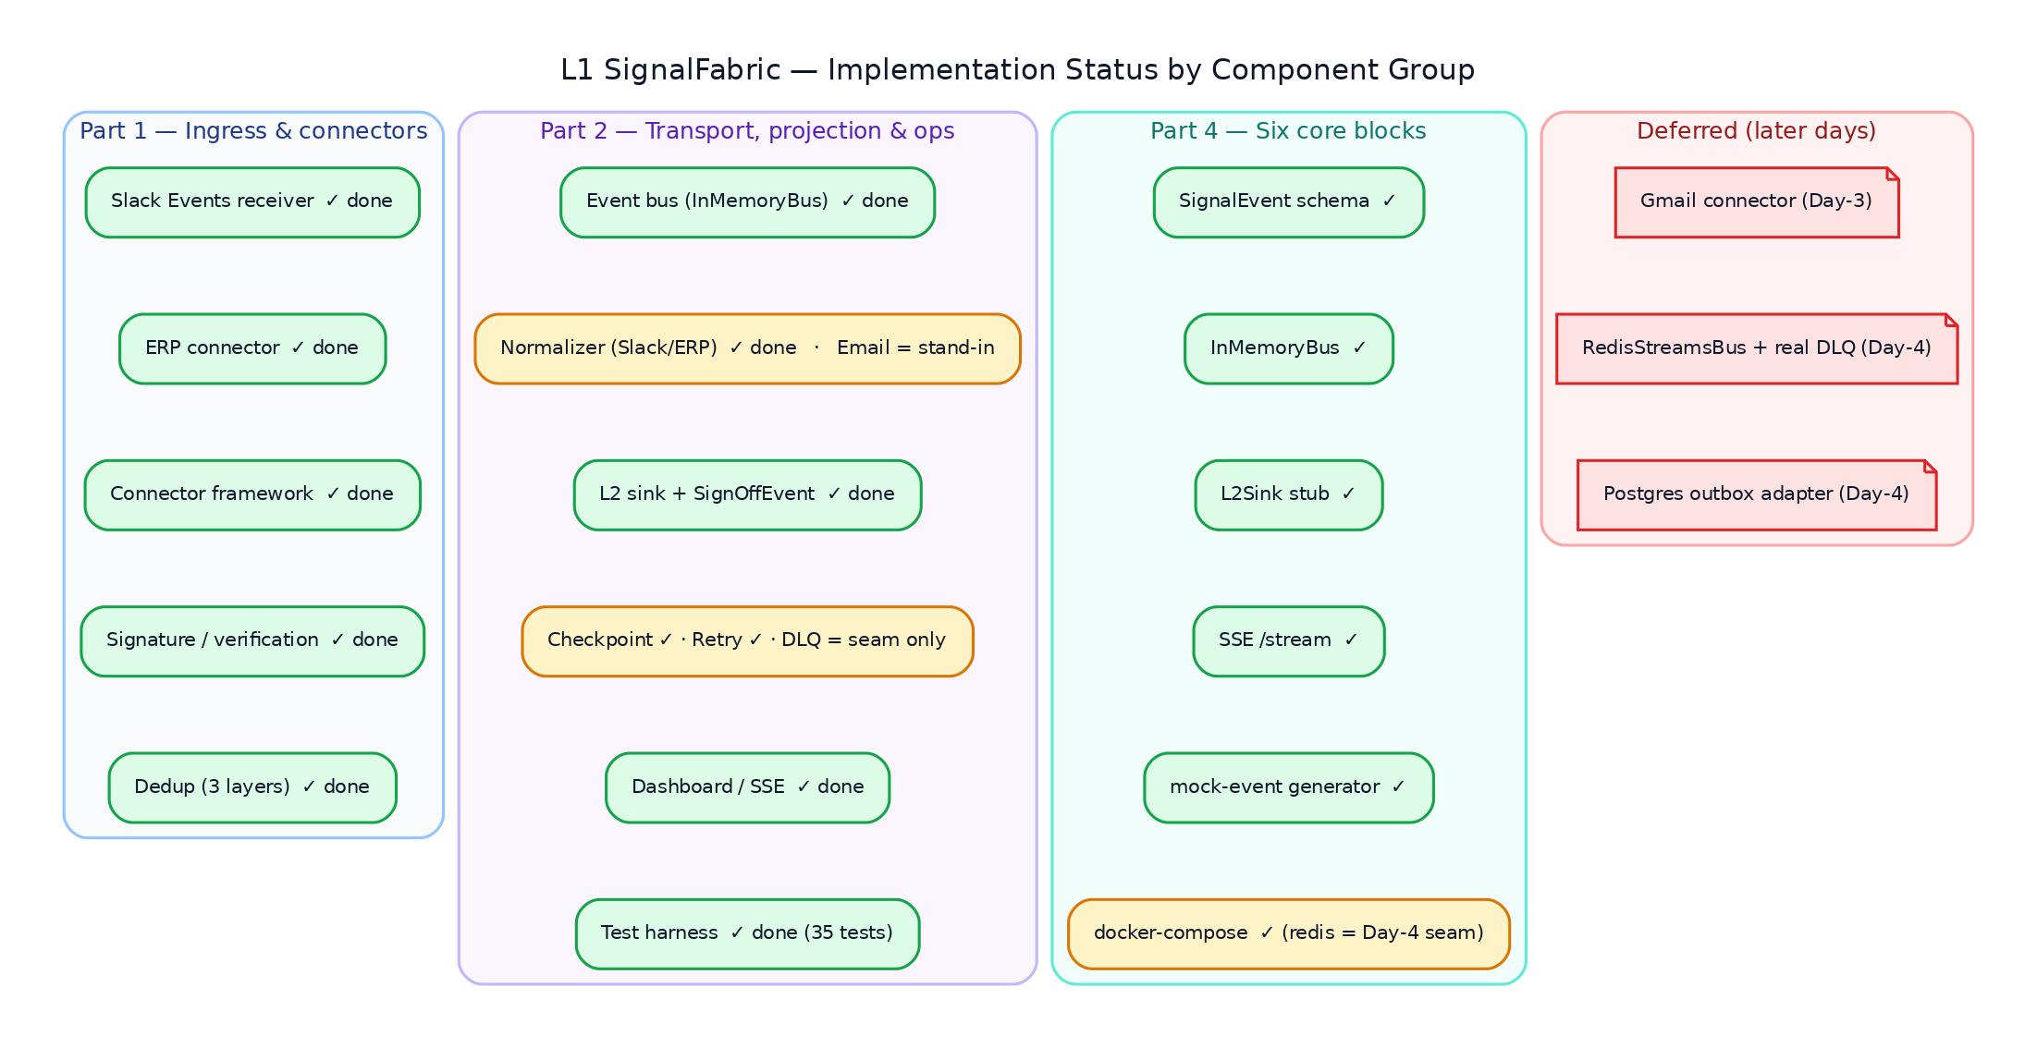
Implementation status by component group — green = done, amber = partial/stand-in, red = deferred.
Legend: ✅ Done (implemented + tested) · 🟡 Partial (works, but a stand-in or
seam, not the production form) · ⛔ Deferred (later day, Protocol/seam in place).
Component | Status | Where | Notes
Slack Events receiver | ✅ Done | api/routes/slack.py, connectors/slack/ | handshake + signature + ingest + event_id dedup
ERP connector | ✅ Done | connectors/erp/ | outbox poll + watermark + 3 source systems
Connector framework | ✅ Done | core/connector.py | EventStreamConnector + verify/ingest/position/commit
Signature / verification | ✅ Done | connectors/slack/verify.py | constant-time HMAC + replay window + dev bypass
Dedup | ✅ Done | core/signal.py, core/dedup.py, core/bus.py | three layers (connector-local · dedup_id · bus LRU)
Event bus | ✅ Done | core/bus.py | InMemoryBus: dedup + fan-out + replay + stats
Normalizer (Slack, ERP) | ✅ Done | connectors/*/mappers.py | pure, fixture-tested
Normalizer (Email) | 🟡 Partial | demo/email_normalize.py | labelled stand-in for the Day-3 Gmail connector
L2 sink + SignOffEvent | ✅ Done | l2/store.py | JSONL projection; SignOffEvent node materialized
Checkpoint | ✅ Done | core/watermark.py | in-memory + file stores; lossless resume
Retry (idempotency) | ✅ Done | core/bus.py + dedup layers | retried poll/redelivery is safe
DLQ | 🟡 Partial | core/bus.py (publish try/except) | subscriber-isolation seam only; durable DLQ is Day-4
Dashboard / SSE | ✅ Done | api/live.py, api/static/dashboard.html | per-stage counts + trace + sparkline
Test harness | ✅ Done | tests/ (35), scripts/ | contract → e2e + smoke
SignalEvent schema | ✅ Done | core/signal.py | canonical model + enums + dedup_id
InMemoryBus | ✅ Done | core/bus.py | the six-block bus
L2Sink stub | ✅ Done | l2/store.py | the six-block sink
SSE /stream | ✅ Done | api/live.py | snapshot + live rows + keepalive
Mock-event generator | ✅ Done | demo/generator.py, seed.py, stream.py | deterministic multi-source clusters
docker-compose | ✅ Done | docker-compose.yml | service ✅; redis shipped as the Day-4 seam
Gmail connector | ⛔ Deferred | (Day-3) | Pub/Sub push + OIDC verify + history.list
RedisStreamsBus + durable DLQ | ⛔ Deferred | (Day-4) | same EventBus Protocol; redis seam already in compose
Postgres outbox adapter | ⛔ Deferred | (Day-4) | swap InMemoryOutboxAdapter; connector/mappers unchanged

────────────────────────────────────────

Part 1 — Ingress & connector foundation
Slack Events receiver · ERP connector · connector framework · signature/verification · dedup
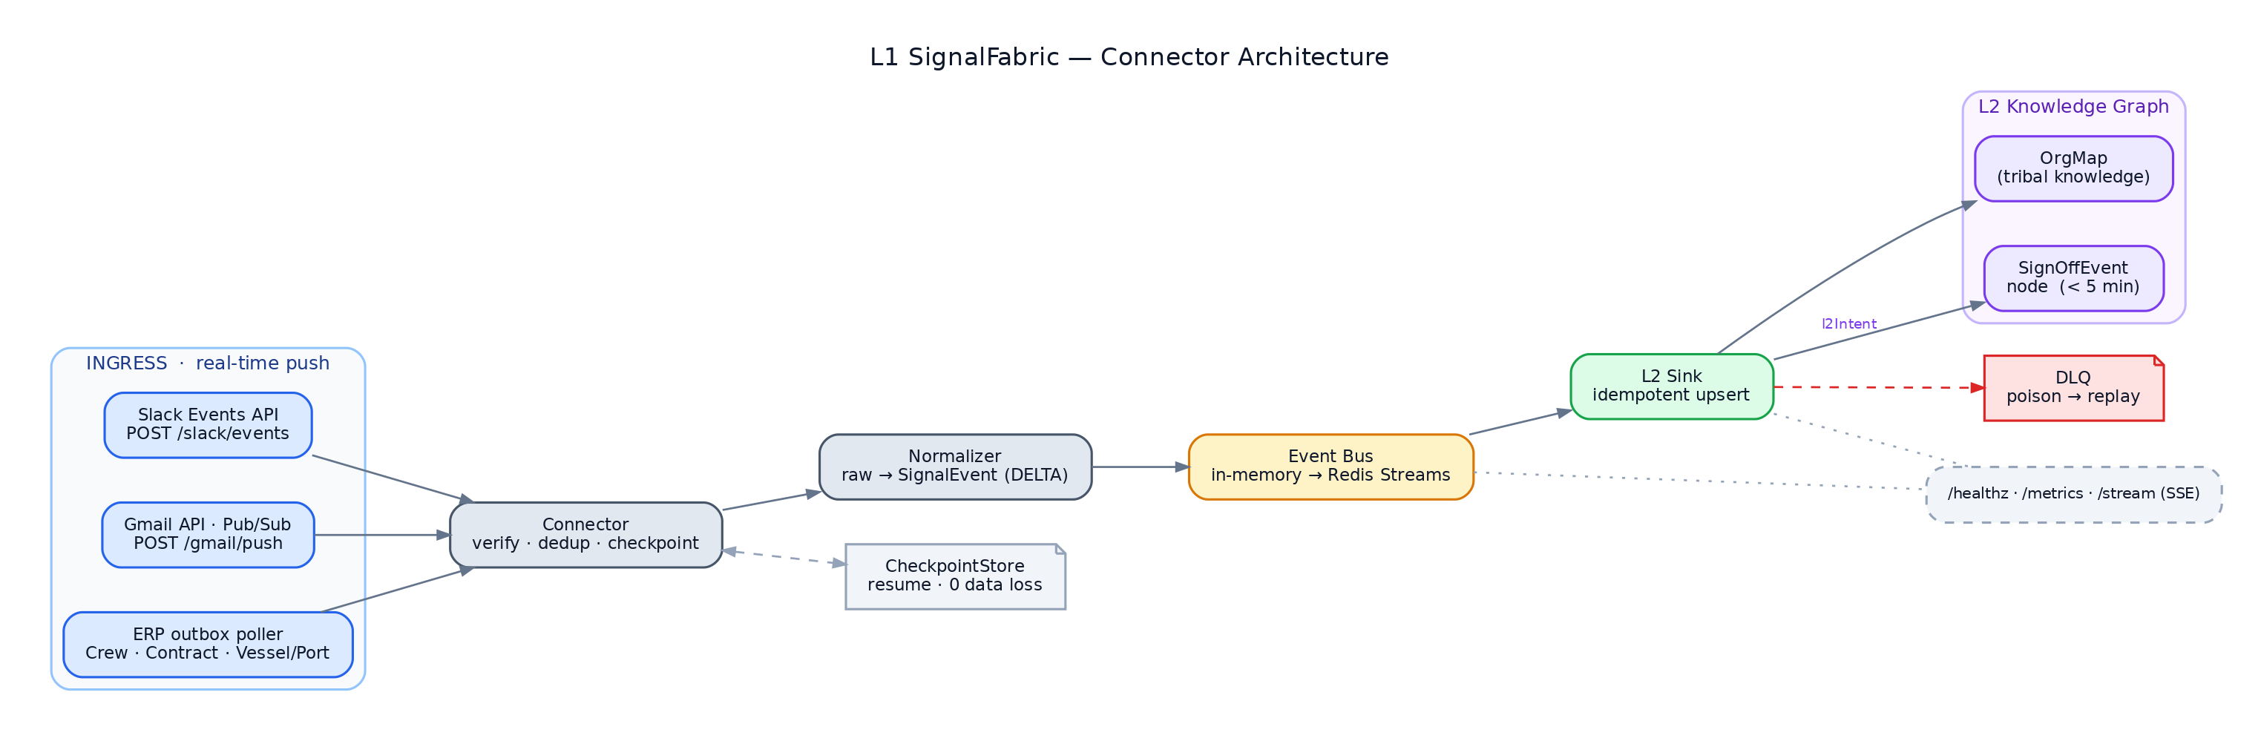
Connector architecture — ingress (Slack / Gmail / ERP) → connector (verify · dedup · checkpoint) → normalizer → event bus → L2 sink → OrgMap / SignOffEvent, with the checkpoint, DLQ, and observability seams.

1.1 Slack Events receiver
Role & Responsibility. Accept inbound Slack Events API HTTP pushes, authenticate
them, normalize each event_callback into SignalEvents, and publish to the bus — while
acking within Slack's 3-second budget. Handles the url_verification handshake, HMAC
signature verification, per-event_id idempotency, and fan-out to the per-type mappers
(message / reaction_added / member_joined_channel).
Where it is implemented in code.
Concern | Location
HTTP route (transport glue only) | `api/routes/slack.py` — slack_events() (POST /slack/events)
Connector logic | `connectors/slack/connector.py` — SlackConnector.verify() / .ingest()
Raw → SignalEvent mappers | `connectors/slack/mappers.py` — map_message, map_reaction, map_member_joined, MAPPERS

The route is intentionally thin: it reads the raw body, wraps it in an
InboundRequest, calls connector.verify(...), and either echoes the challenge
(CHALLENGE), returns 401 (REJECT), or normalizes-and-publishes (OK). All
Slack-specific logic lives in the connector, so it is unit-testable without a web
server. The event.type → mapper dispatch table (MAPPERS) means unhandled event
types are silently ignored (return []) rather than erroring.
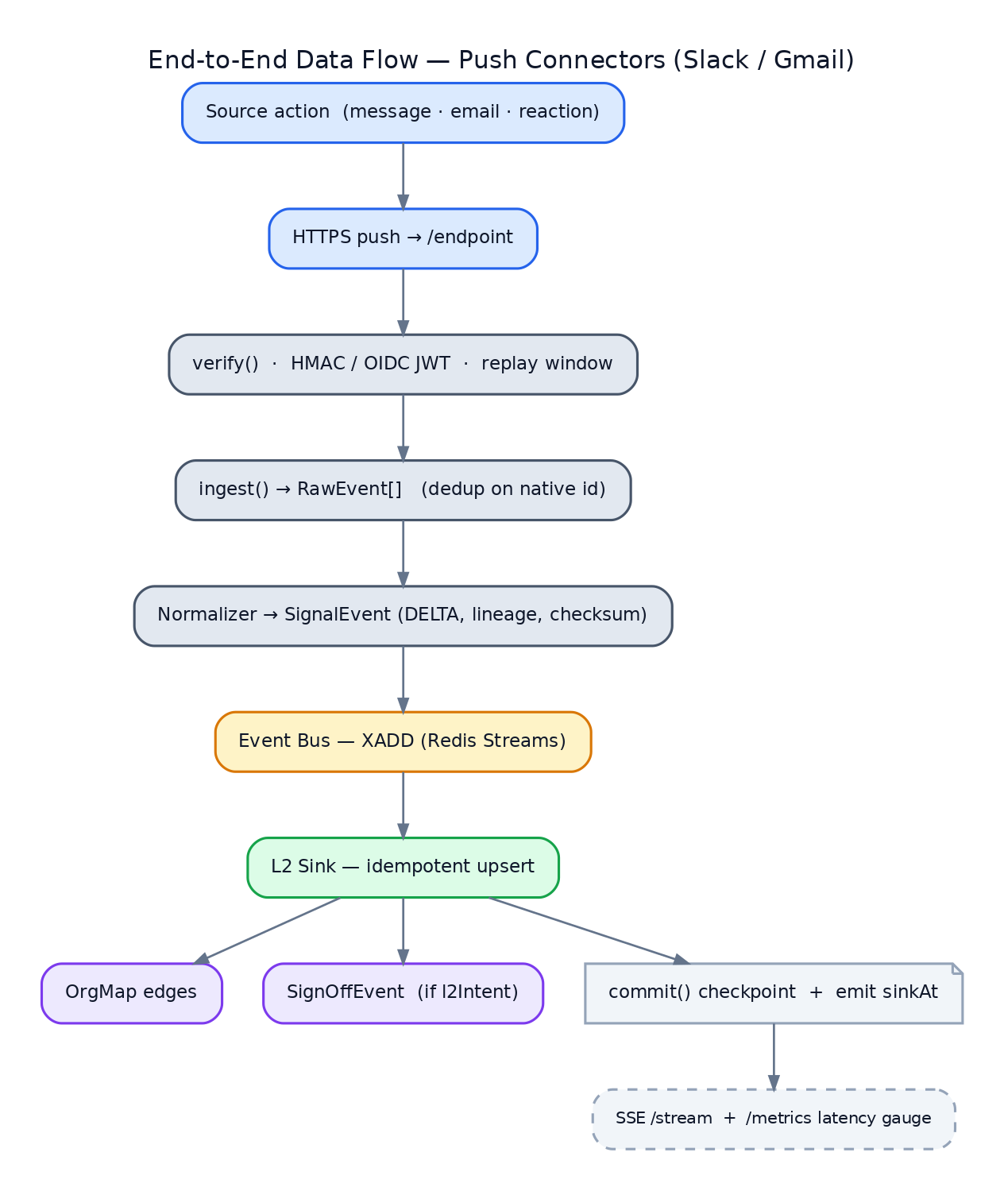
End-to-end data flow for the push connectors (Slack / Gmail) — verify → ingest → normalize → bus → L2 sink + checkpoint. *(Design-level reference; Gmail push is the Day-3 deferral, the rest is implemented.)*

1.2 ERP connector
Role & Responsibility. Pull/CDC connector covering the three ERP source systems
(Crew DB, Contract/CLM, Vessel/Port DB) through a single transactional-outbox feed.
It composes a swappable fetch adapter + the shared row mapper + a watermark, so polling
resumes losslessly across restarts (the "50 records, 0 data loss" exit criterion).
The table field on each outbox row selects the target source system and entity.
Where it is implemented in code.
Concern | Location
Connector (poll / position / commit / ingest) | `connectors/erp/connector.py` — ErpConnector
Fetch adapter contract + mimic | `connectors/erp/adapter.py` — ErpFetchAdapter (ABC), InMemoryOutboxAdapter, RawRecord
Outbox row → SignalEvent | `connectors/erp/mappers.py` — outbox_row_to_signal, TABLE_MAP

poll() fetches new rows since the cursor, maps each to SignalEvents, and advances
the watermark per row after its signals are produced. Because every event carries a
stable dedup_id (folding in source_sequence), a retried poll is safe — duplicates are
dropped downstream. The adapter is the only part that changes to go live: swap
InMemoryOutboxAdapter for a Postgres signal_outbox poller or Debezium feed; connector
and mappers are unchanged.
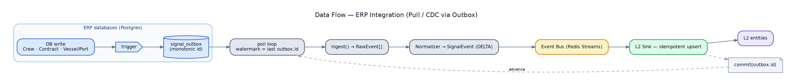
ERP pull/CDC flow via the transactional outbox — DB write → outbox → poll (watermark) → ingest → normalize → bus → L2, with `commit(outbox.id)` advancing the cursor. *(Design-level reference; the Postgres outbox is the Day-4 adapter swap, the connector path is implemented.)*

1.3 Connector framework (EventStreamConnector)
Role & Responsibility. The uniform lifecycle every source implements, so the core
treats push (webhook) and pull (CDC/outbox) connectors identically. It is the L1
realization of the upstream stubbed Phase-3 CDCExtractor. Defines the four lifecycle
methods and the framework-agnostic request/result value types so connectors never depend
on the web framework.
Where it is implemented in code. `core/connector.py`:
Symbol | Responsibility
EventStreamConnector (ABC) | verify(request) → VerifyResult; ingest(raw) → list[SignalEvent] (abstract); position() / commit(ckpt) for pull connectors (default no-op)
InboundRequest | Framework-agnostic view of an inbound HTTP push (case-insensitive header() lookup) — the FastAPI route adapts Starlette's Request into this
VerifyResult / VerifyOutcome | The verify contract: OK (proceed), CHALLENGE (echo handshake value), REJECT (401 + reason); constructors .ok(), .challenge_with(), .reject()
Checkpoint | Type alias for a resume position (outbox seq, ISO timestamp, Gmail historyId, …)

Push connectors override verify + ingest; pull connectors additionally use
position/commit. Sensible defaults mean each connector implements only what it needs.

1.4 Signature / verification
Role & Responsibility. Prove an inbound Slack request is authentic before any event is
ingested. Recompute Slack's HMAC-SHA256 over v0:{timestamp}:{raw_body} keyed by the
signing secret, compare in constant time, and reject stale timestamps to block
replay. A dev bypass keeps the demo runnable with no secret configured.
Where it is implemented in code.
Concern | Location
HMAC verification primitive | `connectors/slack/verify.py` — verify_slack_signature(), SignatureCheck
Verify policy (handshake → signature → dev-bypass) | `connectors/slack/connector.py` — SlackConnector.verify()
Config knobs | `config.py` — slack_signing_secret, slack_dev_allow_unverified, slack_replay_window_sec

verify_slack_signature uses hmac.compare_digest (constant-time) and enforces the
replay window (abs(now - ts) > replay_window_sec → reject). The connector's policy
order is: (1) url_verification handshake → return the challenge; (2) signing secret
configured → verify the signature; (3) no secret + dev_allow_unverified → accept with a
warning, else reject. The now parameter is injectable so tests can assert the
stale-timestamp path deterministically.

1.5 Dedup (idempotency)
Role & Responsibility. Turn the connectors' at-least-once delivery into
exactly-once downstream. Provide a stable identity for an event so the same source
event ingested twice yields the same key and the bus/sink can drop the duplicate. There
are three complementary layers of de-duplication.
Where it is implemented in code.
Layer | Location | What it dedups
Canonical-event identity | `core/signal.py` — SignalEvent.dedup_id (property) | sha256 of (source_system, entity, sorted key, source_sequence) — the bus-level dedup key
Raw-payload helper | `core/dedup.py` — dedup_key() | hashes a raw payload before a SignalEvent exists (natural keys or whole payload)
Connector-local Slack guard | `connectors/slack/connector.py` — _seen_event_ids set | drops a re-delivered Slack event_id at ingest time (Day-1; folds into bus dedup later)
ERP idempotent resume | `core/watermark.py` + ErpConnector.poll | the watermark means a retried poll re-reads nothing past the cursor

The bus enforces dedup centrally (§2.1) using dedup_id; the connector-local guards and
the watermark are upstream optimizations that keep duplicates from even reaching the bus.
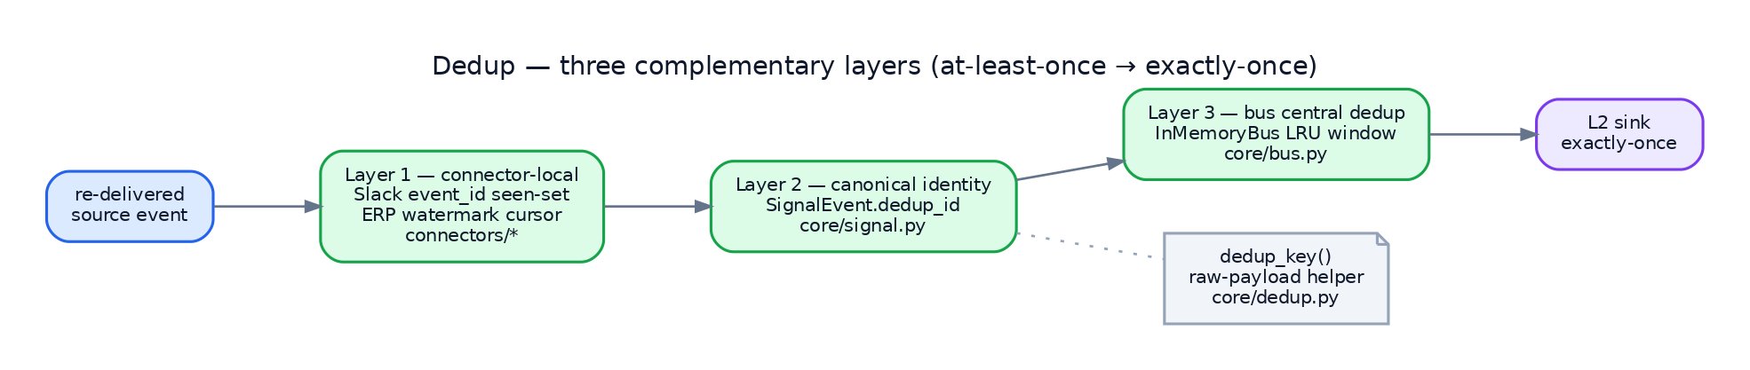
The three dedup layers: connector-local guards, the canonical `dedup_id`, and the bus's central LRU window — together turning at-least-once delivery into exactly-once downstream.
────────────────────────────────────────

Part 2 — Transport, projection & operations
Event bus · normalizer · L2 sink + SignOffEvent · checkpoint/retry/DLQ · dashboard · test harness

2.1 Event bus
Role & Responsibility. The agreed seam between the ingress track and the core/sink
track. Anything a connector can publish a normalized event to. Three concrete
implementations exist behind one Protocol, each adding capability:
- idempotency — duplicate dedup_id events are dropped (LRU window keeps memory flat);
- fan-out — subscribers (the L2 sink) receive every new event; a failing subscriber is
isolated and logged, never dropping the event for the others;
- replay — a bounded ring buffer brings a late subscriber/viewer immediately current.
Where it is implemented in code. `core/bus.py`:
Symbol | Role
EventBus (runtime-checkable Protocol) | the contract — async publish(event) — connectors/routes depend only on this
LoggingEventBus | Day-1 placeholder: logs + keeps last N (no subscribers/durability)
InMemoryBus | production-shaped bus: dedup (_seen LRU + _dedup_window), subscribe/unsubscribe fan-out, replay(), stats(), and a bounded console log (recent_log) for the UI

InMemoryBus.publish checks dedup_id against the LRU set, drops + counts duplicates,
else appends to history, bumps the per-source/per-entity counters, and fans out to
subscribers (awaiting async ones via inspect.isawaitable). The viewer bus
BroadcastBus (§2.5) implements the same Protocol and *taps* an InMemoryBus purely to
surface its PUBLISH/DUP-DROP console log in the dashboard. The Day-4 RedisStreamsBus
will implement the same publish/subscribe/replay surface — swap-in by construction.
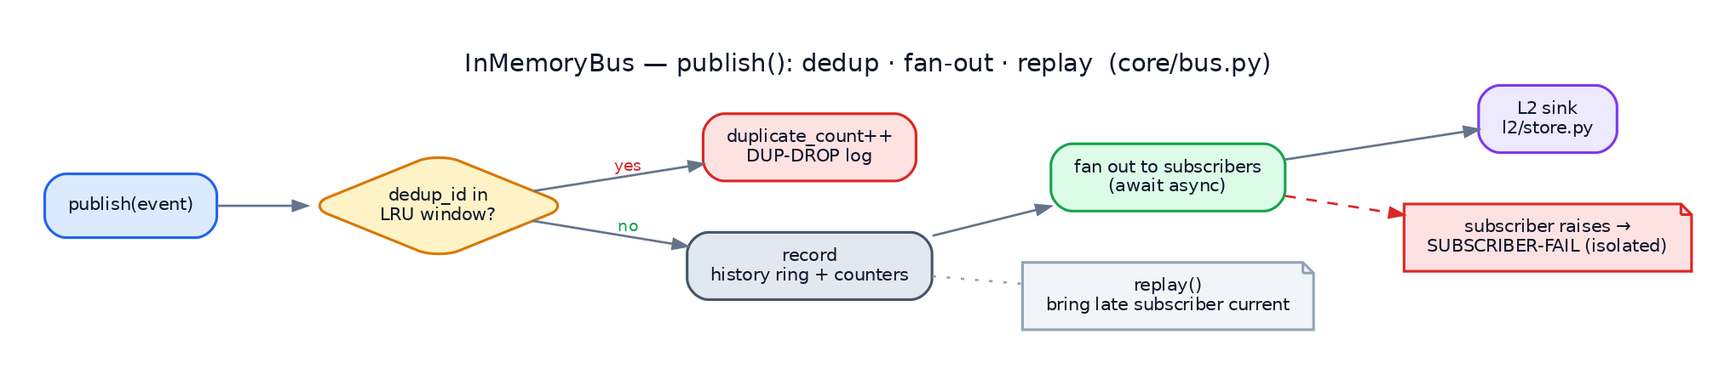
`InMemoryBus.publish()` control flow — dedup check against the LRU window (drop duplicates), record to the history ring + counters, fan out to subscribers (awaiting async), isolate a failing subscriber, and `replay()` to bring a late subscriber current.

2.2 Normalizer
Role & Responsibility. Convert each source's native payload into the canonical
SignalEvent — the "raw → SignalEvent" seam. Normalizers are pure (no I/O, no clock
beyond supplied timestamps) so they are proven against recorded fixtures and reused
unchanged regardless of transport (HTTP Events API vs Socket Mode; webhook vs poll).
Where it is implemented in code. One normalizer per source family:
Source | Location | Notes
Slack | `connectors/slack/mappers.py` | map_message / map_reaction / map_member_joined; _ts_to_dt parses Slack epoch ts
ERP | `connectors/erp/mappers.py` | outbox_row_to_signal; TABLE_MAP routes table → (source_system, entity, pk)
Email | `demo/email_normalize.py` | email_to_signal; labelled demo stand-in for the Day-3 Gmail connector — metadata only, no body; sets l2Intent=CREATE_SIGNOFF_EVENT on sign-off mail

Email normalization lives under demo/ (not connectors/) deliberately: the real Gmail
connector (Pub/Sub push + OIDC verify + history.list) is Day-3 work and will replace it.

2.3 L2 sink + SignOffEvent
Role & Responsibility. The downstream end of the demo pipe: subscribe to the bus and
project each canonical SignalEvent into the L2 store (a lightweight stand-in for the
real OrgMap + SignOffEvent knowledge graph). Slack events become OrgMap edges, ERP rows
become entity nodes, and a sign-off email (l2Intent=CREATE_SIGNOFF_EVENT) materializes a
dedicated SignOffEvent node.
Where it is implemented in code. `l2/store.py`:
Symbol | Role
L2JsonlStore.project() (static, pure) | SignalEvent → L2 record: signoff_event \ | edge \ | node
L2JsonlStore.append() | project + persist one record to append-only JSONL; updates by_kind/by_label/signoff counters and recent
_SLACK_LABEL / _ERP_LABEL | edge/node label maps (POSTED_IN / REACTED_IN / MEMBER_OF; Crew / Contract / Vessel)

Wiring (in `api/app.py` create_app): for an InMemoryBus the sink is
attached via bus.subscribe(store.append) (fan-out); for the default BroadcastBus it is
attached via bus.set_sink(store.append). The SignOffEvent rule is the demo's payoff:
project() checks metadata.l2Intent == "CREATE_SIGNOFF_EVENT" first and emits a
signoff_event node carrying subject/from/thread_id. Sruthy's real graph sink implements
the same "subscribe to the bus, write downstream" contract.

2.4 Checkpoint / retry / DLQ
Role & Responsibility. Make ingestion lossless and safe to retry. Persist a
source's progress (checkpoint/watermark) only after the sink acks, so a restart resumes
exactly where it left off; tolerate redelivery (retry) via dedup; isolate poison
subscribers so one bad consumer never drops events for the others.
Where it is implemented in code.
Concern | Location
Watermark stores | `core/watermark.py` — WatermarkStore (ABC), InMemoryWatermarkStore (tests), FileWatermarkStore (survives restart)
Checkpoint contract | `core/connector.py` — position() / commit(checkpoint); Checkpoint alias
ERP checkpoint use | `connectors/erp/connector.py` — ErpConnector.poll commits the cursor per row
Retry safety (idempotency) | `core/bus.py` InMemoryBus.publish dedup; §1.5 dedup layers
Subscriber isolation (DLQ seam) | `core/bus.py` — try/except around each subscriber: SUBSCRIBER-FAIL logged, event preserved for others

Scope note. A *dedicated* dead-letter queue is not yet a standalone component in
this scaffold — its seam is the subscriber-isolation try/except in
InMemoryBus.publish, which today logs SUBSCRIBER-FAIL and counts it rather than
routing the failed event to a durable DLQ. The Day-4 RedisStreamsBus is where a real
DLQ (Redis Streams XCLAIM/pending-entries-list) lands behind the same Protocol.
Checkpointing and retry are fully implemented; DLQ is a documented seam.

2.5 Dashboard
Role & Responsibility. Visualize the whole pipe in the browser — per-stage live
counts (ingress → normalized → bus → L2 → tail), a "Run Demo 1" trace showing
raw → normalized → L2 record for each event, a signals/sec sparkline, and
Start-live / Load-history controls to replay the generated dataset. It is driven by a
viewer bus that fans events out over Server-Sent Events.
Where it is implemented in code.
Concern | Location
Viewer bus + SSE + demo routes | `api/live.py` — BroadcastBus, GET / (dashboard), GET /stream (SSE), GET /bus/log, POST /demo/{inject,start,backlog,stop}, GET /demo/status
Single-file UI | `api/static/dashboard.html`
Demo orchestration (single injection) | `api/live.py` — demo_inject, _mock_pair (one coherent Slack msg + sign-off email + ERP row)
Headless Demo-1 driver | `scripts/demo1.py`

BroadcastBus implements the EventBus Protocol, runs the L2 sink on every publish,
tracks the per-stage counters (ingress/total/l2/signoff), and pushes each event as
an SSE payload carrying the full raw → normalized → l2_record trace. The /stream
generator emits a snapshot first (to bring a fresh tab current), then live rows with a
15-second keepalive. Slow clients drop lines (QueueFull) but totals stay authoritative.

2.6 Test harness
Role & Responsibility. Prove each component and the end-to-end pipe without external
services. Covers the contract, the canonical model, signature verification, ERP watermark
losslessness, the InMemoryBus, the L2 projection pipe, the live/SSE surface, the API, and
the demo streamer — plus an in-process smoke script.
Where it is implemented in code. `tests/` (35 tests) + scripts:
File | Proves
`tests/test_contract.py` | Slack & ERP connectors satisfy EventStreamConnector
`tests/test_signal.py` | SignalEvent defaults (DELTA, event_id), tz-aware validation, dedup_id/dedup_key stability
`tests/test_slack_signature.py` | valid / tampered / stale signature, and route rejects unsigned when a secret is set
`tests/test_erp.py` | outbox → 3 source systems, watermark advance / no redelivery, lossless file-watermark resume
`tests/test_inmemory_bus.py` | Protocol conformance, ordered fan-out, async await, dedup, subscriber isolation, replay, create_app wiring
`tests/test_l2_pipe.py` | L2 projection, demo/inject whole-pipe flow, /healthz stage reporting
`tests/test_live.py` | BroadcastBus fan-out/counts, /bus/log, dashboard served, idle /demo/status
`tests/test_api.py` | /healthz, handshake, message ingest publishes, duplicate dedup, unhandled-type ignore
`tests/test_demo_stream.py` | seed split, backlog drains all sources + idempotent second pass, live replay time-ordering
`scripts/smoke.py` | in-process Day-1 ingress smoke (make smoke)

Run with make test (pytest) or make smoke.
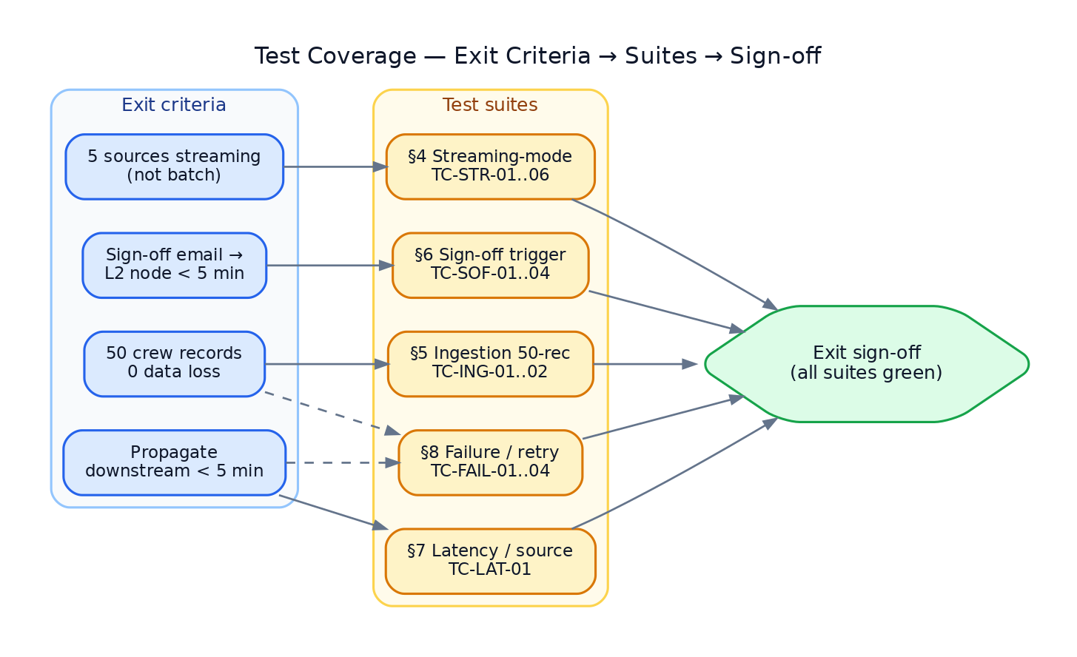
Test map — which suite proves which component, from the connector contract through the canonical model, signature, ERP watermark, bus, L2 pipe, live/SSE, API, and demo streamer.
────────────────────────────────────────

Part 3 — Day-1 scaffold (the foundation that was laid first)
Scaffold · EventStreamConnector interface · Slack & ERP skeletons · Slack URL-verify handshake
This part records the initial scaffold — the first runnable slice that everything
above builds on. (It overlaps Part 1 by design; here the lens is "what landed on Day 1".)

3.1 Project scaffold
Role & Responsibility. A fresh checkout boots and the Day-1 demo runs with **no
secrets** — env-driven config with dev-safe defaults, a FastAPI application factory wiring
connectors + bus + routes, container packaging, and Make targets.
Where it is implemented in code.
Concern | Location
App factory (wires connectors + bus + L2 + routes) | `api/app.py` — create_app()
ASGI entrypoint | `main.py`, and uvicorn api.app:app
Config (env + dev-safe defaults) | `config.py` — Settings, SERVICE_NAME, SERVICE_VERSION
Health endpoint | `api/routes/health.py` — GET /healthz
Packaging / commands | `Dockerfile`, `Makefile`, `requirements.txt`, `pyproject.toml`

3.2 EventStreamConnector interface
Role & Responsibility. The agreed connector contract laid down first so both tracks
build against it (see §1.3 for the full method-by-method breakdown).
Where it is implemented in code. `core/connector.py` —
EventStreamConnector, InboundRequest, VerifyResult, VerifyOutcome, Checkpoint.

3.3 Slack & ERP skeletons
Role & Responsibility. Minimal-but-real connector skeletons proving the push and pull
shapes against the interface: Slack (verify + ingest + mappers, event_id dedup) and ERP
(outbox adapter + watermark + per-table mappers).
Where it is implemented in code.
Skeleton | Location
Slack | `connectors/slack/` — connector.py, verify.py, mappers.py
ERP | `connectors/erp/` — connector.py, adapter.py, mappers.py

3.4 Slack URL-verify handshake
Role & Responsibility. Handle the one-time url_verification request Slack sends when
you set the Request URL — echo the challenge value back as plain text and do not
ingest it. This is what lets a real Slack app register against the endpoint.
Where it is implemented in code.
Step | Location
Detect handshake, return CHALLENGE | `connectors/slack/connector.py` — SlackConnector.verify() (first branch)
Carry the challenge value | `core/connector.py` — VerifyResult.challenge_with()
Echo it as plain text | `api/routes/slack.py` — slack_events() CHALLENGE branch → PlainTextResponse
Test | `tests/test_api.py` — test_slack_url_verification_handshake

curl -sX POST localhost:8001/slack/events \
-H 'content-type: application/json' \
-d '{"type":"url_verification","challenge":"abc123"}' # -> abc123
────────────────────────────────────────

Part 4 — The six core building blocks
SignalEvent schema · InMemoryBus · L2Sink stub · SSE /stream · mock-event generator · docker-compose
These are the six components tracked in `COMPONENTS.md`. (Several are also
covered above from a different angle; this part is the canonical six-block reference.)
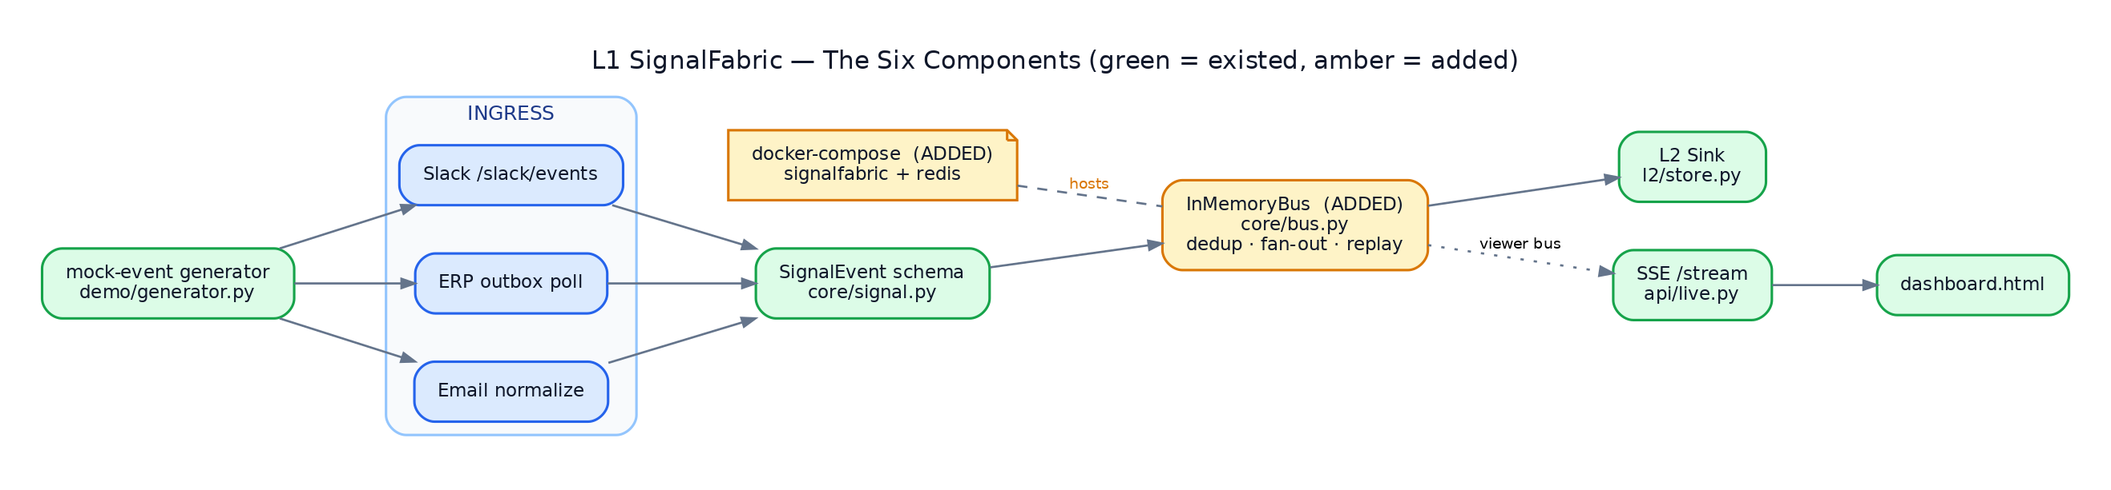
The six core building blocks in context — mock-event generator → connectors → SignalEvent schema → InMemoryBus → L2 sink, with the SSE viewer bus driving the dashboard and docker-compose hosting the stack (green = pre-existing, amber = added).

4.1 SignalEvent schema
Role & Responsibility. The single canonical event model every connector emits and the
bus / L2 sink consume. 1:1 with the upstream Record (entity, key, sourceSystem,
tenantId, data, operation, timestamp, lineage) so the stream stays batch-compatible — the
only L1 difference is that streams are continuous, so operation is always DELTA. It
also owns the canonical dedup identity and the timezone-aware-timestamp guarantee.
Where it is implemented in code. `core/signal.py`:
Symbol | Role
SignalEvent (pydantic model) | the canonical event; dedup_id property; _require_tz validator (rejects naive timestamps)
SourceSystem (enum) | SLACK, EMAIL, CREW_DB, CONTRACT_CLM, VESSEL_PORT_DB
Operation (enum) | DELTA (L1 default), SNAPSHOT (upstream batch parity)
Lineage | provenance: extraction_id, source_endpoint, source_sequence, checksum

Dependency-light (pydantic only) so it can be vendored back upstream unchanged.

4.2 InMemoryBus
Role & Responsibility. The Day-1 production-shaped bus — idempotency (dedup), subscriber
fan-out, and replay — behind the EventBus Protocol. See §2.1 for the full behavior.
Where it is implemented in code. `core/bus.py` — InMemoryBus
(publish, subscribe/unsubscribe, replay, stats, recent_log). Wired via
create_app(bus=InMemoryBus()) in `api/app.py`; proven in
`tests/test_inmemory_bus.py`.

4.3 L2Sink stub
Role & Responsibility. Project published SignalEvents into the L2 store (OrgMap
edges / entity nodes / SignOffEvent nodes) — the demo pipe's downstream end. See §2.3.
Where it is implemented in code. `l2/store.py` — L2JsonlStore
(project pure projection, append persist). Subscribed/sinked in
`api/app.py`; proven in `tests/test_l2_pipe.py`.

4.4 SSE /stream
Role & Responsibility. Stream live pipeline activity to the browser over Server-Sent
Events: an initial snapshot then per-event rows with full stage traces, with keepalives and
slow-client tolerance. See §2.5.
Where it is implemented in code. `api/live.py` — GET /stream,
BroadcastBus.subscribe/_fanout/snapshot. Consumed by
`api/static/dashboard.html`; proven in
`tests/test_live.py`.

4.5 Mock-event generator
Role & Responsibility. Generate a large, coherent, deterministic stream of **raw
source events** in the exact shapes the connectors ingest (Slack event_callback,
Gmail-style email metadata, ERP outbox rows). Crew changes are emitted as **multi-source
clusters** (ERP status change → sign-off email → #crew-changes Slack post → contract
completion → reliever onboarding) so the demo tells one story across all sources. Seeded
RNG + fixed anchor → byte-identical reruns.
Where it is implemented in code.
Concern | Location
World generator | `demo/generator.py` — WorldGenerator, GenConfig, WorldEvent
Seed CLI (split at anchor + entities + meta) | `demo/seed.py` — make seed
Stream driver (backlog / live replay) | `demo/stream.py` — DemoStreamer.run_backlog / run_live
Per-injection mock builder (dashboard Demo 1) | `api/live.py` — _mock_pair
Dataset docs | `demo/README.md`

DemoStreamer routes each raw line through the real connectors (SlackConnector.ingest,
ErpConnector outbox + watermark) and the email stand-in, publishing canonical
SignalEvents — backlog proves idempotency (second_pass_new == 0), live advances a
virtual clock to surface NEW signals continuously. Proven in
`tests/test_demo_stream.py`.

4.6 docker-compose
Role & Responsibility. Run the whole stack locally with one command — the FastAPI
service plus the Redis seam for the Day-4 RedisStreamsBus (included but not yet
required by the in-memory pipeline). Persists the dataset and L2 store across runs.
Where it is implemented in code.
Concern | Location
Compose stack (signalfabric + redis) | `docker-compose.yml`
Service image | `Dockerfile`, `.dockerignore`

docker compose up --build # → dashboard at http://localhost:8001/
────────────────────────────────────────

Appendix — file → component index
File | Component(s)
core/signal.py | SignalEvent schema · canonical dedup_id
core/connector.py | EventStreamConnector interface · checkpoint contract
core/bus.py | Event bus · InMemoryBus · LoggingEventBus · dedup · subscriber isolation
core/dedup.py | Dedup (raw-payload helper)
core/watermark.py | Checkpoint / lossless resume
connectors/slack/connector.py | Slack Events receiver · verify policy · url-verify handshake · event_id dedup
connectors/slack/verify.py | Signature / verification (HMAC)
connectors/slack/mappers.py | Normalizer (Slack)
connectors/erp/connector.py | ERP connector · poll · checkpoint
connectors/erp/adapter.py | ERP fetch adapter (swap-to-go-live seam)
connectors/erp/mappers.py | Normalizer (ERP)
api/app.py | Scaffold · app factory · bus/sink wiring
api/routes/slack.py | Slack ingress route (transport glue)
api/routes/health.py | /healthz
api/live.py | Dashboard · BroadcastBus · SSE /stream · demo routes
api/static/dashboard.html | Dashboard UI
l2/store.py | L2 sink + SignOffEvent
demo/generator.py · seed.py · stream.py | Mock-event generator
demo/email_normalize.py | Normalizer (Email — Gmail Day-3 stand-in)
config.py | Scaffold config (Slack secret, replay window, paths)
docker-compose.yml · Dockerfile | docker-compose · packaging
tests/ · scripts/smoke.py · scripts/demo1.py | Test harness

