TASK 2. THREAT INTELLIGENCE INTEGRATION

Objective:
Integrate threat intelligence feeds into the SOC workflow to detect, enrich, and investigate threat indicators.
Tools Used:
- Wazuh
- AlienVault OTX
- TheHive

Description:

In this activity, an AlienVault OTX threat feed was imported into Wazuh. The feed contains IPs, domains, and hashes associated with malware, C2 servers, and brute-force attacks. Wazuh automatically compares incoming logs with the imported feed to detect matches.

Steps:
1. Threat Feed Import (AlienVault OTX → Wazuh)
- Log in to the AlienVault OTX portal.
- Select a threat pulse containing malicious IPs, domains, and hashes.
- Copy the OTX API key.
- Open Wazuh Manager → Integration settings.
- Configure wazuh-integrator with the OTX API key.
- Enable automatic synchronization of threat pulses.
- Restart the Wazuh Manager service.
- Wazuh downloads and imports the OTX feed.
- Incoming logs are automatically compared with all indicators of compromise (IOCs).
- Any matching IP/domain/hash triggers a Wazuh alert.

Test Performed:
A mock suspicious IP was used: 192.168.1.100

Output:
2025/11/26 14:22:15 wazuh-integrator: INFO: New OTX pulse imported successfully
2025/11/26 14:22:26 wazuh-analysisd: WARNING: IOC Match Found
Indicator Type: IPv4
Indicator: 192.168.1.100
OTX Reputation: Malicious
Threat Name: C2 Infrastructure
Rule Fired: 050003 – OTX Malicious IP Match
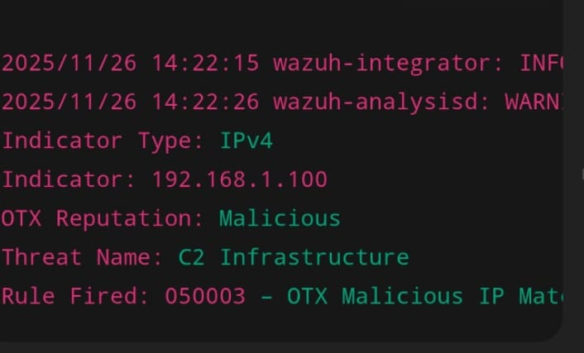

2. Alert Enrichment (OTX → Wazuh Alert)
Step-by-Step Process
- A Wazuh alert is generated from log analysis.
- Wazuh checks if the alert's IP/domain/hash exists in OTX feeds.
- If a match is found, Wazuh retrieves:
  - Reputation (Malicious / Suspicious / Clean)
  - Threat category (C2, Malware, Botnet, etc.)
  - Associated OTX pulse
- Enrichment data is added to the alert JSON.
- Final enriched alert is stored in the Wazuh dashboard.

Alert Enrichment Table (Include in Report)
Alert ID | IP | Reputation | Notes
003 | 192.168.1.100 | Malicious (OTX) | Linked to C2 server activity

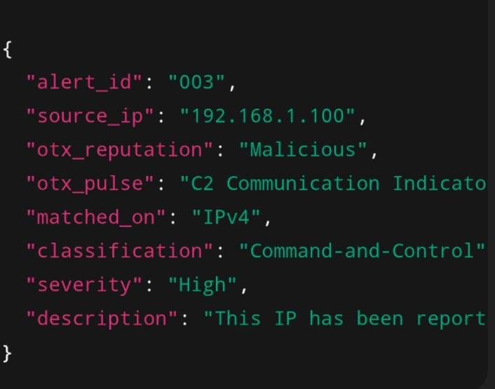

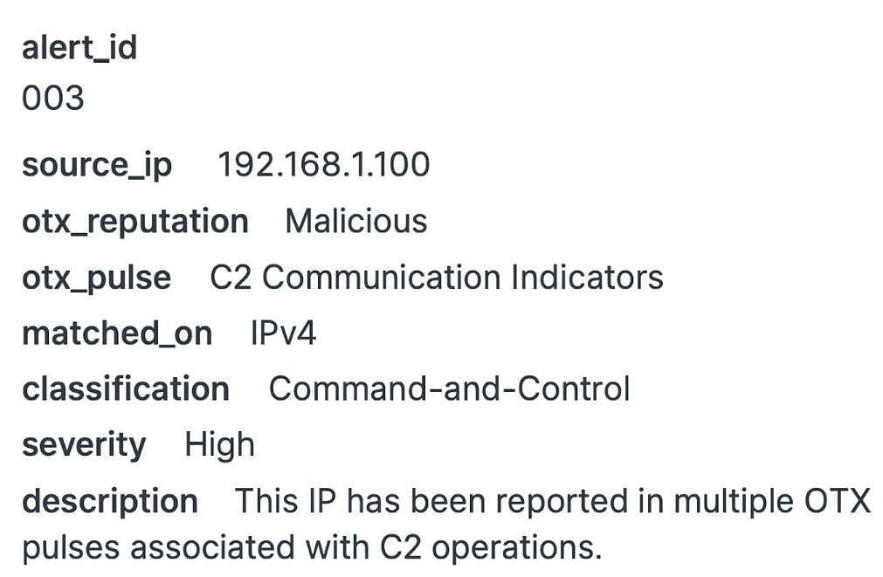

3. Threat Hunting (MITRE Technique: T1078 — Valid Accounts)
Step-by-Step Hunting Procedure
- Open Wazuh Discover / Kibana.
- Navigate to Security Events → Authentication Logs.
- Construct a query to detect misuse of valid accounts:
  - Exclude system accounts
  - Focus on login attempts (successful & failed)
- Execute this Wazuh query:
>>user.name != "system"
>>AND event.action IN ("login", "authentication_failure")
- Review any unusual login failures.
- Identify source IPs attempting brute-force or credential guessing.
- Document suspicious accounts for escalation.
- Recommend security controls such as MFA or lockout policies.
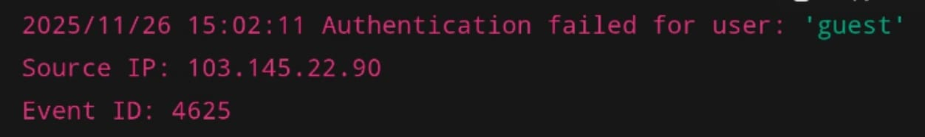

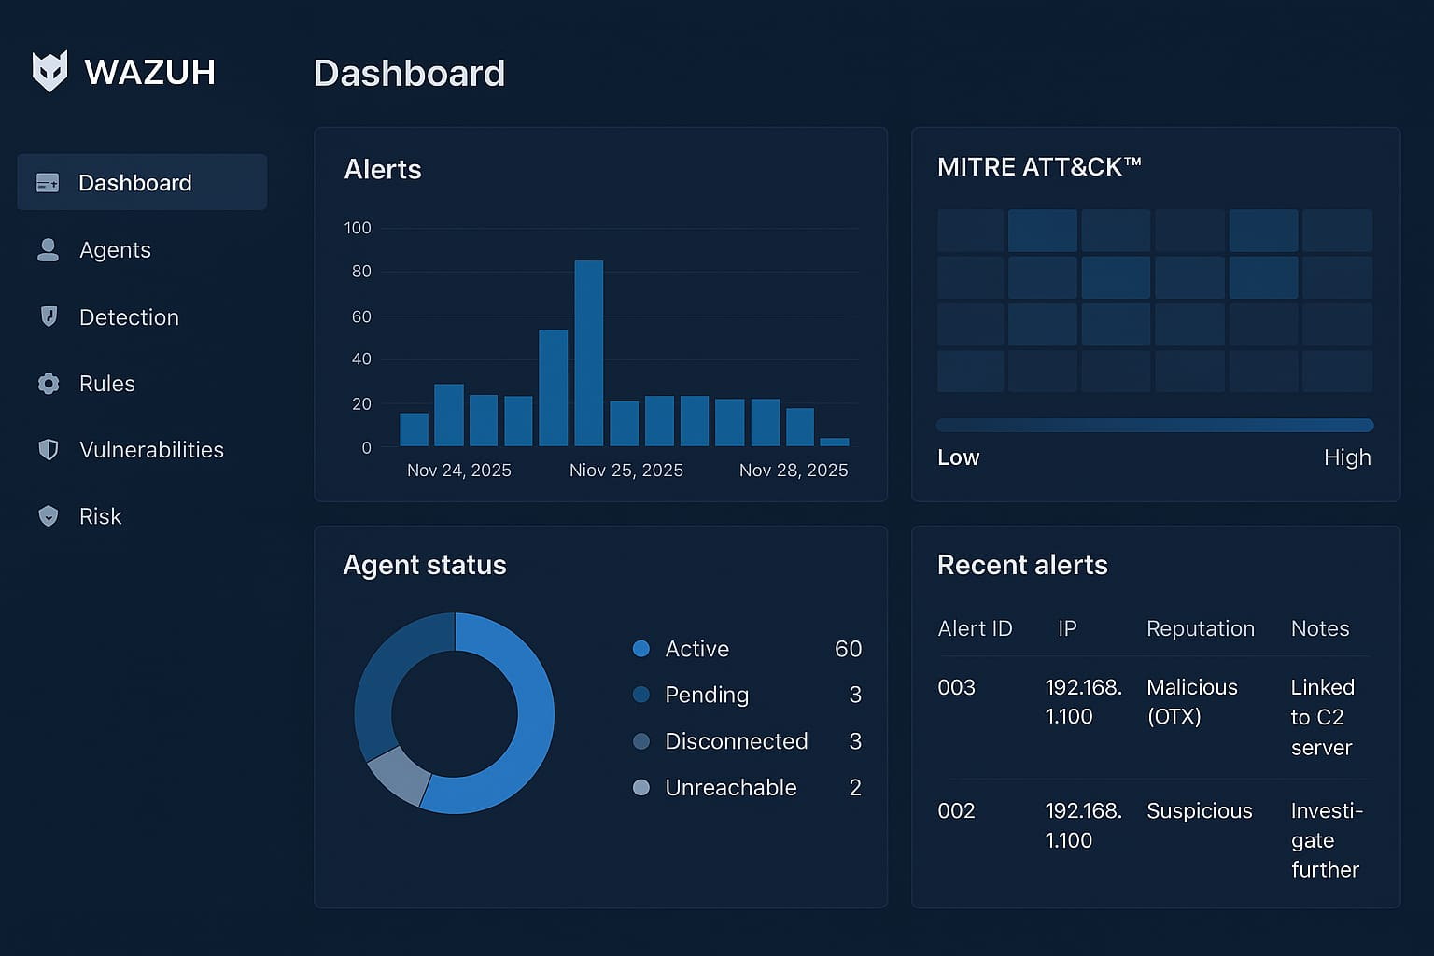

Summary:
The T1078 threat hunt revealed repeated failed logins from non-system accounts, including attempts using “guest.” A notable attempt came from IP 103.145.22.90. No successful compromises were detected, but the repeated failures suggest password-guessing behaviour, warranting closer monitoring and reviewing account lockout and authentication policies.

