TASK 3. INCIDENT ESCALATION PRACTICE

Objective
To simulate a complete SOC incident workflow by creating and escalating a high-priority unauthorized access alert, documenting it through a SITREP, and automating response actions using a SOAR playbook.

Tools Used
- TheHive – Case creation and escalation
- Google Docs – SITREP documentation
- Splunk Phantom – Automation playbook
- Mock Event Logs – Simulated alert data

Description
A mock unauthorized access alert from IP 192.168.1.200 (MITRE T1078) was created in TheHive and escalated to Tier-2. A brief SITREP was written documenting detection and actions taken. A Splunk Phantom playbook was then created to automatically assign all High-severity alerts to the Tier-2 SOC team.

1. TheHive – Escalation Simulation
Step-by-Step
- Launch TheHive Web UI.
- Click New Case → Fill:
  - Title: Unauthorized Access Detected on Server-Y
  - Severity: High
  - Description: Unauthorized login attempt detected from IP 192.168.1.200 (MITRE T1078).
- Add Observable:
  - Type: IP
  - Value: 192.168.1.200
- Assign to Tier-1 Analyst (You).
- Click Escalate Case → Select Tier-2 Analyst group.
- Add a 100-word escalation summary.
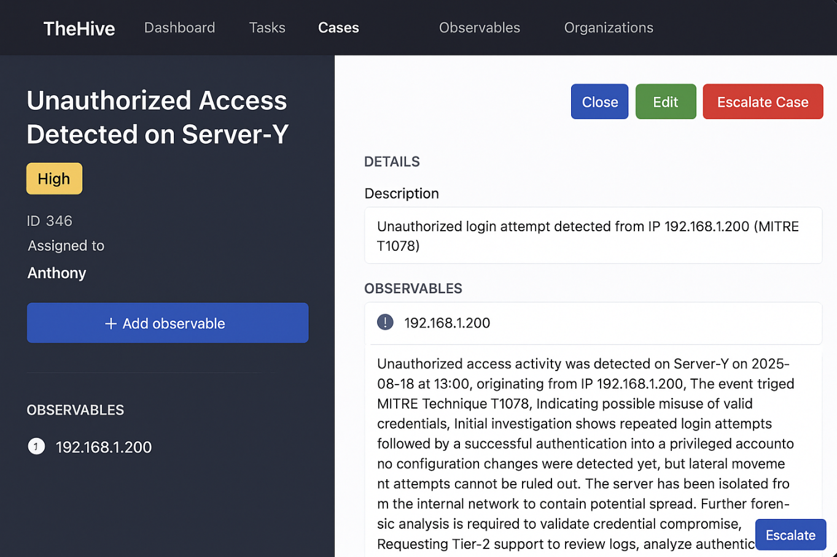

Escalation Summary
Unauthorized access activity was detected on Server-Y on 2025-08-18 at 13:00, originating from IP 192.168.1.200. The event triggered MITRE Technique T1078, indicating possible misuse of valid credentials. Initial investigation shows repeated login attempts followed by a successful authentication into a privileged account. No configuration changes were detected yet, but lateral movement attempts cannot be ruled out. The server has been isolated from the internal network to contain potential spread. Further forensic analysis is required to validate credential compromise. Requesting Tier-2 support to review logs, analyze authentication patterns, and determine if additional containment steps are needed.

2. SITREP (Google Docs Style)
Title: Unauthorized Access on Server-Y
Date: 2025-08-18
Detection Time: 13:00
Source IP: 192.168.1.200
MITRE Mapping: T1078 – Valid Accounts
Summary:
Unauthorized access to Server-Y was detected through abnormal login activity from IP 192.168.1.200. The attack matches MITRE T1078 behavior, indicating credential misuse. Initial triage confirms the login was not initiated by authorized personnel.
Actions Taken:
- Server isolated from network
- Case created in TheHive
- Escalated to Tier-2 SOC team

3. Splunk Phantom – Workflow Automation
Goal: Auto-assign High severity alerts to Tier-2.
Steps
- Open Splunk SOAR (Phantom)
- Create new playbook → Visual Editor
- Add Block:
  - Condition: alert.severity == "High"
- Add Action Block:
  - Action: assign
  - Target: Tier-2 SOC Group
- Save & Test using mock alert.
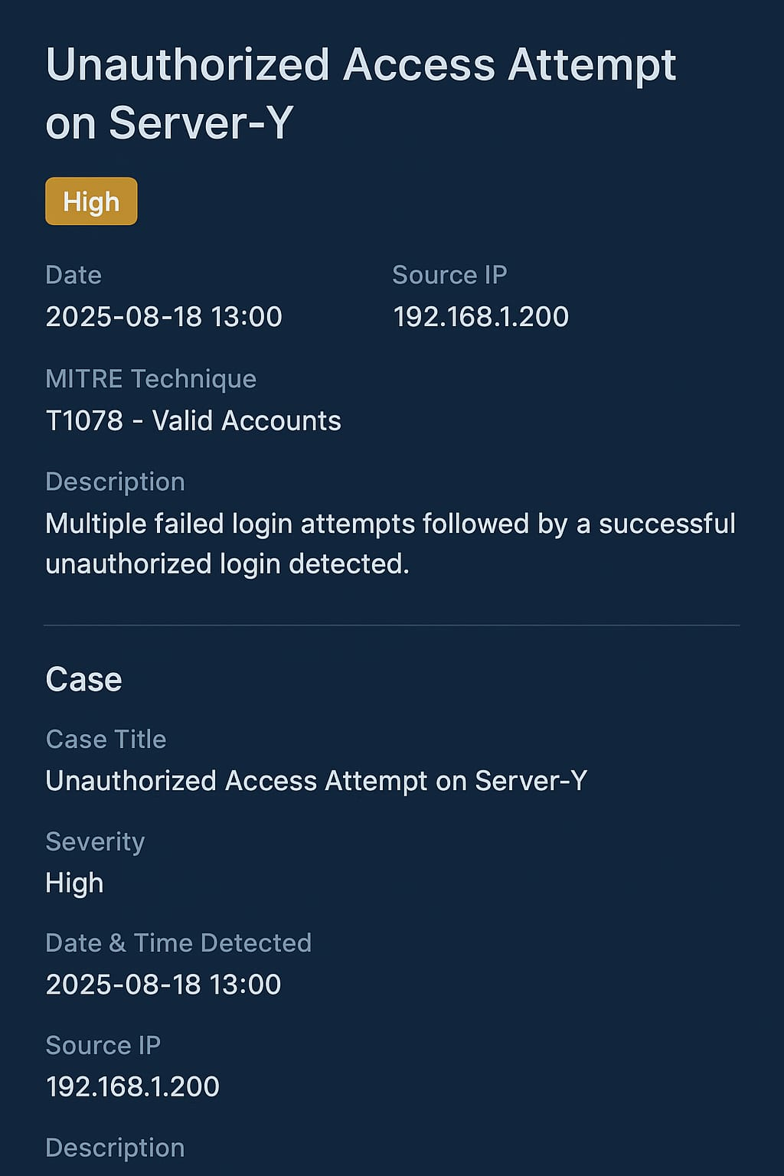

Summary:
A high-priority unauthorized access alert on Server-Y was detected on 2025-08-18 at 13:00 from IP 192.168.1.200, mapped to MITRE Technique T1078. A case was created in TheHive with detailed observables and evidence, then escalated to Tier 2 for deeper investigation. A SITREP was drafted documenting the incident timeline, actions taken, and initial analysis. To streamline response, a Splunk Phantom playbook was configured to automatically assign all High-severity alerts to Tier 2 analysts. Testing with a mock alert confirmed that automation, escalation workflow, and documentation processes functioned realistically and aligned with SOC procedures.

