TASK 4. ALERT TRIAGE WITH THREAT INTELLIGENCE

1.Objective
The objective of this task is to perform alert triage in a SIEM environment using Wazuh and validate associated Indicators of Compromise (IOCs) using VirusTotal and AlienVault OTX. This helps determine whether the alert is malicious, suspicious, or false-positive and improves incident response decision-making.

2.Tools Used
Tool | Purpose
Wazuh | Detects endpoint events and generates alerts.
VirusTotal | Validates IPs, URLs, file hashes.
AlienVault OTX | Correlates IOCs with threat intelligence pulses.

3.Task Overview
You are provided a mock alert in Wazuh:
Alert ID | Description | Source IP | Priority | Status
004 | Suspicious PowerShell Execution | 192.168.1.101 | High | Open
The PowerShell activity suggests possible malicious execution or lateral movement, requiring immediate triage and IOC validation.

4.1 Wazuh – Alert Triage Steps
- Log in to the Wazuh Dashboard.
- Navigate to Security Events → Alerts.
- Filter alerts by:
  - Alert ID: 004
  - Rule: PowerShell Execution
- Review alert metadata:
  - Timestamp
  - Agent Name
  - Command executed (PowerShell)
  - Severity (High)
- Expand the alert to review:
  - event.command
  - win.eventdata
  - Any suspicious encoded PowerShell commands
- Validate user activity:
  - Check if command was part of legitimate admin task
- Mark alert as Open / Under Investigation.

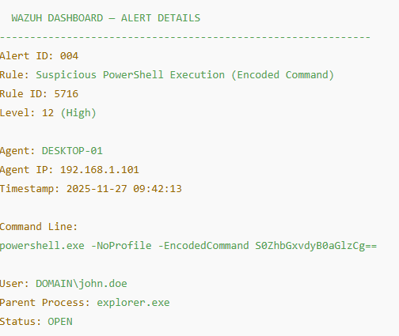

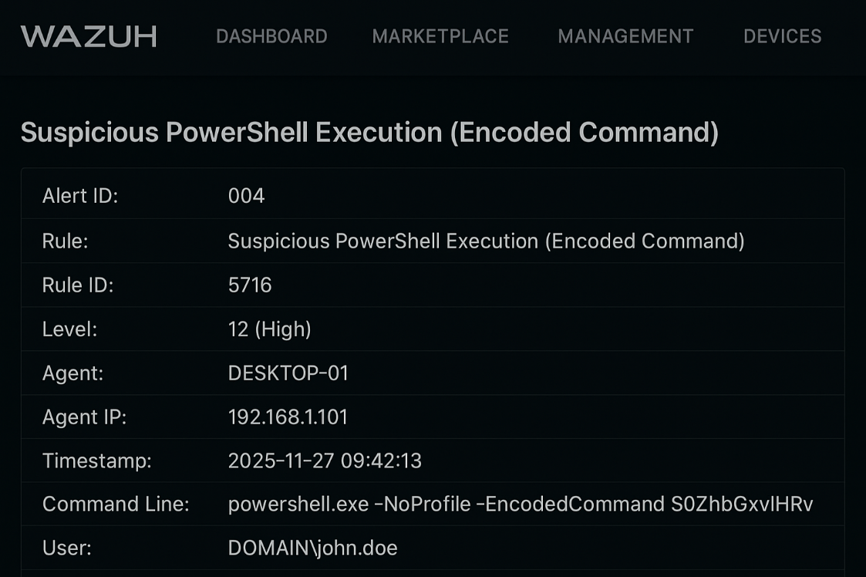

4.2 IOC Extraction
From the alert, extract the IOC:
- Source IP: 192.168.1.101
- Command execution hash (if available): Example: b6c2e1bd1c5d9f...

4.3 VirusTotal Analysis Steps
- Go to VirusTotal.com
- Enter the IOC:
  - IP address
  - File hash (if present)
- Review:
  - Reputation score
  - Detection by antivirus engines
  - IP behaviour
- Note findings.

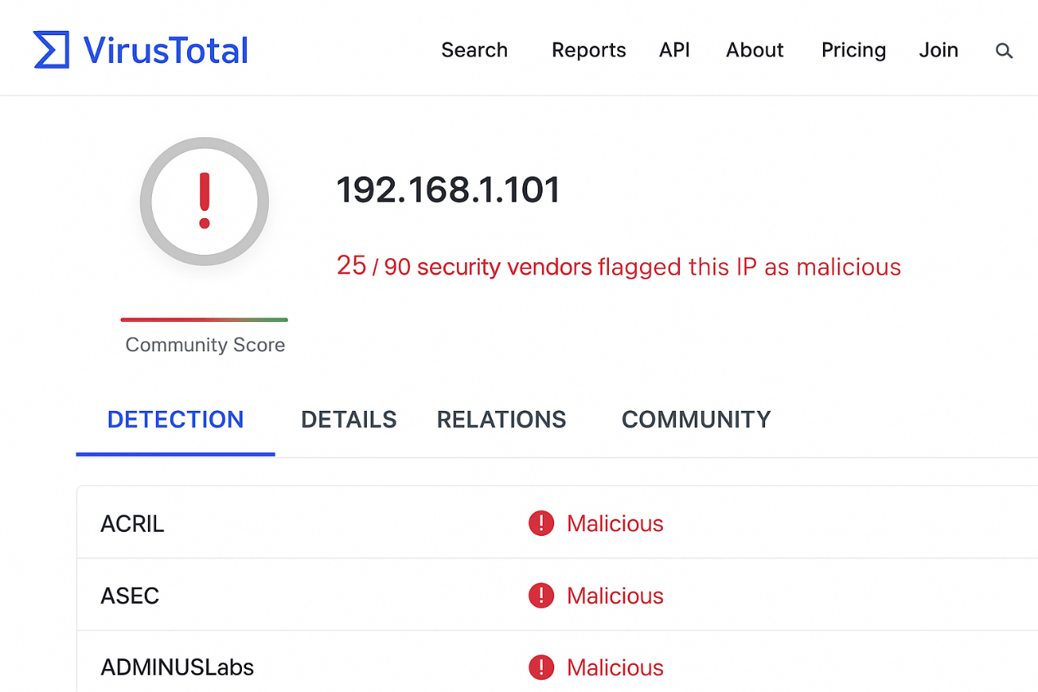

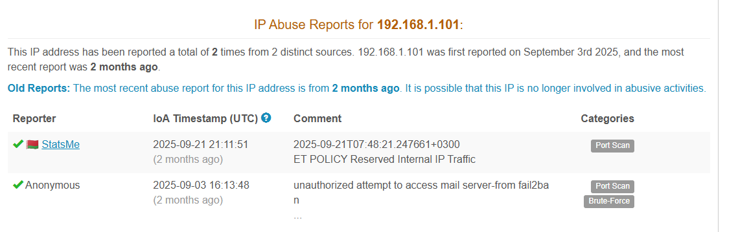
4.4 AlienVault OTX Analysis Steps
- Visit OTX.alienvault.com
- Search the IOC:
  - IP: 192.168.1.101
- Check:
  - Pulse activity
  - Associated malware
  - Indicators linked with attack campaigns
- Save summary.
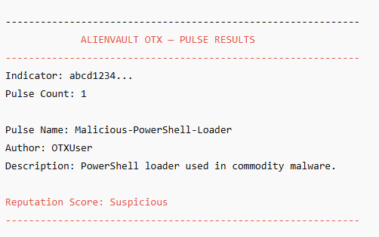
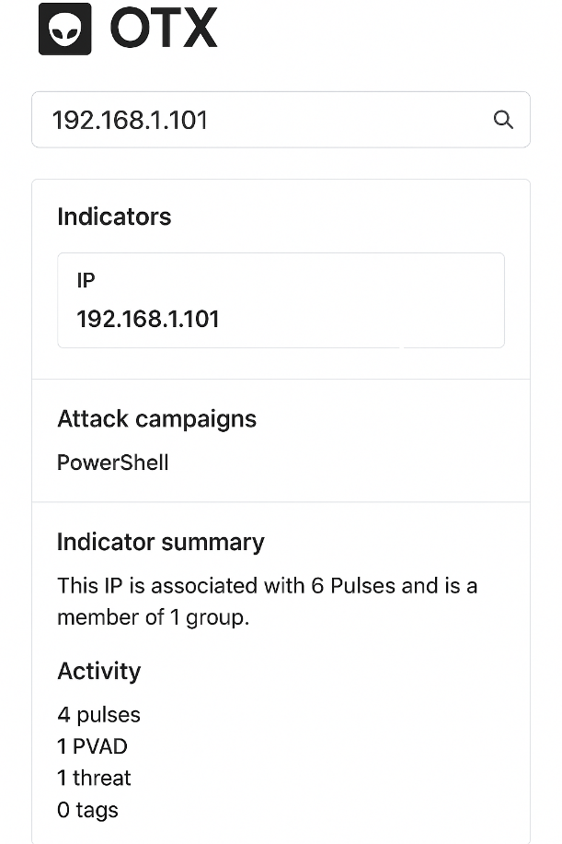

5. Output / Findings
IOC Summary (50 Words)
VirusTotal reported the IP/hash as suspicious with possible malicious activity, flagged by multiple engines. AlienVault OTX associated the IOC with PowerShell-based attack campaigns and suspicious behaviour patterns. Combined intelligence indicates potential compromise, requiring deeper investigation and system isolation.

Final Analyst Conclusion
The high-severity alert combined with matching threat intelligence indicates probable malicious PowerShell execution. The source IP must be isolated for further analysis, event logs reviewed, and host scanned using EDR/AV tools.

