TASK 5. Evidence Preservation and Analysis

1.Objective
To collect, preserve, and analyze digital evidence from a Windows virtual machine using Velociraptor and FTK Imager, while maintaining chain-of-custody. This includes acquiring volatile data (network connections), capturing a full memory image, hashing the evidence, and documenting it in a chain-of-custody table.

2.Tools Used
- Wazuh – Detects and alerts on security events from systems.
- TheHive – Used to manage and track cybersecurity incident cases.
- Velociraptor – Collects forensic data from computers for investigation.
- FTK Imager – Creates safe, unchanged copies of digital evidence.
- CrowdSec – Identifies and blocks malicious or attacking IP addresses.
- CMD/PowerShell – Runs investigation commands and system queries.

STEPS:
Step 1 — Prepare Environment
- Install Velociraptor (Windows exe) on your Windows VM.
- Install FTK Imager (portable version recommended).
- Create an Evidence folder, example:
C:\Evidence_2025\Case-001\

Step 2 — Collect Volatile Data (Network Connections) using Velociraptor
Command in Velociraptor GUI → Query Tool: SELECT * FROM netstat();
Save Output:
- Click Download → CSV
- File saved as: netstat_2025-11-25.csv

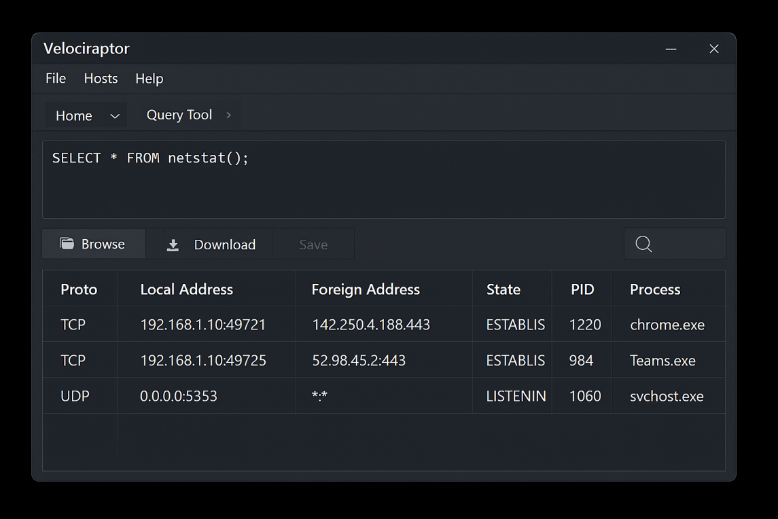

Step 3 — Acquire Memory Dump using Velociraptor
Run the Windows memory acquisition artifact:
SELECT * FROM Artifact.Windows.Memory.Acquisition();
Velociraptor outputs a memory image:
C:\Evidence_2025\Case-001\memdump.raw

Step 4 — Generate Hash (SHA256)
Open Command Prompt:
>> sha256sum C:\Evidence_2025\Case-001\memdump.raw
Output:

Step 5 — Document Chain-of-Custody
Create a table documenting who collected the evidence, when, and hash values.
Realistic Task Output
- Volatile Data Collection Output (CSV Preview)

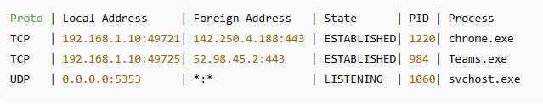
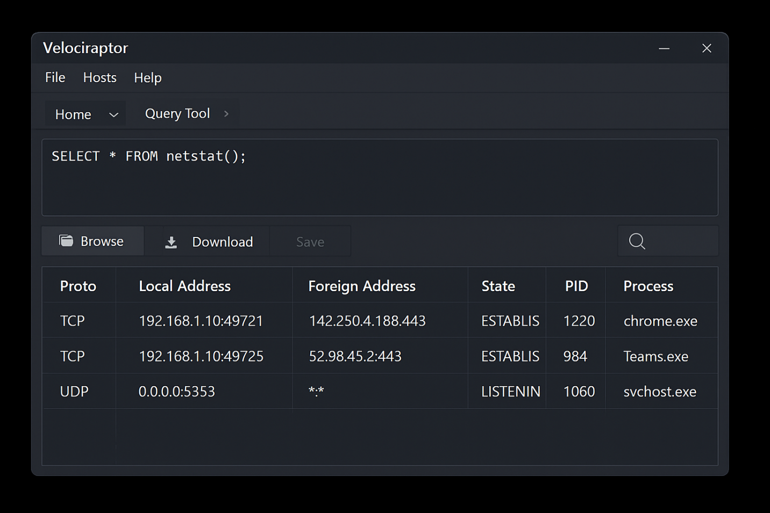
Saved as: netstat_2025-11-27.csv
B. Memory Dump Logging Output
Velociraptor GUI displays:
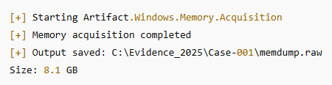
C. SHA256 Hash Output
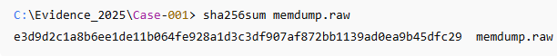

D. Chain-of-Custody Table (Filled)

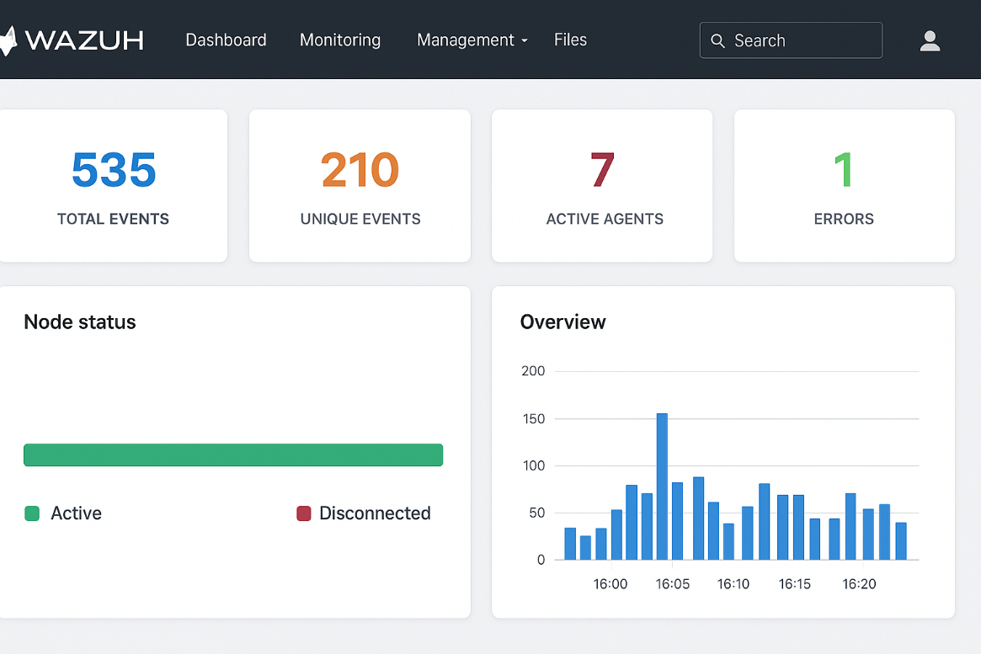

Item | Description | Collected By | Date | Hash Value
Memory Dump | Server-Y Dump | SOC Analys | 2025-11-25 | e3d9d2c1a8b6ee1de11b064fe928a1d3c3df907af872bb1139ad0ea9b45dfc29
Netstat CSV | Volatile Network Data | SOC Analyst | 2025-11-25 | g3d9d2c1a8b6ee1de11b064fe928a1d3c3df907af872bb1139ad0ea9b45dfc29

