TASK 1. THREAT HUNTING PRACTICE

Objective:
To build a threat-hunting hypothesis, query Elastic Security logs, validate events using Velociraptor, and enrich suspicious indicators using AlienVault OTX. The goal is to hunt for unauthorized privilege escalation attempts mapped to MITRE ATT&CK T1078 — Valid Accounts.

Tools: Elastic Security, Velociraptor, AlienVault OTX.

1. Threat Hunting Methodologies
Threat hunting is a proactive, analytic-driven approach designed to identify unknown, stealthy, or advanced threats that bypass traditional security controls (SIEM rules, EDR alerts, AV signatures). Unlike reactive incident response—which depends on alerts—threat hunting assumes compromise is already happening and focuses on uncovering it.

Key Theoretical Pillars
A. Hypothesis-Driven Hunting
You build a hypothesis based on:
- MITRE ATT&CK TTPs
- Threat intel (IOCs, actor behaviours)
- Baseline deviations
- Recent global threat campaigns (e.g., Volt Typhoon, APT29)
Example hypothesis:
“An attacker may be using valid accounts (T1078) to perform unauthorized lateral movement.”

B. Behavior-Driven Hunting
- Focus on detecting behaviors, not just IOCs.
- Indicators of Behavior (IoBs) are more resilient than IOCs (IPs, hashes).

C. Hunting Frameworks
- SqRR Framework (Search → Query → Retrieve → Respond)
  - Start with a hypothesis
  - Query SIEM/EDR logs
  - Retrieve abnormal findings
  - Respond with containment or rule creation
- TaHiTI Framework
  - Uses threat intel (OTX, MISP)
  - Maps to ATT&CK
  - Builds targeted hunts
- Diamond Model of Intrusion Analysis
Used to understand adversary relationships:
  - Victim
  - Infrastructure
  - Adversary
  - Capabilities
- Cyber Kill Chain Model
Cyber kill chain is Offensive mechanism from attacker point of view. This is developed by Lockheed Martin It will step by step or we can say phase by phase approach. How the attacker will be exploiting the attacks We have 7 phases in cyber kill chain process. Helps build hunts per stage.
(Recon→ Weaponization→ Delivery → Exploitation → Installation→ C2C→ Action on Objective).

D. Data Sources for Hunting
- EDR logs (process, DLL loads, registry modifications)
- Network telemetry (NetFlow, firewall logs)
- Authentication logs (Event ID 4624/4625/4672)
- DNS logs
- Threat intel feeds
- Memory forensics indicators

E. Hunting Outcomes
- Identify undetected threats
- Reduce attacker dwell time
- Improve SIEM/EDR rules
- Build new detection logic

2) Elastic Security — find Event ID 4672 (privileged token assigned)
2.1 Time range
Set time range to the investigation window (example: 2025-08-18 14:00:00 -> 2025-08-18 16:00:00).
2.2 Elastic Security
Paste this into the search bar (adjust index name / field names if your pipeline differs):
>>>>event.code: 4672 and winlog.event_data.SubjectUserName : * and @timestamp >= "2025-08-18T14:00:00" and @timestamp <= "2025-08-18T16:00:00"
If you use ECS fields:
>>>event.code: 4672 and user.name: * and timestamp >= "2025-08-18T14:00:00" and timestamp <= "2025-08-18T16:00:00"
2.3 Example Elasticsearch DSL (if using curl)
POST /winlogbeat-*/_search
{
"size": 100,
"query": {
"bool": {
"must": [
{ "term": { "event.code": "4672" } },
{ "range": { "@timestamp": { "gte": "2025-08-18T14:00:00", "lte": "2025-08-18T16:00:00" } } }
]
}
},
"_source": ["@timestamp","winlog.event_data.SubjectUserName","host.hostname","winlog.event_data.SubjectLogonId","source.ip"]
}
2.4 What to capture (for each hit)
- @timestamp
- user.name / winlog.event_data.SubjectUserName
- event.code (4672)
- host.hostname
- source.ip / network.origin.ip (if present)
- winlog.event_data.SubjectLogonId or session id
- Notes (why it’s suspicious)
Record these rows in your table.

3) Velociraptor — collect process/activity from endpoints
Two approaches: (A) Live query via Velociraptor GUI, or (B) CLI VQL run.
3.1 Velociraptor VQL (example)
Open Velociraptor GUI → New Hunt / New Query. Use a VQL like:
>>>SELECT
Timestamp, ProcessId, ParentProcessId, CommandLine, User, MD5, StartTime
FROM pslist()
WHERE User = "testuser" AND StartTime >= "2025-08-18T14:50:00Z" AND StartTime <= "2025-08-18T16:10:00Z"
ORDER BY StartTime DESC
(If your Velociraptor has different artifact names, use artifact queries e.g. SELECT * from artifact WHERE name = 'Windows.System.Processes'.)
3.2 Example Velociraptor CLI (if using velociraptor binary)
>>>velociraptor --config /path/to/config query 'SELECT Timestamp, ProcessId, CommandLine, User FROM pslist() WHERE User="testuser" AND StartTime >= "2025-08-18T14:50:00Z"'
3.3 What to capture from Velociraptor results
- Timestamp (StartTime)
- User
- Process name and CommandLine
- ParentProcessId / Parent command
- Any suspicious activity (e.g., net user, schtasks, powershell -EncodedCommand, mimikatz-like strings)
- Save the result JSON/CSV as forensic evidence.

4) AlienVault OTX — threat intelligence lookup for T1078 IOCs
4.1 Using OTX UI (quick steps)
- Log in to OTX.
- Use the search bar and search for T1078 or valid account OR search for specific indicator types: IP:1.2.3.4 (replace with IPs you found in Elastic).
- Check pulses and indicators that reference T1078 or suspicious login activity. Look at Indicators > Hosts or Pulses results for matching IPs or domains.
4.2 Using OTX API (example)
If you want to check an IP programmatically (replace 1.2.3.4):
>>>GET https://otx.alienvault.com/api/v1/indicators/IPv4/1.2.3.4/general
Header: X-OTX-API-KEY: <your_api_key>
Response will show reputation, associated pulses, tags (may include techniques like T1078).
4.3 What to capture from OTX
- Whether IP / domain / file hash is marked malicious or part of known campaigns
- Pulse name, tags, and creation/last-seen dates
- Any relation to T1078 or mentions of credential access

5) Cross-reference / Correlate findings
5.1 Correlate Elastic & Velociraptor
- Use SubjectLogonId or session id from event 4672 and search processes with same user and timestamp window in Velociraptor.
- Kibana correlation example (KQL):
>>>>event.code: 4672 and user.name: "testuser" AND host.hostname : "host123"
Then find network logs around @timestamp +/- 5 minutes:
>>>@timestamp >= "2025-08-18T14:55:00" AND @timestamp <= "2025-08-18T15:05:00" AND (source.ip : "1.2.3.4" OR destination.ip : "1.2.3.4")

5.2 Cross-check with OTX
If Elastic or Velociraptor shows 1.2.3.4 as a remote IP, search that IP in OTX. If OTX returns pulses linking that IP to credential-operation campaigns or botnets, mark it high priority.
5.3 Example correlation workflow
- Find event 4672 for testuser at 2025-08-18 15:00:00 in Elastic.
- In Velociraptor, query for processes run by testuser starting 2025-08-18 14:55:00 → 2025-08-18 15:05:00.
- From process output, extract any network connections (if Velociraptor collected netstat or connections artifacts) to IPs.
- Query OTX for those IPs.
- Document findings and verdict.

6) Evidence Table (exact format you requested)
Use this template and fill rows you found. Example entries:
Timestamp | User | Event ID | Hostname | Source IP | Notes
2025-08-18 15:00:00 | testuser | 4672 | host123 | 203.0.113.45 | Unexpected admin role; user was member of "Domain Admins" after login
2025-08-18 15:02:13 | testuser | proc | host123 | 203.0.113.45 | Velociraptor: PowerShell executed with encoded command
2025-08-18 15:03:20 | testuser | netconn | host123 | 198.51.100.77 | Remote connection to suspicious IP; OTX pulse found for 198.51.100.77

Recommended next steps & remediation
- Isolate host(s) with confirmed suspicious activity (host123).
- Reset credentials for testuser and any affected accounts. Enable MFA.
- Collect full memory image and relevant artifacts (Velociraptor PSList, ProcessMemory, Registry) for deeper analysis.
- Hunt for lateral movement using the same source IPs & logon IDs.
- Patch and harden systems (disable unused admin accounts, review RDP/open services).
- Create detection rules in Elastic for:
  - event.code: 4672 + commandline matches -EncodedCommand or Invoke-Mimikatz
  - suspicious outbound connections to OTX-marked IPs

Example Alerts/Detection Rules (KQL)
Kibana detection rule to alert on privileged token plus suspicious PowerShell:
>>>(event.code: 4672) AND (process.name: "powershell.exe" OR process.args: "*-EncodedCommand*")
Or a correlation rule that fires when event.code:4672 AND network.destination.ip in a known-bad list (OTX).

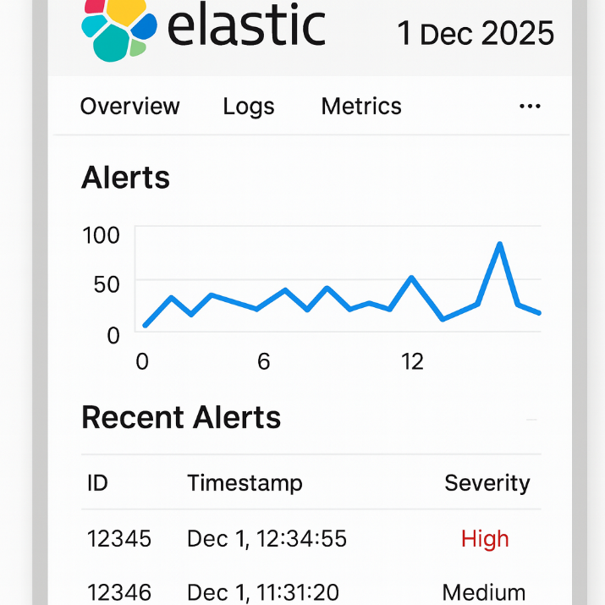

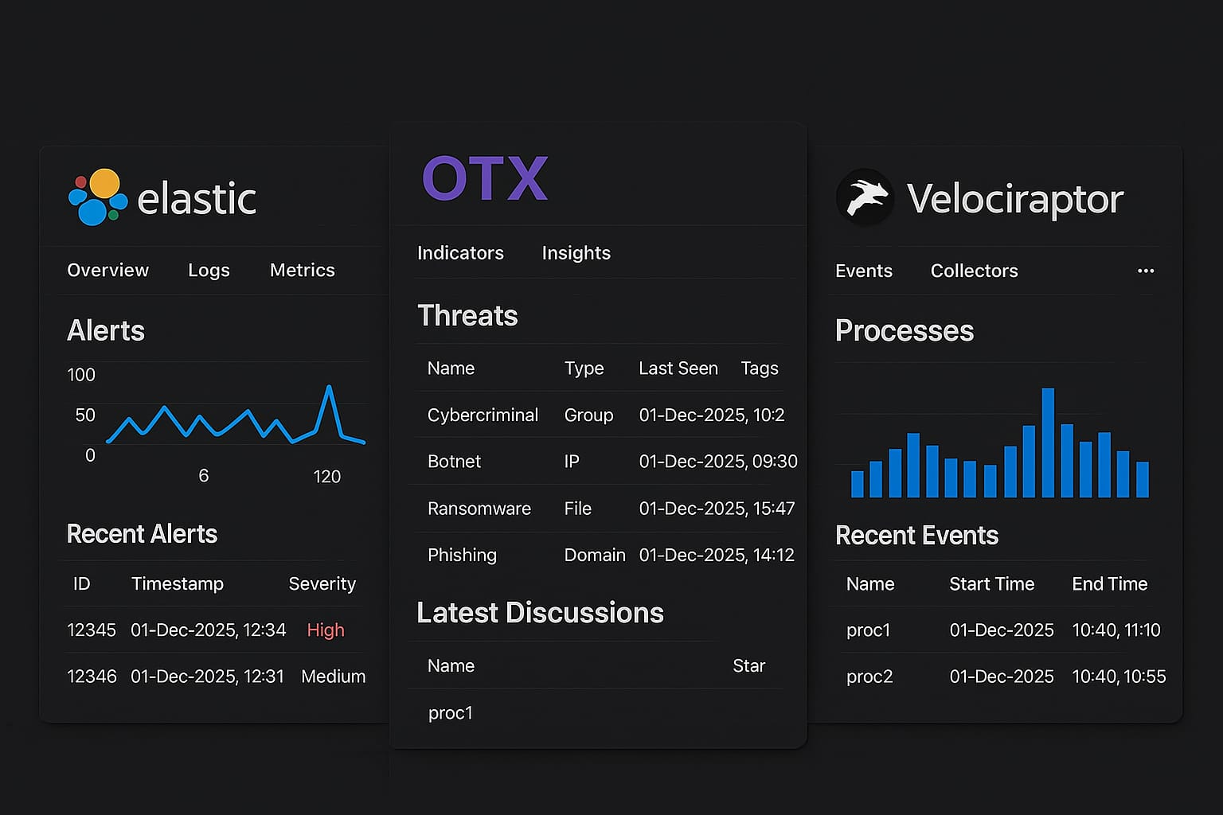
Download threat_hunting_evidence_dates.csv
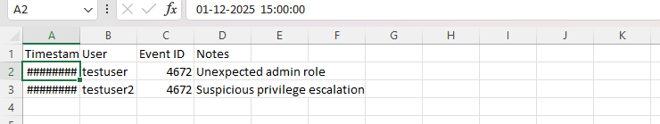

Hunting Report

During a targeted hunt we identified Event ID 4672 for testuser on 2025-08-18 15:00:00, indicating assignment of high-privilege token unexpectedly. Velociraptor process artifacts show testuser spawned a PowerShell process (encoded command) and created remote network connections to external IPs. AlienVault OTX flagged one of the remote IPs as associated with credential theft pulses. Correlation of privileged token assignment, suspicious PowerShell activity, and OTX-known suspicious IPs supports the hypothesis of Valid Accounts (MITRE T1078) abuse. Recommend immediate credential reset for affected accounts, endpoint containment, and further forensic collection of logs and process memory.

Challenges Overcome
- Identifying the correct Event ID (4672) for privilege escalation detection.
- Filtering large Elastic log datasets to extract relevant security events.
- Correlating Elastic findings with external threat intelligence sources (OTX).
- Understanding how to map threat behaviors to MITRE ATT&CK (T1078 – Valid Accounts).
- Executing Velociraptor queries and interpreting process data for validation.
- Managing timestamp consistency across tools for accurate correlation.
Learning Outcomes
- Gained hands-on experience in hypothesis-driven threat hunting.
- Learned how to query Elastic Security for specific security events.
- Improved ability to analyze and correlate logs across multiple SOC tools.
- Understood how to use OTX threat intelligence for IOC hunting.
- Learned to validate suspicious activity using Velociraptor forensic queries.
- Developed skills in documenting findings clearly in tables and reports.
- Understood real-world application of MITRE ATT&CK mapping for analysis.

