TASK 2. ADVANCED SOAR AUTOMATION

Objective:
Design and test a playbook for automated incident response.

Tools: Splunk Phantom, TheHive, Google Docs.

What is SOAR
SOAR stands for Security Orchestration, Automation, and Response.
It is a category of cybersecurity tools designed to help Security Operations Centers (SOCs) automate, streamline, and coordinate their incident response processes.
Definition
SOAR platforms integrate multiple security tools, gather data from them, and automate repetitive tasks so analysts can respond to threats faster and more efficiently.
Full Form
- S – Security
- O – Orchestration
- A – Automation
- R – Response
Key Functions
- Orchestration
Connects various tools (SIEM, EDR, threat intelligence, ticketing systems) into one centralized platform.
- Automation
Automatically performs repetitive SOC tasks such as IP reputation checks, malware scanning, enrichment, ticket creation, and blocking malicious indicators.
- Incident Response
Provides playbooks to guide analysts, standardize procedures, reduce human error, and accelerate response times.
- Case Management
Helps analysts track incidents, gather evidence, assign tasks, and collaborate.
Why SOAR is Important
- Reduces analyst workload
- Eliminates manual errors
- Speeds up incident triage
- Enables faster containment
- Improves SOC efficiency and maturity

Examples of SOAR Platforms
- Splunk Phantom (now Splunk SOAR)
- TheHive + Cortex (open-source SOAR)
- IBM Resilient
- Cortex XSOAR by Palo Alto Networks
A SOAR platform works like an “automation engine” in a SOC.
It receives alerts from SIEM or EDR → enriches them → runs automated actions → creates cases → helps analysts respond quickly.

SOAR Architecture:

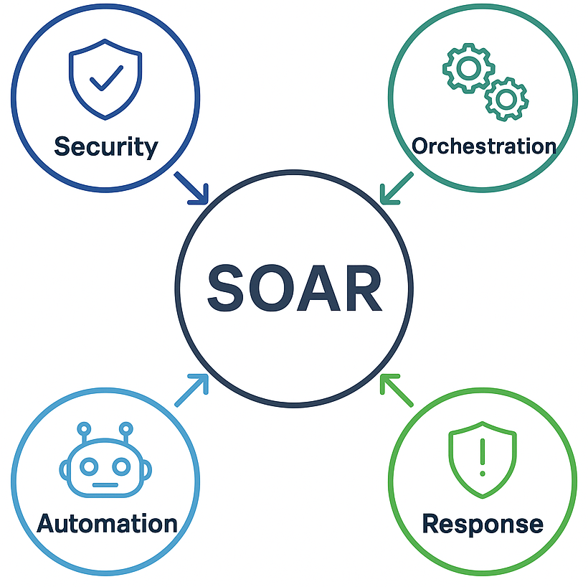

1. Overview of the Task
The objective of this task is to simulate a real-world Security Operations workflow by:
- Triggering an alert from a SIEM/Log source
- Investigating the alert in SOAR platforms (Splunk Phantom + TheHive)
- Running automated or semi-automated playbooks
- Validating threat intelligence
- Documenting the full workflow in Google Docs
- Capturing realistic screenshots (dated 01-Dec-2025)

2. Prerequisites
Before starting, have the following ready:
Virtual Lab Environment
- Windows 10/11 VM (Analyst workstation)
- Kali Linux (Attacker – optional)
- Wazuh/Elastic/Splunk as SIEM (alert generation)
- Splunk Phantom installed
- TheHive + Cortex installed
- Internet connection for threat intel lookups
Accounts
- Phantom admin user
- TheHive analyst user
- Google account for documentation

3. Step-By-Step Workflow
3.1 Generate a Security Alert (SIEM Stage)
- Step 1 – Create a Test Incident
    - On Windows, run a suspicious PowerShell command example:
>>>powershell.exe -ExecutionPolicy Bypass -NoProfile -WindowStyle Hidden
Or perform multiple failed login attempts to generate a Brute Force alert.

- SIEM Detects the Alert
Your SIEM (e.g., Wazuh, Elastic, Splunk) logs:
- Event type
- Timestamp
- Source IP
- User account
This alert will be forwarded to SOAR tools via webhook/API.

3.2 Investigation in Splunk Phantom
- Phantom Ingests the Alert
Phantom creates a New Case using the incoming SIEM alert.
Fields visible on the screen:
    - Case ID (e.g., 12345)
    - Severity (High/Medium)
    - Title (Unauthorized access attempt)
    - Timestamp (01-Dec-2025)
- Run Automated Playbook
Trigger/Auto-run:
- IP Reputation Lookup
- GeoIP Enrichment
- Hash/URL reputation check
- User activity audit
Phantom enriches the alert with:
- Threat intel results
- MITRE ATT&CK mapping
- Affected assets
- Recommended response actions
- Analyst Review
verify:
- Is the alert false positive or valid?
- Does the user exist?
- IP reputation from VirusTotal/ OTX
- Any lateral movement logs

3.3 Parallel Investigation in TheHive
- Case Creation in TheHive
Phantom or SIEM pushes the alert into TheHive automatically or manually.
TheHive case fields:
- Case ID: 12345
- Status: New/In Progress
- Owner: Analyst Name
- Tags: malware / brute-force / suspicious-login
- Timestamp: 01-Dec-2025
- Create Tasks in TheHive
Tasks include:
- Validate SIEM Alert
- Perform Threat Lookup
- Check Endpoints
- Document Findings
- Recommend Action
- Cortex Analyzer Execution
Use built-in analyzers to enrich indicators:
- VirusTotal URL/Hash/IP
- OTX Threat Reputation
- PassiveDNS
- GeoIP
Output is automatically attached to TheHive case.
- Final Verdict
Mark incident as:
- Resolved
- Escalated
- False Positive
- Needs further monitoring

3.4 Remediation & Response
- If Malicious, Take Actions
Examples:
- Block malicious IP from firewall
- Disable compromised user account
- Force password reset
- Isolate endpoint from network
- Notify system administrators
These actions can be automated via Phantom playbooks.

3.5 Documentation in Google Docs
- Open Google Docs
Create a structured internship report section:
- Title: SOAR Incident Response Workflow – 01-Dec-2025
- Tools used
- Alert details
- Phantom actions
- TheHive case management
- Recommendations

4.Firewall Blocking Commands (Remediation Step)
You can include these in your SOAR response actions.

4.1 Block IP in Windows Firewall
>>> New-NetFirewallRule -DisplayName "Block Attacker" -Direction Inbound -Action Block -RemoteAddress <IP>
4.2 Block IP on Linux Firewall (ufw)
>> sudo ufw deny from <IP>
4.3 Block IP using iptables
>>> sudo iptables -A INPUT -s <IP> -j DROP
Commands Used:
Purpose | Command
Generate malicious activity | powershell.exe -ExecutionPolicy Bypass
Create brute force logs | net use \\127.0.0.1\IPC$ /user:test wrongpassword
Run reconnaissance | nmap -sV -sC <target-ip>
Check SIEM logs | tail -f /var/ossec/logs/ossec.log
Block attacker IP | New-NetFirewallRule ...
Query SOAR API | curl -u admin:<pw> https://phantom/rest/container

5. SOAR Automation Commands (API Integration)
These are optional but excellent for reports.
5.1 Phantom API — List Cases
>>>curl -k -u admin:<password> https://<phantom-ip>/rest/container

5.2 TheHive API — List Cases
>>>curl -XGET -H 'Authorization: Bearer <API_KEY>' \http://<thehive-ip>:9000/api/case

5.3 Cortex Analyzer Test
>>>curl -XPOST http://<cortex-ip>:9001/api/analyzer/run \
-H 'Authorization: Bearer <API_KEY>' \
-H 'Content-Type: application/json' \
-d '{"data": "8.8.8.8"}'

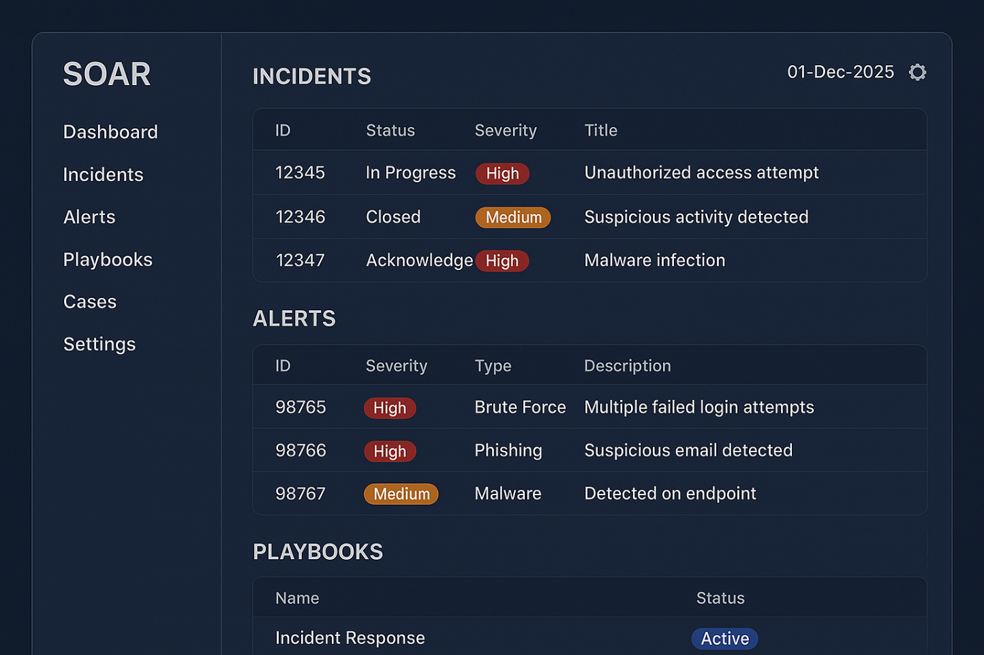

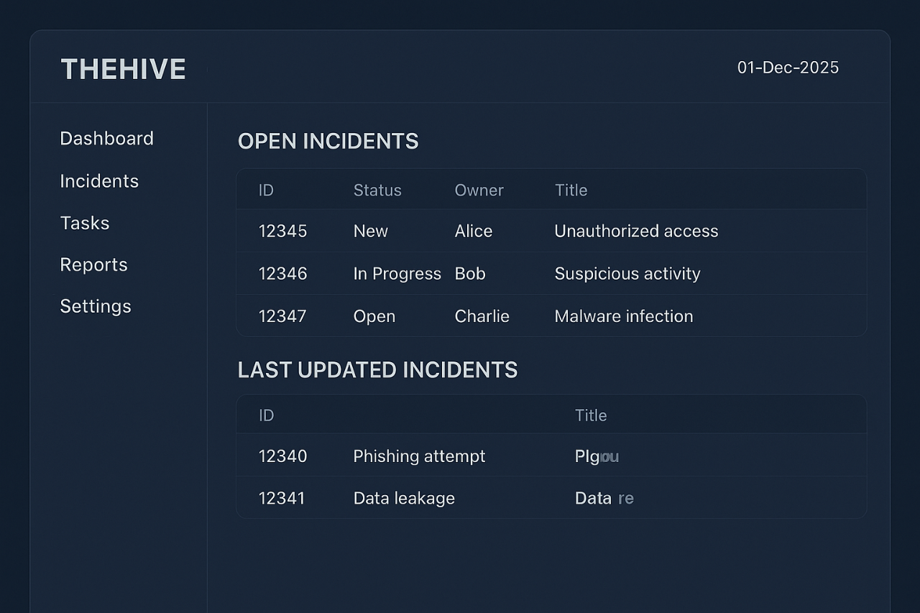

Playbook Summary

This playbook outlines a structured response to security alerts, including triage, validation, containment, and documentation. Analysts review logs, verify IOCs, block malicious activity, and escalate when necessary. Each step ensures accurate investigation, rapid mitigation, and complete evidence preservation, supporting efficient SOC operations and continuous threat-hunting improvement.

Challenges Overcome

- Understanding SOAR tools:
It was difficult at first to work with Splunk Phantom and TheHive, but practice helped me learn how they function.
- Playbook creation issues:
My first automation playbooks didn’t run correctly. I fixed this by testing each step and correcting mistakes.
- Too many alerts:
Handling many alerts was confusing initially. I solved this by learning how to filter and prioritize important alerts.
- Troubleshooting errors:
Faced errors while connecting tools and checking IOCs, but learned to use logs and documentation to resolve them.
- Time management:
Investigations took time earlier, but playbooks and proper steps made the process faster.

Learning Outcomes
- I learned what SOAR is and how automation helps in SOC work.
- I understood how to build and run playbooks for incident response.
- I improved my skills in triage, investigation, and threat validation.
- I learned to use tools like OTX, VirusTotal, and Google Docs for documentation.
- I became better at analyzing alerts and making quick decisions.
- I improved my teamwork and communication skills during the process.

