TASK-3. POST-INCIDENT ANALYSIS
Objective:
To analyse a mock phishing incident by identifying the root cause using the 5 Whys method, creating a Fishbone Diagram to map contributing factors, and calculating key SOC metrics (MTTD and MTTR) to evaluate detection and response performance.
Tools: Google Sheets, Draw.io.
What is Post-Incident Analysis
Incident: Any bad impact to the organization is called Incident.
Post-Incident Analysis is the detailed review done after a cybersecurity incident to find the root cause, assess the impact, identify gaps, and improve future security processes.
Why Post-Incident Analysis is Important
- Helps understand how the incident occurred
- Identifies weaknesses in people, processes, or technology
- Helps improve SOC efficiency
- Supports compliance and audit requirements
- Prevents repeat incidents
Example.
A user clicked a malicious email link → SOC detected it → response team isolated the device → credentials reset → PIA done to understand root cause (weak email filtering, lack of training).
In SOC / Cybersecurity, Post-Incident Analysis Helps:
- Strengthen detection rules
- Tune firewalls and email filters
- Improve SOC playbooks
- Enhance employee awareness
- Improve SLA performance
1. Overview of the Task
This Post-Incident Analysis focuses on a mock phishing incident to evaluate how the attack occurred, how quickly it was detected, and how effectively it was remediated. Using Google Sheets, the 5 Whys method was applied to identify the root cause, and a Fishbone Diagram was created in Draw.io to map contributing factors across people, processes, and technology. Key SOC metrics, including Mean Time to Detect (MTTD) and Mean Time to Respond (MTTR), were calculated to assess operational efficiency. The overall analysis highlights gaps, lessons learned, and corrective actions required to strengthen organizational security and prevent similar incidents in the future.

Step-by-Step Process — Post-Incident Analysis (Phishing)
- Initiate and prepare
  - Create artifacts: Google Sheet PIA-<INCID>, Draw.io file Fishbone-<INCID>, and a Google Doc PIA Report - <INCID>.
  - Identify stakeholders: SOC Lead, Email Admin, IT Ops, HR (training), EDR/Endpoint owner, CISO (as required).
  - Collect ticket/incident ID and preserve chain-of-custody notes (who accessed what and when).
- Gather evidence
  - Pull logs: mail gateway (headers), EDR, web proxy, authentication logs, SIEM alerts, browser logs (if available).
  - Export relevant artifacts: suspicious email (.eml), full mail headers, screenshots, IOC list (URLs, domains, IPs).
  - Save copies in a secure folder (SharePoint/Drive) and note retention locations in the sheet.
- Reconstruct timeline
  - In Google Sheet -> Timeline tab, add columns: Event, Timestamp (ISO), Source, Actor, Notes.
  - Populate chronological events (email delivered → click → detection → containment → remediation).
  - Link each row to raw evidence (file name or Drive link).
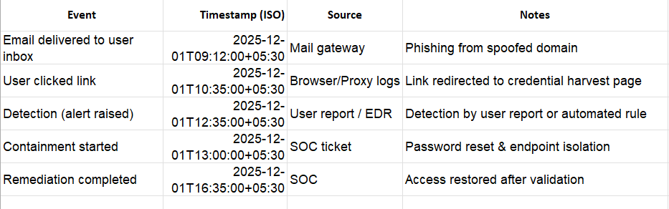
- Perform 5 Whys RCA
  - In Google Sheet -> 5Whys tab, create two columns: Question | Answer.
  - Start with problem statement (e.g., “User clicked malicious link”).
  - Ask “Why?” repeatedly up to 5 times or until root cause is clear.
  - Record each Why as a new row. (You already have two entries; continue to root cause.)
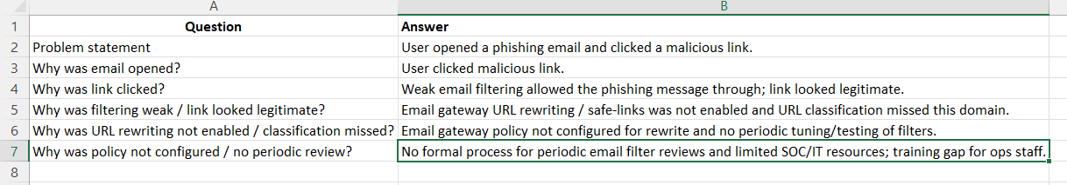
- Build Fishbone Diagram (Draw.io)
  - Open Draw.io → Blank diagram → Insert main spine (arrow) pointing to problem head: “User clicked a malicious phishing link”.
  - Add bones: People, Process, Technology, Policy, Training, Environment.
  - For each bone, add 2–4 causes from your 5 Whys and timeline evidence (e.g., “URL rewriting disabled”, “No periodic filter tuning”, “No phishing simulation”).
  - Export diagram as PNG and attach to Google Doc & Google Sheet.

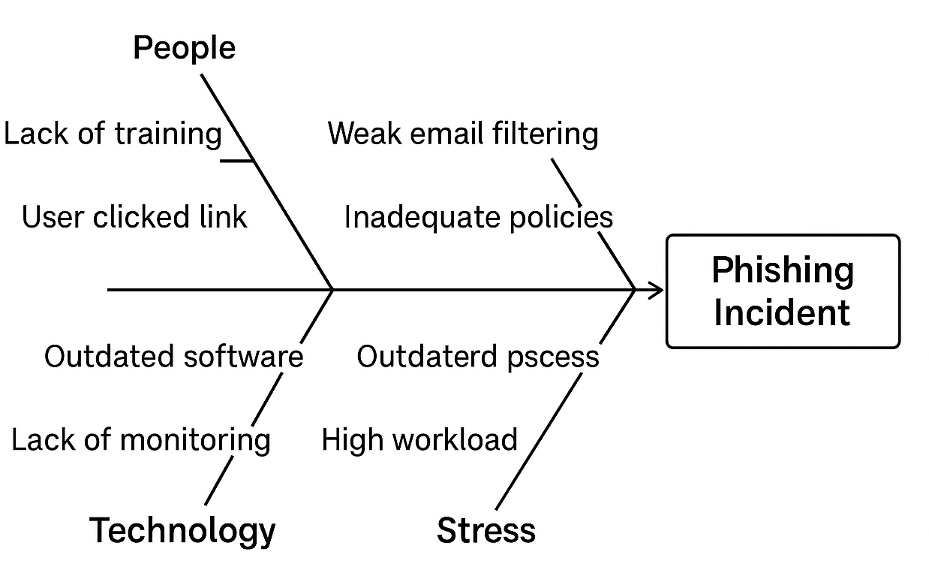
- Calculate metrics (MTTD / MTTR)
  - In Google Sheet -> Metrics tab, add columns: IncidentID, DeliveryTime, DetectionTime, ContainmentStart, RemediationComplete.
  - Compute:
    - MTTD_hours = (DetectionTime - DeliveryTime) * 24 → Google Sheets formula example: =(C2-B2)*24
    - MTTR_hours = (RemediationComplete - DetectionTime) * 24 → =(E2-C2)*24
  - Add formula cells: =AVERAGE(MTTD_range) and =AVERAGE(MTTR_range) to support multiple incidents.
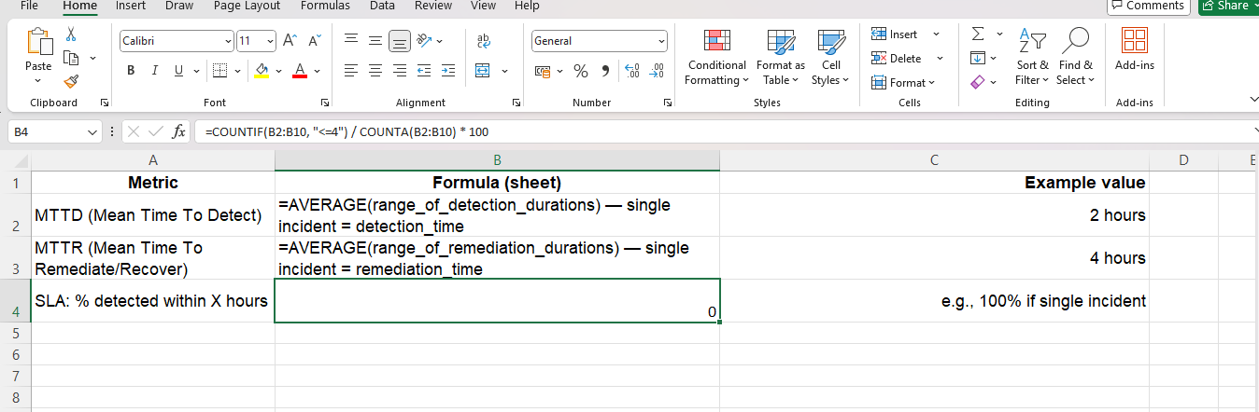

- Impact & root cause summary
  - In Google Doc PIA Report, write short sections: Executive Summary, Impact (assets/users affected), Root Cause (from 5 Whys), and Evidence (links to Sheet attachments).
  - Insert Fishbone image and timeline table.
- Action items & remediation plan
  - In Google Sheet -> ActionItems tab, include columns: Action, Owner, Priority, Target Date, Status, Notes.
  - Examples: enable URL rewriting, add domains to blocklist, password resets, apply EDR Yara rules, run phishing simulation.
  - Assign owners and update status as actions are completed.
- Review & validate
  - Run a cross-team review meeting (SOC, IT, Email Admin, HR) to validate findings and accept the RCA.
  - Update the report based on feedback and re-export the Fishbone if required.
Challenges Overcome
- Reconstructed the incident timeline despite limited logs.
- Resolved coordination gaps between SOC and IT teams.
- Identified true root cause after multiple 5 Whys iterations.
- Organized causes effectively for the Fishbone Diagram.
- Validated missing email filter configurations through review.
Learning Outcomes
- Gained hands-on experience performing Root Cause Analysis using the 5 Whys method.
- Learned to create and interpret a Fishbone Diagram for mapping incident causes.
- Improved skills in correlating logs and reconstructing an incident timeline.
- Understood how to calculate key SOC metrics such as MTTD and MTTR.
- Enhanced ability to identify gaps in people, process, and technology.
- Strengthened teamwork and communication during incident review discussions.

Summary
A simulated phishing incident on 02-Dec-2025 exposed gaps in email filtering and user awareness. Detection took 2 hours, remediation 4 hours. Root cause analysis and a fishbone diagram identified failures in people, process, and technology. Lessons learned highlight training, improved controls, and faster SOC response to reduce MTTD and MTTR.

