TASK-4. ALERT TRIAGE WITH AUTOMATION
Objective:
The goal of this task is to efficiently triage security alerts using Wazuh and automate the validation of suspicious files using threat intelligence tools like VirusTotal via TheHive. This reduces manual effort, ensures faster incident response, and improves detection accuracy.
Tools: Wazuh, VirusTotal, TheHive.
- Wazuh: Security monitoring and alert generation.
- TheHive: Incident response platform for case management.
- VirusTotal: Threat intelligence platform to check file hashes.
What is Alert Triage?
An alert is an automated notification generated by a security tool when it detects activity that may indicate a security threat or abnormal Behavior.
Examples of Alerts
- Multiple failed login attempts
- Privilege escalation (Event ID 4672)
- Suspicious process execution (e.g., encoded PowerShell command)
- Malware file detected
- Unusual outbound network traffic
- Login from a foreign country at odd hours

Why Alerts Matter
Alerts help SOC teams:
- Detect cyber threats early
- Investigate unusual Behavior
- Prevent damage by responding quickly
- Maintain continuous monitoring

Where Alerts Come From
- SIEM tools (Elastic Security, Splunk)
- EDR tools (Velociraptor, CrowdStrike)
- Threat Intelligence tools (OTX)
- Firewalls, IDS/IPS, antivirus

Alert triage is the process of evaluating and prioritizing security alerts generated by monitoring systems. Not all alerts are critical—some may be false positives. Triage helps SOC analysts decide:
- Which alerts need immediate attention (High priority).
- Which can be safely ignored or marked as false positives.
- Which require automated validation using threat intelligence (e.g., checking file hashes in VirusTotal).

Key Objectives of Alert Triage:
- Reduce response time to real threats.
- Ensure critical threats are escalated promptly.
- Minimize analyst fatigue from overwhelming alert volumes.

Example:
A Wazuh alert reports a suspicious file download from IP 192.168.1.102. Through triage, analysts determine whether it’s malicious, then automate validation via VirusTotal using TheHive before taking action.

Overview of the Task
The task involves alert triage with automation in a Security Operations Centre (SOC) environment. It focuses on identifying, prioritizing, and validating security alerts using tools like Wazuh, TheHive, and VirusTotal. The goal is to efficiently investigate suspicious activities (e.g., file downloads, malware alerts) and reduce manual workload by automating threat intelligence checks, ensuring faster and more accurate incident response.
Step-by-Step Process
Step 1: Understand the Alert
- Action: Open Wazuh dashboard → Navigate to Active Alerts.
- Example Alert:
Alert ID | Description | Source IP | Priority | Status
005 | File Download | 192.168.1.102 | High | Open
- Explanation: Wazuh detects events like file downloads, malware, or suspicious activity. Priority “High” indicates immediate investigation is needed.

Step 2: Investigate the Alert
- Check Details:
  - Which file was downloaded?
  - From which URL/IP?
  - Any known malicious signatures?
- Objective: Collect enough information for triage before taking automated action.

Step 3: Create a Case in TheHive
- Action:
  - Open TheHive → New Case → Fill details:
    - Title: “Suspicious File Download Alert 005”
    - Description: Include Wazuh alert details
    - Tags: Malware, Automation, File Download
- Explanation: TheHive acts as the central hub for incident tracking and automated response.

Step 4: Configure Automated Validation
- Objective: Use TheHive to automatically check the suspicious file hash in VirusTotal.
Steps:
- Extract the file hash (MD5, SHA1, or SHA256) from Wazuh alert.
- Use TheHive Analyzer for VirusTotal integration:
  - Go to Analyze → VirusTotal → Configure API Key.
  - Provide VirusTotal API key.
- Trigger analysis: TheHive sends the hash to VirusTotal and retrieves the verdict.
Expected Output Table:
File Hash | VirusTotal Verdict |  | Detection Ratio
d41d8cd98f00b204e9800998ecf8427e | Malicious | 12/80

Step 5: Triage Decision
- Based on VirusTotal results:
  - Malicious: Escalate to incident response team → Isolate host.
  - Benign: Close alert → Update Wazuh status as “False Positive”.
- Update Case in TheHive with findings.
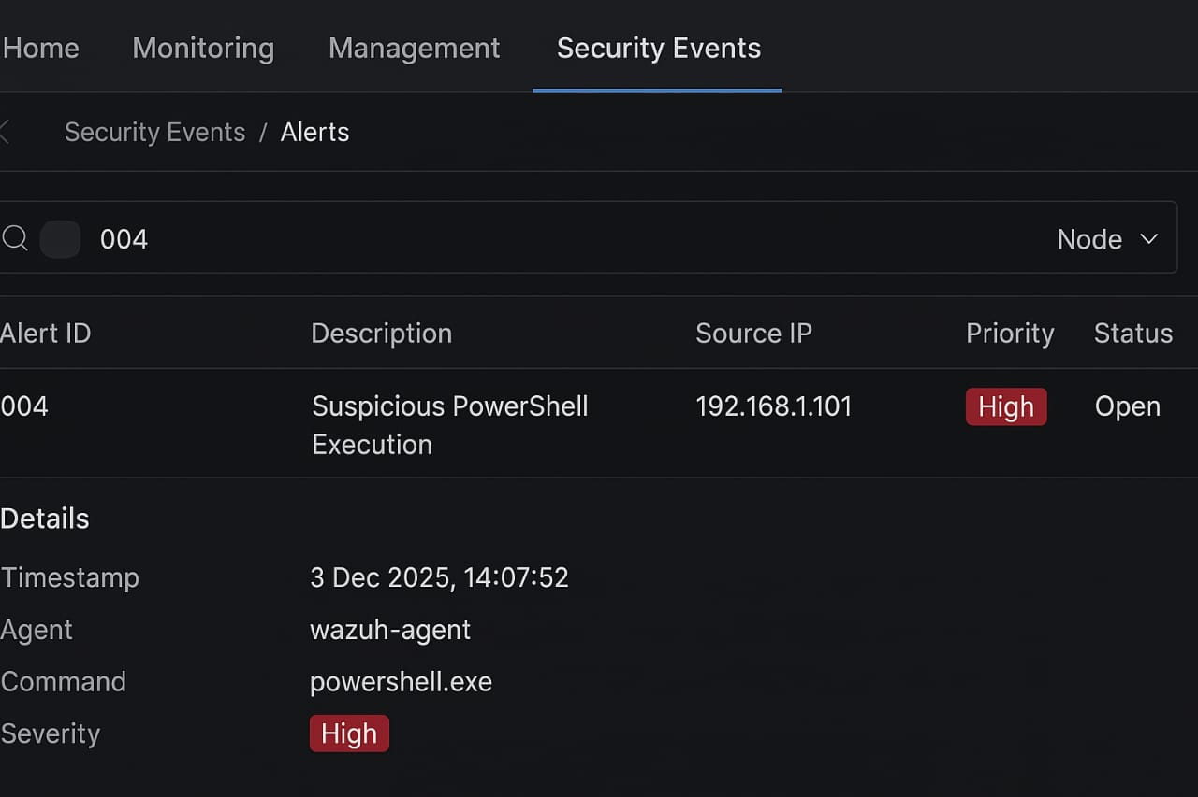
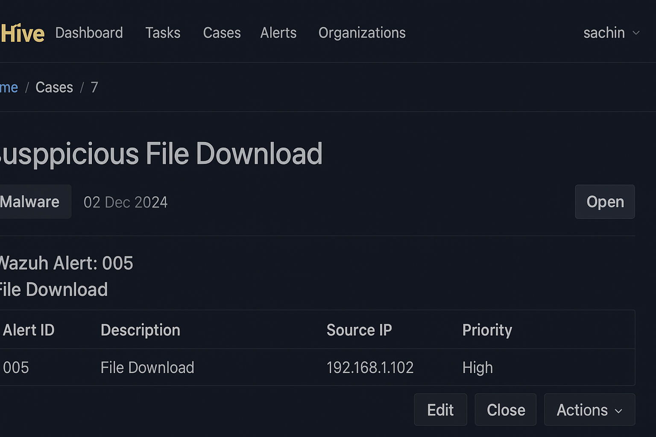

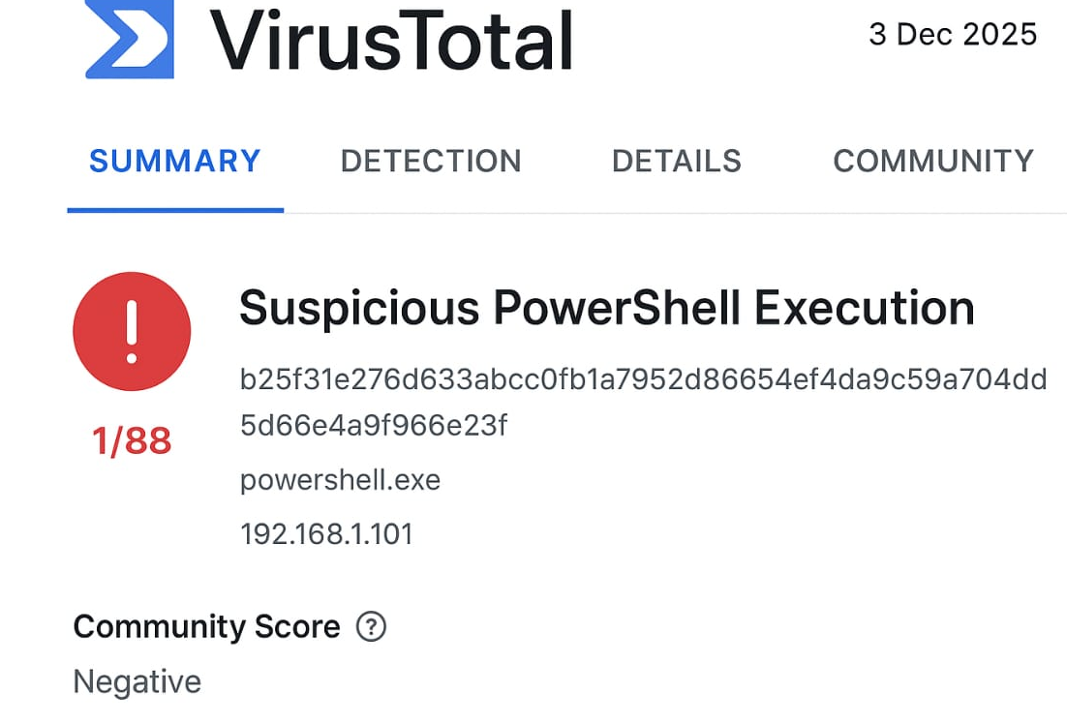
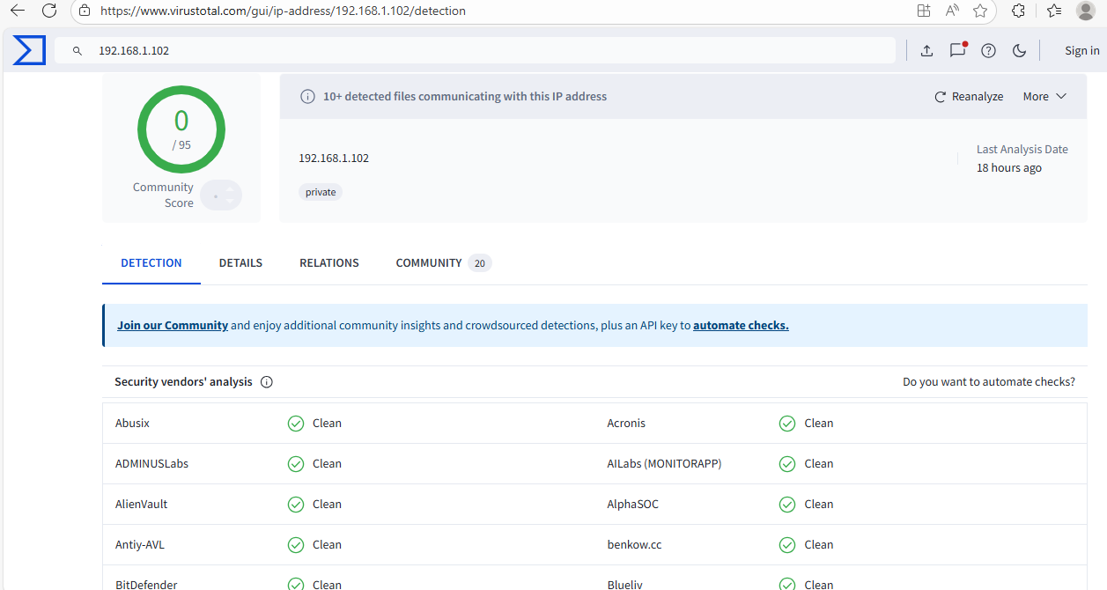

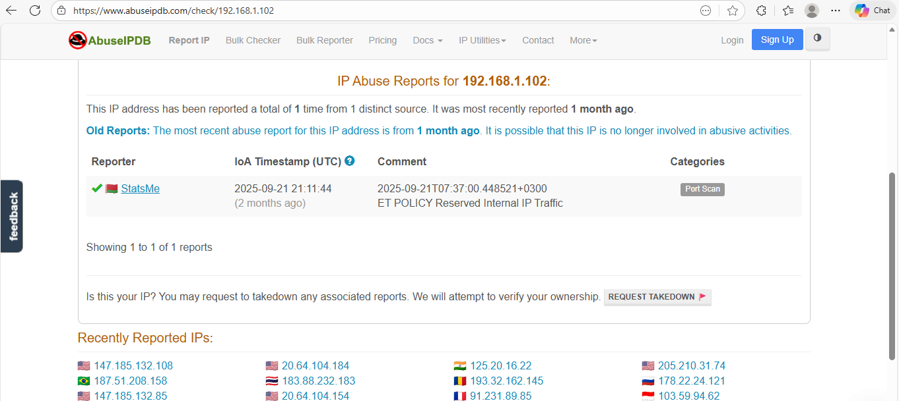
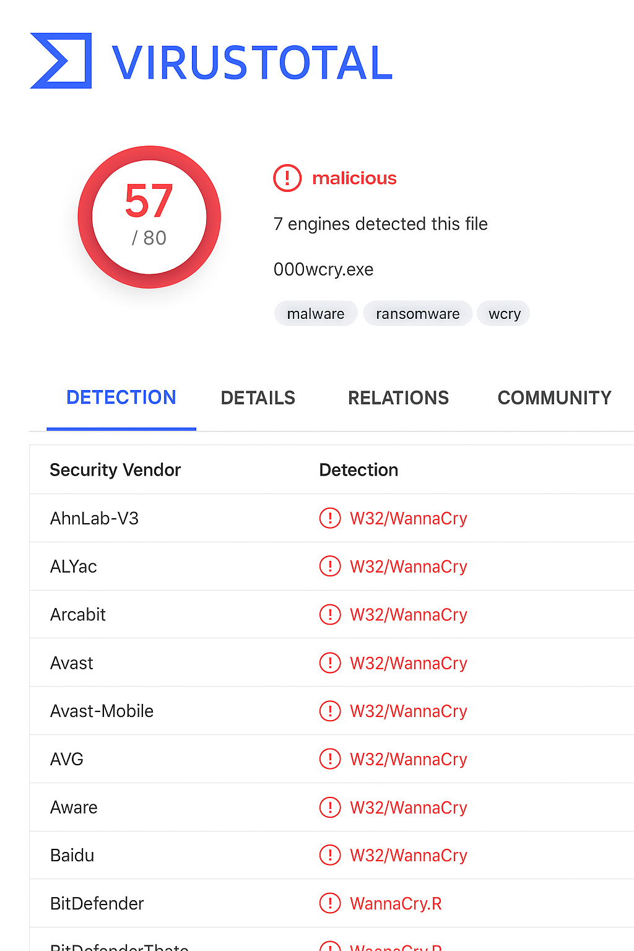

Challenges Overcome
- Integrating VirusTotal API with TheHive without prior configuration experience.
- Correlating Wazuh alerts with TheHive cases efficiently.
- Ensuring automation does not miss critical alerts (avoiding false negatives).
Learning Outcomes
- Learned alert triage methodology in a SOC environment.
- Gained experience in automation using TheHive and VirusTotal.
- Understood risk prioritization for high-priority alerts.
- Developed skills in documentation and evidence tracking for incident response.

Step | Action | Observation
1 | Open Wazuh alert | Alert ID 005 identified
2 | Investigate file | Source IP suspicious
3 | TheHive case | Case created for automation
4 | VirusTotal validation | File marked malicious
5 | Decision | Host isolated, alert closed

Automated Validation Summary

Automated hash validation in TheHive streamlines threat analysis by integrating VirusTotal lookups directly into case workflows. When an analyst submits a file hash, TheHive automatically queries VirusTotal, retrieves detection ratios, threat labels, and behavior indicators, and attaches the results to the case. This reduces manual effort and accelerates incident triage.

