TASK-7. SECURITY METRICS AND EXECUTIVE REPORTING
Objective:
The primary objective of this task is to assess the performance of the Security Operations Center (SOC) by calculating and analyzing key metrics such as MTTD (Mean Time to Detect), MTTR (Mean Time to Respond), false positive rate, and dwell time. This assessment helps in identifying gaps in threat detection and incident response, improving operational efficiency, and providing management with actionable insights through executive reporting. Additionally, the task emphasizes presenting complex SOC metrics in an understandable format for non-technical stakeholders.
Tools:
- Elastic Security: For monitoring security events and creating interactive dashboards showing MTTD, MTTR, and false positive rates.
- Google Sheets: For performing calculations, analyzing dwell time, and summarizing metrics.
- Google Docs: For drafting executive summaries that communicate findings to management in a concise, readable format.

Overview of the Task
Collecting security data from monitoring systems, calculating advanced metrics, visualizing them in dashboards, and summarizing insights for decision-makers. Specifically, it focuses on:
- Creating Elastic Security dashboards to display SOC performance metrics.
- Performing detailed metric analysis in Google Sheets, including dwell time for mock incidents.
- Drafting a concise executive summary in Google Docs, highlighting metrics, trends, and actionable recommendations.
By combining technical data analysis and executive-level reporting, the task bridges the gap between SOC operations and strategic management.

Step-by-Step Process
Step 1: Collect and Extract Data
- Gather alert and incident data from Elastic Security for a given period.
- Extract relevant information such as timestamps of detection, response times, and resolution status.
Step 2: Calculate Key Metrics
- MTTD (Mean Time to Detect): Average time taken to detect incidents after occurrence.
- MTTR (Mean Time to Respond): Average time taken to resolve incidents after detection.
- False Positive Rate: Percentage of alerts incorrectly identified as threats.
- Dwell Time: Duration between initial compromise and incident detection.
Step 3: Visualize Metrics
- Create an Elastic Security dashboard displaying MTTD, MTTR, false positive rates, and incident trends.
- Use charts and tables for better visualization and quick comprehension.
Step 4: Analyze Data in Google Sheets
- Calculate dwell time for a mock incident dataset.
- Identify trends, such as incidents taking longer to detect or respond to during specific periods.
- Highlight metrics exceeding SOC thresholds.
Step 5: Draft Executive Report
- Summarize metrics and insights in 150 words in Google Docs.
- Include actionable recommendations such as improving detection rules, reducing dwell time, or enhancing SOC workflows.
Step 6: Validation and Review
- Cross-verify metrics for accuracy.
- Ensure the executive summary communicates insights clearly and concisely.
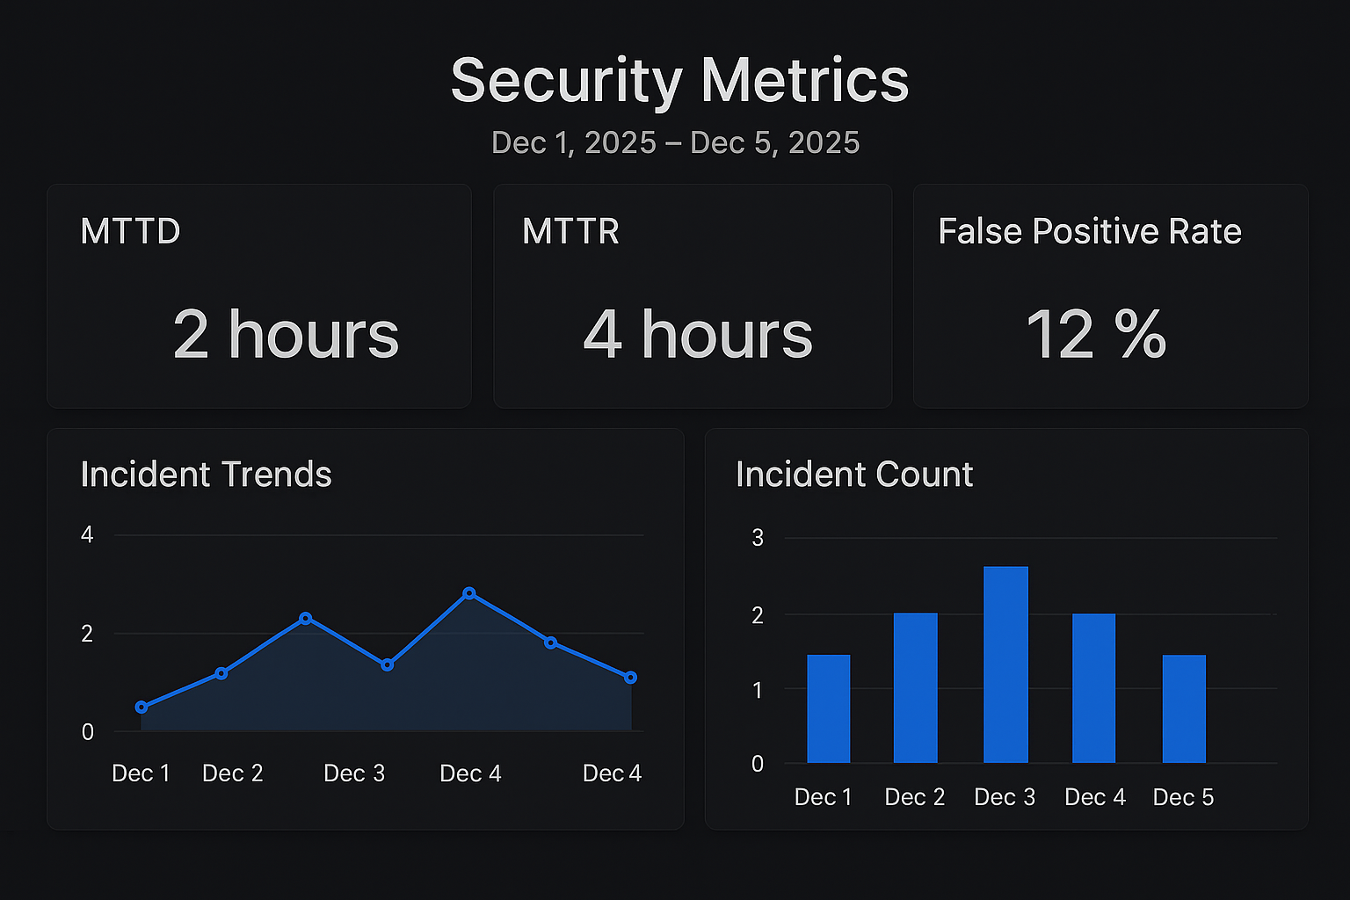
Outcomes
- MTTD: 2 hours (average detection time)
- MTTR: 4 hours (average response time)
- False Positive Rate: 12%
- Dwell Time Analysis: Identified delayed response patterns in certain incident types
- Elastic Security dashboard provides visual representation of SOC performance
- Executive report offers actionable insights for SOC improvement
Challenges Overcome
- Ensuring mock data accurately simulates real SOC alerts and incidents.
- Integrating and analyzing metrics from multiple sources.
- Presenting technical metrics in an executive-friendly format that non-technical management can understand.
- Maintaining consistency and accuracy in metric calculations.
Learning Outcomes
- Enhanced skills in calculating and interpreting advanced SOC metrics.
- Practical experience in creating dashboards in Elastic Security.
- Ability to analyze dwell time and derive actionable insights from incident data.
- Improved proficiency in translating technical SOC metrics into concise executive reports.
- Gained experience in balancing technical accuracy with readability for management.

Executive Summary:
The SOC performance assessment was conducted using key operational metrics, including Mean Time to Detect (MTTD), Mean Time to Respond (MTTR), and False Positive Rate, to evaluate detection and response efficiency. Elastic Security dashboards were created to visualize these metrics, revealing an MTTD of 2 hours, MTTR of 4 hours, and a False Positive Rate of 12%. These values indicate that the SOC demonstrates moderate efficiency but requires optimization in reducing false alerts and accelerating response workflows. A dwell time analysis performed in Google Sheets further highlighted delays between initial compromise and remediation activities. Based on the findings, the primary recommendations include enhancing alert correlation rules, implementing automated triage workflows, improving analyst training, and integrating threat intelligence feeds for quicker contextualization. These steps are expected to reduce detection gaps, minimize false positives, and strengthen SOC readiness in handling future threats effectively.
Dwell Time Summary:
Dwell time analysis revealed delays between breach occurrence and final remediation. The mock incident showed an extended dwell period due to slow triage and manual validation steps. Improving automated detection, faster alert enrichment, and prioritization workflows can significantly reduce dwell time and enhance overall SOC response capability.

