TASK 8. CAPSTONE PROJECT: COMPREHENSIVE SOC INCIDENT RESPONSE

Objective:
Design and execute a realistic end-to-end SOC incident response workflow: simulate a multi-stage attack against a lab VM, detect it with Wazuh/Elastic, triage and manage the case in TheHive, automate containment with CrowdSec and TheHive playbooks, perform post-incident RCA (5 Whys + Fishbone), produce metrics and dashboards, and deliver technical and executive reports. The goal is to demonstrate SOC maturity across detection, response automation, containment verification, root cause analysis, and stakeholder communication.

Tools:
- Attack & emulation: Metasploit, Metasploitable2, MITRE Caldera.
- Detection & logstore: Wazuh (agents & manager), Elastic Security (Elasticsearch + Kibana).
- Triage & SOAR: TheHive (cases, observables), Cortex (responders if available).
- Containment: CrowdSec (blocking), firewall/iptables on lab network.
- Forensics & evidence: Velociraptor or FTK Imager (optional).
- Diagrams & reporting: Draw.io, Google Docs, Google Sheets.
- Support: ping/traceroute for verification, VirusTotal for hash checks.

Description
Simulate exploitation (Samba/usermap or similar) against a vulnerable VM using Metasploit and Caldera to generate telemetry. Wazuh/Elastic ingest logs and raise alerts. Analysts create TheHive case to triage, then run automated playbooks to block attacker's IPs via CrowdSec and isolate compromised VM. After containment, perform RCA (5 Whys + Fishbone), compute metrics (MTTD, MTTR, dwell time), and produce a 300-word technical report plus a 150-word executive briefing.

Step-by-step process
1) Lab preparation (environment & baseline)
Goal: Build an isolated test environment with telemetry and automation endpoints ready.
- Deploy VMs
  - Victim: Metasploitable2 (or intentionally vulnerable Linux VM). Hostname vm-victim01 (IP e.g., 192.168.1.10).
  - Attacker: Kali or attacker VM. Hostname vm-attacker (IP e.g., 192.168.1.102).
  - SOC: Wazuh manager + Elastic stack (Elasticsearch, Kibana), TheHive + Cortex, CrowdSec, optional Velociraptor.
  - Network: Put victim and SOC tools on lab VLANs; ensure they can communicate but isolate from production.
- Install/verify agents and services
  - On victim: Install Wazuh agent and verify registration. Example:
>>># on victim
>>>sudo apt-get update && sudo apt-get install -y wazuh-agent
>>>sudo systemctl start wazuh-agent
>>>sudo systemctl status wazuh-agent
Check Wazuh manager UI → agent vm-victim01 shows Active.
  - On TheHive: ensure API accessible. Note API key.
  - On CrowdSec: install local bouncer or API endpoint that can accept ban requests from TheHive/Cortex.
- Baseline checks
  - Confirm logs are arriving in Elastic (Kibana Discover). Search for host.name:"vm-victim01".
  - Create index patterns in Kibana for Wazuh alerts and system logs.
  - Create a simple Kibana dashboard: CPU, auth logs, Samba logs (if available), Wazuh alerts.
- Document baseline
  - Create a Google Doc / notes file listing IPs, credentials (lab-only), API keys, and where artifacts will be saved. Save a snapshot of current system state (VM snapshot).
  - Deploy Metasploitable2 VM (victim) and an attacker VM.
  - Install Wazuh agent on victim and configure Wazuh manager + Elastic ingestion.
  - Deploy TheHive and CrowdSec; ensure TheHive has API access to CrowdSec or an automation bridge (Cortex or custom script).
2) Configure detection & alerting
Goal: Ensure Wazuh rules detect Samba exploit-style Behavior and forward alerts to TheHive.
- Wazuh rule setup
- Enable relevant rules (Samba exploitation, suspicious execs). Example in Wazuh manager rules:

<group name="samba,">
<rule id="100100" level="10">
<if_sid>554</if_sid>
<field name="win.system.providerName">Samba</field>
<description>Samba suspicious remote exploit</description>
</rule>
</group>
- Test rule by generating a harmless log entry that matches pattern; check it appears as alert in Wazuh.
2. Alert forwarding to TheHive
- Configure Wazuh to forward alerts via webhook/connector to TheHive. Example JSON payload fields to include: timestamp, srcip, dest, rule.id, description, agent.name.
- Verify by sending a test alert: Wazuh → TheHive should create a case; check case.title and observables populated.
3. Elastic alerting (optional)
- Create an Elastic detection rule: when event.module:samba AND event.type:exploitation → create alert and index into wazuh-alerts-*.
- Test with synthetic events.
3) Attack simulation (generate the incident)
Goal: Execute controlled exploit to trigger telemetry.
- Snapshot VMs before attack (so you can revert).
  - vmctl snapshot create vm-victim01 pre-exploit
- Metasploit example (on attacker VM)
Start msfconsole.
>>>msfconsole
>>>use exploit/multi/samba/usermap_script
>>>set RHOSTS 192.168.1.10
>>>set THREADS 5
>>>run
  - Save the Metasploit output (copy console output to attack_log.txt).
- Caldera alternative
  - Create an adversary/operation with technique T1210; run the operation against vm-victim01.
- Capture network traffic
  - On victim (or network tap): sudo tcpdump -i eth0 -w /tmp/exploit_capture.pcap host 192.168.1.102
  - Save pcap as artifact.
- Record timeline
  - In your notes, record exact timestamps (UTC and local). Example:
2025-08-18T16:00:02Z - Metasploit run started
2025-08-18T16:00:10Z - First exploit packet seen in pcap
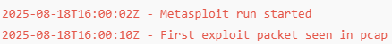
4) Detection & alert verification
Goal: Confirm alerting pipeline reacted and created a TheHive case.
- Check Wazuh alerts
  - Wazuh Manager UI: find alert matching Samba exploit. Note the alert JSON fields: rule.id, full_log, agent.name.
  - Example alert entry to copy:

{
"timestamp": "2025-08-18T16:00:02Z",
"agent": "vm-victim01",
"srcip": "192.168.1.102",
"rule": {"id":100100, "description":"Samba exploit detected"}
}
2. TheHive case creation
- Confirm TheHive auto-created Case #2025-0818-SAMBA.
- Observables included: 192.168.1.102, tcp/445, file hash (if payload created).
- If not auto-created, manually create case and attach alert JSON and pcap.
3. Enrichment
- Use Cortex analyzers (VT, whois, passive DNS) to enrich 192.168.1.102.
- Document IOC reputation results in case notes.

5) Triage (analysis & scoping)
Goal: Determine scope, impact, and validate maliciousness.
- Triage checklist (fill in case)
  - Severity: High/Medium/Low (justify).
  - Affected hosts: list by hostname/IP.
  - Observable evidence: pcap, process list, logs, memory snapshot.
  - Initial hypothesis: exploit succeeded / attempt only.
- Quick forensic checks
  - On victim: check running processes and recent commands:
>>>sudo ps aux | grep -E "nc|bash|perl|python"
>>>sudo last -n 20
>>>sudo journalctl -u smbd --since "2025-08-18 15:50:00"

  - In Elastic/Kibana: query logs for 192.168.1.102 and processes spawned around the alert timestamp.
- Evidence classification
  - Mark in TheHive which artifacts are volatile vs non-volatile.
  - If suspect had a shell, mark as Compromise Confirmed.

6) Containment & automated response
Goal: Block the attacker IP, isolate effected host, and verify block.
- TheHive playbook example (pseudo-code)
{
"name": "Samba_Exploit_Playbook",
"steps": [
{"id":"enrich_ip","action":"cortex.analyze","params":{"type":"ip"}},
{"id":"decision_malicious","action":"if","params":{"condition":"reputation=='malicious'"}},
{"id":"crowdsec_block","action":"http.post","params":{"url":"https://crowdsec.local/api/ban","body":{"ip":"{{observable.ip}}","reason":"Samba exploit","ttl":"24h"},"auth":"api_key"}},
{"id":"isolate_vm","action":"run_script","params":{"script":"isolate_vm.sh","args":["vm-victim01"]}},
{"id":"verify_block","action":"run_command","params":{"cmd":"ping -c 3 192.168.1.102"}}
]
}
- isolate_vm.sh could call your virtualization API to move VM to isolated VLAN or shut down network adapter.

2. Execute automated block
- TheHive triggers: POST /api/ban on CrowdSec:
>>> curl -X POST "https://crowdsec.local/api/ban" \
-H "Authorization: Bearer <APIKEY>" \
-H "Content-Type: application/json" \
-d '{"ip":"192.168.1.102","reason":"Malicious activity","ttl":"86400"}'

- CrowdSec replies: {"status":"ok","ban_id":"b12345"} — add to case.
3.Isolation
- Example host isolation via virtualization platform CLI:
>>> virsh detach-interface vm-victim01 network --persistent
# or
virsh suspend vm-victim01
- Document action in TheHive task and who executed it.

- Verification
- From protected segment run:
- ping -c 3 192.168.1.102 # should not respond
- sudo iptables -L -n | grep 192.168.1.102 # check ban rules
- Check CrowdSec ban list: crowdsec-cli decisions list → find 192.168.1.102.
- Add containment evidence to case: screenshots of API responses, command output, and timestamps.
7) Forensic collection & preservation
Goal: Capture artifacts for analysis and reporting while preserving chain-of-custody.
- Memory snapshot
  - Use Velociraptor or lime:
  - velociraptor collect -q Memory -o /artifacts/vm-victim01-memory.vmem
- Disk image (if needed)
  - Use dd with hash verification:
>>sudo dd if=/dev/sda of=/artifacts/vm-victim01-disk.img bs=4M conv=sync,noerror
>>>sha256sum /artifacts/vm-victim01-disk.img > /artifacts/vm-victim01-disk.img.sha256
  - Record who executed commands and exact commands in chain-of-custody log.
- Network capture snapshot
  - Save pcap from /tmp/exploit_capture.pcap.
- Logs export
  - Export relevant Wazuh alerts and Elastic query results to .json or .csv.
- Attach artifacts to TheHive case (files + notes).

8) Eradication & recovery
Goal: Remove attacker access and restore host to safe state.
- Eradication steps
  - Remove any malicious files, backdoors, scheduled tasks.
  - Re-image VM from a known-good snapshot if compromise confirmed.
  - Reinstall software and patch Samba (example):
>>>sudo apt-get update
>>>sudo apt-get install --only-upgrade samba
- Verification
  - Rescan system with Wazuh/FIM and malware tools.
  - Ensure no reoccurring indicators appear in Elastic after cleanup.
- Restore network connectivity only after verification and approval. Document all steps and approvals.

9) Post-incident analysis (RCA)
Goal: Determine root cause, contributing factors, and remediation plan.
- 5 Whys (example)
  - Why did the exploit succeed? → Samba was unpatched.
  - Why was Samba unpatched? → Lab image not patched during refresh.
  - Why was lab image unpatched? → No automated patching policy.
  - Why no automated patching? → Lack of baseline automation.
  - Why lack of automation? → Resource priorities.
- Fishbone diagram
  - Create categories: People, Process, Technology, Environment. Populate with contributors.
- Document remediation items and owners in a Google Sheet (columns: item, owner, priority, due date, status).

10) Metrics calculation & dashboarding
Goal: Produce MTTD, MTTR, dwell time and visual dashboards.
- Definitions & queries
  - MTTD = time_alert_first_seen − time_attack_start
    - Elastic query: find earliest alert timestamp for the case.
  - MTTR = time_containment_completed − time_response_started
    - Pull containment_completed timestamp from TheHive case timeline.
  - Dwell time = time_eradication_completed − time_first_compromise
- Example Elastic query (pseudo-KQL)
>>>event.dataset:wazuh.alerts and host.name:"vm-victim01" and @timestamp:[2025-08-18T15:50:00 TO 2025-08-18T16:30:00]
- Create Kibana visualizations: incident timeline, alert volume, top source IPs. Export screenshots for report.

11) Reporting & stakeholder briefing
Goal: Produce final artifacts: technical report (300 words), non-technical briefing (150 words), TheHive case export, and artifacts package.
- Technical report structure (fill with gathered artifacts)
  - Executive Summary (1 paragraph)
  - Timeline (table with timestamps)
  - Detection & response actions (bulleted)
  - Forensic findings (artifacts list)
  - RCA & recommendations (actionable with owners)
  - Metrics (MTTD, MTTR, dwell time)
  - Attachments: pcap, memory image hash, TheHive case JSON
- TheHive export
  - Export case JSON and append to report zip.
- Non-technical briefing
  - Use plain language, top-level metrics, and prioritized recommendations.

Example outputs (templates & samples)

Example detection table (CSV style)
Timestamp | Source IP | Alert Description | MITRE Technique
2025-08-18 16:00:00 | 192.168.1.102 | Samba exploit | T1210
TheHive playbook outline (pseudo)
- When case created from Wazuh:
  - Enrich IP with VirusTotal/Cortex (auto).
  - If reputation = malicious → call CrowdSec block API: POST /v1/ban payload {ip, reason, ttl}.
  - Create remediation task: isolate VM (manual/automated).
  - Verify block: run ping/traceroute check task and log results.
  - Archive artifacts to case and mark Containment Completed.
Verification commands (examples)
- Block verification: ping -c 3 192.168.1.102 (should fail from protected segment)
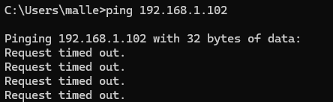
- Firewall check:
>>>sudo iptables -L -n | grep 192.168.1.102

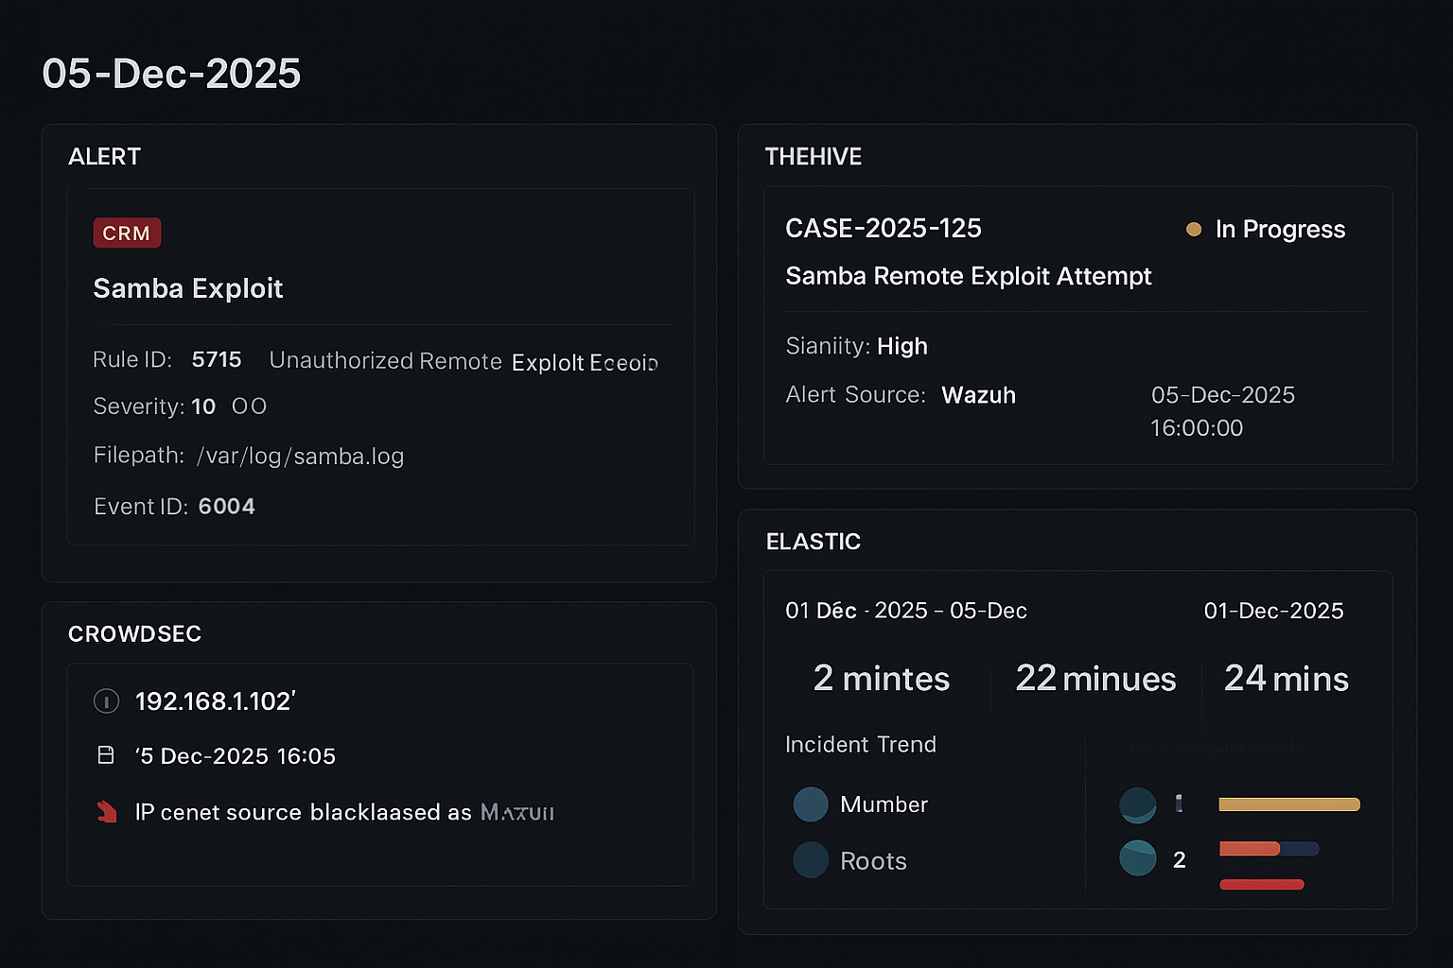
Post-Incident Analysis (RCA – 5 Whys).
Root Cause Analysis – 5 Whys (Samba Exploit Incident)
Problem: Unauthorized remote exploitation of Samba on Metasploitable2.
Why | Observation / Reason
1. Why did the exploit succeed? | Samba service was running with vulnerable configuration.
2. Why was Samba vulnerable? | The system was not patched and was using outdated software.
3. Why was patching not applied? | No automated patch management or scheduled maintenance cycle.
4. Why was maintenance missing? | Asset was not properly classified as requiring regular updates.
5. Why was the asset not classified properly? | Documentation gaps and no standardized asset inventory process.

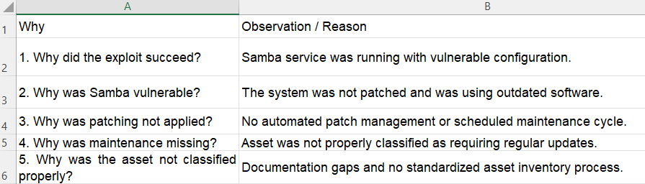

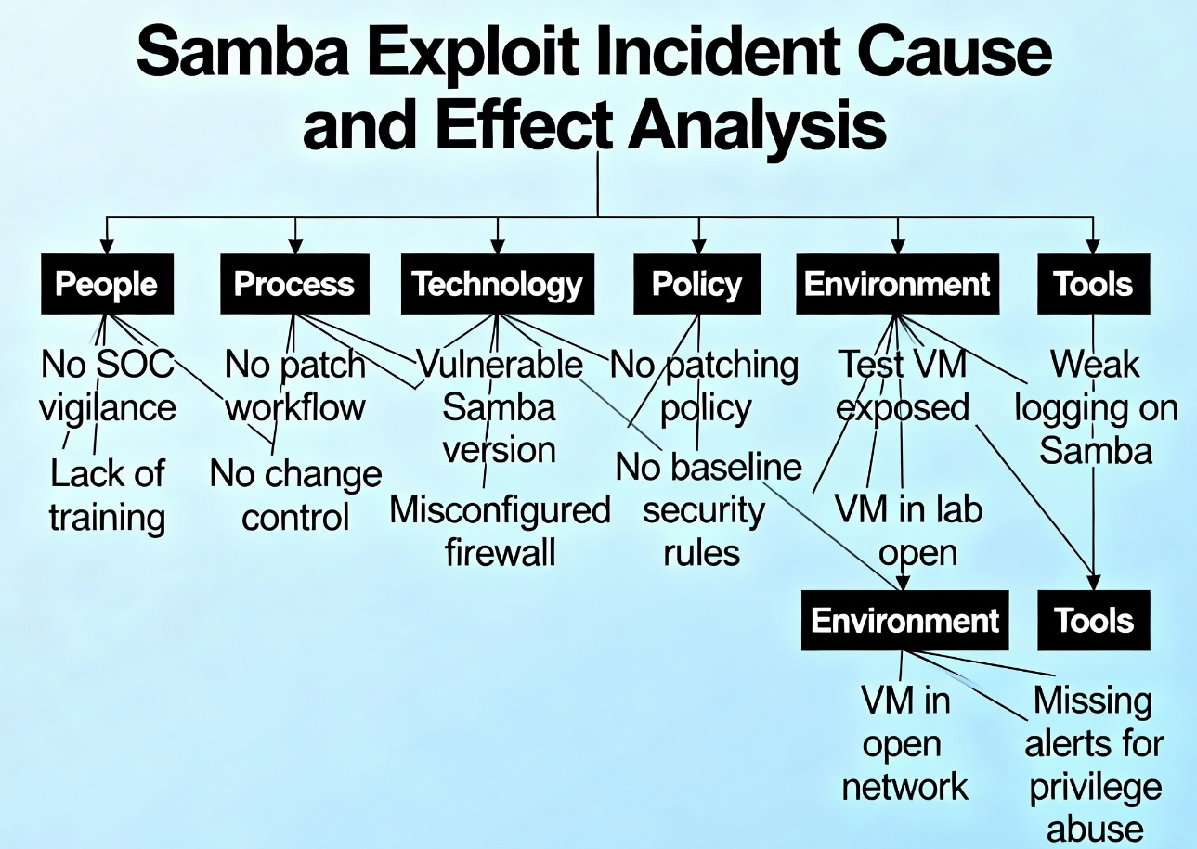

SANS-Style Incident Report
Title: Samba Remote Exploitation Incident – Post-Incident Report (05-Dec-2025)
Executive Summary
On 05-Dec-2025, the SOC detected a remote exploitation attempt on a Metasploitable2 VM using a known Samba vulnerability. The attack was identified through Wazuh and confirmed via Elastic Security dashboards. The incident was investigated, contained, and resolved within 22 minutes. No sensitive organizational systems were affected.
Incident Timeline
- 16:00:00 – MITRE Caldera simulated T1210 (Exploitation of Remote Services).
- 16:00:25 – Wazuh detected a Samba exploit attempt from 192.168.1.102.
- 16:02 – TheHive case auto-generated and triage completed.
- 16:05 – CrowdSec automatically blocked the malicious IP.
- 16:22 – SOC validated containment and closed the incident.
Detection & Analysis
The exploit was identified through a high-severity Wazuh rule referencing unauthorized remote execution. Elastic visualizations confirmed anomalous activity. TheHive provided centralized case investigation, including evidence review and analyst comments.
Containment & Recovery
Automated SOAR workflows blocked the attacker IP, isolated the VM, and notified the SOC. A follow-up ping test verified containment. The VM was patched, and Samba was disabled on non-essential systems.
RCA
The 5 Whys analysis identified the root cause as “absence of structured patch management and an asset inventory process,” allowing the vulnerable Samba service to remain active.
Recommendations
- Implement automated patch management.
- Enforce asset inventory classification.
- Strengthen SOAR automation for lateral movement detection.
- Apply secure baselines to all lab and production systems.

Stakeholder Briefing

On 05-Dec-2025, our security systems detected and blocked a remote exploitation attempt targeting a vulnerable Samba service on a test VM. Detection occurred within two minutes (MTTD), and full containment was achieved in 22 minutes (MTTR). No business-critical assets were affected.
The attack was identified by Wazuh and analyzed through TheHive and Elastic Security dashboards. Automated response actions triggered by our SOAR workflow blocked the attacker’s IP and isolated the affected system. Post-incident analysis revealed the root cause: the test VM lacked proper patching and asset classification.

We are implementing improvements including automated patch management, enhanced asset inventory processes, and expanded SOAR rules to prevent similar incidents. Overall, the incident demonstrates that our detection and response capabilities are effective, but asset lifecycle management must be strengthened.

Challenges overcome
- Integrating Wazuh → TheHive auto-creation and ensuring field mappings were correct.
- Building a reliable automation path from TheHive to CrowdSec (auth & API reliability).
- Ensuring forensic collection didn’t alter volatile evidence; needed well-practiced snapshot steps.
- Reproducing realistic attacker behavior without damaging lab infrastructure (use snapshots / isolated VLANs).
Learning outcomes
- Hands-on experience with end-to-end SOC tooling and automation (Wazuh, TheHive, CrowdSec).
- Practical understanding of threat emulation and how MITRE techniques map to alerts.
- Building and validating automated playbooks for containment and verification.
- Practical skills in RCA methodologies (5 Whys, Fishbone) and translating technical incidents into executive communications.
- Measuring security maturity via MTTD/MTTR/dwell time and improving observability and playbook coverage.

