Team 1.2
LLM Powered Research Co Pilot for Academia
Executive Summary Submission
Gullapalli Sathar, Assistant Professor, VNRVJIET, Hyd.
Project Summary:
This project presents an AI-powered Research Co-Pilot designed to support academic faculty in managing end-to-end research activities more efficiently. Faculty often spend significant time on repetitive tasks such as literature review, summarizing research papers, identifying research gaps, drafting abstracts, and managing citations, which can delay innovation and experimentation. To address this, the proposed system utilizes advanced technologies including Large Language Models (LLMs), Retrieval-Augmented Generation (RAG), and vector embeddings to automate and enhance these processes. The solution enables users to upload research papers and receive structured outputs such as summaries, key insights, citation recommendations, and research gap analysis. It also suggests suitable journals and conferences for publication. By integrating agentic workflows and fine-tuned models, the system ensures accurate, context-aware, and efficient research assistance. The expected outcome is a functional prototype that improves research productivity, enhances quality, and provides scalable deployment recommendations for institutional use.
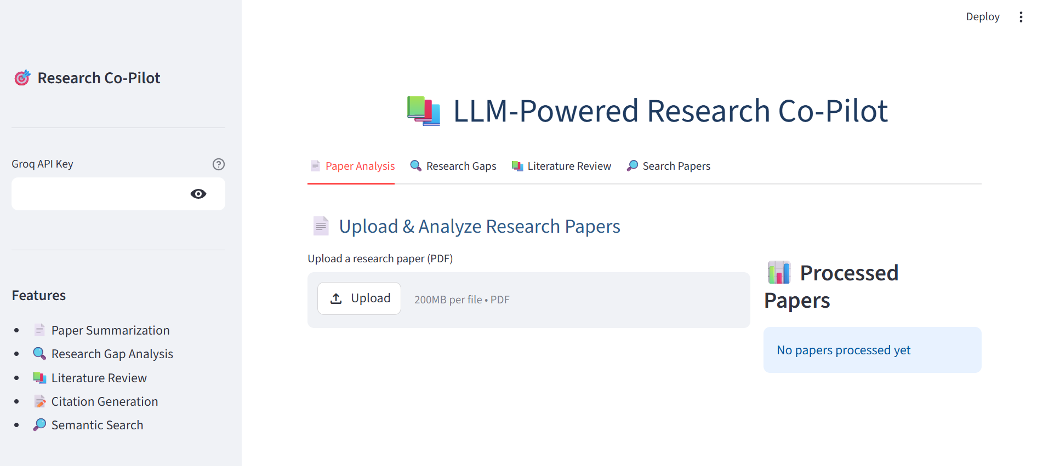

Github link:

