Day -1
Swift Programs
Basic program
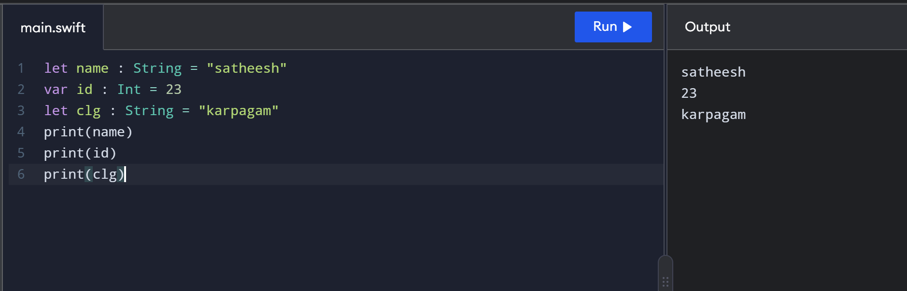
String interpolation
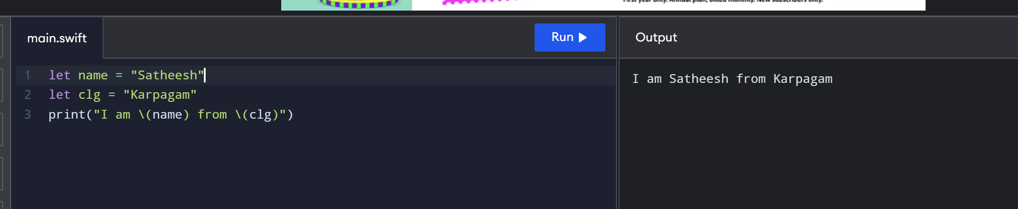
Comparision operators using Boolean values
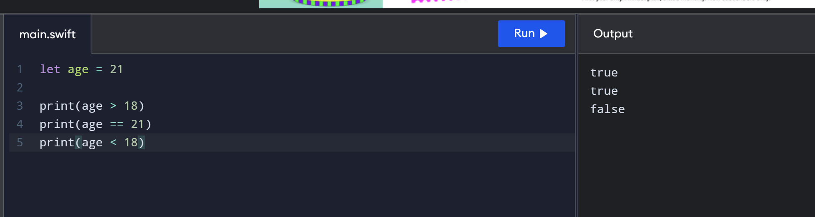

If and else if statement
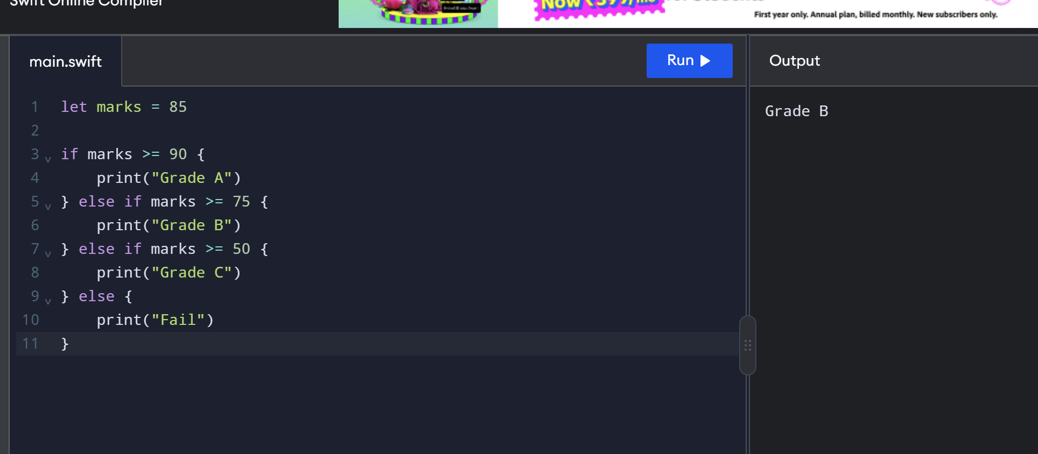
Logical operators
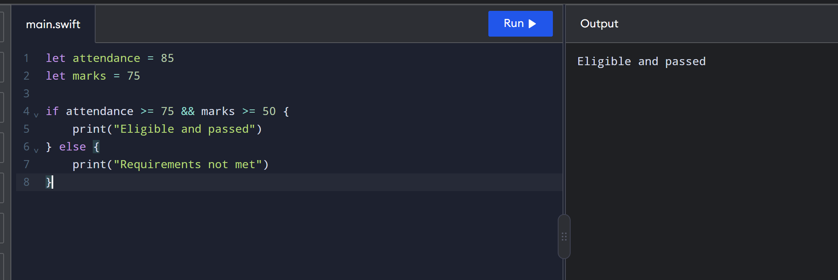
For loop
