1. Out put for the Assignment 10.1

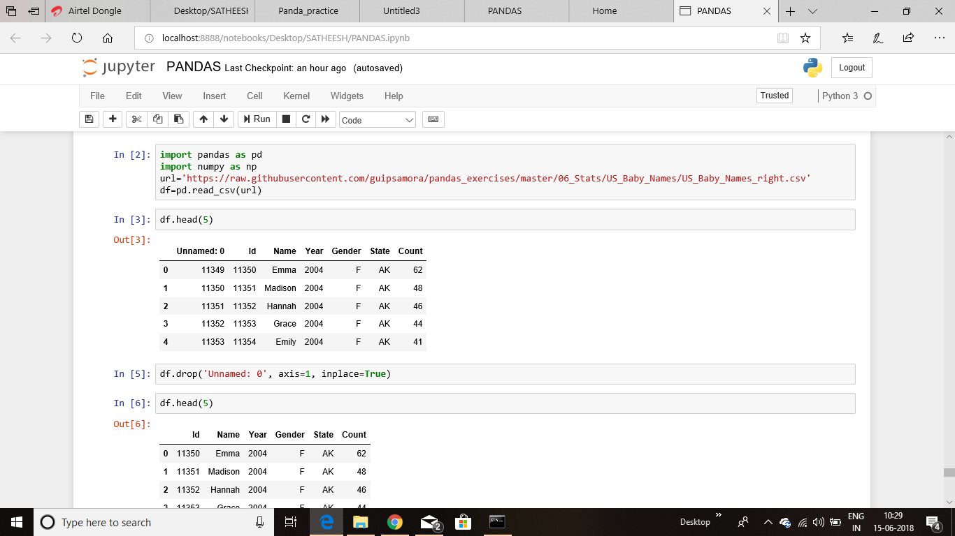

1. output for the Assignment 10.2

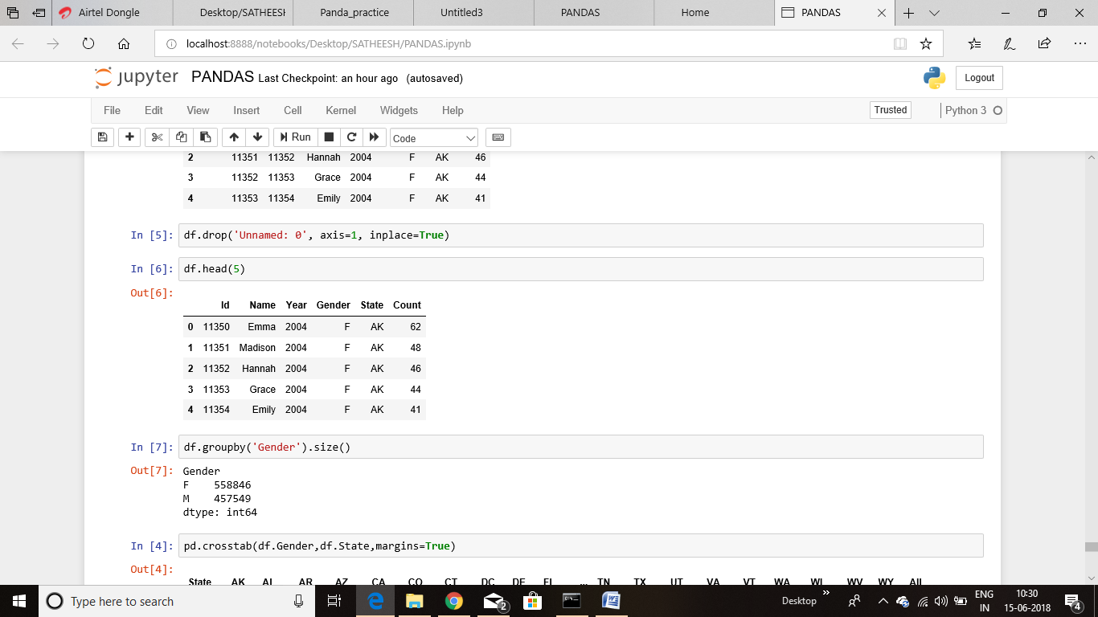

Out put for the Assignment 10.5 & 10.3

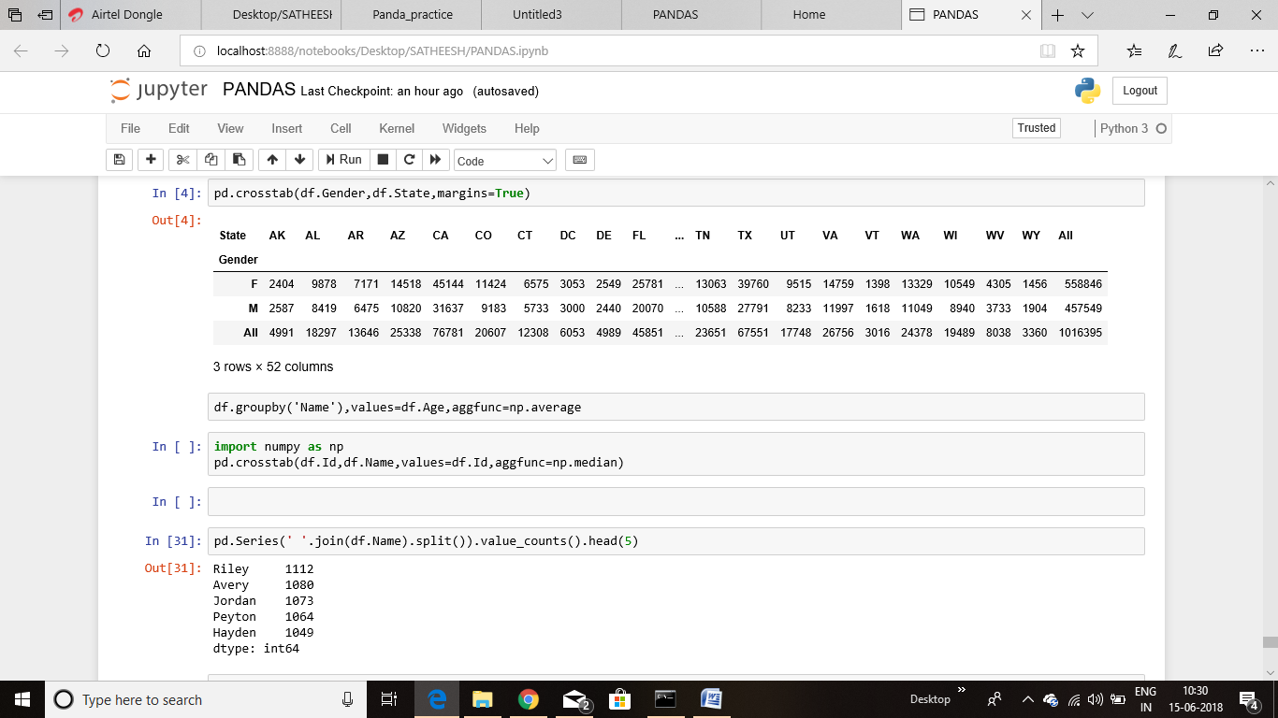

Out put for the Assignment 10.4

