1. Out put for the Assignment 11.1

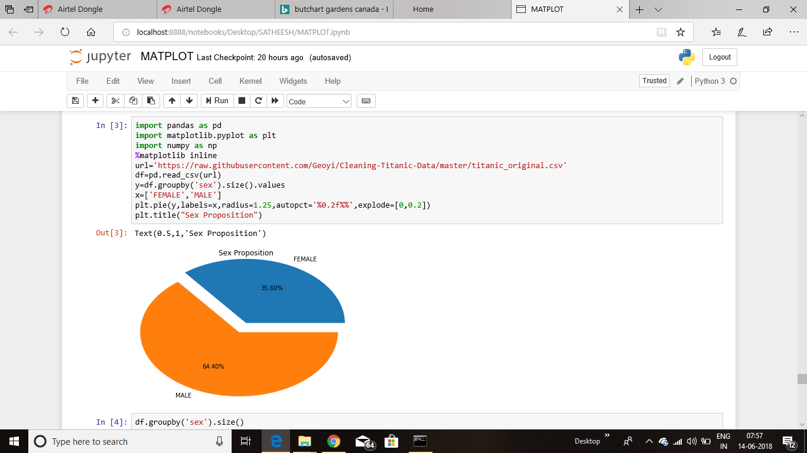

1. Out put for the Assignment 11.2(Age vs Fare)

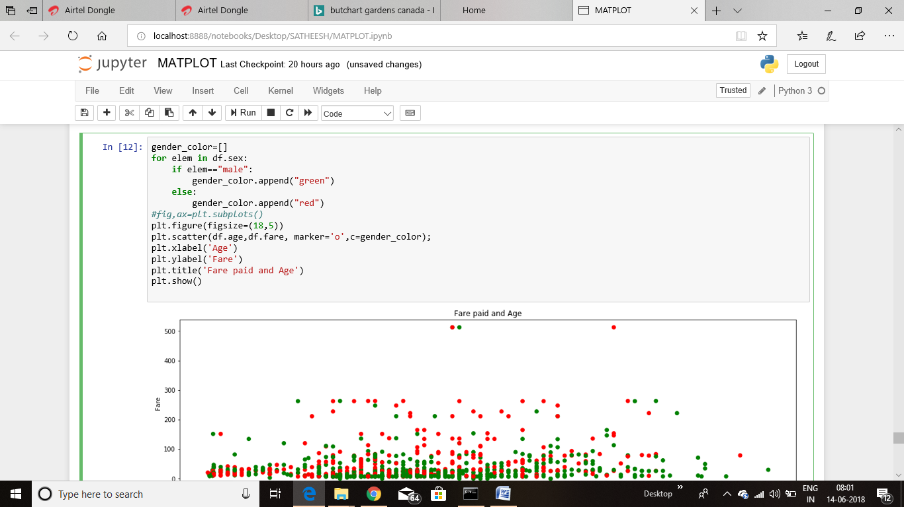

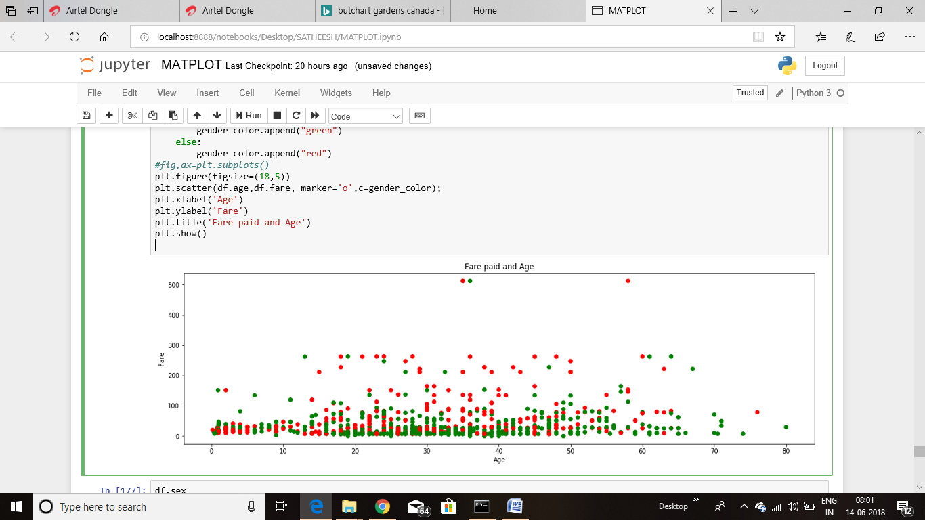

1. Out put for the Assignment 11.2(Fare vs Age)
2. 