1. Out put for the Assignment 14.1

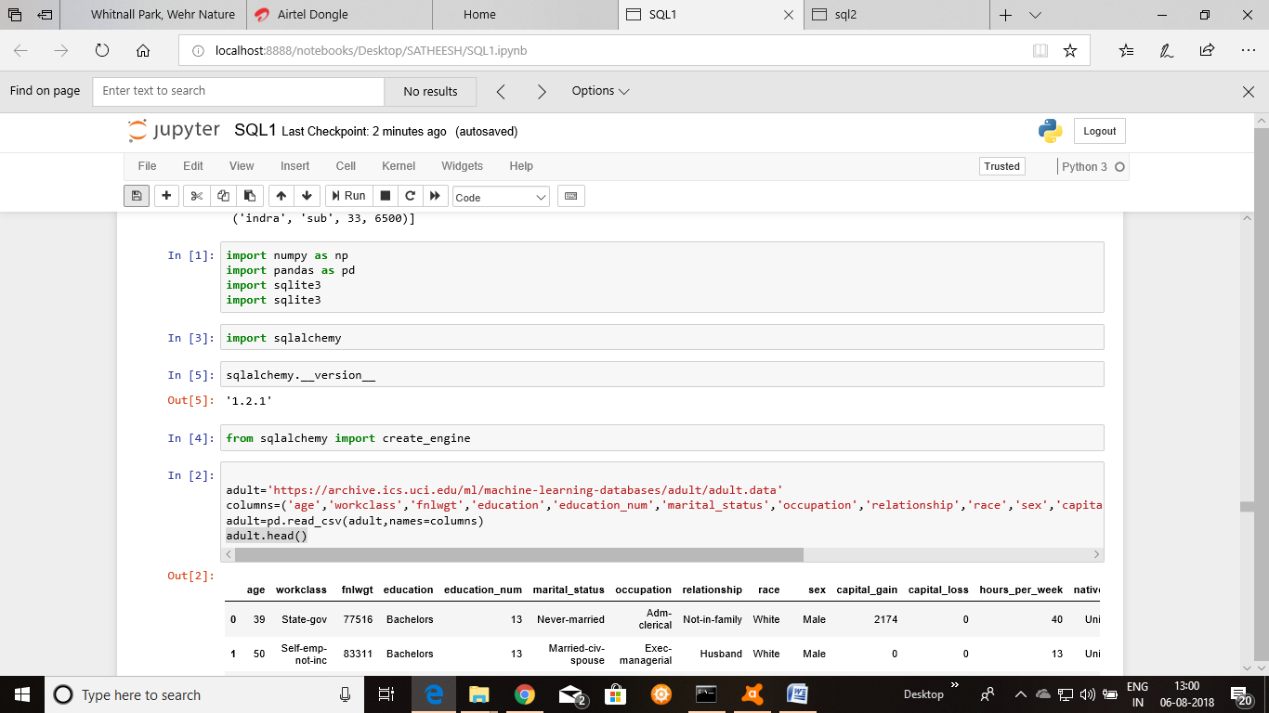

1. Out put for the Assignment 14.2

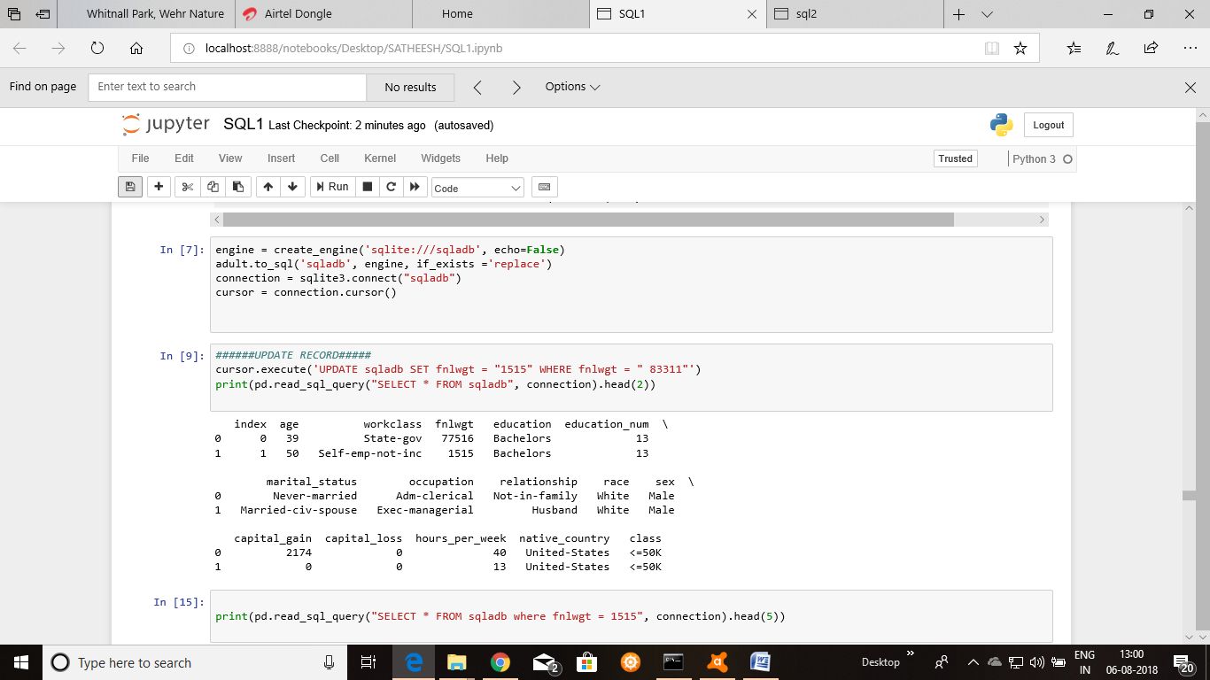

1. Out put for the Assignment 14.3

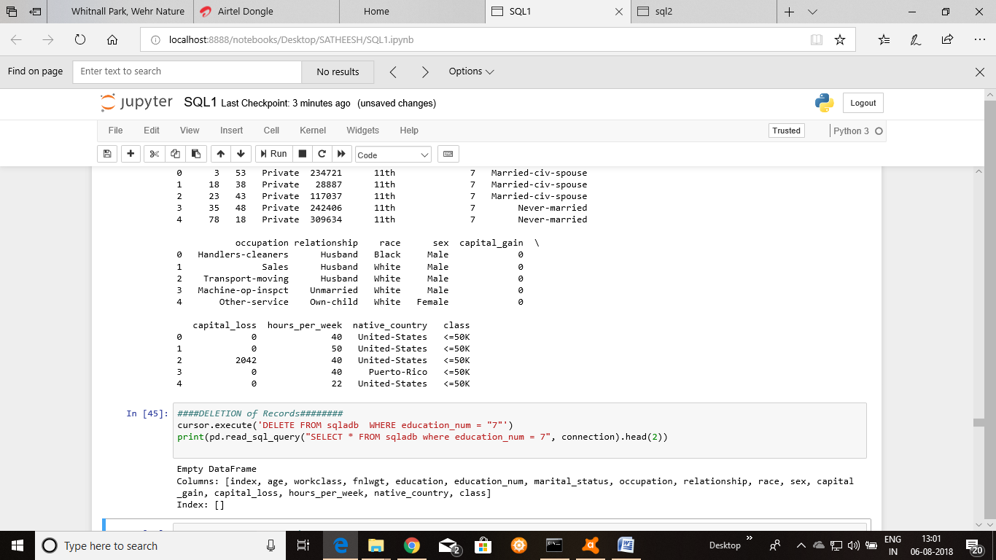

1. Out put for the Assignment 14.4

