1. Out put for the Assignment 4.2(a)

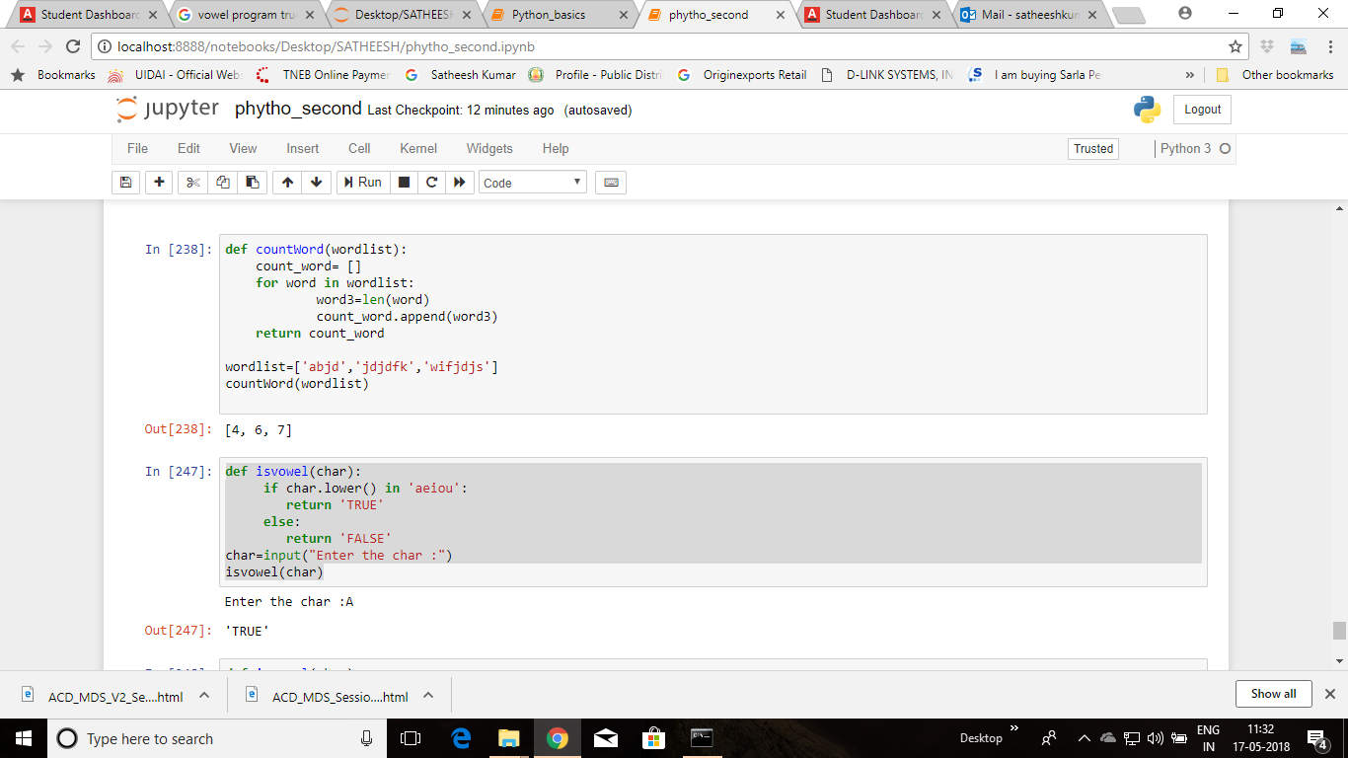

1)Assignment 4.2(b)

