1. Out put for the Assignment 009.1

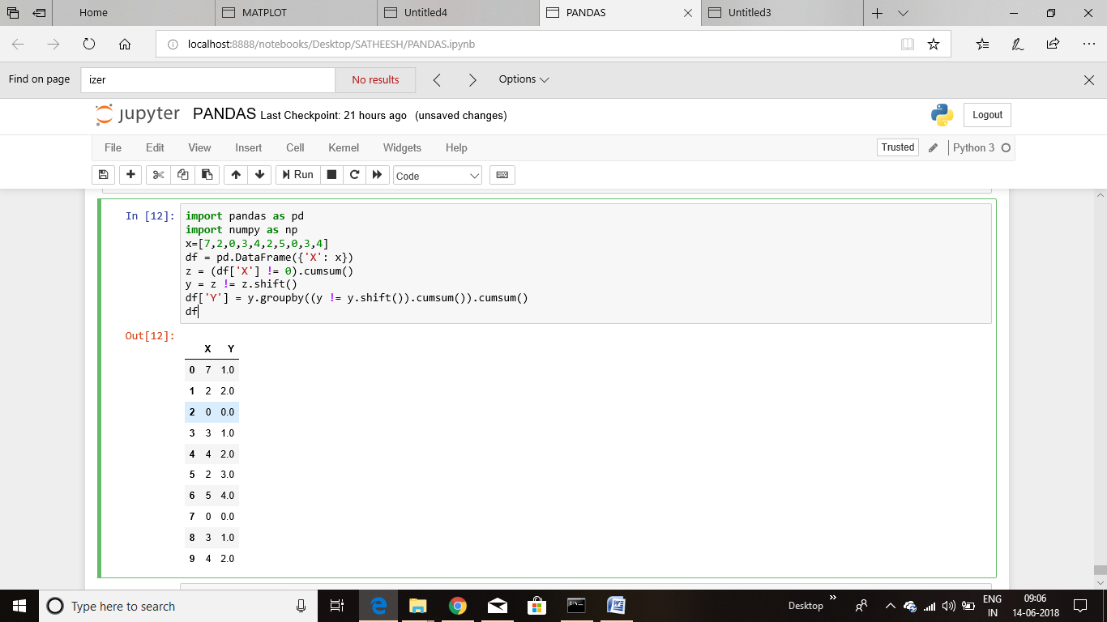

1. output for the Assignment 9.2

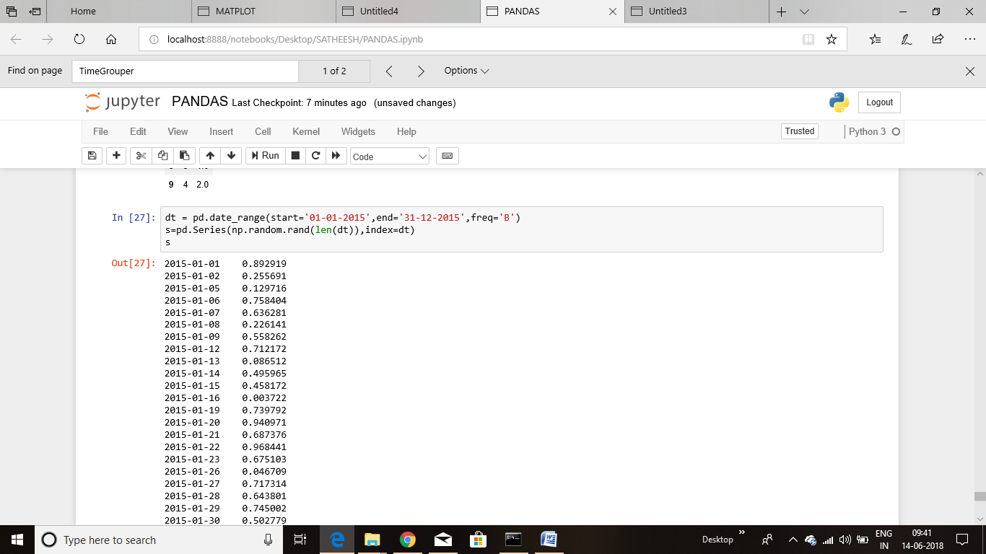

Out put for the Assignment 9.3,4,5