1. Out put for the Assignment 19.2

Problem Statement 1:

Null Hypothesis= **H0:** μ1 = μ2 = μ3   
Alternate Hyp = **Ha**: μ1 ≠ μ2 ≠ μ3

Degrees of freedom

dftotal =        n - 1 = 15 - 1 = 14  
dfwithin =     n - k = 15 - 3 = 12  
dfbetween = k - 1 = 3 - 1 = 2

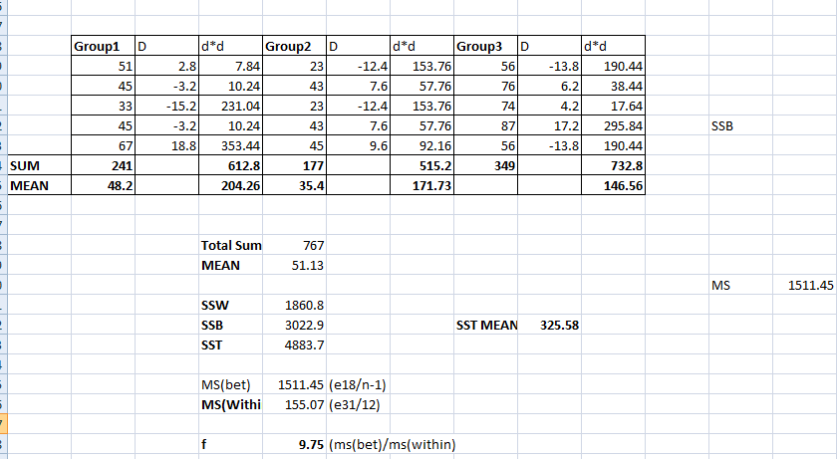

Value of F =9.75

From F- disturbtion table,vlue of F is **3.89.**

As f is higher ,we are **rejecting** Null hypothesis**-** **H0:** μ1 = μ2 = μ3