1. **Booking Service**

This micro service application is used

* to book a room by getting the details from user and saves it into the Booking database table.
* to make Payment for the booked room by reaching out to the endpoints in the Payment service microservice app.
* to send notification message to the Kafka message topic after the Payment.

|  |  |
| --- | --- |
| This Booking micro service app has the following package structures   * **Controller** * **BookingController** Contains the API methods to book a room and make payment * **Service** * **BookingService**   This Interface contains the abstract methods bookRoom, payForRoom, findBookingId   * **BookingServiceImpl**   This class implements the methods of its interface   * **DAO**   **BookingServiceDao**  This interface extends the  JpaRespositry interface for the saving the payment related details to the database table.   * **Entity**   BookingInfoEntity   * **Model**   TranscationDetailsModel  ErrorModel   * **Exception**   InValidPaymentException |  |

* **Controller**

The Controller layer has a class called **BookingController** which is annotated with **@RestController** and **@RequestMapping(value="/booking")** and its Constructor is Autowired to inject the BookingService.

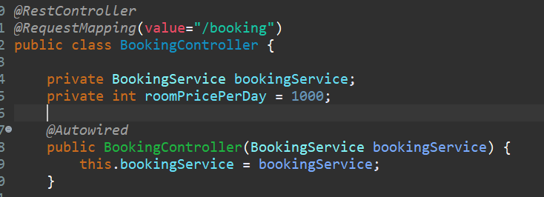

This class the