***COVE***

***Application Environment setup Guide***

|  |  |
| --- | --- |
| Business Project Manager Name: | Manu P Gupta |
| Published Date: | 07/11/2016 |
| Version: | 1.5 |
| Author: | Murali Krishna Pinjala |

***Vodafone***

*COVE*

Authors

| Name | Phone | Email |
| --- | --- | --- |
| Murali | +44-7424800648 | Murali.pinjala@vodafone.com |

Revision History

| Date | Author | Description |
| --- | --- | --- |
| 10/13/2016 | Murali | Liferay Env Configiration |
| 11/02/2016 | Rajanikanth B/ Aneef | Liferay Cluster Configuration |
| 11/03/2016 | Aneef Kandukuri | Updated Andre’s comments |
| 11/06/2016 | Aneef Kandukuri | Updated Liferay license renewal procedure  Updated ojdbc dependency  Updated Andre’s comments |
| 07/11/2016 | Aneef Kandukuri | Updated renewal of license section  Updated portal-setup-wizard.properties section  Updated comments from Andre |

Table of Contents

Introduction 3

Purpose 3

Scope 3

Conventions in this document 3

Installation and Configuration Liferay Tomcat 4

Prerequisites of tomcat liferay installation 4

Installation 9

Parameter Settings for Tomcat 9

EHCACHE Setup and Configuration 11

Database configuration 13

Database configuration testing 15

AcTION Activities for liferay 16

Installation of Java and liferay 16

Liferay database configuration 16

Liferay Tomcat threads configuration 16

Liferay Cluster properties 17

Renewal of liferay licenses 23

# Introduction

## Purpose

This document describes the steps of installation of java, tomcat, liferay, configuration of kernel properties, Oracle database and clustering of liferay DXP servers.

## Scope

Following are the items, which are considered as part of the env setup scope:

* Installation and Configuration Liferay DXP digital enterprise 7.0 GA1 and Tomcat
* Guidelines for configuring Liferay on a Cluster
* Liferay tomcat threads configuration
* Stop existing filters
* Deployment of coop Wars and Jars

## Conventions in this document

1. Blocks of the following format represent a configuration snippet:

Some configuration detail

1. Information presented in the following format represents mandatory actions to be performed

***Note: some configuration to be edited /added***

1. Section marked as “**STEP TO BE PERFORMED ON MASTER NODE**”, represents a step to be performed on master node. (for 2 node configuration)
2. Section marked as “**STEP TO BE PERFORMED ON NON-MASTER NODE**”, represents a step to be performed on non- master node. (for 2 node configuration)
3. Section marked as “**STEP CAN BE PERFORMED CONCURRENTLY ON ALL NODES**”, represents a step that can be performed concurrently on all nodes. (**for more than 2 node configuration**)

# Installation and Configuration Liferay Tomcat

## Prerequisites of tomcat liferay installation

**Software Availability**

Download the required package with specific version as below:

|  |  |
| --- | --- |
| **Software** | **Version** |
| liferay-dxp-digital-enterprise-7.0-ga1-20160617092557801.zip | 7(bundled with Tomcat 8.0.32) |
| Java(JDK) | 1.8.0_101 |
| Liferay License |  |

1. Upload the files to Justshare using the following URL:

<http://justshare.vodafone.com>

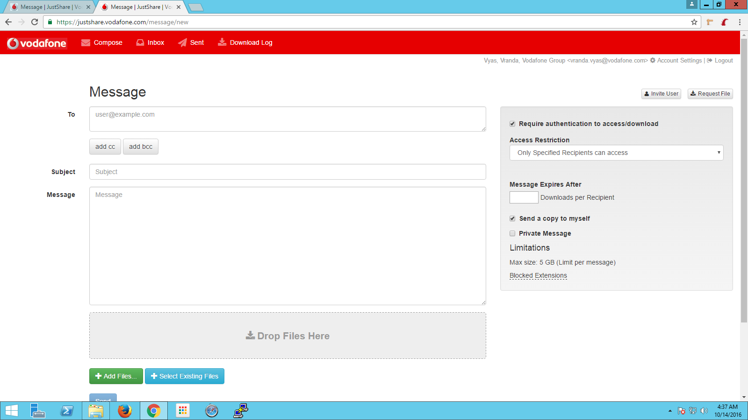

1. Add the email Id, to which you need to send the files, and add the files using “Add Files” button on the screen.
2. Give Subject (mandatory field) and click Send.
3. Login to Citrix using the following URL:

<http://vfg-citrix-ext.vodafone.com/vpn/index.html>

Using your Vodafone email Id and password, also verifying it by Symantec VIP code that we receive on our registered device.

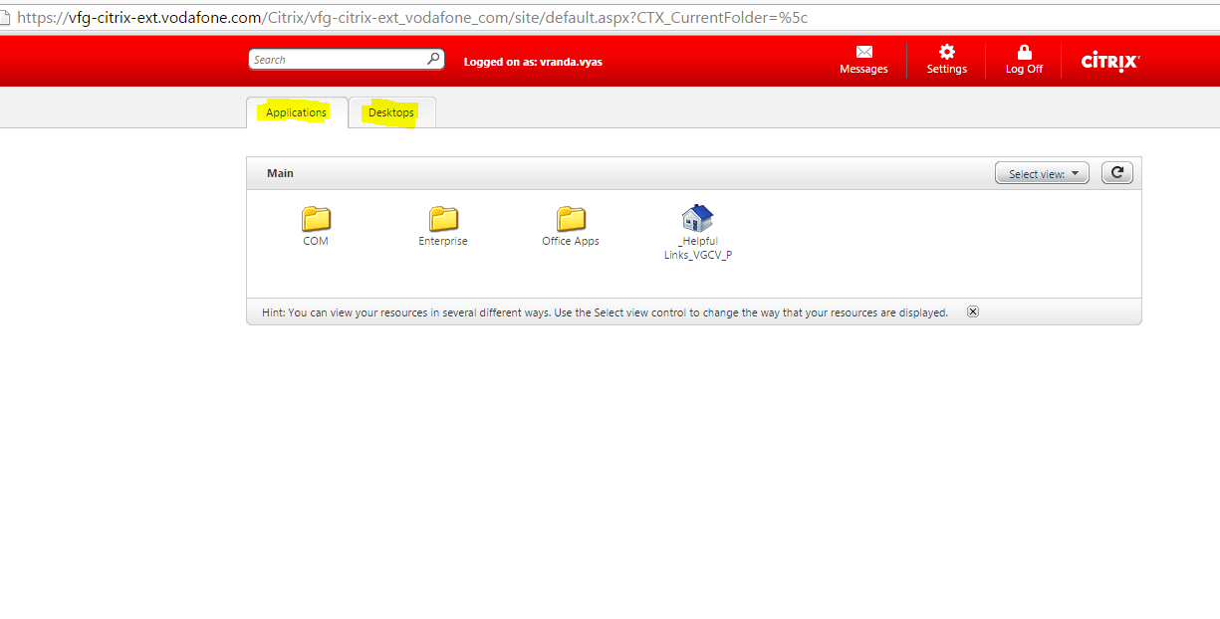

1. Two tabs are available on your screen once you login to citrix:
2. Applications
3. Desktop
4. Select Desktop and Open a VDI from that (any one that you have available):

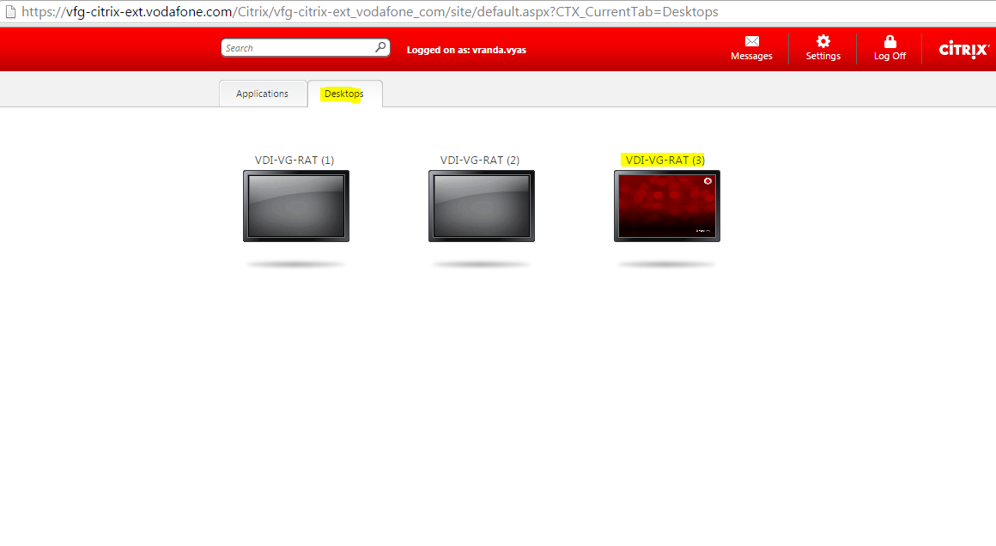

1. Once you are into the VDI, open your Vodafone email ID and look for the Justshare mail (in your inbox)

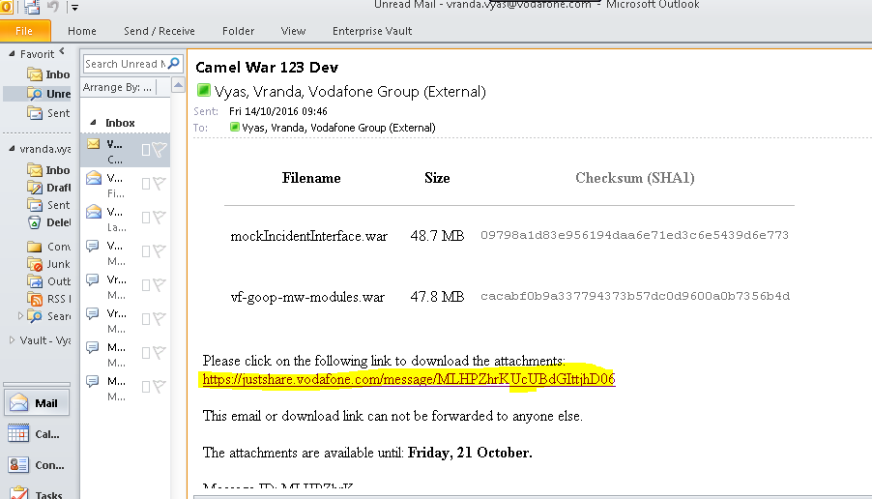

1. Click on the link and you will be prompted to download the specific files.
2. Now we need to transfer the files to the Jump Server (using WinSCP), copy the file and paste it in the transfer folder of Jump Server.

**Note:** Use your unix credentials, whenever prompted for username and password.

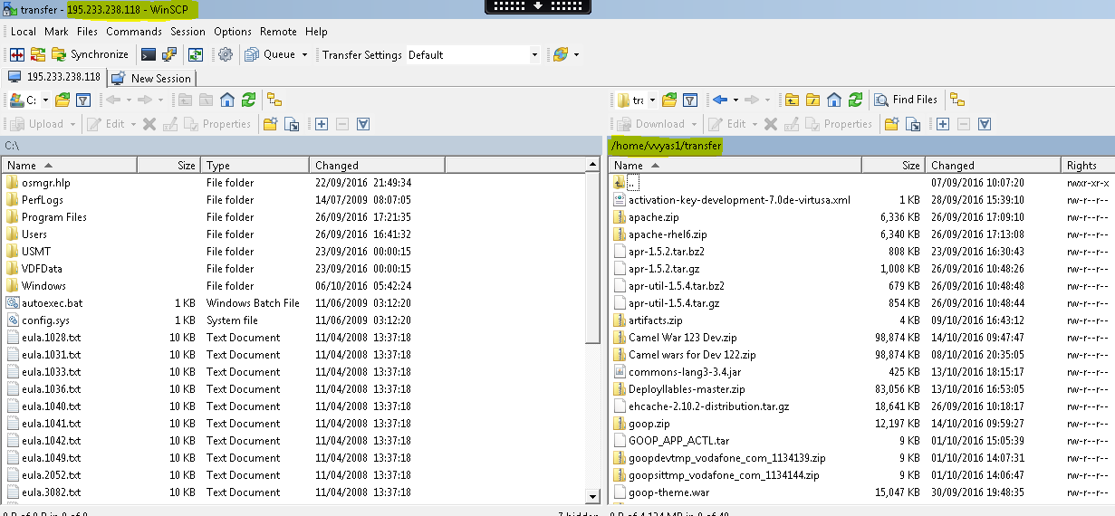

1. Once the deployment files are within the ‘transfer’ folder of the Jump Server, we can transfer them to respective Application Servers using the following steps:
   1. Open Putty
   2. Give Jump Server IP: 195.233.238.118 and click login, when prompted for username and password, use your unix credentials.

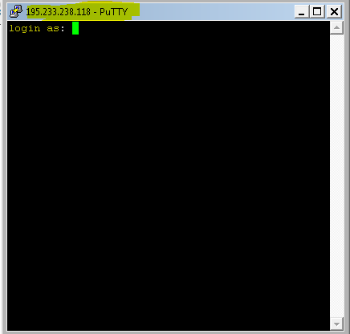

* 1. Once you log in, give the following command to transfer the file to respective server location:

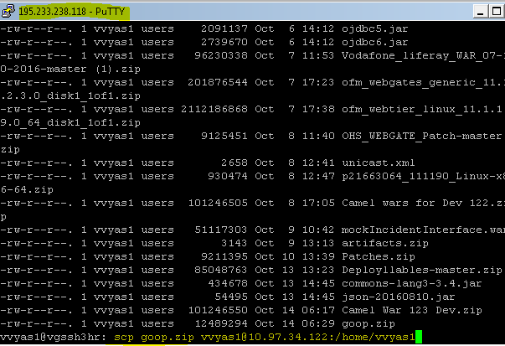

**$scp liferay-dxp-digital-enterprise-7.0-ga1-20160617092557801.zip <unix_user>@<<Target_machineIP>>:/tmp**

* 1. Once you have transferred the files to the application server, you will have to login as functional user to transfer within the functional user directory(as we do not have permission to transfer there directly)

**$ ssh <<unix_user>>@<<Target_machineIP>>**

**$<<unix_user>> password**

**$ cd /tmp**

**$** **chmod 777 liferay-dxp-digital-enterprise-7.0-ga1-20160617092557801.zip**

**$sudo su - <<functional_user>>**

**$cd /opt/SP/weloadm/software (the directory where you have to copy the files)**

**$cp /tmp/liferay-dxp-digital-enterprise-7.0-ga1-20160617092557801.zip . (location within the functional user)**

**Note**: Also copy the license file to the same location. This needs to be retrieved at the project level as it depends on contract agreements. It comes on a form of a file which needs to be individually deployed to each Liferay application server.

**$cp license_file /opt/SP/weloadm/software**

1. After following all the above steps, we will have our files with required ownership within functional user directory.

**Installing JDK**

The application server should have a 64-bit Java 1.8.0_101. Please install this if not present already. Note down the path where the JDK is available as you JAVA_HOME, which will be referenced further in the installation notes below.

## Installation

* 1. Login as the functional user weloadm (default functional user for application server).

$sudo su – weloadm

$unix password

* 1. Life ray bundle which is including apache tomcat and life ray application should be available at the below location as copied in previous steps:

$cd /opt/SP/weloadm/software/

* 1. It has a bundle of tomcat version is: 8.0.32, Liferay version is: 7.0.

$cd /opt/SP/weloadm/software/

$unzip liferay-dxp-digital-enterprise-7.0-ga1-20160617092557801.zip

## Parameter Settings for Tomcat

**Installation and Configuration for Liferay and Tomcat**

1. We have to change the following files for java availability to the application.
2. Navigate to /opt/SP/weloadm/liferay-dxp-digital-enterprise-7.0-ga1/tomcat-8.0.32/bin and edit the below mentioned files.

$ cd /opt/SP/weloadm/liferay-dxp-digital-enterprise-7.0-ga1/tomcat-8.0.32/bin

$ vi catalina.sh

Edit/Add the below parameters:

JAVA_HOME=/opt/SP/weloadm/software/jdk1.8.0_101

JRE_HOME=/opt/SP/weloadm/software/jdk1.8.0_101/jre

Note: PFB screen for reference

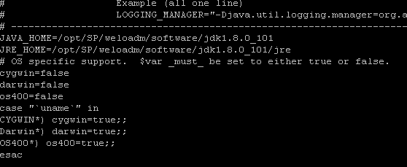

**Save and Exit.**

$ vi startup.sh

export JAVA_HOME=/usr/local/java

export JRE_HOME=/usr/local/jdk

**Save and Exit.**

$ vi $HOME/.bash_profile

export JAVA_HOME=/opt/SP/weloadm/software/jdk1.8.0_101

export JRE_HOME=/opt/SP/weloadm/software/jdk1.8.0_101/jre

export PATH=$PATH:/opt/SP/weloadm/software/jdk1.8.0_101/bin=/opt/SP/weloadm/software/jdk1.8.0_101/jre/bin

**Save and Exit**

1. **Startup Tomcat by using following command**:

$ cd opt/SP/weloadm/liferay-dxp-digital-enterprise-7.0-ga1/tomcat-8.0.32/bin

$ nohup ./startup.sh >> nohup.out &

1. To test if the application is started, go to the browser and give the following URL in the address bar:

http://<Application_Server>:7010/[NAV]

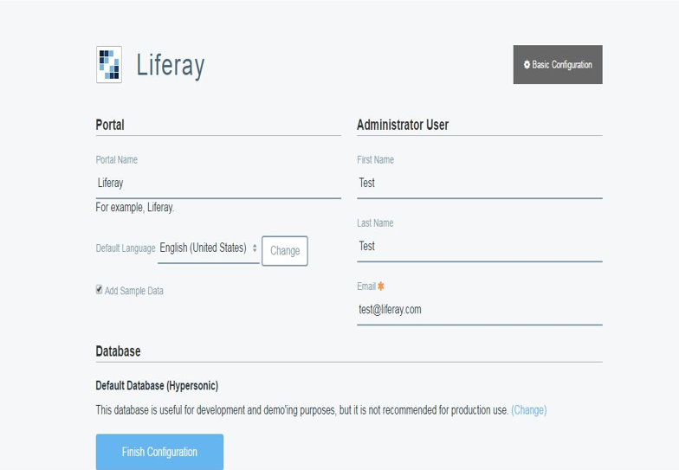

1. To shutdown the server and use the following command:

$ cd opt/SP/weloadm/liferay-dxp-digital-enterprise-7.0-ga1/tomcat-8.0.32/bin

$ ./shutdown.sh

**Configuration test:**

Run the configtest.sh script from to check the configurations are fine or not.

**$cd opt/SP/weloadm/liferay-dxp-digital-enterprise-7.0-ga1/tomcat-8.0.32/bin**

**$./configtest.sh**

# EHCACHE Setup and Configuration

1. Download the ehcache 2.10 software package from justshare.
2. Copy the package to the given location :

**$cd /opt/SP/weloadm/software**

1. Unzip the package and navigate to given location to check the available jar files:

**$cd /opt/SP/weloadm/software/ehcache-2.10.2/lib**

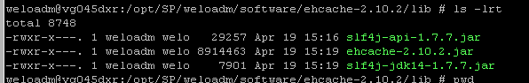

1. Navigate to the given location and edit the following file:

**$cd /opt/SP/weloadm/software/liferay-dxp-digital-enterprise-7.0-ga1/tomcat-8.0.32/bin**

**$vi setenv.sh**

Add the following to the file (EOF)

**CLASSPATH="$CLASSPATH:/opt/SP/weloadm/software/ehcache-2.10.2/lib/ehcache-2.10.2.jar:/opt/SP/weloadm/software/ehcache-2.10.2/lib/slf4j-api-1.7.7.jar:/opt/SP/weloadm/software/ehcache-2.10.2/lib/** **slf4j-jdk14-1.7.7.jar"**

NOTE: These files can be placed inside <<liferay>>/<<tomcat>>/lib folder as they are to be used by Liferay.

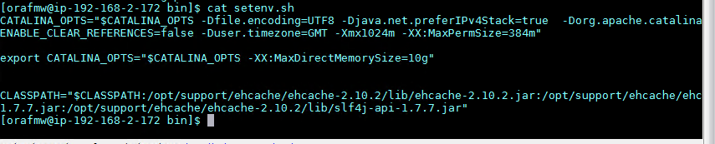

1. Find the below section in the ehcache.xml file under: /**opt/SP/weloadm/software/ehcache-2.10.2/** and edit with the following values.

|  |
| --- |
| <cache name="offheapCache"  maxEntriesLocalHeap="100000"  eternal="false"  timeToLiveSeconds="600"  maxBytesLocalOffHeap="4g"/>  </cache> |

1. Restart the server

**$cd /opt/SP/weloadm/software/liferay-dxp-digital-enterprise-7.0-ga1/tomcat-8.0.32/bin**

**$./startup.sh**

# Database configuration

1. Download ojdbc7.jar from /opt/SP/softwares/installables to and place file in liferay-dxp-digital-enterprise-7.0-ga1/tomcat-8.0.32/lib/ext
2. Open the liferay console on browser using the following URL:

http://<<ServerIP>>:7010

1. Click on the highlighted section, as given in screen below:

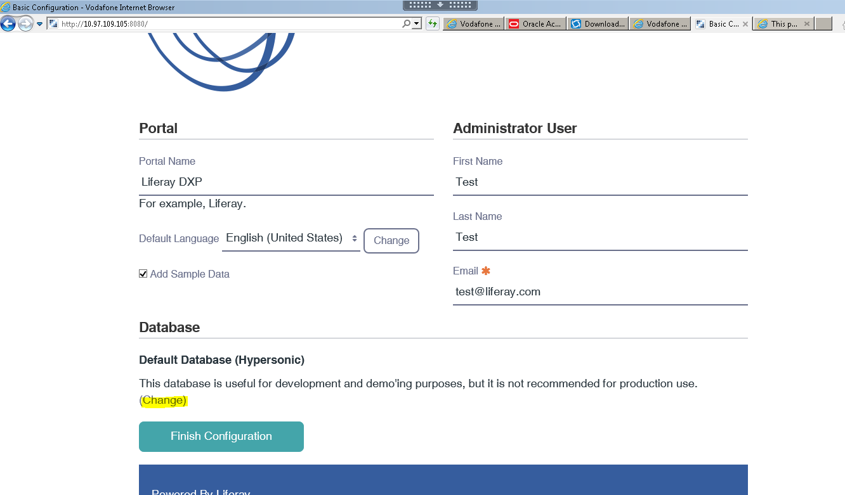

1. Select Oracle from the drop down section, as highlighted in the screenshot:

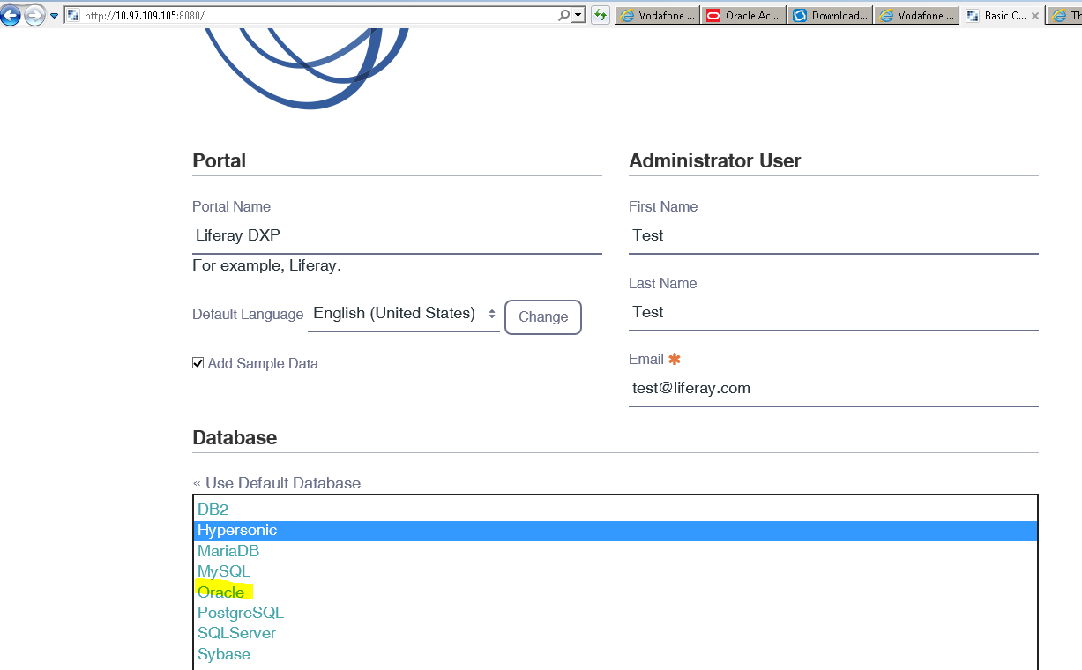

1. Database configuration details to be given in the liferay console in JDBC URL section :

**jdbc:oracle:thin:@(DESCRIPTION =(ADDRESS_LIST =(ADDRESS = (PROTOCOL = TCP)(HOST = vono31-32cl-scan.dc-dublin.de )(PORT = 33000))(LOAD_BALANCE = yes))(CONNECT_DATA =**

**(SERVER = DEDICATED)**

**(SERVICE_NAME = GOOPDEV_TAF.test.vis)**

**(FAILOVER_MODE =**

**(TYPE = SELECT)**

**(METHOD = BASIC)**

**(RETRIES = 180)**

**(DELAY = 5)**

**)**

**)**

**)**

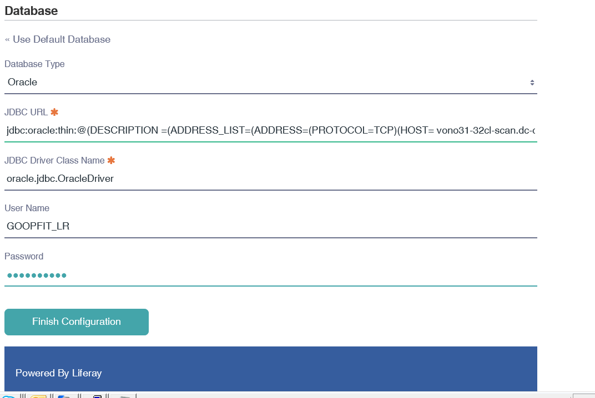

**Note:** Provide the username and password as per the environment.

1. The screen below shows successful configuration being saved in the **portal-setup-wizard.properties** file

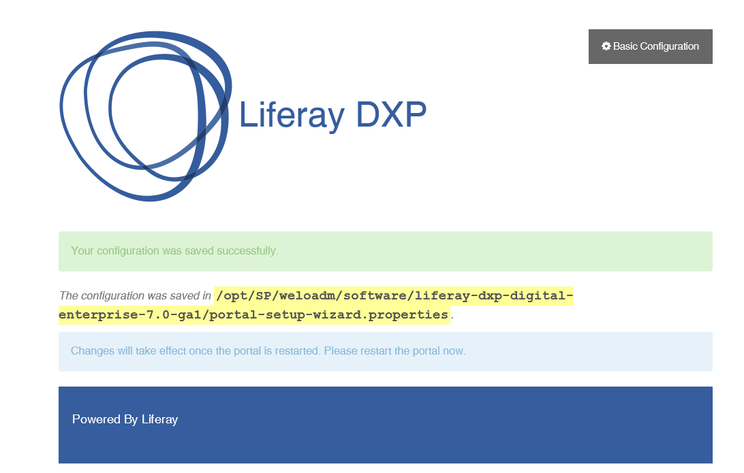

## Database configuration testing

Navigate to the below location and check if the configurations are saved, restart the server.

**$cd /opt/SP/weloadm/software/liferay-dxp-digital-enterprise-7.0-ga1**

**$vi portal-setup-wizard.properties**

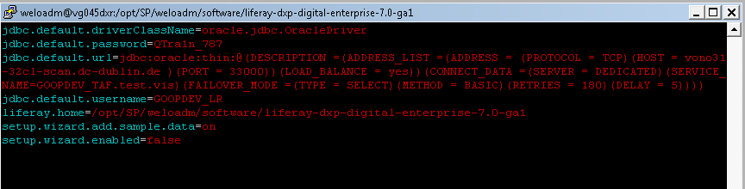

# AcTION Activities for liferay

# Installation of Java and liferay

# Liferay database configuration

# Liferay Tomcat threads configuration

**STEP CAN BE PERFORMED CONCURRENTLY ON ALL NODES**

1. Go to liferay-dxp-digital-enterprise-7.0-ga1/tomcat-8.0.32/conf and open the server.xml file and change the following configuration. Please add the below attributes in connector tag

|  |
| --- |
| ***maxThreads=“75“***  ***minSpareThreads=“50“*** |

For example the above configuration is done on lower environments as follows.

<Connector port="8080" protocol="HTTP/1.1"

               connectionTimeout="20000"

               redirectPort="8443" URIEncoding="UTF-8" maxThreads=“75“

minSpareThreads=“50“

/>

# Liferay Cluster properties

**STEP CAN BE PERFORMED CONCURRENTLY ON ALL CLUSTER NODES**

1. NAS Location

It requires a common NAS location for sharing the common data between the nodes. This needs to be in placed before starting the cluster setup,

Create a new file named “com.liferay.portal.store.file.system.configuration.AdvancedFileSystemStoreConfiguration.cfg” in below location

|  |  |
| --- | --- |
| # | $LIFERAY_HOME/osgi/configs/ |

And copy the below content to “com.liferay.portal.store.file.system.configuration.AdvancedFileSystemStoreConfiguration.cfg” file.

rootDir=<<Shared NAS Location>>/document_library

1. Required Jars

Vodafone Just share location which contains the below jar files.

|  |  |
| --- | --- |
| **Source Page** | <http://justshare.vodafone.com> |

* 1. ehcache.jar
  2. ehcache-jgroupsreplication.jar
  3. jgroups.jar

Download the (a, b, c) .jar files from the just share which is shared and place in below location of both nodes.

|  |  |
| --- | --- |
| # | $LIFERAY_HOME/tomcat-8.0.32/webapps/ROOT/WEB-INF/lib/ |

1. Open portal-setup-wizard.properties from $LIFERAY_HOME and add/update the below property highlighted in yellow.

|  |
| --- |
| admin.email.from.address=andre.neves@vodafone.com  admin.email.from.name=Andre Neves  jdbc.default.driverClassName=oracle.jdbc.OracleDriver  jdbc.default.password=XXXXXXXXXXXXXXX  jdbc.default.url=jdbc:oracle:thin:@(DESCRIPTION =(ADDRESS_LIST =(ADDRESS = (PROTOCOL = TCP)(HOST = vopo21hr-vip )(PORT = 33001))(LOAD_BALANCE = yes))(CONNECT_DATA =(SERVER = DEDICATED)(SERVICE_NAME=GOOPPROD.prod.vis)(FAILOVER_MODE =(TYPE = SELECT)(METHOD = BASIC)(RETRIES = 180)(DELAY = 5))))  jdbc.default.username=GOOPPROD_LR  liferay.home=/var/SP/weloadm/admin/liferay-dxp-digital-enterprise-7.0-ga1  setup.wizard.add.sample.data=off  setup.wizard.enabled=false  cluster.link.enabled=true  cluster.link.autodetect.address=vopo21hr-vip:33001  # Set the HTTP and HTTPs ports when running the portal in a J2EE server that  # is sitting behind another web server like Apache. Set the values to -1 if  # the portal is not running behind another web server like Apache.  #  web.server.http.port=  web.server.https.port=443  #  # Set the hostname that will be used when the portlet generates URLs.  # Leaving this blank will mean the host is derived from the servlet  # container.  web.server.host=cove.vodafone.com  #  # Set the preferred protocol.  #  web.server.protocol=https  web.socket.protocol=wss  web.socket.host=cove.vodafone.com  web.socket.port=443  rest.api.protocol=https  rest.api.host=cove.vodafone.com  rest.api.port=443  auto.login.hooks=uk.vodafone.portal.hook.autologin.AutoLoginHook  velocity.engine.resource.manager.cache.enabled=false  minifier.enabled=false  article.goop.config=propsconfig  article.user.config=userUtil  article.default.config=default  session.timeout=60  # Cluster Setup Properties  com.liferay.portal.servlet.filters.layoutcache.LayoutCacheFilter=true  com.liferay.portal.servlet.filters.audit.AuditFilter=false  com.liferay.portal.servlet.filters.sso.ntlm.NtlmFilter=false  com.liferay.portal.servlet.filters.sso.ntlm.NtlmPostFilter=false  com.liferay.portal.sharepoint.SharepointFilter=false  com.liferay.portal.servlet.filters.sso.opensso.OpenSSOFilter=false  com.liferay.portal.servlet.filters.sso.cas.CASFilter=false  com.liferay.portal.servlet.filters.etag.ETagFilter=true  com.liferay.portal.servlet.filters.strip.StripFilter=false  com.liferay.portal.servlet.filters.gzip.GZipFilter=false  theme.images.fast.load=true  rtlet.css.enabled=false  javascript.fast.load=true  theme.css.fast.load=true  velocity.engine.resource.manager.cache.enabled=true  session.tracker.memory.enabled=false  counter.increment=2000  counter.increment.com.liferay.portal.model.Layout=10  direct.servlet.context.reload=false  # Document Repository and Image Gallery  dl.store.impl=com.liferay.portal.store.file.system.AdvancedFileSystemStore  # Unicast related properties  web.server.display.node=true  cluster.link.node.bootup.response.timeout=1800000  cluster.link.channel.properties.control=/unicast.xml  cluster.link.channel.properties.transport.0=/unicast.xml  ehcache.bootstrap.cache.loader.factory=com.liferay.portal.cache.ehcache.JGroupsBootstrapCacheLoaderFactory  ehcache.cache.event.listener.factory=net.sf.ehcache.distribution.jgroups.JGroupsCacheReplicatorFactory  ehcache.cache.manager.peer.provider.factory=net.sf.ehcache.distribution.jgroups.JGroupsCacheManagerPeerProviderFactory  net.sf.ehcache.configurationResourceName.peerProviderProperties=file=/unicast.xml  ehcache.multi.vm.config.location.peerProviderProperties=file=/unicast.xml  live.users.enabled=true |

1. Enable Jvm route and cluster related in tomcat server.xml for load-balancing with AJP

|  |  |
| --- | --- |
| # | $LIFERAY_HOME/tomcat-8.0.32/conf/server.xml |

Section 1:

|  |
| --- |
| <Engine name="Catalina" defaultHost="localhost" jvmRoute="NODE2"> |

Section: 2

Update the cluster information inside Engine

|  |
| --- |
| <!--<Cluster className="org.apache.catalina.ha.tcp.SimpleTcpCluster"/>-->  <Cluster  channelSendOptions="8"  channelStartOptions="3"  className="org.apache.catalina.ha.tcp.SimpleTcpCluster">  <Manager  className="org.apache.catalina.ha.session.DeltaManager"  expireSessionsOnShutdown="false"  notifyListenersOnReplication="true"  />  <Channel className="org.apache.catalina.tribes.group.GroupChannel">  <Sender className="org.apache.catalina.tribes.transport.ReplicationTransmitter">  <Transport className="org.apache.catalina.tribes.transport.nio.PooledParallelSender" />  </Sender>  <Receiver  address="<<NODE IP>>"  autoBind="0"  className="org.apache.catalina.tribes.transport.nio.NioReceiver"  maxThreads="6"  port="4100"  selectorTimeout="5000"  />  <!-- <Interceptor className="com.dm.tomcat.interceptor.DisableMulticastInterceptor" /> -->  <Interceptor className="org.apache.catalina.tribes.group.interceptors.TcpPingInterceptor" staticOnly="true"/>  <Interceptor className="org.apache.catalina.tribes.group.interceptors.TcpFailureDetector" />  <Interceptor className="org.apache.catalina.tribes.group.interceptors.StaticMembershipInterceptor">  <Member  className="org.apache.catalina.tribes.membership.StaticMember"  port="4100"  host="<<Other Cluster NODE IP>>"  uniqueId="{0,0,0,0,0,0,0,0,0,0,0,0,0,0,1,2}"  />  <Member  className="org.apache.catalina.tribes.membership.StaticMember"  port="4100"  host="<<Other Cluster NODE IP>>"  uniqueId="{0,0,0,0,0,0,0,0,0,0,0,0,0,0,1,3}"  />  <Member  className="org.apache.catalina.tribes.membership.StaticMember"  port="4100"  host="<<Other Cluster NODE IP>>"  uniqueId="{0,0,0,0,0,0,0,0,0,0,0,0,0,0,1,4}"  />  </Interceptor>  <Interceptor className="org.apache.catalina.tribes.group.interceptors.MessageDispatch15Interceptor" />  </Channel>  <Valve  className="org.apache.catalina.ha.tcp.ReplicationValve"  filter=".*\.gif;.*\.js;.*\.jpg;.*\.png;.*\.htm;.*\.html;.*\.css;.*\.txt;"  />  <ClusterListener className="org.apache.catalina.ha.session.ClusterSessionListener" />  </Cluster> |

**Note: The member section from the above table need to be added as per the number of Nodes present in the cluster. (considered 4 NODE in above example)**

1. Create file called “unicast.xml “under below mentioned location

|  |  |
| --- | --- |
| # | $LIFERAY_HOME/tomcat-8.0.32/webapps/ROOT/WEB-INF/classes |

Copy the below content to unicast.xml.

**Note: this xml file is referring to portal-setup-wizard.properties file. Refer section LIFERAY CLUSTER PROPERTIES**

|  |
| --- |
| <config xmlns="urn:org:jgroups"          xmlns:xsi="<http://www.w3.org/2001/XMLSchema-instance>"          xsi:schemaLocation="urn:org:jgroups <http://www.jgroups.org/schema/JGroups-3.1.xsd>">      <TCP singleton_name="liferay"                   bind_port="7800"           loopback="true"           recv_buf_size="${tcp.recv_buf_size:20M}"           send_buf_size="${tcp.send_buf_size:640K}"                   discard_incompatible_packets="true"           max_bundle_size="64K"           max_bundle_timeout="30"           enable_bundling="true"           use_send_queues="true"           sock_conn_timeout="300"           timer_type="old"           timer.min_threads="4"           timer.max_threads="10"           timer.keep_alive_time="3000"           timer.queue_max_size="500"           thread_pool.enabled="true"           thread_pool.min_threads="1"           thread_pool.max_threads="10"           thread_pool.keep_alive_time="5000"           thread_pool.queue_enabled="false"           thread_pool.queue_max_size="100"           thread_pool.rejection_policy="discard"           oob_thread_pool.enabled="true"           oob_thread_pool.min_threads="1"           oob_thread_pool.max_threads="8"           oob_thread_pool.keep_alive_time="5000"           oob_thread_pool.queue_enabled="false"           oob_thread_pool.queue_max_size="100"           oob_thread_pool.rejection_policy="discard"/>      <TCPPING timeout="3000"               initial_hosts="${jgroups.tcpping.initial_hosts: =<<NODE IP>>[7800],<<Other NODE IP>>[7800], <<Other NODE IP>>[7800], <<Other NODE IP>>[7800]}"               port_range="1"               num_initial_members="10"/>      <MERGE2  min_interval="10000"               max_interval="30000"/>      <FD_SOCK/>      <FD timeout="3000" max_tries="3" />      <VERIFY_SUSPECT timeout="1500"  />      <BARRIER />      <pbcast.NAKACK2 use_mcast_xmit="false"                     discard_delivered_msgs="true"/>      <UNICAST />      <pbcast.STABLE stability_delay="1000" desired_avg_gossip="50000"                     max_bytes="4M"/>      <pbcast.GMS print_local_addr="true" join_timeout="3000"                  view_bundling="true"/>      <UFC max_credits="2M"           min_threshold="0.4"/>      <MFC max_credits="2M"           min_threshold="0.4"/>      <FRAG2 frag_size="60K"  />      <!--RSVP resend_interval="2000" timeout="10000"/-->      <pbcast.STATE_TRANSFER/>  </config> |

1. Changes in web.xml.

Navigate to the below location

|  |  |
| --- | --- |
| # | $LIFERAY_HOME/tomcat-8.0.32/webapps/ROOT/WEB-INF/web.xml |

Add <distributable/> tag in tomcat web.xml file just before </web-app>.

1. Changes in setenv.sh file.

Navigate to the below location

|  |  |
| --- | --- |
| # | $LIFERAY_HOME/tomcat-8.0.32/bin |

Add the following to the setenv.sh at the end of CATALINA_OPTS

|  |
| --- |
| -Djgroups.bind_addr=<<NODE IP>> -Djgroups.tcpping.initial_hosts=<<NODE IP>>[7800],<<Other NODE IP>>[7800], <<Other NODE IP>>[7800], <<Other NODE IP>>[7800] |

# Renewal of liferay licenses

This step need to be performed only if required to update the existing licenses or for the first time installation. If there is already a valid license present in the environment on which this installation is being done, then there is no need to perform this step.

* Stop the Liferay application server
* Delete the contents of the ${liferay.home}/osgi/state folder if present
* Start the application server
* Place the activation key xml file in the Liferay deploy directory (${auto.deploy.deploy.dir} , which defaults to ${liferay.home}/deploy)
* Wait for the activation key file to be auto-deployed
* Proceed to using Liferay DXP