

GOOP-OHS/Webgate Installation & Integration
Author: | GOOP Infra Team
Version: | 0.1
Date Issued: | 08/15/2016

Contents
1. Document Control 3
2. Introduction 4
3. Prerequisites 4
3.1 Editing limits.conf 4
3.2 Setup Kernel Parameters 4
3.3 Reload sysctl for the changes to take effect. 4
3.4 Required Libraries 4
3.5 Creating Folder Structure 5
3.5.1 Create folders by executing the below commands 5
3.5.2 Change ownership and group 5
3.6 Software Availability 6
3.7 Java Installation 6
3.7.1 Download JAVA jdk1.8.0_101 software from Just share which is shred and place in below location 6
3.7.2 Install Java with Alternatives 6
3.7.3 Check Installed Java Version using below command. 6
4. Oracle HTTP Server Installation 7
5. Creating OHS Instance 14
6. Verification and Restart of OHS instance 20
7. OHS instance Configuration 20
8. Webgate Installation 22
9. Integrating Webgate with OHS 28
9.1 Configuring Webgate in OHS 28
9.2 Implementation of Security Patches in OHS 30
9.3 Implementation of Bundle Patch in Webgate 31
9.4 OHS Wallet Creation (Only for SSL Enabled Environments (https)) 32
10. Resource List 38
11. Sanity Testing 39

Document Control

Version | Date | Author | Department | Comment
Draft 1.0 | 10/08/2016 | Rajanikanth Bollam | GOOP INFRA Team (VirtusaPolaris) | Initial Draft version
0.1 | 14/10/2016 | Rajanikanth Bollam | GOOP INFRA Team (VirtusaPolaris) | Added pre-requisites into the document  Added OHS installation & Instance creation  Added Java Installation  Added webgate installation and integrating with OHS configurations  Revised for adding Software Install locations and formatted document

Reviewer | Department | Version | Comment

Introduction
This document is intended towards the installation & configuration steps for OHS and Webgate integration which need to be performed by the team responsible for installing the software on the integrated application infrastructure on respective environments.

Prerequisites

3.1 Editing limits.conf
Open the following file using vi editor while logged in as a root user:
Note: Add or amend the below entries
#sudo su -
#vi /etc/security/limits.conf

Enter the following va006Cues just before “# End of file”

wwwadm soft nproc 2047
wwwadm hard nproc 16384
wwwadm soft nofile 4096
wwwadm hard nofile 65536
wwwadm soft stack 10240

Save the file...

3.2 Setup Kernel Parameters
Open the following file using vi editor while logged in as a root user:
Note: Add or amend the below entries
# vi /etc/sysctl.conf

kernel.sem = 256 32000 100 142
kernel.shmmax = 10737418240

Save the file...

3.3 Reload sysctl for the changes to take effect.
Execute the below command while logged in as a root user
# | sysctl -p /etc/sysctl.conf

3.4 Required Libraries
Execute the following commands while logged in as a root user:
Note: Type ‘y’ and press Enter whenever prompted. If already installed, then ignore. If below versions are not found, please install the latest version for that OS
# | yum install binutils-2.20.51.0.2-5.28.el6
# | yum install compat-libcap1-1.10-1
# | yum install compat-libstdc++-33-3.2.3-69.el6
# | yum install compat-libstdc++-33-3.2.3-69.el6.i686
# | yum install gcc-4.4.4-13.el6
# | yum install gcc-c++-4.4.4-13.el6
# | yum install glibc-2.12-1.7.el6
# | yum install glibc-2.12-1.7.el6.i686
# | yum install glibc-devel-2.12-1.7.el6.i686
# | yum install libaio-0.3.107-10.el6
# | yum install libaio-devel-0.3.107-10.el6
# | yum install libgcc-4.4.4-13.el6
# | yum install libstdc++-4.4.4-13.el6
# | yum install libstdc++-4.4.4-13.el6.i686
# | yum install libstdc++-devel-4.4.4-13.el6
# | yum install libXext.i686
# | yum install libXtst.i686
# | yum install libXext
# | yum install libXtst
# | yum install openmotif-2.2.3
# | yum install openmotif22-2.2.3
# | yum install redhat-lsb-core-4.0-7.el6
# | yum install sysstat-9.0.4-11.el6
# | yum install xorg-x11-utils*
# | yum install xorg-x11-apps*
# | yum install xorg-x11-xinit*
# | yum install xorg-x11-server-Xorg*
# | yum install xterm

3.5 Creating Folder Structure

3.5.1 Create folders by executing the below commands
# | mkdir -p /opt/SP/wwwadm/software
# | mkdir -p /opt/SP/wwwadm/installables
# | mkdir -p /opt/SP/wwwadm/software/ohs

3.5.2 Change ownership and group
Execute the following commands
# | cd /opt/SP/wwwadm
# | chown -R wwwadm wwwadm
# | chgrp -R www wwwadm

3.6 Software Availability

Source Page | http://justshare.vodafone.com

3.7 Java Installation

3.7.1 Download JAVA jdk1.8.0_101 software from Just share which is shred and place in below location
# | /opt/SP/wwwadm/software

3.7.2 Install Java with Alternatives
# | Unzip jdk-8u101-linux-i586.tar.gz
# | cd /opt/SP/wwwadm/software/jdk1.8.0_101/
# | alternatives --install /usr/bin/java java /opt/jdk1.8.0_101/bin/java 2
# | alternatives --config java

It asks for the java selection

Selection Command
-----------------------------------------------
- /opt/SP/wwwadm/software/jdk1.8.0_101/bin/java

Enter to keep the current selection[+], or type selection number: 1

# | alternatives --install /usr/bin/jar jar /opt/SP/wwwadm/software/jdk1.8.0_101/bin/jar 2
# | alternatives --install /usr/bin/javac javac /opt/SP/wwwadm/software/jdk1.8.0_101/bin/javac 2
# | alternatives --set jar /opt/SP/wwwadm/software/jdk1.8.0_101/bin/jar
# | alternatives --set javac /opt/SP/wwwadm/software/jdk1.8.0_101/bin/javac

3.7.3 Check Installed Java Version using below command.
# | java -version

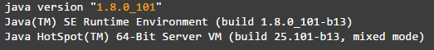

Oracle HTTP Server Installation
- Download ofm_webtier_linux_11.1.1.7.0_64_disk1_1of1.zip software from Just share which is shred and place in below location
# | /opt/SP/wwwadm/software

- Refer the following commands to install the suite while logged in as wwwadm user:
Step01: Execute Installer

# | cd /opt/SP/wwwadm/software
# | unzip ofm_webtier_linux_11.1.1.7.0_64_disk1_1of1.zip
# | unzip p18231786_111220_Generic.zip
# | cp refhost.xml /opt/SP/wwwadm/software/Disk1/stage/prereq/linux64
# | cd /opt/SP/wwwadm/software/Disk1
# | ./runInstaller

The script will prompt for a JRE location. Please specify JRE/JDK location (E.g. /opt/SP/wwwadm/software/jdk1.8.0_101/) on your Web Server. Note: that “/bin/java” should exist on this directory.
For Inventory Directory, provide the below mentioned location
Inventory Directory | /opt/SP/wwwadm/software/OraInventory
Group name | www

Click Ok.
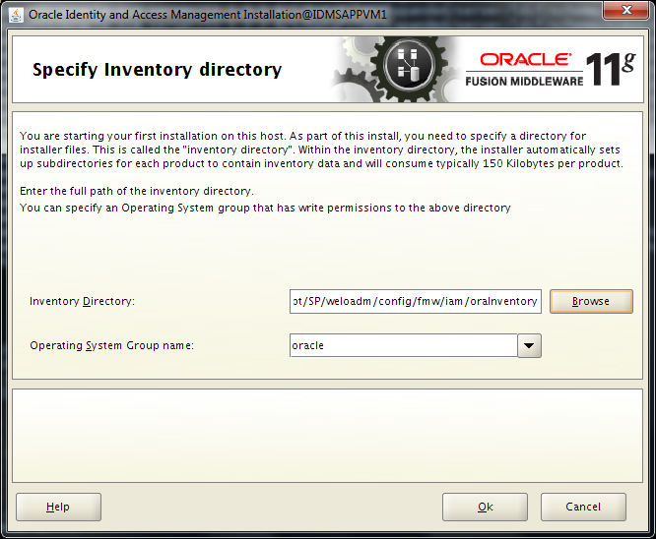

For Inventory Location Confirmation Dialog, check “Continue Installation with local inventory”, and click Ok.

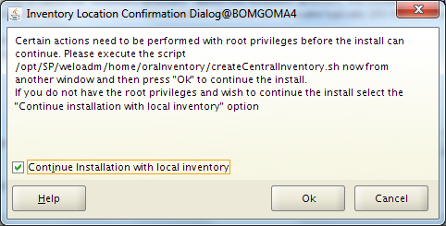

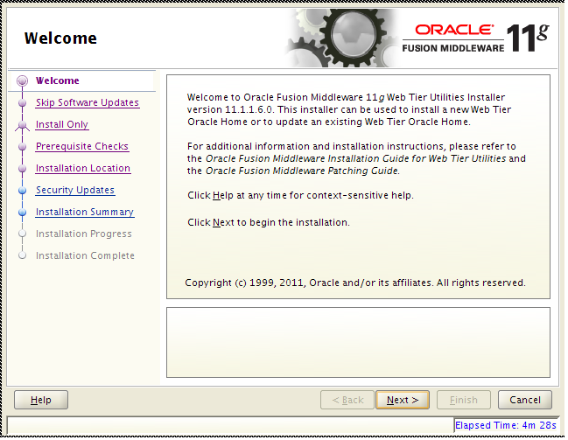
Step02: Click Next
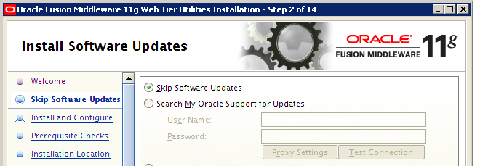
Step03: Skip Software Updates and Click Next

.

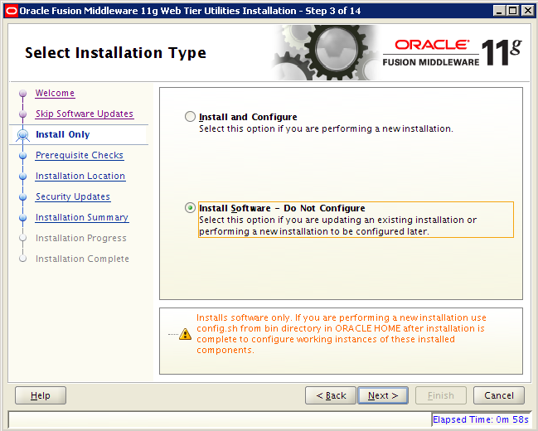
Step03: Select ‘Install Software – Do Not Configure’ and Click Next
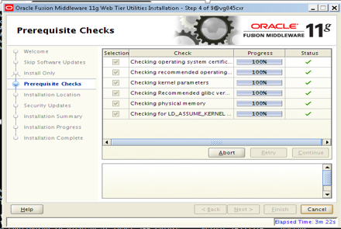
Step04: Click on Next once Prcerequisites checks is done with out any warnings

Step05: Specify Installation Location
Oracle Middleware Home | /opt/SP/wwwadm/software/ohs
Oracle Home Directory | Oracle_WT1

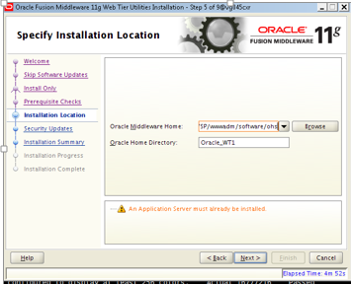
Step06: Uncheck “I wish to receive security updates via My Oracle Support” and click Next
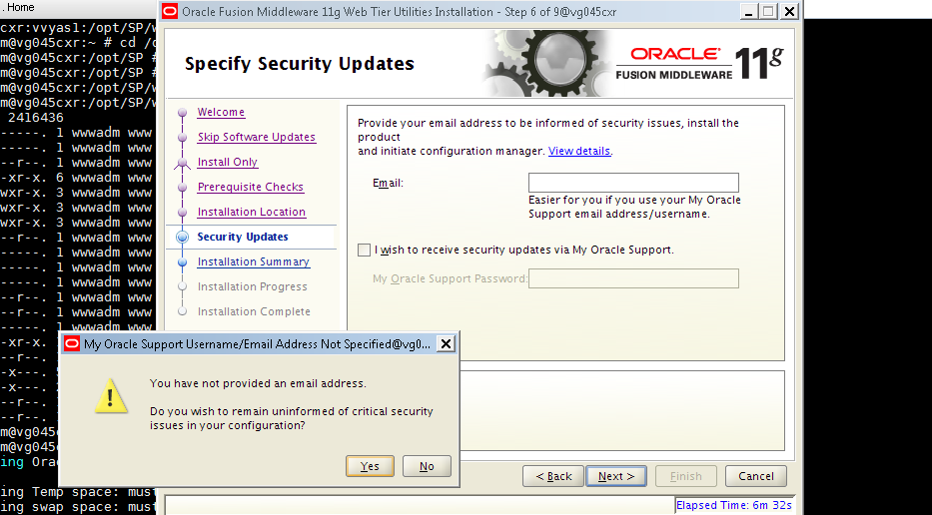
Step07: In the next Confirmation Dialog, click Yes

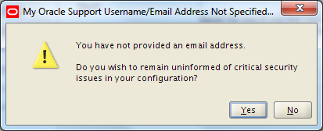

Step08: Verify the Installation Summary and save the rsp file (ex: webserver.rsp) in below mentioned location for future references. And click Install

# | /opt/SP/wwwadm/home

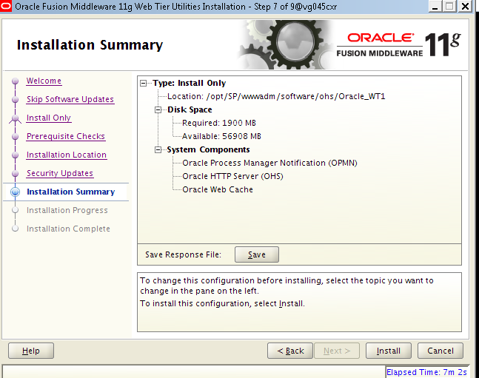
Step09: When the Installation Progress is complete, click Next

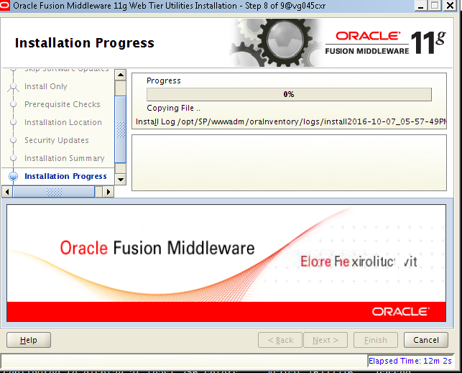

Step10: When Installation is complete save the rsp file (ex: OHS_Installation_successful.rsp) under below mentioned location for future references. And click Finish
# | /opt/SP/wwwadm/home

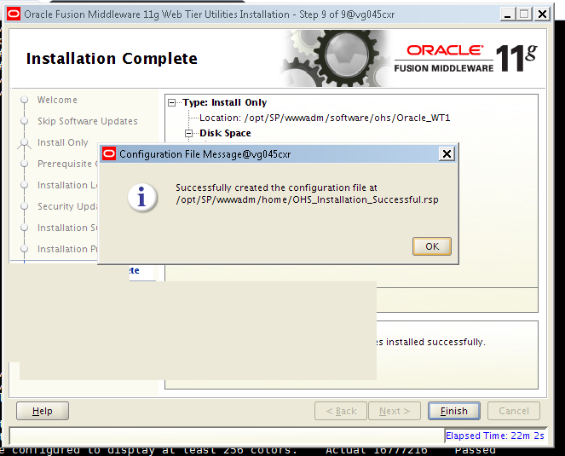

Creating OHS Instance

- Edit the port details in staticports.ini for the instance creation
# | cp /opt/SP/wwwadm/installables/Disk1/stage/Response/staticports.ini /opt/SP/wwwadm/home
# | cd /opt/SP/wwwadm/home
# | #vi staticports.ini

OPMN local port | 6700
OPMN Remote port | 6701
OHS | 8080
OHS proxy port | 8889
OHS SSL port | 4443

Sample staticports.ini file: Update ports which are highlighted below for installation –
#######################################################################################
#This file is a template file for staticports.ini
#This file must be edited to provide the ports which required to be set
#Those ports which are not provided explicitly in this file will be assigned automatically
#The ports should be specified as a single port
#Keep in mind to uncomment the port no
#######################################################################################
########################Begin section for OPMN Port No################################
######################################################################################
[OPMN]
#This port indicates the OPMN Local Port
OPMN Local Port = 6700
#This port indicates the OPMN Remote Port
OPMN Remote Port = 6701
########################Begin section for ohs component################################
#This port nos will be considered only if OHS is selected for configuration
#######################################################################################

[OHS]
#The http_main port for ohs component
OHS Port = 8080
#This port indicates the OHS Proxy Port
OHS Proxy Port = 8889
#This port indicates the OHS SSL Port
OHS SSL Port = 4443
########################Begin section for Web Cache component################################
#This port nos will be considered only if Web Cache is selected for configuration
######################################################################################
[WEBCACHE]
#The port indicates the Web Cache Listen Port
#Web Cache Listen Port = 7777
#The port indicates the Web Cache Admin Port
#Web Cache Admin Port = 7778
#The port indicates the Web Cache Statistics Port
#Web Cache Statistics Port = 7779
#The port indicates the Web Cache Invalidation Port
#Web Cache Invalidation Port = 7780
#The port indicates the Web Cache SSL Port
#Web Cache SSL Port = 7781

Step01: Run the config.sh

# | cd /opt/SP/wwwadm/software/ohs/Oracle_WT1/bin
# | ./config.sh

The script will prompt for a JRE location. Please specify JRE/JDK location (E.g. /opt/SP/wwwadm/software/jdk1.8.0_101/) on your Web Server. Note: that “/bin/java” should exist on this directory.
After providing it prompts to below welcome screen.
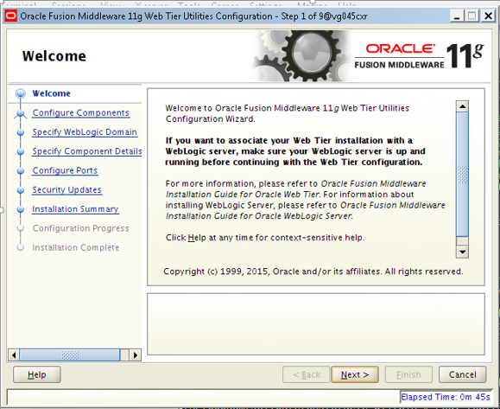

Step02: Click Next
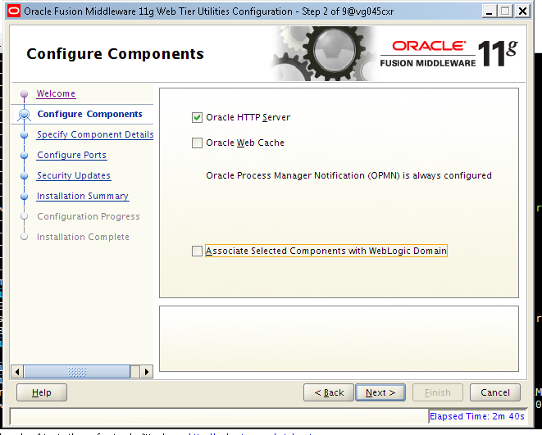
Step03: Select only ‘Oracle HTTP Server’ from the available list of components to configure and click next

Step04: Provide the Instance Home Location, OHS Instance Name and OHS Component name (instance name is referred here for DEV environment, this is environment specific) and click Next
OHS Instance Home | /opt/SP/wwwadm/software/ohs/Oracle_WT1/instances/goop-dev
OHS Instance Name | goop-dev

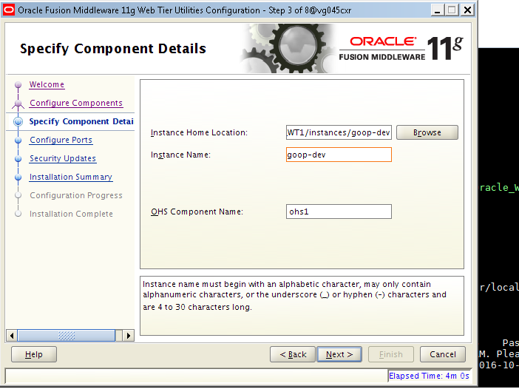

Step05: Select the option of Specify Ports using Configuration file and enter the staticports.ini file location as shown below and click on Next.
# | cd /opt/SP/wwwadm/home/staticports.ini

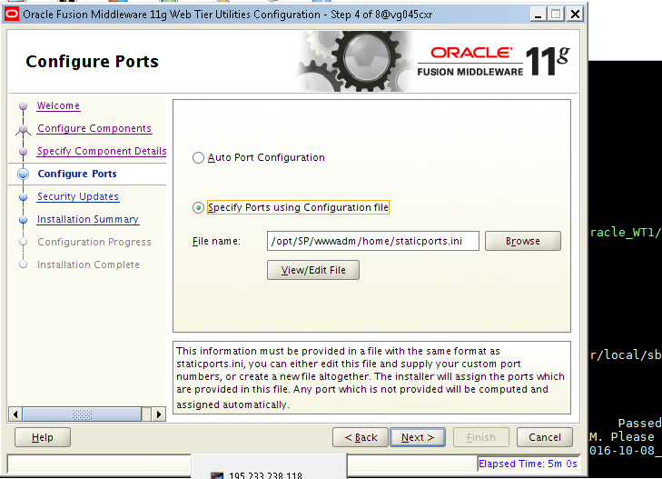

Step05: Uncheck “I wish to receive security updates via My Oracle Support” and click Next

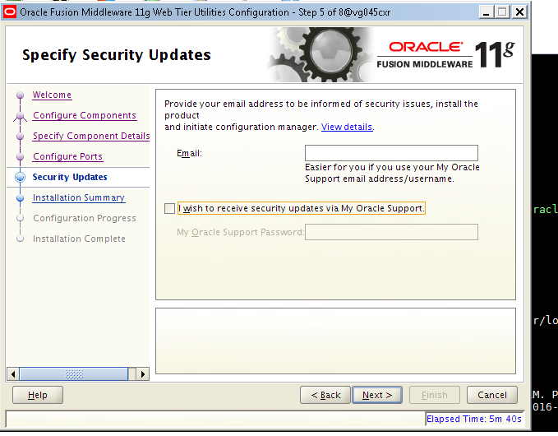

Step06: In the next Confirmation Dialog, click Yes

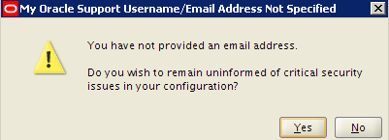

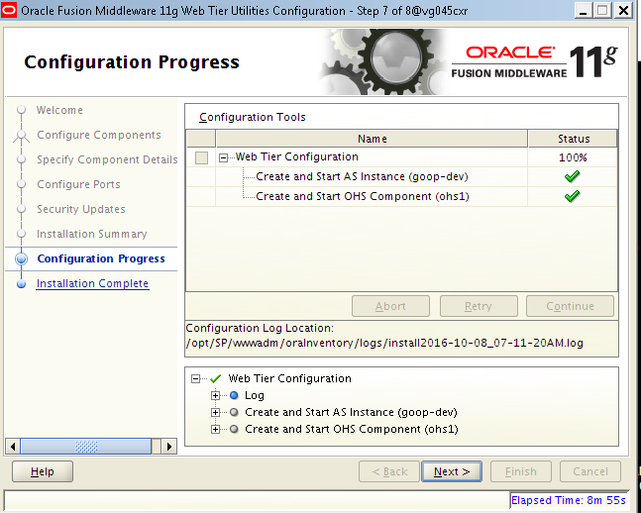
Step07: Click on next once after the configuration is completed

- Click on Finish to complete the OHS11G configurati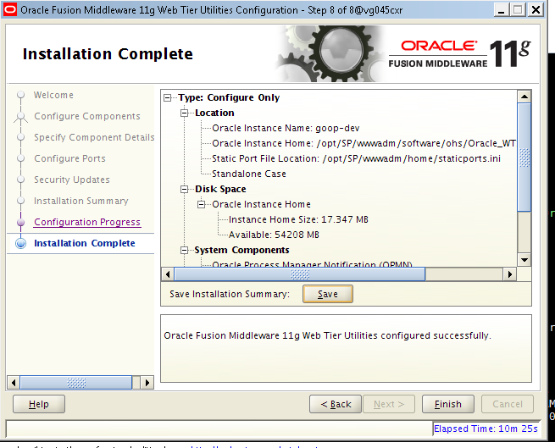
Step08: Verify the Installation Summary and save the rsp file (ex: webserver_config.rsp) in below mentioned location for future references. And click Finish
# | /opt/SP/wwwadm/home

Verification and Restart of OHS instance

# | cd /opt/SP/wwwadm/software/ohs/Oracle_WT1/instances/goop-dev/bin
# | ./opmnctl stopall
# | ./opmnctl startall
# | ./opmnctl status
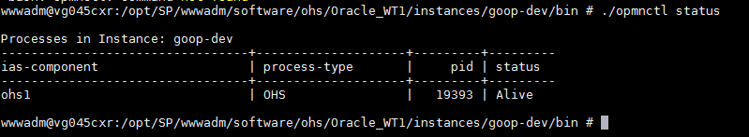

OHS instance Configuration
Follow the below configuration steps to enable the load balancing in web server using proxy.
# | cd /opt/SP/wwwadm/software/ohs/Oracle_WT1/instances/goop-dev/config/OHS/ohs1/moduleconf
# | vi tccluster.conf

Sample tccluster.conf file: Update the application IP and port details which are highlighted below for installation –
<Location /balancer-manager>
SetHandler balancer-manager
Order allow,deny
Allow from all
</Location>
Header add Set-Cookie "ROUTEID=goop.%{BALANCER_WORKER_ROUTE}e; path=/" env=BALANCER_ROUTE_CHANGED
<Proxy balancer://TCcluster>
BalancerMember http://10.97.34.122:8080 route=NODE1
BalancerMember http://10.97.34.123:8080 route=NODE2
ProxySet stickysession=ROUTEID
ProxySet lbmethod=byrequests
ProxySet nofailover=OFF
</Proxy>
#Do not proxy balancer-manager
ProxyPass /balancer-manager !
######Context roots to be load balanced #######
<Location /web/goop>
ProxyPass balancer://TCcluster/web/goop
ProxyPassReverse balancer://TCcluster/web/goop
RequestHeader unset Accept-Encoding
Order allow,deny
Allow from all
</Location>

Webgate Installation
- Download ofm_webgates_generic_11.1.2.3.0_disk1_1of1.zip software from Just share which is shred and place in below location
# | /opt/SP/wwwadm/installables
- Refer the following commands to install the suite while logged in as wwwadm user:
Step01: Execute Installer
# | cd /opt/SP/wwwadm/installables
# | unzip ofm_webgates_generic_11.1.2.3.0_disk1_1of1.zip
# | cp /opt/SP/wwwadm/software/ p18231786_111220_Generic/refhost.xml /opt/SP/wwwadm/installables/Disk1/stage/prereq/linux64
# | cd /opt/SP/wwwadm/software/Disk1
# | ./runInstaller
The script will prompt for a JRE location. Please specify JRE/JDK location (E.g. /opt/SP/wwwadm/software/jdk1.8.0_101/) on your Web Server. Note: that “/bin/java” should exist on this directory.
Step02: If Prompted, For Inventory Directory, provide the below mentioned location in table, and click on Ok.
For Inventory Directory, provide the below mentioned location
Inventory Directory | /opt/SP/wwwadm/software/OraInventory
Group name | www
Click Ok.For Inventory Location Confirmation Dialog, check “Continue Installation with local inventory”, and click Ok.

Step03: Click on Next in the Welcome Screen.

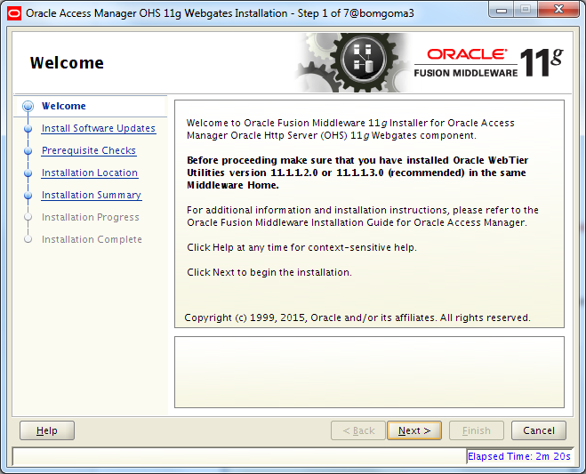

Step04: Click on Next in the Welcome Screen. Select Skip Software Updates and click on Next.
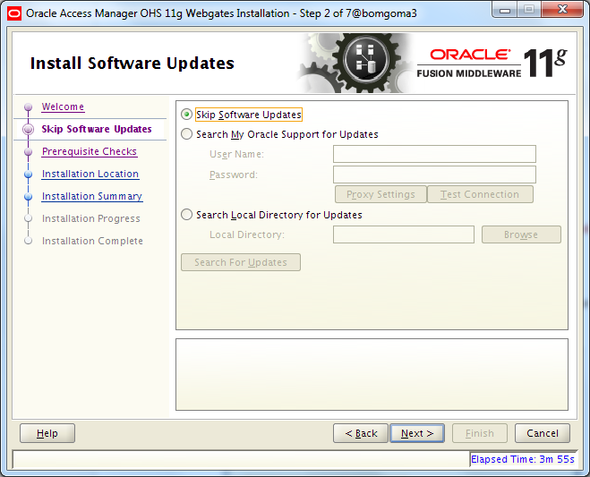

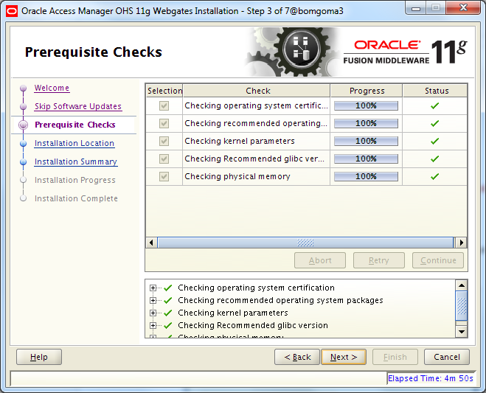
Step05: After Pre-Requisite Checks are over, click on Next

Step06: Specify Installation Location, and click on Next.

Oracle Middleware Home | /opt/SP/wwwadm/software/ohs
Oracle Home Location | /opt/SP/wwwadm/software/ohs/webgate

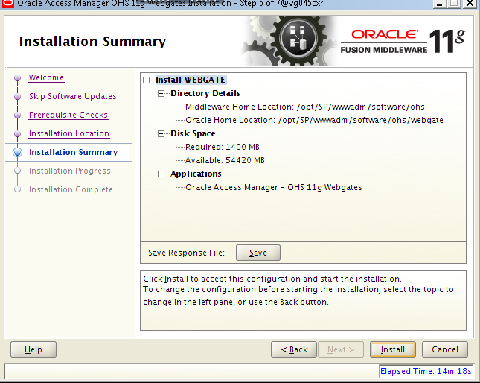
Step07: Verify the Installation Summary and save the rsp file (ex: webgate.rsp) in below mentioned location for future references. And click Install

# | /opt/SP/wwwadm/home

Step08: Click Next
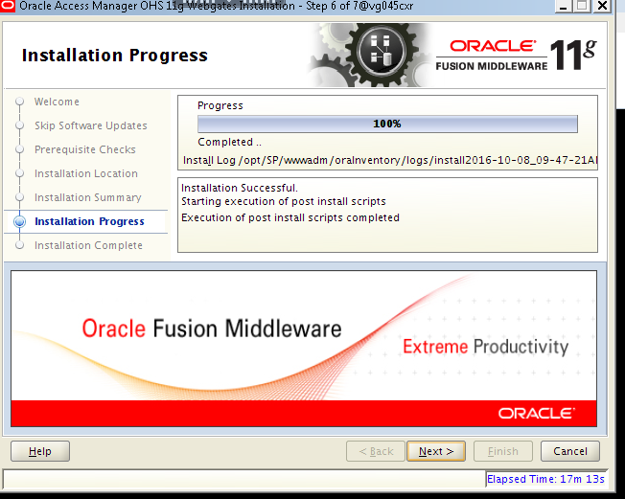

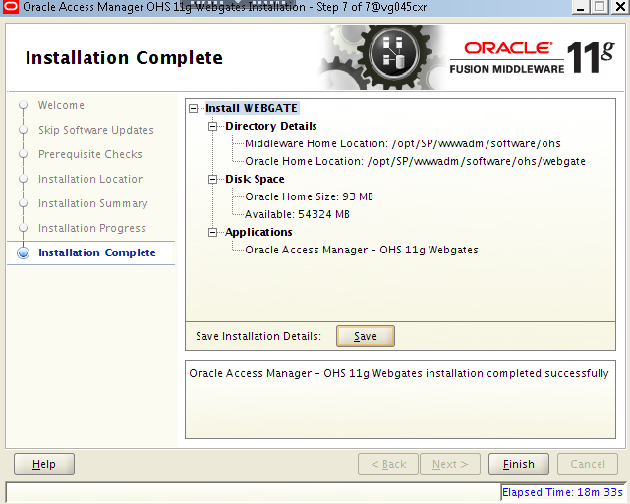
Step08: Verify the Installation Summary and save the rsp file (Ex: webgate_install_success.rsp) in below mentioned location for future references. And click Finish

# | /opt/SP/wwwadm/home

Integrating Webgate with OHS

9.1 Configuring Webgate in OHS

- Execute the below commands while logged in as wwwadm user:
# | cd /opt/SP/wwwadm/software/ohs/webgate/webgate/ohs/tools/deployWebGate
# | ./deployWebGateInstance.sh -w /opt/SP/wwwadm/software/ohs/Oracle_WT1/instances/goop-dev/config/OHS/ohs1 -oh /opt/SP/wwwadm/software/ohs/webgate
# | export LD_LIBRARY_PATH=$LD_LIBRARY_PATH:/opt/SP/wwwadm/software/ohs/ Oracle_WT1/lib
# | cd /opt/SP/wwwadm/software/ohs /webgate/webgate/ohs/tools/setup/InstallTools
# | ./EditHttpConf -w /opt/SP/wwwadm/software/ohs/Oracle_WT1/instances/goop-dev /config/OHS/ohs1 -oh /opt/SP/wwwadm/software/ohs/webgate

- Copy the artifact files to below mentioned location. (I believe the artefacts are already provided): (
# | /opt/SP/wwwadm/software/ohs/Oracle_WT1/instances/goop-dev/config/OHS/ohs1/webgate/config

PFB screen shot for the reference.
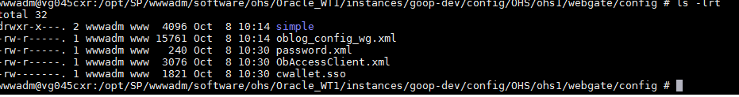

- Execute the below commands while logged in as wwwadm user to restart the OHS instance:
# | cd /opt/SP/wwwadm/software/ohs/Oracle_WT1/instances/goop-dev/bin
# | ./opmnctl stopall
# | ./opmnctl startall
# | ./opmnctl status

9.2 Implementation of Security Patches in OHS

- Download p21461025_111190_Linux-x86-64.zip, p21663064_111190_Linux-x86-64.zip, p21118593_111230_Linux-x86-64.zip packages from Just share which is shred and place in below location
# | /opt/SP/wwwadm/software

- Execute the below commands while logged in as wwwadm:
NOTE- Shut down all OHS instances before executing the below steps

# | cd /opt/SP/wwwadm/software/ohs/Oracle_WT1/instances/goop-dev/bin
# | ./opmnctl stopall
# | cd /opt/SP/wwwadm/software
# | unzip p21461025_111190_Linux-x86-64.zip
# | cd 21461025
# | export ORACLE_HOME=/opt/SP/wwwadm/software/ohs/Oracle_WT1
# | export MW_HOME=/opt/SP/wwwadm/software/ohs
# | export JAVA_HOME=/opt/SP/wwwadm/software/jdk1.8.0_101/
# | /opt/SP/wwwadm/software/ohs/Oracle_WT1/OPatch/opatch apply -jdk /opt/SP/wwwadm/software/jdk1.8.0_101
# | When Prompted for Email Address, leave blank
# | Confirm to ignore security updates
# | Confirm with ‘y’ to apply patch
# | cd /opt/SP/wwwadm/software
# | unzip p21663064_111190_Linux-x86-64.zip
# | cd 21663064
# | /opt/SP/wwwadm/software/ohs/Oracle_WT1/OPatch/opatch apply -jdk /opt/SP/wwwadm/software/jdk1.8.0_101
# | When Prompted for Email Address, leave blank
# | Confirm to ignore security updates
# | Confirm with ‘y’ to apply patch

9.3 Implementation of Bundle Patch in Webgate

- Execute the below commands while logged in as wwwadm:
NOTE- Shut down all OHS instances before executing the below steps

# | cd /opt/SP/wwwadm/software
# | unzip p21118593_111230_Linux-x86-64.zip
# | cd 21118593
# | export ORACLE_HOME=/opt/SP/wwwadm/software/ohs/webgate
# | export MW_HOME=/opt/SP/wwwadm/software/ohs
# | export JAVA_HOME=/opt/SP/wwwadm/software/jdk1.8.0_101
# | /opt/SP/wwwadm/software/ohs/webgate/OPatch/opatch apply -jdk /opt/SP/wwwadm/software/jdk1.8.0_101
# | When Prompted for Email Address, leave blank
# | Confirm to ignore security updates
# | Confirm with ‘y’ to apply patch

- Start all the OHS instance after Patch has been applied properly.
# | cd /opt/SP/wwwadm/software/ohs/Oracle_WT1/instances/goop-dev/bin
# | ./opmnctl startall
# | ./opmnctl status

9.4 OHS Wallet Creation (Only for SSL Enabled Environments (https))

- Execute the following commands while logged in as wwwadm user:
# | cd /opt/SP/wwwadm/home
# | mkdir certificates
# | mkdir keystores
# | cd certificates
# | mkdir goopdevtmp.vodafone.com
# | cd /opt/SP/wwwadm/home/keystores
# | mkdir goopdevtmp.vodafone.com

- Move the certificate file and private key files into their corresponding folders as mentioned in below table:

CERTIFICATE / PRIVATE KEY FILE | DESTINATION LOCATION
goopdevtmp.vodafone.com.cert  goopdevtmp.vodafone.com.key | /opt/SP/wwwadm/home/certificates/goopdevtmp.vodafone.com

- Execute the following commands while logged in as wwwadm user to encrypt the private keys:
# | cd /opt/SP/wwwadm/software/ohs/webgate/webgate/ohs/tools/openssl
# | ./openssl rsa -in /opt/SP/wwwadm/home/certificates/goopdevtmp.vodafone.com/ PrivateKey.key -passin pass: -out /opt/SP/wwwadm/home/certificates/ goopdevtmp.vodafone.com/ PrivateKey.key -passout pass:<<Password>> -des

- Create a CA Trust certificates chain file named aaa_chain.pem in the location below:

/opt/SP/wwwadm/home/certificates/aaa_chain.pem

The content of the file should be as below:

-----BEGIN CERTIFICATE-----

*****Content of Vodafone (Corporate Services 2009) Certificate*****

-----END CERTIFICATE-----
-----BEGIN CERTIFICATE-----

*****Content of Vodafone (Corporate Domain 2009) Certificate*****

-----END CERTIFICATE-----
-----BEGIN CERTIFICATE-----

*****Content of BaltimoreCyberTrustRoot Certificate*****

-----END CERTIFICATE-----

- Execute the following commands while logged in as wwwadm user to create pkcs12 files:

# | cd /opt/SP/wwwadm/software/ohs/webgate/webgate/ohs/tools/openssl
# | ./openssl pkcs12 -export -in /opt/SP/wwwadm/home/certificates/ goopdevtmp.vodafone.com/ goopdevtmp.vodafone.com.cert_*.crt -inkey /opt/SP/wwwadm/home/certificates/ goopdevtmp.vodafone.com/PrivateKey.key -certfile /opt/SP/wwwadm/home/certificates/aaa_chain.pem -out /opt/SP/wwwadm/home/keystores/ goopdevtmp.vodafone.com/ewallet.p12

- Execute the below steps while logged in as wwwadm user to set Auto Login for the OHS wallet:

# | cd /opt/SP/wwwadm/software/ohs/ Oracle_WT1/bin
# | ./owm

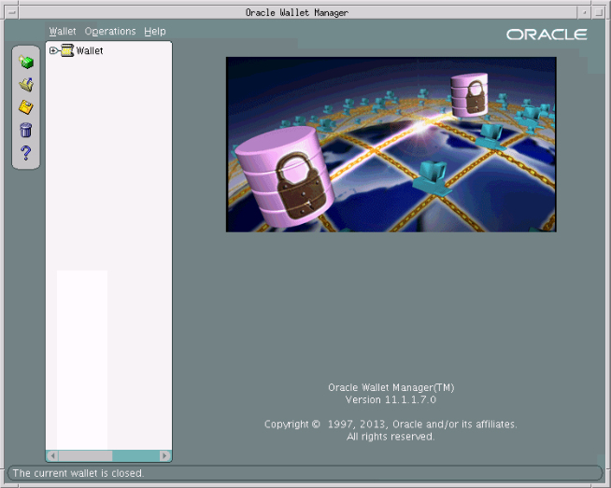

Step01: Click on "Wallet" tab and then click on "Open"

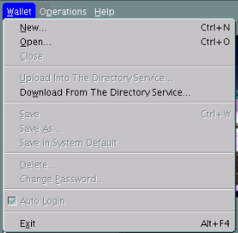

Step02: When the below prompt pops up, ignore and click on "Yes"

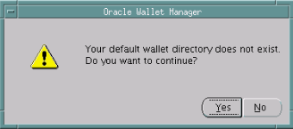

Step03: In the "Select Directory" window, select the wallet from the below location and click on "OK":

# | /opt/SP/wwwadm/home/keystores/goopdevtmp.vodafone.com

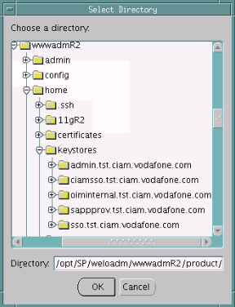

Step04: Enter the credentials for wallet as per <<Password>> used to encrypt the private key file and click on OK.
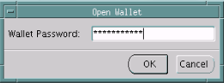

Step05: Once the wallet is opened, you can see all the Trusted Certificates. The Certificate Entry under Wallet will show as Empty, but that can be ignored:
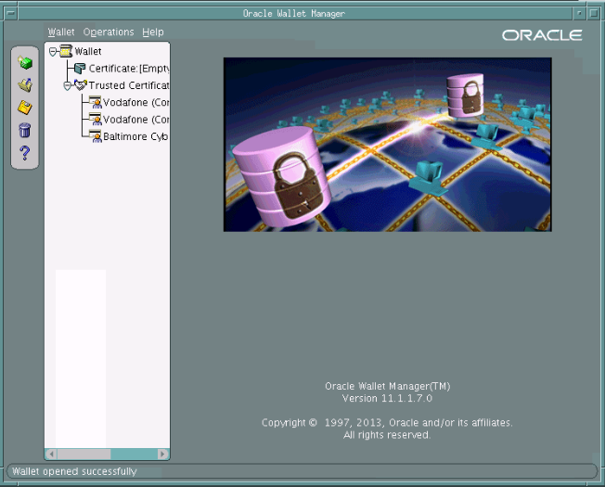

Step06: Click on "Wallet" tab and then Select/Check on "Auto Login"

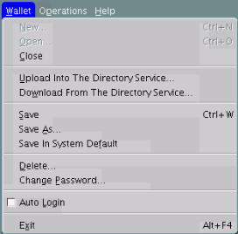

Step07: Click on "Wallet" tab and verify that "Auto Login" is checked:
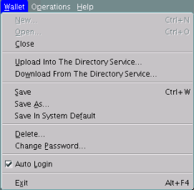

Step08: Click on "Wallet" tab and select "Close" to close the wallet:

Step09: Copy the OHS wallet Folders as per below table:

WALLET NAME | SOURCE VM | SOURCE FOLDER | DESTINATION VMs | DESTINATION FOLDER
goopdevtmp.vodafone.com | GOOP WEBSERVER | /opt/SP/wwwadm/home/keystores/ goopdevtmp.vodafone.com | GOOP WEBSERVER | /opt/SP/wwwadm/software/ohs/Oracle_WT1/instances/goop-dev/config/OHS/ohs1/keystores/ goopdevtmp.vodafone.com

Step10: Modify the wallet location in OHS Instance’s ssl.conf file as shown below.
# | SSLWallet "${ORACLE_INSTANCE}/config/${COMPONENT_TYPE}/${COMPONENT_NAME}/keystores/goopdevtmp.vodafone.com"

Step11: Modify the OHS Instance’s ssl.conf file as shown below. (Environment specific)
# | <VirtualHost *:4443>  ServerName goopdevtmp.vodafone.com  RewriteEngine On  RewriteOptions inherit  UseCanonicalName On

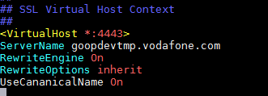
Step11: Execute the below commands while logged in as wwwadm user to restart the OHS instance:
# | cd /opt/SP/wwwadm/software/ohs/Oracle_WT1/instances/goop-dev/bin
# | ./opmnctl stopall
# | ./opmnctl startall
# | ./opmnctl status

Resource List

The below resource needs to be protected or unprotected at CIAM end.
URL Pattern | Protected
https://[HOSTNAME]:[PORT]/o/* | No
https://[HOSTNAME]:[PORT]/combo* | No
https://[HOSTNAME]:[PORT]/documents/* | No
http(s)://[HOSTNAME]:[PORT]/goop/public/* | No
http(s)://[HOSTNAME]:[PORT]/goop/secure/* | Yes
http://[HOSTNAME]/group/control_panel/* | Yes
http:// [HOSTNAME]/c/portal/* | Yes
http:// [HOSTNAME]/web/goop/* | Yes

Sanity Testing
Test the webserver by opening it in browser with the following URL:
https://goopdevtmp.vodafone.com:4443/web/goop
- It redirects to CIAM login page
- After Successful logon, The Application page will be displayed.

