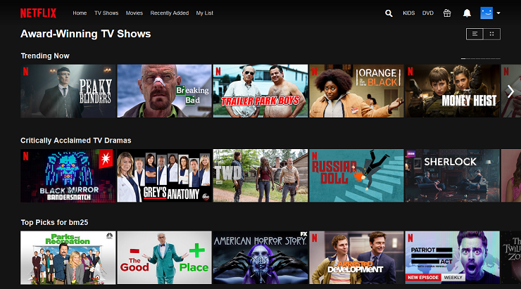

**Project Name: NETFLIX**

**Ch**iranjeevi & Satheesh

Edureka presents

**Overview**

Netflix is an American subscription streaming service and production company. Launched on August 29, 1997, it offers a library of films and television series through distribution deals as well as its own productions, known as Netflix Originals.

**Goals**

1. Login page

2. Subscription page

3. Payment page

4. Streaming page

5. Login and logout page

**History**

Netflix was founded in 1997 by Reed Hastings and Marc Randolph in Scotts Valley, California.

**Technologies used in NETFLIX**

1. Html

2. CSS

**For coding**

Visual Studio

Git Bash

**For images**

imgbb