INTRODUCTION
Generative Artificial Intelligence (often referred to as Generative AI or GenAI) is an emerging and rapidly developing area within artificial intelligence that focuses on producing new and original content. This content can include text, images, videos, audio, and even computer code, all generated based on instructions or prompts provided by users. In contrast to traditional AI systems, which mainly analyze data or perform classification tasks, generative AI has the capability to create new outputs by learning patterns from large datasets.
The functioning of generative AI relies heavily on advanced deep learning techniques, particularly large foundation models such as Large Language Models (LLMs). These models are trained using enormous volumes of data and employ sophisticated neural network structures like transformer architectures to understand relationships, context, and patterns within the information they process. Because of this training process, generative AI systems can produce responses that resemble human communication and creativity.
The release of tools such as ChatGPT in 2022 significantly increased public awareness and global adoption of generative AI technologies. Since then, organizations across various industries have started integrating generative AI into their operations to improve efficiency, automate repetitive tasks, enhance decision-making, and deliver personalized digital experiences.
Despite its many advantages, generative AI also introduces several challenges. Issues such as information accuracy, bias in generated outputs, data privacy concerns, and ethical implications need to be carefully addressed when implementing these systems. Nevertheless, generative AI represents a major technological advancement that is reshaping the way humans interact with machines and transforming numerous industries worldwide.

1. FOUNDATIONAL CONCEPTS OF GENERATIVE AI, GENERATIVE MODELS AND THEIR TYPES
1.1 What is Generative AI?
Generative AI refers to a category of artificial intelligence systems designed to produce new content automatically. These systems can generate various forms of output including written text, digital images, music, conversations, videos, and software code.
Unlike conventional AI systems that focus on tasks such as data classification, prediction, or analysis, generative AI is capable of creating entirely new data that resembles the information it was trained on.

1.2 Difference Between Artificial Intelligence and Generative AI
Artificial Intelligence (AI) is a broad field that involves building systems capable of performing tasks that normally require human intelligence. Examples include voice assistants, recommendation systems, and autonomous vehicles.
Generative AI, on the other hand, is a specific branch within AI that focuses on the generation of new digital content rather than just analyzing or processing existing data.

1.3 Foundation Models
Foundation models are large-scale machine learning models trained on extensive datasets containing diverse types of information, such as text, images, and audio. Because of their large training scope, these models can be adapted to perform multiple tasks.
Typical capabilities of foundation models include:
- Answering questions
- Generating written content
- Producing images
- Summarizing large documents
An example of such a model is the GPT (Generative Pre-trained Transformer) series.

1.4 Large Language Models (LLMs)
Large Language Models are specialized foundation models that focus specifically on processing and generating human language.
These models:
- Predict the next word in a sentence based on context
- Perform tasks like translation, summarization, and conversation
- Use billions of parameters to capture language patterns
Examples of LLMs include GPT-based models used in modern conversational AI systems.

1.5 How Generative AI Works
Generative AI systems rely on technologies such as:
- Machine Learning
- Deep Learning
- Artificial Neural Networks
During training, these models analyze extremely large datasets to identify patterns, relationships, and structures within the data. Once trained, they can generate new outputs by predicting the most probable next element in a sequence—for example, the next word in a sentence or the next pixel in an image.
Instead of simply classifying existing information, generative models learn the underlying distribution of the data and create new examples that resemble the original dataset.

1.6 Types of Generative AI Models
Diffusion Models
Diffusion models generate data by gradually adding noise to data and then learning how to reverse the process to recreate meaningful outputs. They are widely used in high-quality image generation systems.
Generative Adversarial Networks (GANs)
GANs consist of two neural networks:
- Generator – produces synthetic data
- Discriminator – evaluates whether the data is real or generated
Both networks compete with each other during training, allowing the generator to produce highly realistic outputs.

Variational Autoencoders (VAEs)
Variational Autoencoders use two main components:
- Encoder – compresses data into a latent representation
- Decoder – reconstructs data from the latent space
VAEs are commonly used to generate new variations of existing data.

Transformer-Based Models
Transformer models use a mechanism called self-attention, which allows them to understand the relationships between words in a sequence.
They are highly effective for language-related tasks and serve as the core architecture behind modern LLMs such as GPT models.

1.7 Evolution of Generative AI
The development of generative AI has progressed through several important stages:
- Early statistical language models
- 2013 – Introduction of Variational Autoencoders (VAEs)
- 2014 – Development of Generative Adversarial Networks (GANs)
- 2017 – Introduction of Transformer architecture
- 2022 onwards – Widespread adoption through tools such as ChatGPT

1.8 Applications of Generative AI
Generative AI is used in a wide range of industries including:
- Finance – fraud detection and automated customer service
- Healthcare – drug discovery and medical data simulation
- Automotive – vehicle design and simulation
- Media and entertainment – digital content creation
- Telecommunications – customer service chatbots
- Energy sector – predictive analytics and forecasting

1.9 Benefits of Generative AI
Generative AI provides several advantages, including:
- Accelerating research and innovation
- Improving customer experiences
- Automating business processes
- Increasing employee productivity
- Supporting creativity and content development

1.10 Limitations of Generative AI
Despite its benefits, generative AI has certain limitations:
- Possibility of generating incorrect or misleading information
- Risk of bias in model outputs
- Data security and privacy concerns
- High computational requirements
- Limited explainability of model decisions

1.11 Best Practices for Implementation
To effectively adopt generative AI technologies, organizations should:
- Begin with internal or low-risk applications
- Ensure transparency in AI usage
- Implement strong data security policies
- Continuously monitor AI outputs
2. AI TOOLS IN 2024
In recent years, artificial intelligence has become widely integrated into digital tools used for productivity, communication, and creative work. By 2024, AI-powered applications have significantly improved the way individuals and organizations generate content, manage information, and automate complex tasks. Many of these tools rely on advanced machine learning models and large language models to assist users in performing everyday activities more efficiently.

2.1 AI for Content Creation
One of the most common applications of AI in 2024 is automated content generation. AI tools are capable of producing high-quality written material for blogs, marketing campaigns, and social media platforms.
Examples include:
- Jasper AI
- Anyword
These tools help users create marketing text, product descriptions, advertisements, and articles in a short amount of time. As a result, businesses can maintain a strong online presence while reducing the effort required for manual writing.

2.2 AI for Communication and Email Management
AI is also improving professional communication by assisting users with email composition, summarization, and automated responses.
Common AI tools in this area include:
- Shortwave
- ChatGPT
- Claude
These systems can summarize long email threads, suggest replies, and draft messages automatically, helping users manage communication more effectively.

2.3 AI as a Personal Knowledge Assistant
Modern AI tools can function as digital knowledge managers, helping users organize ideas, notes, and information.
Examples include:
- Notion AI
- Mem
These platforms act like a “second brain” by storing information, summarizing notes, and generating insights. Such capabilities support better organization and productivity for students, professionals, and researchers.

2.4 AI for Video Creation and Editing
Artificial intelligence has also transformed the video production process. AI tools can now generate videos directly from text prompts and automate editing tasks.
Examples include:
- Runway ML
- Wondershare Filmora
These tools allow creators to produce professional-quality videos with minimal technical expertise, making content production faster and more accessible.

2.5 AI for Image Generation and Design
AI-based image generation tools enable users to create unique visual content simply by describing what they want.
Popular tools include:
- Midjourney
- Adobe Photoshop (with integrated AI features)
These systems are widely used in graphic design, digital art, and advertising, allowing designers to experiment with creative ideas more efficiently.

2.6 AI for Voice and Music Generation
AI technologies can now synthesize realistic human voices and generate original music compositions.
Examples include:
- ElevenLabs
- Suno
These tools are used in applications such as audiobook narration, voice assistants, game development, and music production.

2.7 AI for Presentations and Business Communication
AI tools can automatically design professional presentations by analyzing the content provided by users.
Examples include:
- Beautiful.ai
- Pitch
Such systems simplify the process of creating visually appealing slides and allow users to focus more on delivering their ideas effectively.

2.8 AI for Website Development
In 2024, AI-powered platforms also assist users in building websites without extensive coding knowledge.
Examples include:
- Wix
- Framer
These platforms use AI to automatically generate layouts, design elements, and website structures based on user input.

3. LARGE LANGUAGE MODELS (LLMs) AND HOW THEY ARE BUILT
3.1 What Are Large Language Models?
Large Language Models (LLMs) are advanced AI systems designed to understand and generate natural human language. They are capable of performing tasks such as answering questions, writing essays, summarizing information, and engaging in conversations.
Modern LLMs, such as GPT-4, are trained using massive datasets that include books, articles, websites, and other text sources.

3.2 Data-Driven Nature of AI
Unlike traditional software programs that follow fixed instructions, LLMs learn from data. During training, these models analyze enormous datasets to identify patterns and relationships between words.
Instead of memorizing answers, the model calculates probabilities to predict the most suitable response for a given prompt.

3.3 Role of Deep Learning
LLMs are built using deep learning, a specialized form of machine learning that utilizes artificial neural networks with many layers.
These networks process information in a way that resembles the functioning of the human brain. Through multiple layers of processing, the model gradually learns complex linguistic patterns.

3.4 Transformer Architecture
Most modern language models are based on transformer architecture, which was introduced in 2017.
Transformers use a mechanism called self-attention, allowing the model to analyze the relationships between words in a sentence and understand the broader context.
This architecture enables the model to process entire sequences of text simultaneously rather than word-by-word.

3.5 Autoregressive Text Generation
Many LLMs use autoregressive modeling, where the system predicts the next word in a sequence based on previously generated words.
For example:
If the prompt is:
"Grass is usually..."
The model calculates probabilities and may generate the word “green” because it is statistically the most likely continuation.
This process repeats step-by-step to generate full sentences and paragraphs.

3.6 Applications of LLMs
Large Language Models are widely used in various fields, including:
- Virtual assistants and chatbots
- Automated content generation
- Language translation
- Sentiment analysis
- Customer service automation
- Research and data analysis

3.7 AI as a Multi-Purpose Technology
Modern AI systems are highly versatile. They can function as:
- Generative systems that create new content
- Conversational assistants that interact with users
- Analytical tools that process large amounts of information
Because of these capabilities, AI has become an essential technology across industries such as education, healthcare, finance, and entertainment.

4. TIMELINE OF THE EVOLUTION OF ARTIFICIAL INTELLIGENCE
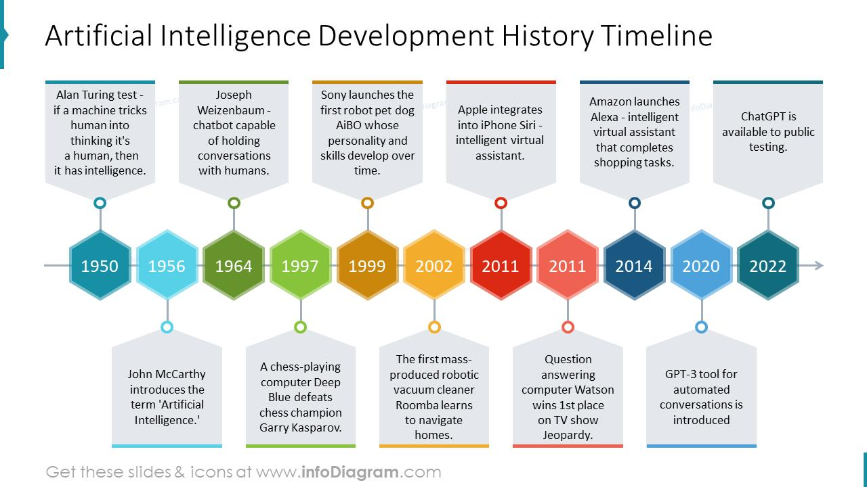
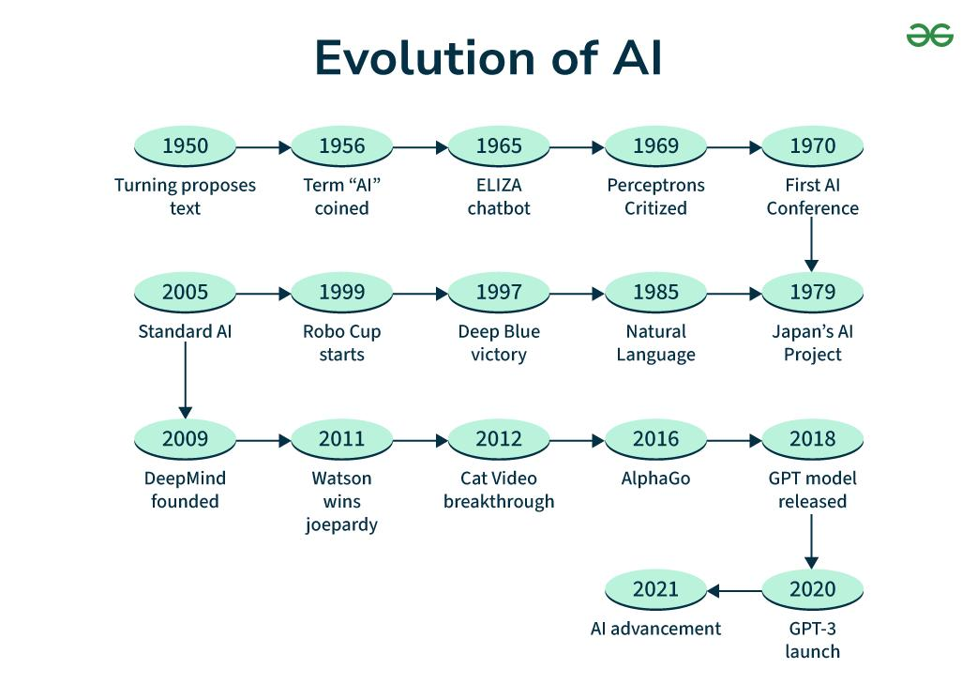
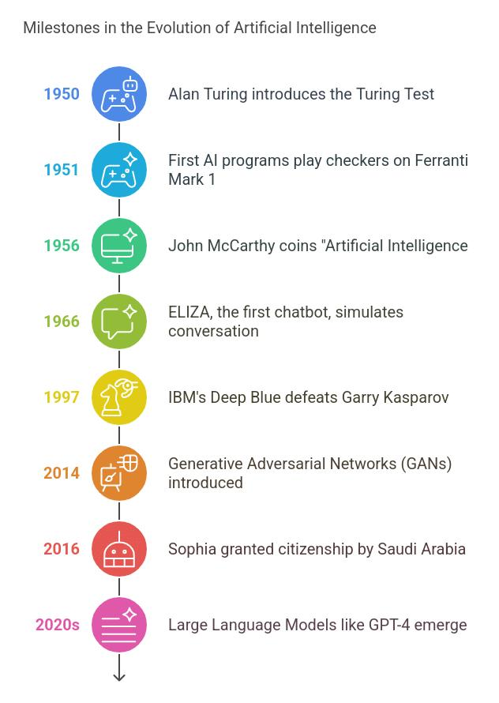
7
The development of artificial intelligence has taken place over many decades, with important milestones marking its progress.

Early Foundations (1920–1940s)
- 1921 – The word robot was introduced by Karel Čapek in the play Rossum’s Universal Robots.
- 1929 – Makoto Nishimura created Gakutensoku, considered Japan’s first robot.
- 1949 – Edmund Berkeley published the book Giant Brains, or Machines That Think.

Birth of Artificial Intelligence (1950–1956)
- 1950 – Alan Turing proposed the Turing Test for evaluating machine intelligence.
- 1952 – Arthur Samuel developed a self-learning checkers program.
- 1955 – John McCarthy introduced the term Artificial Intelligence.

Early Growth of AI (1957–1979)
- 1958 – Development of the programming language LISP for AI research.
- 1961 – The industrial robot Unimate was used in manufacturing.
- 1966 – Creation of ELIZA, one of the first conversational AI systems.
- 1973 – Funding for AI research declined after the Lighthill Report, beginning the first AI funding crisis.

AI Boom and Winter (1980–1993)
- 1980 – Expert systems began to be commercially used in businesses.
- 1981 – Japan launched the Fifth Generation Computer Project.
- 1987 – A reduction in funding led to a period known as the AI Winter.

AI Expansion Era (1993–2011)
- 1997 – IBM Deep Blue defeated world chess champion Garry Kasparov.
- 2002 – Release of the robotic vacuum Roomba.
- 2011 – IBM Watson won the quiz show Jeopardy!.

