**Ansible & Icinga2 Implementation with Ansible**

# **WHY ANSIBLE?**

Working in IT, you're likely doing the same tasks over and over. What if you could solve problems once and then automate your solutions going forward?

**Ansible** is here to help.

**ANSIBLE**

It is an open source, simple, power full and agent less for App deployment, configuration management and orchestration. All from one system. Ansible is powerful automation that you can learn quickly, self-documenting, and doesn’t require a grad-level computer science degree to read. Automation shouldn’t be more complex than the tasks it’s replacing.

### **TEAM IMPACT**

* Save time and be more productive.
* Eliminate repetitive tasks.
* Fewer mistakes & errors.
* Improve collaboration and job satisfaction.

Now let us see how to install, configure and work around with ansible commands and playbooks.

**Installations:-**

yum install ansible

Ansible is an agent less tool and it communicate client server via ssh. To communicate client over ssh we can generate ssh key for password less authentication.

**Configurations:-**

Conf File ==> /etc/ansible/hosts

Example:-

mail4 **ansible_ssh_host**=172.22.0.88 **ansible_ssh_port**=1001

[lamatri@MUMLBMODB8V ~]$ vi /etc/ansible/hosts

[icingamaster]

icingam1 ansible_ssh_host=172.29.22.140

[bmwebservers]

web1 ansible_ssh_host=172.22.1.60

web2 ansible_ssh_host=172.22.1.65

[bmappservers]

app1 ansible_ssh_host=172.22.0.90

app2 ansible_ssh_host=172.22.0.91

app3 ansible_ssh_host=172.22.0.92

app4 ansible_ssh_host=172.22.0.93

app5 ansible_ssh_host=172.22.0.94

app6 ansible_ssh_host=172.22.0.125

app7 ansible_ssh_host=172.22.0.124

app8 ansible_ssh_host=172.22.0.156

app9 ansible_ssh_host=172.22.0.164

app10 ansible_ssh_host=172.22.0.165

app11 ansible_ssh_host=172.22.0.13

app12 ansible_ssh_host=172.22.0.20

app13 ansible_ssh_host=172.22.0.48

app14 ansible_ssh_host=172.22.0.49

app15 ansible_ssh_host=172.22.2.73

app16 ansible_ssh_host=172.22.0.97

app17 ansible_ssh_host=172.22.0.228

app18 ansible_ssh_host=172.22.0.201

app19 ansible_ssh_host=172.22.1.3

app20 ansible_ssh_host=172.22.1.4

app21 ansible_ssh_host=172.22.2.149

app22 ansible_ssh_host=172.22.2.74

[bmimgservers]

bmimg1 ansible_ssh_host=172.23.0.55

bmimg2 ansible_ssh_host=172.23.0.57

bmimg3 ansible_ssh_host=172.23.0.58

bmimg4 ansible_ssh_host=172.23.0.60

bmimg5 ansible_ssh_host=172.23.0.112

bmimg6 ansible_ssh_host=172.23.0.113

bmimg7 ansible_ssh_host=172.23.0.143

bmimg8 ansible_ssh_host=172.23.0.144

bmimg9 ansible_ssh_host=172.22.1.7

bmimg10 ansible_ssh_host=172.22.1.8

[bmredisservers]

bmrd1 ansible_ssh_host=172.22.2.91

bmrd2 ansible_ssh_host=172.22.2.94

bmrd3 ansible_ssh_host=172.22.2.84

bmrd4 ansible_ssh_host=172.22.2.87

bmrd5 ansible_ssh_host=172.22.2.97

[bmmemcacheservers]

mc1 ansible_ssh_host=172.22.0.31

mc2 ansible_ssh_host=172.22.0.32

mc3 ansible_ssh_host=172.23.0.162

mc4 ansible_ssh_host=172.22.0.42

mc5 ansible_ssh_host=172.23.0.107

[bmcassandraservers]

cas1 ansible_ssh_host=172.22.0.27

cas2 ansible_ssh_host=172.22.0.28

cas3 ansible_ssh_host=172.22.0.138

cas4 ansible_ssh_host=172.22.0.139

[bmnodejsservers]

nd1 ansible_ssh_host=172.22.2.102

nd3 ansible_ssh_host=172.22.2.103

nd4 ansible_ssh_host=172.22.2.104

nd5 ansible_ssh_host=172.22.2.105

nd6 ansible_ssh_host=172.22.2.106

nd7 ansible_ssh_host=172.22.2.125

nd8 ansible_ssh_host=172.22.2.126

nd9 ansible_ssh_host=172.22.2.127

nd10 ansible_ssh_host=172.22.2.128

nd11 ansible_ssh_host=172.22.2.129

nd12 ansible_ssh_host=172.22.2.130

[bmnodejsluservers]

newndlu1 ansible_ssh_host=172.22.0.17

newndlu2 ansible_ssh_host=172.22.0.18

newndlu3 ansible_ssh_host=172.22.0.19

newndlu4 ansible_ssh_host=172.22.0.25

[bmsphinxsearchservers]

spx3 ansible_ssh_host=172.23.0.84

spx12 ansible_ssh_host=172.23.0.127

spx14 ansible_ssh_host=172.23.0.128

spx15 ansible_ssh_host=172.23.0.129

spx16 ansible_ssh_host=172.23.0.130

spx17 ansible_ssh_host=172.23.0.131

spx25 ansible_ssh_host=172.22.1.152

spx26 ansible_ssh_host=172.22.1.153

spx29 ansible_ssh_host=172.22.0.78

spx30 ansible_ssh_host=172.22.1.233

spx36 ansible_ssh_host=172.23.0.98

spx37 ansible_ssh_host=172.23.0.142

spx39 ansible_ssh_host=172.23.0.223

spx40 ansible_ssh_host=172.23.0.226

[bmsphinxviewprofileservers]

spx1 ansible_ssh_host=172.23.0.80

spx2 ansible_ssh_host=172.23.0.83

spx38 ansible_ssh_host=172.23.0.222

[bmsphinxmatchsummaryhpusaservers]

spx4 ansible_ssh_host=172.23.0.99

spx18 ansible_ssh_host=172.23.0.132

[bmsphinxmatchsummaryktyservers]

spx13 ansible_ssh_host=172.23.1.116

spx22 ansible_ssh_host=172.23.0.136

[bmsphinxmatchsummaryecservers]

spx5 ansible_ssh_host=172.23.0.97

spx19 ansible_ssh_host=172.23.0.133

[bmsphinxmatchsummarybgrservers]

spx6 ansible_ssh_host=172.23.0.65

spx20 ansible_ssh_host=172.23.0.134

[bmsphinxmatchsummarymdservers]

spx7 ansible_ssh_host=172.22.0.64

spx21 ansible_ssh_host=172.23.0.135

[bmsphinxunifiedinboxhpusaservers]

spxui1 ansible_ssh_host=172.23.0.165

spxui9 ansible_ssh_host=172.23.0.190

spxui14 ansible_ssh_host=172.22.0.67

spxui26 ansible_ssh_host=172.22.0.221

[bmsphinxunifiedinboxktyservers]

spxui5 ansible_ssh_host=172.23.0.169

spxui7 ansible_ssh_host=172.23.0.164

spxui13 ansible_ssh_host=172.22.0.50

spxui27 ansible_ssh_host=172.22.0.222

spxui33 ansible_ssh_host=172.22.1.237

spxuikty1 ansible_ssh_host=172.22.1.227

[bmsphinxunifiedinboxecservers]

spxui2 ansible_ssh_host=172.23.0.166

spxui6 ansible_ssh_host=172.23.0.163

spxui12 ansible_ssh_host=172.22.0.69

spxui28 ansible_ssh_host=172.22.0.223

spxui32 ansible_ssh_host=172.22.1.234

[bmsphinxunifiedinboxbgrservers]

spxui3 ansible_ssh_host=172.23.0.167

spxui10 ansible_ssh_host=172.23.0.191

spxui15 ansible_ssh_host=172.22.0.68

spxui29 ansible_ssh_host=172.22.0.224

[bmsphinxunifiedinboxmdservers]

spxui4 ansible_ssh_host=172.23.0.168

spxui8 ansible_ssh_host=172.22.0.167

spxui11 ansible_ssh_host=172.23.0.11

spxui30 ansible_ssh_host=172.22.1.249

spxui31 ansible_ssh_host=172.22.1.230

spxuimd1 ansible_ssh_host=172.22.1.225

[bmsphinxonlineservers]

spxol12 ansible_ssh_host=172.22.1.39

spxol13 ansible_ssh_host=172.22.1.41

spxol14 ansible_ssh_host=172.22.1.42

spxol15 ansible_ssh_host=172.22.1.43

spxol16 ansible_ssh_host=172.22.1.44

spxol17 ansible_ssh_host=172.22.1.45

spxol18 ansible_ssh_host=172.22.1.46

spxol19 ansible_ssh_host=172.22.1.47

[bmsphinxlatestupdateservers]

spxlu1 ansible_ssh_host=172.22.1.231

spxlu2 ansible_ssh_host=172.22.1.235

[bmsphinxseoservers]

spxseo1 ansible_ssh_host=172.22.1.232

spxseo2 ansible_ssh_host=172.22.1.236

[bmsphinxmailerservers]

spx10 ansible_ssh_host=172.23.1.117

[bmmongoshardingservers]

shrd1 ansible_ssh_host=172.22.2.107

shrd2 ansible_ssh_host=172.22.2.108

[bmcronservers]

appcron ansible_ssh_host=172.23.0.175

appcron2 ansible_ssh_host=172.22.0.83

[bmpwaservers]

pwa1 ansible_ssh_host=172.22.0.142

pwa2 ansible_ssh_host=172.22.0.151

[cbswebservers]

web3 ansible_ssh_host=172.22.1.20

web4 ansible_ssh_host=172.22.1.21

web5 ansible_ssh_host=172.22.1.22

web6 ansible_ssh_host=172.22.0.134

web7 ansible_ssh_host=172.22.2.76

web8 ansible_ssh_host=172.22.2.67

web9 ansible_ssh_host=172.22.2.77

[cbsimgservers]

cbsimg1 ansible_ssh_host=172.22.1.10

cbsimg2 ansible_ssh_host=172.23.0.146

cbsimg3 ansible_ssh_host=172.23.0.145

[cbsredisservers]

rd1 ansible_ssh_host=172.22.2.131

rd2 ansible_ssh_host=172.22.2.132

rd3 ansible_ssh_host=172.22.2.133

[cbsnodejsservers]

cnd1 ansible_ssh_host=172.22.2.109

cnd2 ansible_ssh_host=172.22.2.110

cnd3 ansible_ssh_host=172.22.2.111

[cbsmongoshardingservers]

cshrd1 ansible_ssh_host=172.22.2.112

cshrd2 ansible_ssh_host=172.22.2.113

[cbssphinxsearchservers]

spx8 ansible_ssh_host=172.22.0.127

spx9 ansible_ssh_host=172.22.0.185

spx11 ansible_ssh_host=172.22.0.182

spx27 ansible_ssh_host=172.22.0.72

spx32 ansible_ssh_host=172.22.0.210

[cbssphinxonlineservers]

cspxol1 ansible_ssh_host=172.22.1.102

cspxol2 ansible_ssh_host=172.22.1.113

cspxol3 ansible_ssh_host=172.22.1.103

cspxol4 ansible_ssh_host=172.22.1.104

cspxol5 ansible_ssh_host=172.22.1.105

cspxol6 ansible_ssh_host=172.22.1.106

cspxol7 ansible_ssh_host=172.22.1.107

cspxol8 ansible_ssh_host=172.22.1.108

cspxol9 ansible_ssh_host=172.22.1.109

cspxol10 ansible_ssh_host=172.22.1.110

[cbssphinxmailerservers]

spx28 ansible_ssh_host=172.22.0.73

[bmoutboundmailservers]

mail1 ansible_ssh_host=172.22.0.85

mail2 ansible_ssh_host=172.22.0.86

mail3 ansible_ssh_host=172.22.0.87

**mail4** **ansible_ssh_host**=172.22.0.88 **ansible_ssh_port**=1001

[cbsoutboundmailservers]

mail6 ansible_ssh_host=172.22.0.184

mail7 ansible_ssh_host=172.22.0.186

mail8 ansible_ssh_host=172.22.0.188

mail9 ansible_ssh_host=172.22.0.76

[corporatemailservers]

mail5 ansible_ssh_host=172.22.0.89

[bmdbportalmaster]

mmdb ansible_ssh_host=172.29.23.68

mdb1 ansible_ssh_host=172.29.23.76

mdb2 ansible_ssh_host=172.29.23.77

mdb3 ansible_ssh_host=172.29.23.78

mdb4 ansible_ssh_host=172.29.23.79

odb1 ansible_ssh_host=172.29.23.69

odb2 ansible_ssh_host=172.29.23.70

odb6 ansible_ssh_host=172.29.23.178

odblu1 ansible_ssh_host=172.29.23.12

bmvm ansible_ssh_host=172.29.23.170

bmvm2 ansible_ssh_host=172.29.23.171

bmvm3 ansible_ssh_host=172.29.23.172

[bmdbportalslave]

sdb1 ansible_ssh_host=172.29.23.109

sdb2 ansible_ssh_host=172.29.23.71

sdb3 ansible_ssh_host=172.29.23.110

sdb4 ansible_ssh_host=172.29.23.111

sdb9 ansible_ssh_host=172.29.23.201

sdb10 ansible_ssh_host=172.29.22.202

odb7 ansible_ssh_host=172.29.23.179

[bmdbsphinxslave]

sdb7 ansible_ssh_host=172.29.23.41

sdb8 ansible_ssh_host=172.29.23.42

file4 ansible_ssh_host=172.29.22.108

[bmdbbackupslave]

sdb11 ansible_ssh_host=172.29.23.214

sdb5 ansible_ssh_host=172.29.23.114

sdb6 ansible_ssh_host=172.29.23.40

mmdbbkp ansible_ssh_host=172.29.23.26

[bmdbnonportalmaster]

odb4 ansible_ssh_host=172.29.23.72

odb9 ansible_ssh_host=172.29.23.15

[bmdbnonportalslave]

odb3 ansible_ssh_host=172.29.23.73

odb5 ansible_ssh_host=172.29.23.46

odb10 ansible_ssh_host=172.29.23.16

odb11 ansible_ssh_host=172.29.22.56

[cbsdbportalmaster]

cmdb1 ansible_ssh_host=172.29.23.95

#ctyweb2 ansible_ssh_host=

[cbsdbportalslave]

csdb1 ansible_ssh_host=172.29.23.96

csdb4 ansible_ssh_host=172.29.23.184

[cbsdbsphinxslave]

csdb5 ansible_ssh_host=172.29.23.14

[cbsdbbackupslave]

csdb3 ansible_ssh_host=172.29.23.115

[cbsdbnonportalmaster]

csdb2 ansible_ssh_host=172.29.23.74

[dbserverothers1]

rrfdb ansible_ssh_host=172.29.2.101

odb8 ansible_ssh_host=172.29.23.13

[dbserverothers2]

tgdb1 ansible_ssh_host=172.29.23.53

tgdb2 ansible_ssh_host=172.29.23.54

[bmmailer]

mailer1 ansible_ssh_host=172.22.0.181

file2 ansible_ssh_host=172.23.0.183

mlfm ansible_ssh_host=172.23.0.176

[cbsmailer]

mailer2 ansible_ssh_host=172.22.0.253

mailer3 ansible_ssh_host=172.22.0.251

mailer4 ansible_ssh_host=172.22.0.166

mailer5 ansible_ssh_host=172.22.0.74

cbsmlfm ansible_ssh_host=172.23.0.180

[mbazaar]

mbweb1 ansible_ssh_host=172.22.0.137

mbslr1 ansible_ssh_host=172.22.1.221

[nonportal]

cms1 ansible_ssh_host=172.22.0.101

cms2 ansible_ssh_host=172.22.0.75

camp1 ansible_ssh_host=172.22.0.103

camp2 ansible_ssh_host=172.22.0.102

camp3 ansible_ssh_host=172.22.0.176

camp4 ansible_ssh_host=172.22.1.40

camp5 ansible_ssh_host=172.22.2.80

camp6 ansible_ssh_host=172.22.2.90

[countryservers]

#ctyweb1 ansible_ssh_host=172.23.0.147

ctyweb2 ansible_ssh_host=172.23.0.150

ctynd1 ansible_ssh_host=172.22.2.115

ctynd2 ansible_ssh_host=172.22.2.116

ctyshrd1 ansible_ssh_host=172.22.2.117

ctyshrd2 ansible_ssh_host=172.22.2.118

[otherservers]

bmvp ansible_ssh_host=172.23.0.173

bmvp2 ansible_ssh_host=172.23.0.174

bmvp3 ansible_ssh_host=172.23.0.229

bmvp4 ansible_ssh_host=172.23.0.230

cbsvp1 ansible_ssh_host=172.23.0.177

bmext ansible_ssh_host=172.22.2.135

bmext2 ansible_ssh_host=172.22.1.220

cbsext ansible_ssh_host=172.22.2.114

cbsext2 ansible_ssh_host=172.22.1.224

apps4bm ansible_ssh_host=172.22.0.168

mima1 ansible_ssh_host=172.22.1.15

mima2 ansible_ssh_host=172.22.1.16

cbsmima1 ansible_ssh_host=172.22.1.17

cbsmima2 ansible_ssh_host=172.22.1.18

csockio ansible_ssh_host=172.22.2.134

**Example Commands:-**

[lamatri@MUMLBMODB8V ~]$ ansible -m **ping** **app1** #[Check Ping on Specific host]

**app1** | **SUCCESS** => {

"changed": false,

"**ping**": "**pong**"

}

[lamatri@MUMLBMODB8V ~]$ ansible -m **ping** **bmmailer** #[Check Ping on hostgroup]

**mlfm** | **SUCCESS** => {

"changed": false,

"**ping**": "**pong**"

}

**file2** | **SUCCESS** => {

"changed": false,

"**ping**": "**pong**"

}

**mailer1** | **SUCCESS** => {

"changed": false,

"**ping**": "**pong**"

}

Here **Ping** is **predefined module** in **ansible**. Now let us see how to execute **custom commands** in ansible.

[lamatri@MUMLBMODB8V ~]$ ansible -m shell -a '**free -m**' **mlfm**

**mlfm** | **SUCCESS** | rc=0 >>

total used free shared buffers cached

Mem: 24110 20501 3609 0 2959 9774

-/+ buffers/cache: 7767 16343

Swap: 4095 4095 0

In this example we have got the result for the **server command 'free -m'** with the help of **predefined shell module** in **ansible**.

[lamatri@MUMLBMODB8V ~]$ ansible -m shell -a '**free -m**' **bmmailer**

**mlfm** | **SUCCESS** | rc=0 >>

total used free shared buffers cached

**Mem**: 24110 20501 3609 0 2959 9774

-/+ buffers/cache: 7767 16343

Swap: 4095 4095 0

**file2** | **SUCCESS** | rc=0 >>

total used free shared buffers cached

**Mem**: 96550 89353 7196 0 1014 85210

-/+ buffers/cache: 3129 93420

Swap: 4095 0 4095

**mailer1** | **SUCCESS** | rc=0 >>

total used free shared buffers cached

Mem: 25994 22508 3486 0 5161 8071

-/+ buffers/cache: 9274 16719

Swap: 4095 0 4095

[lamatri@MUMLBMODB8V ~]$ ansible -m **shell** **--become** -a '**systemctl reload httpd**' **app1**

**app1** | **SUCCESS** | rc=0 >>

**--become** or **-b** defines **sudo** option.

**Ansible PlayBook:-**

For Ansible, nearly every YAML file starts with a list. Each item in the list is a list of key/value pairs, commonly called a “hash” or a “dictionary”. So, we need to know how to write lists and dictionaries in YAML.

All YAML files can optionally begin with --- and end with .... This is part of the YAML format and indicates the start and end of a document.

PlayBook is a group of task similar like a bash(group of commands).

**Example PlayBook 1:-**

[lamatri@MUMLBMODB8V alex_ansible_playbook]$ cat restart_icinga_master.yaml

---

- hosts: icingam1

become: yes

tasks:

- name: Restarting Icinga2 service on icinga master(MUMLBMICINGAM1) server.

service: name=icinga2 state=restarted enabled=yes

Above example is a simple playbook to restart icinga server on particular host.

[lamatri@MUMLBMODB8V ~]$ ansible-playbook **--syntax-check** alex_ansible_playbook/restart_icinga_master.yaml

playbook: alex_ansible_playbook/restart_icinga_master.yaml

[lamatri@MUMLBMODB8V ~]$

To execute playbook syntax is ansible-playbook <playbook name>

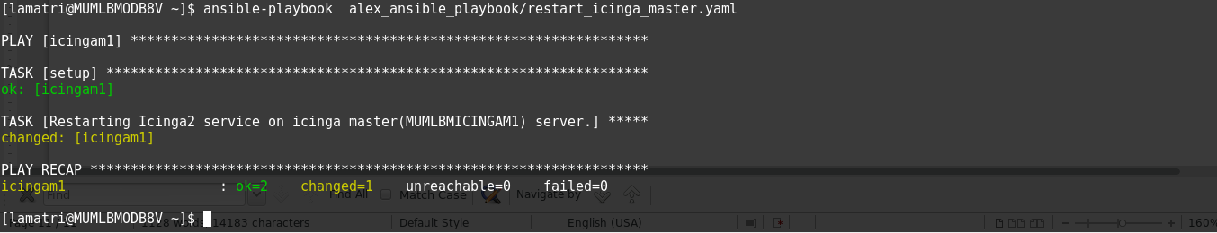

Step1:- **Play [ icingam1 ]**

Playbook going to play in icingam1 group that is mentioned in ansible host file.

Step2:- **TASK [setup]**

It will establish the connection to the corresponding host mentioned in the icingam1 group and copy the python scripts related to the list of task.

Ok: [icingam1] indicates that connection successfully established to the host icigam1. If un-success then it will indicate with red color and no more task will play onto that particular failure host.

Step3:- **TASK [Restarting Icinga2 service on icinga master(MUMLBMICINGAM1) server.]\*\***

While executing task in host, task is success full and there is some changes happened because of task then it indicates orange color with changed state(changed: [icingam1]) else it will indicate red color with failed state.

If a state is failed then no more task will play for that particular host. It will jump to next task for next host.

Step4:- **PLAY RECAP**

Once all task has been played it will show the success host and task with different color identifications.

**Playbook For adding Icinga2 Client to Icinga2 Master:-**

Here I am going to configure Icinga2 client and add the same in Icinga2 master for APP23-30 via ansible playbook. Let us see the steps.

**Step1:- Add Host information in Ansible Host File.**

[lamatri@MUMLBMODB8V alex_ansible_playbook]$ sudo vi /etc/ansible/hosts

[bmappservers]

#app1 ansible_ssh_host=172.22.0.90

#app2 ansible_ssh_host=172.22.0.91

#app3 ansible_ssh_host=172.22.0.92

#app4 ansible_ssh_host=172.22.0.93

#app5 ansible_ssh_host=172.22.0.94

#app6 ansible_ssh_host=172.22.0.125

#app7 ansible_ssh_host=172.22.0.124

#app8 ansible_ssh_host=172.22.0.156

#app9 ansible_ssh_host=172.22.0.164

#app10 ansible_ssh_host=172.22.0.165

#app11 ansible_ssh_host=172.22.0.13

#app12 ansible_ssh_host=172.22.0.20

#app13 ansible_ssh_host=172.22.0.48

#app14 ansible_ssh_host=172.22.0.49

#app15 ansible_ssh_host=172.22.2.73

#app16 ansible_ssh_host=172.22.0.97

#app17 ansible_ssh_host=172.22.0.228

#app18 ansible_ssh_host=172.22.0.201

#app19 ansible_ssh_host=172.22.1.3

#app20 ansible_ssh_host=172.22.1.4

#app21 ansible_ssh_host=172.22.2.149

#app22 ansible_ssh_host=172.22.2.74

app23 ansible_ssh_host=172.22.2.201

app24 ansible_ssh_host=172.22.2.202

app25 ansible_ssh_host=172.22.2.203

app26 ansible_ssh_host=172.22.2.204

app27 ansible_ssh_host=172.22.2.205

app28 ansible_ssh_host=172.22.2.206

app29 ansible_ssh_host=172.22.2.207

app30 ansible_ssh_host=172.22.2.208

I have commented app1 to 22 because icinga2 is already done on that host so just commented.

[lamatri@MUMLBMODB8V ~]$ cd alex_ansible_playbook/

Here I have create icinga directory, under that I have created conf(for configurations file), script (for certain process), plugins (for custom service check scripts).

[lamatri@MUMLBMODB8V alex_ansible_playbook]$ ls -ltr icinga/

total 16

drwxrwxr-x 4 lamatri lamatri 4096 Jun 9 16:16 conf

drwxrwxr-x 2 lamatri lamatri 4096 Jul 21 16:03 scripts

drwxrwxr-x 2 lamatri lamatri 4096 Jul 27 14:00 plugins

Under conf there are seperate conf for server configuration(host conf) and client configurations(zone conf). Server configuration files created based on server group name

example **bmappservers**_host.conf, **bmimgservers**_host.conf and so on...

[lamatri@MUMLBMODB8V alex_ansible_playbook]$ ls -ltr icinga/conf/

total 8

drwxrwxr-x 2 lamatri lamatri 4096 Jul 11 16:28 client

drwxr-xr-x 2 lamatri lamatri 4096 Aug 30 13:05 server

[lamatri@MUMLBMODB8V alex_ansible_playbook]$ cat icinga/conf/server/**bmappservers**_host.conf

object Host "**icinga2_client_hostname**" {

check_command = "hostalive"

address = "**icinga2_client_ipaddress**"

zone = "master" //optional trick: sync the required host object to the client, but enforce the "master" zone to execute the check

check_interval = 1m

retry_interval = 15s

max_check_attempts = 3

vars.endpoint = "**icinga2_client_hostname**"

vars.all_servers_application_group = "**icinga2_client_hostname**"

vars.bm_application_servers_group = "**icinga2_client_hostname**"

vars.bm_app_servers_group = "**icinga2_client_hostname**"

vars.datadisk = "**icinga2_client_hostname**"

vars.hostgroup = "bm-app-cluster"

vars.notification["mail"] = { groups = [ "sedbm" ]}

vars.notification["telegram" ] = { groups = [ "icingatelegram" ]}

vars.notification[ "sms" ] = { groups = [ "level1", "level2" ] }

vars.enable_pagerduty_host = true

}

[lamatri@MUMLBMODB8V alex_ansible_playbook]$ cat icinga/conf/client/zones.conf

/*

* Generated by Icinga 2 node setup commands

* on 2017-07-03 13:01:39 +0530

*/

object Endpoint "MUMLBMICINGAM1" {

host = "172.29.22.140"

port = "5665"

}

object Zone "master" {

endpoints = [ "MUMLBMICINGAM1" ]

}

object Endpoint NodeName {

}

object Zone ZoneName {

endpoints = [ NodeName ]

parent = "master"

}

**object Zone "global-templates" {**

**global = true**

**}**

The below script is to rename the hostname on host configuration file and sync it to icinga2 master.

[lamatri@MUMLBMODB8V alex_ansible_playbook]$ cat icinga/scripts/copy_client_configurations_to_icingaserver.sh

#!/bin/bash

cp -f icinga/conf/server/zones.conf /tmp/${2}_zone.conf

cp -f icinga/conf/server/${1}_host.conf /tmp/${2}_host.conf

cp -f icinga/conf/server/${1}_dependencies.conf /tmp/${2}_dependencies.conf

sed -i "s/icinga2_client_hostname/${2}/g" /tmp/${2}_*.conf

sed -i "s/icinga2_client_ipaddress/${3}/g" /tmp/${2}_*.conf

rsync -az /tmp/${2}_*.conf ${4}:/tmp/

Under plugins directory there are list of custom scripts for service checks to copy the same to icinga2 client server.

[lamatri@MUMLBMODB8V alex_ansible_playbook]$ ls -ltr icinga/plugins/

total 168

-rwxr-xr-x 1 lamatri lamatri 8414 Jun 9 15:11 check_cpu.sh

-rwxr-xr-x 1 lamatri lamatri 2359 Jun 9 15:11 check_apachethread.pl

-rwxr-xr-x 1 lamatri lamatri 3259 Jul 11 16:47 check_open_files.pl

-rwxr-xr-x 1 lamatri lamatri 5667 Jul 11 16:52 check_network_bandwidth

-rwxr-xr-x 1 lamatri lamatri 126484 Jul 24 12:50 check_mysql_health

-rwxr-xr-x 1 lamatri lamatri 13159 Jul 27 13:59 check_memory

[lamatri@MUMLBMODB8V alex_ansible_playbook]$ cat install_and_configure_icinga_and_nagiosplugins_on_centos7_server.yaml

---

- hosts: '{{ groupname_or_hostname }}'

become: yes

tasks:

- name: Install the icinga repository on remote servers.

yum: name=http://packages.icinga.org/epel/7/release/noarch/icinga-rpm-release-7-1.el7.centos.noarch.rpm state=installed

- name: Install an icinga2 package on remote servers.

yum: name=icinga2 state=installed

- name: Install an nagios plugins package on remote servers.

yum: name=nagios-plugins-all state=installed

- name: Installing expect rpm for icinga node setup wizard script dependencies

action: yum pkg=expect state=installed

- name: Genrating Ticket in icinga master server.

command: icinga2 pki ticket --cn '{{ ansible_hostname }}'

delegate_to: icingam1

register: vle1

- name: Genrated ticket in icinga master for the host {{ ansible_hostname }}. Please find the ticket below.

debug:

var: vle1.stdout

delegate_to: 127.0.0.1

- name: Executing node setup wizard on icinga2 client server.

shell: |

set timeout 30

spawn /sbin/icinga2 node wizard

expect -re {[^:]*: } {send "y\n"}

expect -re {[^:]*: } {send "{{ ansible_hostname }}\n"}

expect -re {[^:]*: } {send "MUMLBMICINGAM1\n"}

expect -re {[^:]*: } {send "y\n"}

expect -re {[^:]*: } {send "172.22.0.140\n"}

expect -re {[^:]*: } {send "\n"}

expect -re {[^:]*: } {send "\n"}

expect -re {[^:]*: } {send "\n"}

expect -re {[^:]*: } {send "\n"}

expect -re {[^:]*: } {send "y\n"}

expect -re {[^:]*: } {send "{{ vle1.stdout }}\n"}

expect -re {[^:]*: } {send "\n"}

expect -re {[^:]*: } {send "\n"}

expect -re {[^:]*: } {send "y\n"}

expect -re {[^:]*: } {send "y\n"}

expect eof

args:

executable: /usr/bin/expect

- name: Commenting un-required icinga2 conf files on client server.

replace: dest=/etc/icinga2/icinga2.conf regexp='include_recursive "conf.d"' replace='//include_recursive "conf.d"' backup=yes

- name: Copying zone.conf to icinga client server.

template: src=icinga/conf/client/zones.conf dest=/etc/icinga2/zones.conf mode=644

- name: Copying nagios plugins to '{{ ansible_hostname }}' server.

template: src={{ item }} dest=/usr/lib64/nagios/plugins/ mode=0755

with_fileglob:

- icinga/plugins/*

- name: Preparing Service Configuration files for icinga2 client servers and copying to Icing Master('MUMLBMICINGAM1') server.

command: /bin/bash icinga/scripts/copy_client_configurations_to_icingaserver.sh {{ groupname_of_the_host }} {{ ansible_hostname }} {{ ansible_default_ipv4.address }} 172.22.0.140

delegate_to: 127.0.0.1

become: no

- name: Moving client hosts/zone configuration file to corresponding path with proper permissions.

copy: src={{ item.src }} dest={{ item.dest }} mode=644

with_items:

- { src: '/tmp/{{ ansible_hostname }}_host.conf', dest: '/etc/icinga2/zones.d/global-client-host-conf/{{ ansible_hostname }}.conf' }

- { src: '/tmp/{{ ansible_hostname }}_zone.conf', dest: '/etc/icinga2/zones.d/master/global-client-zone-conf/{{ ansible_hostname }}.conf' }

# - { src: '/tmp/{{ ansible_hostname }}_dependencies.conf', dest: '/etc/icinga2/zones.d/master/dependencies/{{ server_type }}/{{ groupname_of_the_host }}/disable-check_http-{{ ansible_hostname }}.conf' }

delegate_to: icingam1

- name: Restart Icinga2 service on icinga2 client servers.

service: name=icinga2 state=restarted enabled=yes

- include: restart_icinga_master.yaml

**Step2:- Execute the following playbook.**

[lamatri@MUMLBMODB8V alex_ansible_playbook]$ ansible-playbook install_and_configure_icinga_and_nagiosplugins_on_centos7_server.yaml --extra-vars "groupname_or_hostname=bmappservers groupname_of_the_host=bmappservers"

Output 1:-

Here in the above figure you can find the difference of color.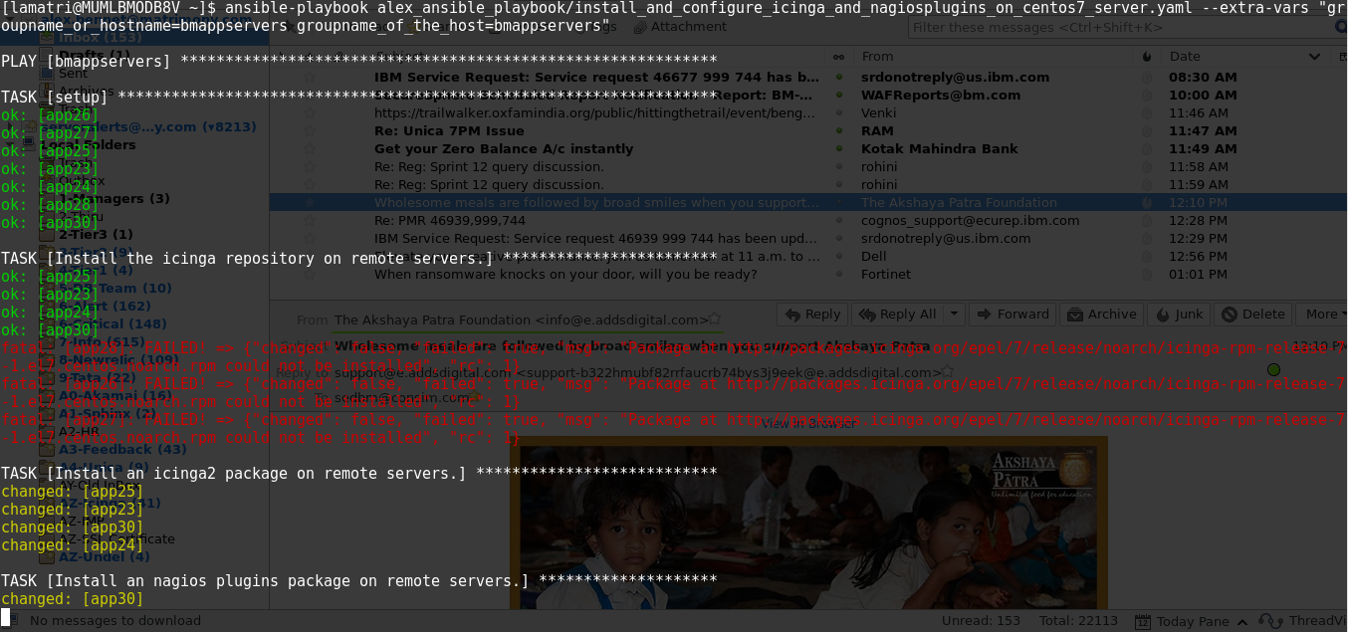

Output2.1:-

Green – Task success or already done [ for example:- task to install httpd. If it already available in server then it will be green ] 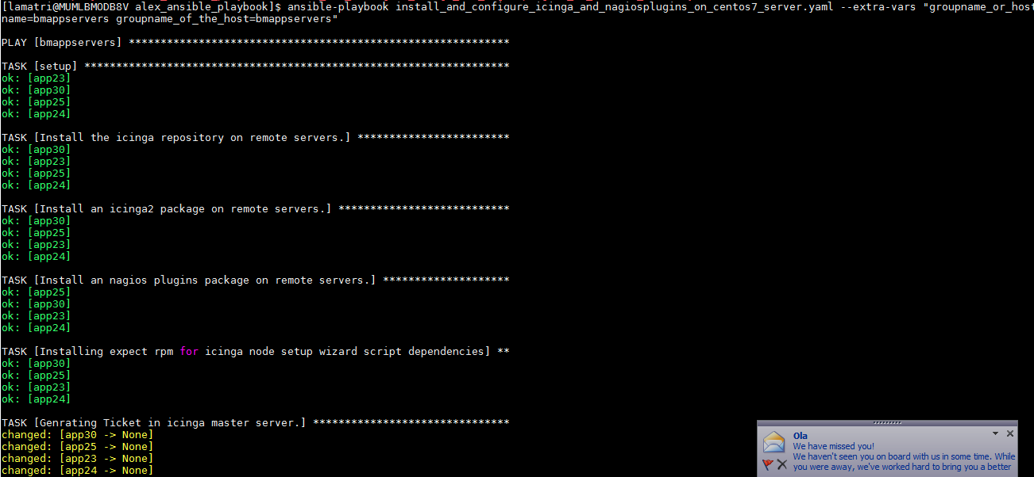

Yellow – Task success and changes happened in server because of task.

Red – Failure and next task will not continue for that particular failure host. (refer output 1).

Output2.2:-

Output2.3:-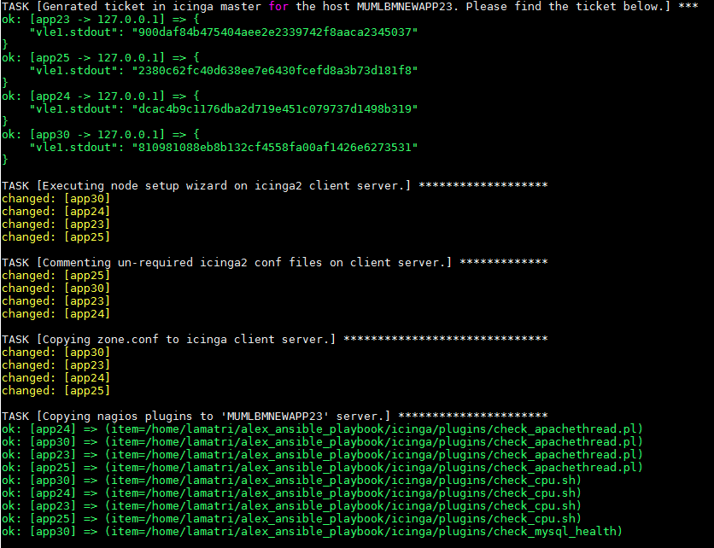

The above playbook completed successfully. Now login to icinga webinterface and check it.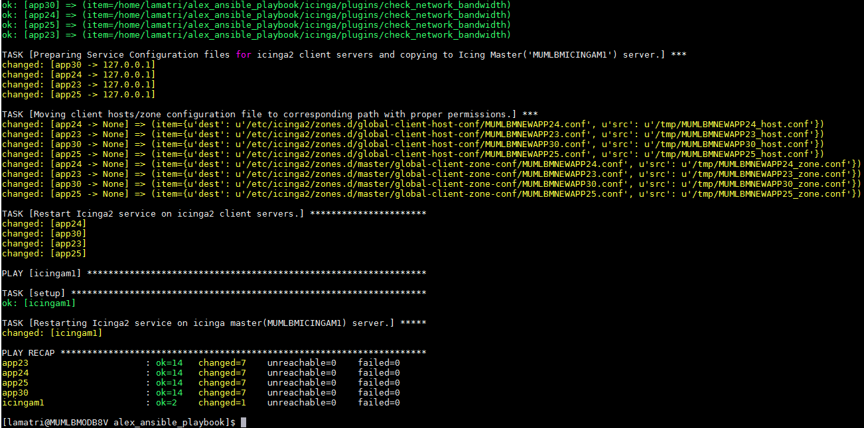

Output2.4:-

In the below figure u can find the 4 host is added in icinga2.

Before adding new host there were 253 host up. After adding new host it is 257 host up.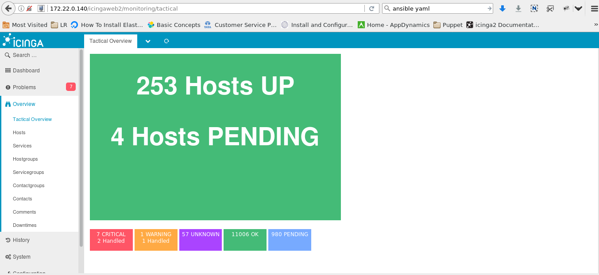

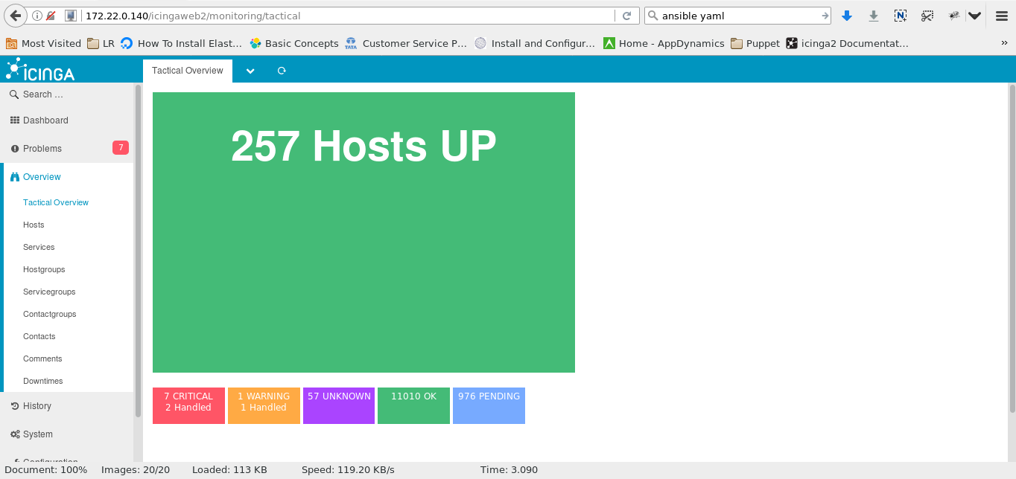

Note:-

[lamatri@MUMLBMODB8V alex_ansible_playbook]$ ansible-playbook install_and_configure_icinga_and_nagiosplugins_on_centos7_server.yaml --extra-vars "**groupname_or_hostname**=**bmappservers** **groupname_of_the_host**=**bmappservers**"

For the above groupname_or_hostname name should be the below group name or individual hostname for the corresponding group and for groupname_of_the_host the group name should be the group name from the below corresponding to the host.

[lamatri@MUMLBMODB8V alex_ansible_playbook]$ grep "\[" /etc/ansible/hosts | grep -v "#"

[icingamaster]

[bmwebservers]

[bmappservers]

[bmimgservers]

[bmredisservers]

[bmmemcacheservers]

[bmcassandraservers]

[bmnodejsservers]

[bmnodejsluservers]

[bmsphinxsearchservers]

[bmsphinxviewprofileservers]

[bmsphinxmatchsummaryhpusaservers]

[bmsphinxmatchsummaryktyservers]

[bmsphinxmatchsummaryecservers]

[bmsphinxmatchsummarybgrservers]

[bmsphinxmatchsummarymdservers]

[bmsphinxunifiedinboxhpusaservers]

[bmsphinxunifiedinboxktyservers]

[bmsphinxunifiedinboxecservers]

[bmsphinxunifiedinboxbgrservers]

[bmsphinxunifiedinboxmdservers]

[bmsphinxonlineservers]

[bmsphinxlatestupdateservers]

[bmsphinxseoservers]

[bmsphinxmailerservers]

[bmmongoshardingservers]

[bmcronservers]

[bmpwaservers]

[cbswebservers]

[cbsimgservers]

[cbsredisservers]

[cbsnodejsservers]

[cbsmongoshardingservers]

[cbssphinxsearchservers]

[cbssphinxonlineservers]

[cbssphinxmailerservers]

[bmoutboundmailservers]

[cbsoutboundmailservers]

[corporatemailservers]

[bmdbportalmaster]

[bmdbportalslave]

[bmdbsphinxslave]

[bmdbbackupslave]

[bmdbnonportalmaster]

[bmdbnonportalslave]

[cbsdbportalmaster]

[cbsdbportalslave]

[cbsdbsphinxslave]

[cbsdbbackupslave]

[cbsdbnonportalmaster]

[dbserverothers1]

[dbserverothers2]

[bmmailer]

[cbsmailer]

[mbazaar]

[nonportal]

[countryservers]

[otherservers]

[lamatri@MUMLBMODB8V alex_ansible_playbook]$