CS 008 Introduction to World Wide Web Design

Sierra Thibodeau, Cody Pettibone, Emile Rivatt

Assignment Four

Red Sox Fan Page

Version <1.0>

Table Of Contents

Time Log 3

Software Requirements Specifications 4

Introduction 4

Purpose 4

Definitions, acronyms, and abbreviations 4

Overall Description 4

Story Board 5

Assignment requirements 6

Specific requirements 8

|  |  |  |  |
| --- | --- | --- | --- |
| Time Log | | | |
| Estimated time to complete assignment => | | | _10_ Hours |
| Date | Time Spent  (in hours) | Description | Author |
| 5/1/14 | 1.0 | First Version of Software Requirements | Sierra Thibodeau, Cody Pettibone, Emile Rivat |
| 5/2/14 | 1.0 | Layout of Website and Storyboard | Sierra Thibodeau, Cody Pettibone, Emile Rivat |
| 5/2/14 | 1.0 | Creating Style Sheet | Sierra Thibodeau, Cody Pettibone, Emile Rivat |
| 5/2/14 | 1.0 | Home Page | Sierra Thibodeau |
| 5/6/14 | 1.0 | Gallery Page | Sierra Thibodeau |
| 5/7/14 | 1.0 | Roster Page | Cody Pettibone |
| 5/7/14 | 1.0 | Game Schedule Page | Cody Pettibone |
| 5/7/14 | 1.0 | Statistics Page | Emile Rivat |
| 5/7/14 | 2.0 | Register Page | Emile Rivat |
|  |  |  |  |
|  |  |  |  |
|  |  |  |  |
|  |  |  |  |
|  |  |  |  |
|  |  |  |  |
|  |  |  |  |
|  |  |  |  |
|  |  |  |  |
|  |  |  |  |
|  |  |  |  |
|  | 10 | <=Total Time Spent |  |
|  |  |  |  |

# Software Requirements Specifications

## Introduction

### Purpose

The purpose of this document is to describe the requirement specification for the web site “Assignment 4”.

The intended audience for this document is the prospective developers of this site. The goal being that you can give this document to someone and they can make the site without having to ask any questions.

The web site to be created is designed for people who are fans of the Boston Red Sox. This website provides pictures of the Red Sox in recent years, statistics, current rosters, current game schedule and the opportunity to fill out a survey for the site.

### Definitions, acronyms, and abbreviations

HTML – Hypertext markup language – used to define your content.

PHP – Personal Home Page – language that helps to customize html.

CSS – Cascading Style Sheets – used to define the look of a web site.

W3 Validation – refers to both Html and CSS validation tool provided by the W3c.org. the html validator is located at:

<http://validator.w3.org/>

with the CSS validator located at:

<http://jigsaw.w3.org/css-validator/>

## Overall Description

This site is about the Boston Red Sox. The main page has a slider of recent pictures and the history of the Boston Red Sox. The gallery page holds photos of recent years including 2013, 2012, and 2011. Each windows opens into a new tab.

The Game Schedule page holds the current 2014 Boston Red Sox game schedule. The Roster page holds the current players for 2014. The Statistics page holds the statistics for the current players.

The last page is the Form page has a survey to get a sense of the users that visit the page. It asks for favorite Red Sox players, favorite baseball positions, and other sports.

### Story Board

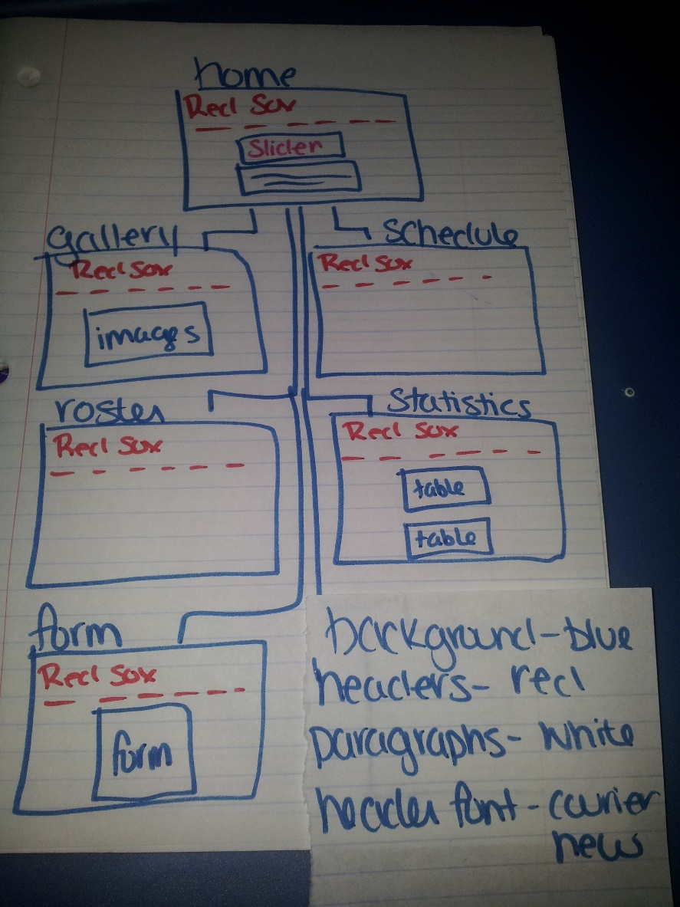

## Assignment requirements

1. *Location* – all files will be located in the public folder of your uvm account. The assignment web page and the submit process will detail the exact location. Failure to have your site located in the correct folder by the due dates will result in a zero on the assignment. Be sure to pay attention to the lowercase letters.
2. *Html Validation* – All pages will pass W3C Html validation for html 5.
3. *CSS Validation* – All pages will pass W3C CSS 3.0 validation.
4. *Meta Information* – All pages will contain a proper title tag, Meta tags (author, character set and description).
5. *Head Section* – put the doctype and head section information in a file named top.php so you can include it all the pages.
6. *Header* – All pages will contain a header with the logo about your site. File name should be header.php
7. *Navigation* – All pages will contain navigation to all other pages on the site using an ordered list. File name should be nav.php
8. *Content* – Each page will have a minimum of 150 words not counting titles, lists or links. Use the article, aside or section html elements. All files will use .php extension.
9. *Pages*- A minimum of 6 pages
10. *Browser compatibility* - This site will be checked on Firefox, Safari, Chrome and Internet Explorer.
11. *Screen Resolutions* – Your site should be able to handle a little flexibility in different size screens and still look reasonable well.
12. *Footer* – All pages will contain a footer with the content determined by you. Your site will be broken up into separate functional files, ie header, nav, footer. You will use .php extension and include these files in each page
13. Create a form.php which will contain the following:
    1. one text box for a users email address.
    2. one additional text box.
    3. one list box.
    4. two check boxes.
    5. two radio buttons.
    6. Submit and ReSet command buttons.
    7. Field sets and legends as needed
    8. data should be validated for not missing, valid format etc as needed with both html and php
    9. form should email the person who filled it out
    10. form data should be saved to a file on the uvm share
14. Create a gallery.php which will be a page with a list of photos
    1. Use the html target attribute to open the image in a new window.
15. Data files : Create a tables in roster.php, gameSchedule.php, and statistics.php
    1. Format the table with CSS.
16. *CSS* – all pages will have a linked style sheet. I will be looking for a flexible layout like my sample (it can look different it just needs to be a little bit flexible). Be sure to use classes and ID’s as needed.
17. *Don't* forget update your mainindex.html file.
18. *Content* – Each page will have a minimum of 150 words not counting titles, lists or links. Be sure to use the correct elements to hold your content.

## Specific requirements

1. *Background color*: Use a background color: blue for all pages.
2. *Headers*: Red
3. *Text color*: white
4. *Font:* For headers: Courier New
5. *Links:* Horizontal links on top of the page
6. *Images:* Images will open into a new tab
7. *Tables:* white background with red borders
8. *Form:* In the center of the page, background color: white with lightblue headers and red text. The form will display all necessary text boxes, radio buttons, check lists, and drop down boxes.
9. *Registration:* The form will save all submitted information into a registration.csv file
10. *Email:* The form will email the information that was filled out to the email entered