MongoDB-Let's learn!

MongoDB

MongoDB is
- Open source document database
- NoSQL database
- Highly scalable
- Schemaless

Data is stored in JSON format and internally supported by BSON format.

The document is the unit of storing data in a MongoDB database
A simple example of a JSON document is as follows :
A collection is the group of documents.
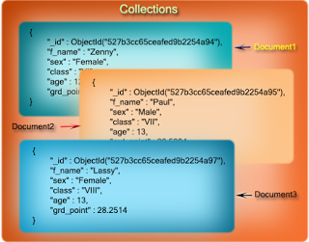

MongoDB installation on Ubuntu
Step #1 Set up the package database
In this step, we will import the MongoDB GPG public key.
MongoDB is already included in Ubuntu package repositories, but the official MongoDB repository provides most up-to-date version and is the recommended way of installing the software. Ubuntu ensures the authenticity of software packages by verifying that they are signed with GPG keys, so we first have to import they key for the official MongoDB repository.
sudo apt-key adv --keyserver hkp://keyserver.ubuntu.com:80 --recv 7F0CEB10

Then we’ll create a list file for MongoDB:

echo 'deb http://downloads-distro.mongodb.org/repo/ubuntu-upstart dist 10gen' | sudo tee /etc/apt/sources.list.d/mongodb.list

Now reload the package database:

sudo apt-get update

Step #2: Install Latest Stable Version MongoDB

At this point, installing MongoDB is as simple as running just one command:

sudo apt-get install -y mongodb-org

Step #3: Get MongoDB Running

Start-Up MongoDB

sudo service mongod start

Enter the MongoDB Command Line

mongo

Shutdown MongoDB

sudo service mongod stop
Once the installation is done we can procede with the following
Create Database

>use DB_NAME

Example: use mydb
To display the database you are using, type db
>db
Check the list of databases

>show dbs

Note: To show your db in the list it should contain at-least one document.
Test is the default database

Dropping database
Drops the current database

>db.dropDatabase()

Creating a collection

>db.createCollection(name, option)

"option" field can have 4 different values. They are
- capped
- autoIndexID
- size
- max
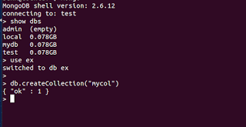
creating database and collection

Check the list of collection

>show collections

Dropping a collection

>db.COLLECTION_NAME.drop()

· String − This is the most commonly used datatype to store the data. String in MongoDB must be UTF-8 valid.
· Integer − This type is used to store a numerical value. Integer can be 32 bit or 64 bit depending upon your server.
· Boolean − This type is used to store a boolean (true/ false) value.
· Double − This type is used to store floating point values.
· Min/ Max keys − This type is used to compare a value against the lowest and highest BSON elements.
· Arrays − This type is used to store arrays or list or multiple values into one key.
· Timestamp − ctimestamp. This can be handy for recording when a document has been modified or added.
· Object − This datatype is used for embedded documents.
· Null − This type is used to store a Null value.
· Symbol − This datatype is used identically to a string; however, it's generally reserved for languages that use a specific symbol type.
· Date − This datatype is used to store the current date or time in UNIX time format. You can specify your own date time by creating object of Date and passing day, month, year into it.
· Object ID − This datatype is used to store the document’s ID.
· Binary data − This datatype is used to store binary data.
· Code − This datatype is used to store JavaScript code into the document.
· Regular expression − This datatype is used to store regular expression.

Insert a document

>db.COLLECTION_NAME.insert(document)
Example: db.mycol.insert({
_id: ObjectId(7df78ad89c),
title: 'MongoDB Overview',
description: 'NoSQL',})
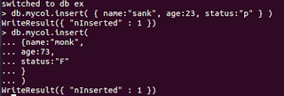
Inserting a document

If _id fiels is not specified then MongoDB assigns an unique object id to the document.
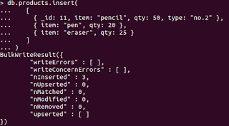
Inserting multiple documents
Update a document

>db.COLLECTION_NAME.update(Selection_Criteria, Updated_data)
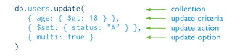

Delete document
Here Remove() method is used to delete a document.
>db.COLLECTION_NAME.remove(DELETION_CRITERIA)
Query Document
find() method is used to query data.
>db.COLLECTION_NAME.find()
using find() query to get all the documents with status "p"
We can use pretty() method to get the result in the formatted way.
>db.mycol.find().pretty()
Limit() method
Accepts number as argument, and displays that much of documents.
>db.COLLECTION_NAME.find().limit(NUMBER)
If you don't specify the number argument in limit() method then it will display all documents from the collection.
Bulk Write Operation
MongoDB provides clients the ability to perform write operations in bulk. Bulk write operations affect a single collection. MongoDB allows applications to determine the acceptable level of acknowledgement required for bulk write operations.

The db.collection.bulkWrite() method provides the ability to perform bulk insert, update, and remove operations. MongoDB also supports bulk insert through the db.collection.insertMany()
bulkWrite() supports the following write operations:
- insertOne
- updateOne
- updateMany
- replaceOne
- deleteOne
- deleteMany

Skip() method

It also accepts number as an argument which is used to skip document or documents.

>db.COLLECTION_NAME.find().limit(NUMBER).skip(NUMBER)
Sort() method
It is used to sort the documents in ascending or in descending order. To specify sorting order 1 and -1 are used. 1 is used for ascending order while -1 is used for descending order.

>db.COLLECTION_NAME.find().sort({KEY:1})
Indexing
Indexes support the efficient resolution of queries. A scan without indexes is inefficient.To create an index you need to use ensureIndex() method of MongoDB.
>db.COLLECTION_NAME.ensureIndex({KEY:1})
Here key is the name of the field on which you want to create index and 1 is for ascending order. To create index in descending order you need to use -1.
Aggregate() method
Aggregations operations process data records and return computed results. Aggregation operations group values from multiple documents together, and can perform a variety of operations on the grouped data to return a single result. In SQL count(*) and with group by is an equivalent of mongodb aggregation.
>db.COLLECTION_NAME.aggregate(AGGREGATE_OPERATION)
Replication
Replication is the process of synchronizing data across multiple servers. Replication provides redundancy and increases data availability with multiple copies of data on different database servers. Replication protects a database from the loss of a single server. Replication also allows you to recover from hardware failure and service interruptions.
Working

Replica set is a group of two or more nodes (generally minimum 3 nodes are required).
In a replica set, one node is primary node and remaining nodes are secondary.
All data replicates from primary to secondary node.
At the time of automatic failover or maintenance, election establishes for primary and a new primary node is elected.
After the recovery of failed node, it again join the replica set and works as a secondary node.
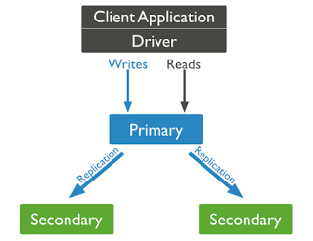
Working of replica
Sharding

Sharding is the process of storing data records across multiple machines and it is MongoDB's approach to meeting the demands of data growth. As the size of the data increases, a single machine may not be sufficient to store the data nor provide an acceptable read and write throughput. Sharding solves the problem with horizontal scaling. With sharding, you add more machines to support data growth and the demands of read and write operations.

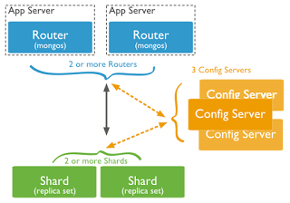

In the following diagram, there are three main components −
- Shards − Shards are used to store data. They provide high availability and data consistency. In production environment, each shard is a separate replica set.
- Config Servers − Config servers store the cluster's metadata. This data contains a mapping of the cluster's data set to the shards. The query router uses this metadata to target operations to specific shards. In production environment, sharded clusters have exactly 3 config servers.
- Query Routers − Query routers are basically mongo instances, interface with client applications and direct operations to the appropriate shard. The query router processes and targets the operations to shards and then returns results to the clients. A sharded cluster can contain more than one query router to divide the client request load. A client sends requests to one query router. Generally, a sharded cluster have many query routers.

