JAVA configuration in EC2 Instance

1.Download java file in your local machine
2.copy the jave file to ec2-user using command
$ scp -i file_name.pem jdk.tar.gz ec2-user@DNS:/home/ec2-user/

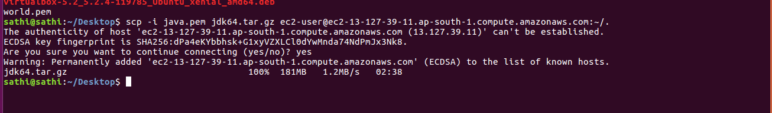
3.Login in to ec2 machine them Move to /usr/lib/jvm directory
4.Copy the jdk.tar.gz file to jvm directory using command
$ cp /home/ec2_user/jdk.tar.gz
5.Unpack the jdk.tar.gz file using command
$ tar -xf jdk.tar.gz
6.Unpack directory have stringer owner ship go and change directory permission to root , prevent the feature conflicts using command
$ chown root:root jdk1.8.0_151

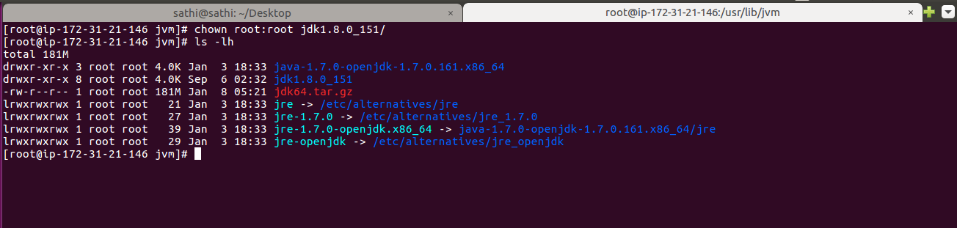
7.Check the java version, it uses a default version of java
$ java -version
8.Then use alternatives command
$ alternatives
alternatives - maintain symbolic links determining default commands
alternatives creates, removes, maintains and displays information about the symbolic links comprising the alternatives system.The alternatives system is a reimplementation of the Debian alternatives system.
A symbolic link is much like a desktop shortcut within Windows. The symbolic link merely points to the location of a file.
Alternatives [options] –install link name path priority [--slave link name path]... [--initscriptservice]

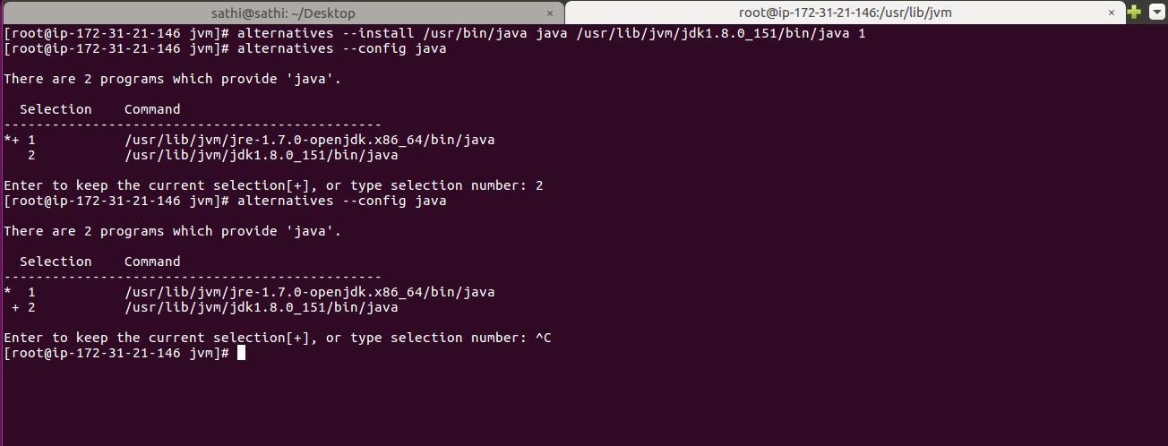

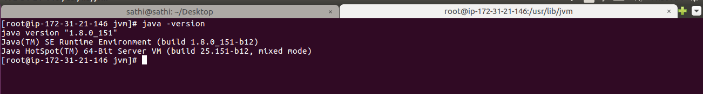

9. To set the java environment change directory to /etc/profile.d directory
creat a new file called java.sh
$ nano java.sh

write this content in the above created file
(export JAVA_HOME=’/usr/lib/jvm/jdk1.8.0_151’)
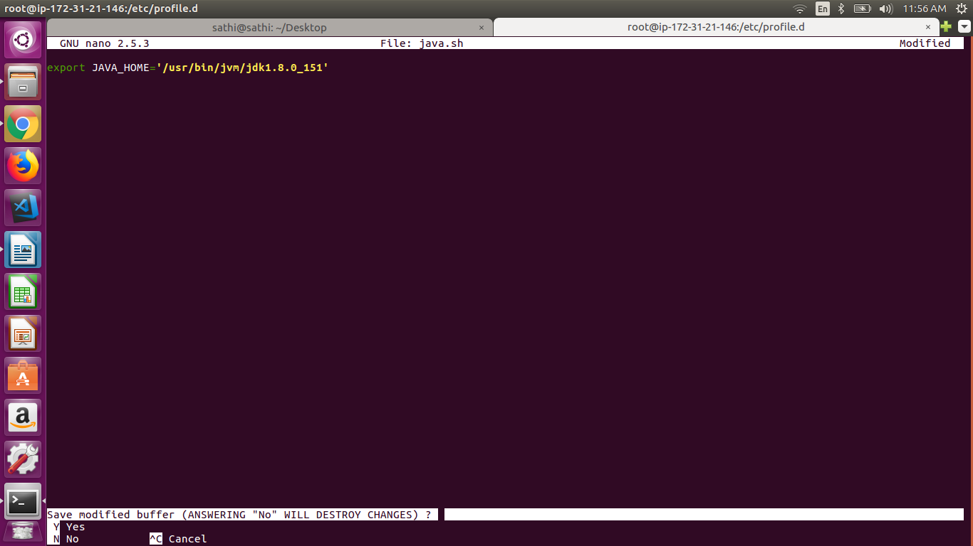

10.Finally get back to home directory then check the java -version
you will result of present configured version.

