Kubernetes

is an open-source system for automating deployment, scaling, and management of containerized applications.

Planet Scale
Designed on the same principles that allows Google to run billions of containers a week, Kubernetes can scale without increasing your ops team.

Never Outgrow
Whether testing locally or running a global enterprise, Kubernetes flexibility grows with you to deliver your applications consistently and easily no matter how complex your need is.

Run Anywhere
Kubernetes is open source giving you the freedom to take advantage of on-premises, hybrid, or public cloud infrastructure, letting you effortlessly move workloads to where it matters to you.

Kubernetes Features

Automatic binpacking
Automatically places containers based on their resource requirements and other constraints, while not sacrificing availability. Mix critical and best-effort workloads in order to drive up utilization and save even more resources.

Self-healing
Restarts containers that fail, replaces and reschedules containers when nodes die, kills containers that don't respond to your user-defined health check, and doesn't advertise them to clients until they are ready to serve.

Horizontal scaling
Scale your application up and down with a simple command, with a UI, or automatically based on CPU usage.

Service discovery and load balancing
No need to modify your application to use an unfamiliar service discovery mechanism. Kubernetes gives containers their own IP addresses and a single DNS name for a set of containers, and can load-balance across them.

Automated rollouts and rollbacks
Kubernetes progressively rolls out changes to your application or its configuration, while monitoring application health to ensure it doesn't kill all your instances at the same time. If something goes wrong, Kubernetes will rollback the change for you. Take advantage of a growing ecosystem of deployment solutions.

Secret and configuration management
Deploy and update secrets and application configuration without rebuilding your image and without exposing secrets in your stack configuration.

Storage orchestration
Automatically mount the storage system of your choice, whether from local storage, a public cloud provider such as GCP or AWS, or a network storage system such as NFS, iSCSI, Gluster, Ceph, Cinder, or Flocker.

Batch execution
In addition to services, Kubernetes can manage your batch and CI workloads, replacing containers that fail, if desired.

Overview

Kubernetes Basics

This tutorial provides a walkthrough of the basics of the Kubernetes cluster orchestration system.

What can Kubernetes do for you?

With modern web services, users expect applications to be available 24/7, and developers expect to deploy new versions of those applications several times a day. Containerization helps package software to serve these goals, enabling applications to be released and updated in an easy and fast way without downtime. Kubernetes helps you make sure those containerized applications run where and when you want, and helps them find the resources and tools they need to work

Kubernetes Clusters

- Kubernetes coordinates a highly available cluster of computers that are connected to work as a single unit.
- Kubernetes automates the distribution and scheduling of application containers across a cluster in a more efficient way.

A Kubernetes cluster consists of two types of resources:

- The Master coordinates the cluster

- Nodes are the workers that run applications

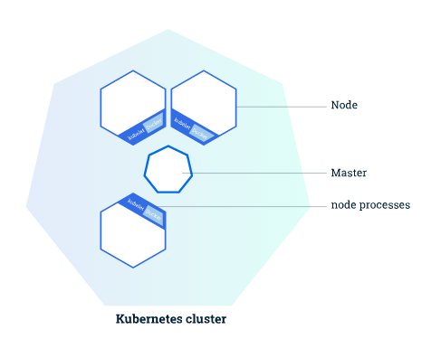

The Master is responsible for managing the cluster.The master coordinates all activities in your cluster, such as scheduling applications, maintaining applications' desired state, scaling applications, and rolling out new updates.

