Git

Git is a distributed revision control and source code management system with an emphasis on speed. Git was initially designed and developed by Linus Torvalds for Linux kernel development. Git is a free software distributed under the terms of the GNU General Public License version 2.

Version Control System
Version Control System (VCS) is a software that helps software developers to work together and maintain a complete history of their work.
Listed below are the functions of a VCS:
- Allows developers to work simultaneously.
- Does not allow overwriting each other’s changes.
- Maintains a history of every version.

Types of version control
When you work on a development team, you may be touching similar parts of the code throughout a project. As a result, changes made in one part of the source can be incompatible with those made by another developer working at the same time.
Version control helps solve these kinds of problems and provides:
- A complete history of every file, which enables you to go back to previous versions to analyze the source of bugs and fix problems in older versions.
- The ability to work on independent streams of changes, which allows you to merge that work back together and verify that your changes conflict.
- The ability to trace each change with a message describing the purpose and intent of the change and connect it to project management and bug tracking software.

There are two types of version control: centralized and distributed.

Centralized version control:
With centralized version control systems, you have a single “central” copy of your project on a server and commit your changes to this central copy. You pull the files that you need, but you never have a full copy of your project locally. Some of the most common version control systems are centralized, including Subversion (SVN) and Perforce.

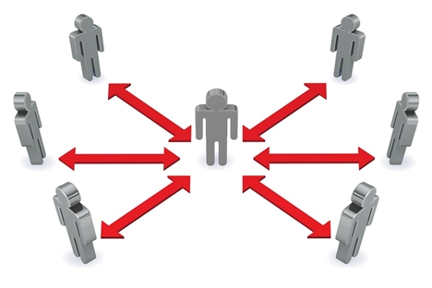

Distributed version control:

With distributed version control systems (DVCS), you don't rely on a central server to store all the versions of a project’s files. Instead, you clone a copy of a repository locally so that you have the full history of the project. Two common distributed version control systems are Git and Mercurial.
While you don't have to have a central repository for your files, you may want one "central" place to keep your code so that you can share and collaborate on your project with others. That's where Bitbucket comes in. Keep a copy of your code in a repository on Bitbucket so that you and your teammates can use Git or Mercurial locally and to push and pull code.

Blobs
Blob stands for Binary Large Object. Each version of a file is represented by blob. A blob holds the file data but doesn’t contain any metadata about the file. It is a binary file, and in Git database, it is named as SHA1 hash of that file. In Git, files are not addressed by names. Everything is content-addressed.

Trees
Tree is an object, which represents a directory. It holds blobs as well as other sub-directories. A tree is a binary file that stores references to blobs and trees which are also named as SHA1 hash of the tree object.

Commits
Commit holds the current state of the repository. A commit is also named by SHA1 hash. You can consider a commit object as a node of the linked list. Every commit object has a pointer to the parent commit object. From a given commit, you can traverse back by looking at the parent pointer to view the history of the commit. If a commit has multiple parent commits, then that particular commit has been created by merging two branches.

Branches
Branches are used to create another line of development. By default, Git has a master branch, which is same as trunk in Subversion. Usually, a branch is created to work on a new feature. Once the feature is completed, it is merged back with the master branch and we delete the branch. Every branch is referenced by HEAD, which points to the latest commit in the branch. Whenever you make a commit, HEAD is updated with the latest commit.

Tags
Tag assigns a meaningful name with a specific version in the repository. Tags are very similar to branches, but the difference is that tags are immutable. It means, tag is a branch, which nobody intends to modify. Once a tag is created for a particular commit, even if you create a new commit, it will not be updated. Usually, developers create tags for product releases.

Clone
Clone operation creates the instance of the repository. Clone operation not only checks out the working copy, but it also mirrors the complete repository. Users can perform many operations with this local repository. The only time networking gets involved is when the repository instances are being synchronized.

Pull
Pull operation copies the changes from a remote repository instance to a local one. The pull operation is used for synchronization between two repository instances. This is same as the update operation in Subversion.

Push
Push operation copies changes from a local repository instance to a remote one. This is used to store the changes permanently into the Git repository. This is same as the commit operation in Subversion.

HEAD
HEAD is a pointer, which always points to the latest commit in the branch. Whenever you make a commit, HEAD is updated with the latest commit. The heads of the branches are stored in .git/refs/heads/ directory.

Patch
Patch is a text file, whose contents are similar to Git diff, but along with code, it also has metadata about commits; e.g., commit ID, date, commit message, etc. We can create a patch from commits and other people can apply them to their repository.

Different Platforms
GNU/Linux and Mac OS uses line-feed (LF), or new line as line ending character, while Windows uses line-feed and carriage-return (LFCR) combination to represent the line-ending character.
To avoid unnecessary commits because of these line-ending differences, we have to configure the Git client to write the same line ending to the Git repository.
For Windows system, we can configure the Git client to convert line endings to CRLFformat while checking out, and convert them back to LF format during the commit operation. The following settings will do the needful.
$ git config – global core.autocrlf true
For GNU/Linux or Mac OS, we can configure the Git client to convert line endings from CRLF to LF while performing the checkout operation.
$ git config – global core.autocrlf input

GitHub is a web-based hosting service for software development projects that uses the Git revision control system. It also has their standard GUI application available for download

Advantages of Git

Free and open source

Fast and small

As most of the operations are performed locally, it gives a huge benefit in terms of speed.

Implicit backup

Data present on any client side mirrors the repository, hence it can be used in the event of a crash or disk corruption.

Security

Git uses a common cryptographic hash function called secure hash function (SHA1), to name and identify objects within its database.

Easier branching

CVCS uses cheap copy mechanism, If we create a new branch, it will copy all the codes to the new branch, so it is time-consuming and not efficient. Also, deletion and merging of branches in CVCS is complicated and time-consuming. But branch management with Git is very simple. It takes only a few seconds to create, delete, and merge branches.

Changing the Last Commit:git commit --amend
The git commit –amend command is a convenient way to modify the most recent commit. It lets you combine staged changes with the previous commit instead of creating an entirely new commit. It can also be used to simply edit the previous commit message without changing its snapshot. But, amending does not just alter the most recent commit, it replaces it entirely, meaning the amended commit will be a new entity with its own ref. To Git, it will look like a brand new commit, which is visualized with an asterisk (*) in the diagram below.

Setting Up Git

$ git config - - global user.name “sathi”
who gets credit for changes

$ git config - - global user.email aaaaa@gmail.com
what email you use

$ git config - - global colour.ui true
pretty command line colors

Git Work Flow
- You modify a file from the working directory.
- add these files to the staging area.
- perform commit operation that moves the files from the staging area. After push operation, it stores the changes permanently to the Git repository.

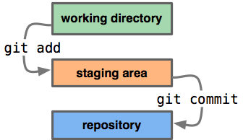

Move on to the important git commands
$ git status
To check what’s changed since last commit
$ git add - - all or git add .
To add all the files from the directory to stageing area.
$ git add <list of files>
Add the list of files
$ git add *.txt
Add all the text files in current directory

$ git add “*.txt”
If couts arround the *.txt . Add all text files in the whole project
$ git add src/*.txt
Add all the text files in src directory
$ git add src/
Add all files in src directory

$ git commit -m “created a README.txt”
Commit the staged snapshot. With commit message (-m <message>)
Note:README files are a quick and simple way for other users to learn more about your work.
$ git commit -a -m “created a README.txt”
-a = Tell the command to automatically stage files that have been modified and commit the staged snapshot. (both process in a single command(add+commit))

Log
$ git log
To see the list of our recent commits(it contines commit sha hase Id, Author,Date and commit message)
$ git log - -oneline -p
To see the patch output, what lines are added and deleted
$ git log - -oneline - -stat
Will show you home maney insertions and deletions

$ git log - -oneline - -graph
To see the visual represetation of the branch merging into master
Date Ranges Log
$ git log - -until=1.minute.ago
untile 1minute ago
$ git log - -since=1.day.ago
since 1day ago
$ git log - -since=2.month.ago - -until=4.weeks.ago
since 2months ago and untile 4weeks ago
$ git log - -since=2000-01-01 - -until=2012-12-21
since and until absolute

Diffs
$ git diff
Show unstaged diffrences since last commit
- removed line with red
- added line with green
$ git diff - -staged
View the staged diffrences
$ git diff HEAD
Diffrence between last commit and current state
(includes both staged and unstaged files)
$ git diff HEAD^
parent of latest
$ git diff HEAD^^
Grandparent of latest
$ git diff HEAD~5
Five commits ago
$ git diff HEAD^..HEAD
Second most recent commit vs most recent commit
$ git diff <SHA1(commit ID 1> <SHA2(commit ID 2)>
Range of SHAS(secure hash function)
$ git diff master admin
Diffrence between two branchs
$ git diff - -since=1.month.ago - -until=1.week.ago
Time base diffrence
Blame
$ git blame Readme.md –date short
To see the all changes line by line, author, date, which commit created, line and content
Excluding Files
Some time you dont want to include some folder to remote repository
go to the .git/info/exclude file add your folder name. It will wxclude this folder from git not from you local repository.
Excluding From All Copies
you need exclude from all copies.
Add that file to .gitignore file
Ex: logs/*.log add this pattern
Any log files in logs folder it never included rm

Removing Files
$ git rm Readme.txt
Deleted from the local filesystem and untracked
Untracking Files
$ git rm - -cached Readme.txt
It stops tracking the file

Reset, Checkout, and Revert

Command | Scope | Common use cases
git reset | Commit-level | Discard commits in a private branch or throw away uncommited changes
git reset | File-level | Unstage a file
git checkout | Commit-level | Switch between branches or inspect old snapshots
git checkout | File-level | Discard changes in the working directory
git revert | Commit-level | Undo commits in a public branch

Reset
On the commit-level, resetting is a way to move the tip of a branch to a different commit. This can be used to remove commits from the current branch.
Ex: $ git checkout hotfix
$ git reset HEAD^2
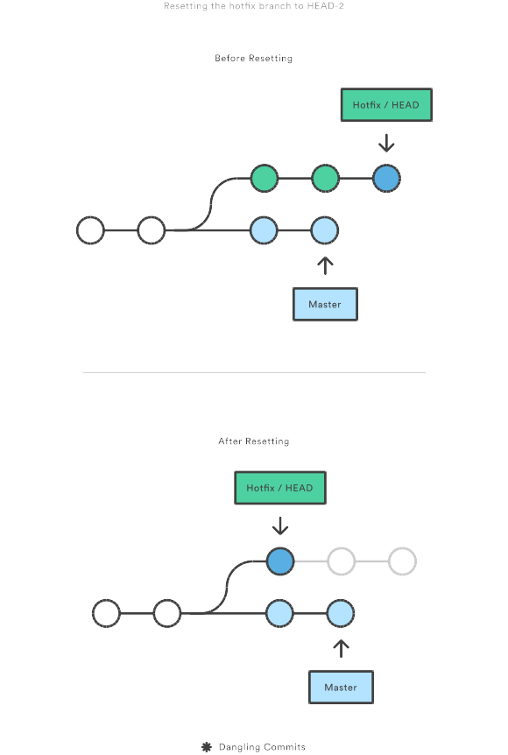

$ git reset HEAD <file_name>
To unstage the staged changes
????????????????????????????????????????/
Cloning a repository
$ git clone https://github.com/devlopment/sathigit.git
$ git remote -v
It will list all the remote url
$ git branch admin
It creat the new branch
$ git checkout admin
To jump on that new admin branch
$ git branch -d admin
To delete that branch
$ git checkout -b admin
shortcut for create new branch and checks out the branch
$ git merge admin
merge with master branch
Note:
1.Fast-Forward Merging : without any changes in the master only changes in the other branch
2.Recursive Merging : git can’t fast-forward since changes were made in both branches
Pull
$ git pull
sync our local repository with the remote one
(git pull is same as git fetch)
every time you pull from remote one it creates new branch called origin/master, you need to merge that origin/master with master using below command
$ git merge origin/master
merges the origin/masteer with master
$ git push
update origin/master be at the same as our local repo

Tagging
A tag is a reference to a commit used mostly for release versioning

$ git tag
list all the tags
$ git checkout <tag>
check out code at commit
$ git tag -a v1.0.0 -m “version 1.0.0”
To add a new tag
$ git push –tags
To push new tags
Rebase
$ git rebase
1.Move all changes to master which are not in origin/master to a temporary.
2.Run all origin/master commits.
3.Run all commits in the temporary area, one at a time.
(No merge commits needed)
Purging history
Removing files from git history
Example:
Bob was committed a file he shouldn’t have
Even if he delete it now, the contents will be visible on history.
TREE FILTER
To rewrite history we gone use to:
$git filter-branch –tree-filter < Any shell command >...
Git will check each commit out into working directory, run your command , and re-commit.
Example:
Bob wanna do this
$git filter-branch --tree-filter ‘rm –f passwords.index’
Removes “password.index” from root project
$git filter-branch –tree-filter ‘rm –f password.index’ -- --all
Goes through all branches, and removes “password.index” from each commit
## -- --all = filters all commits in all branches
## Head = filters only current branch
COMMAND FAILS, FILTER FAILS
$ git filter-branch –tree-filter ‘rm password.index” -- --all
Fails if file isn’t present
$ git filter-branch –tree-filter ‘rm –f password.index’ -- --all
INDEX FILTER
It works on staging area
$ git filter-branch --index-filter <command>....
Git will run your command against each commit, but without checking it out first(so it’s faster)
$ git filter-branch ‘rm –f password.index’
Operates on working directory
$ git filter-branch --index-filter ‘git rm –cached --ignore-unmatch password.index’
Operates on staging area
As with “—tree-filter”,if the command fails the filter will stop
$ git filter-branch –index-filter ‘git rm --cached password.index’
Fails if file isn’t present
$ git filter-branch --index-filter ‘git rm --cached --ignore-unmatch password.index’
Succeeds even if file isn’t present
Force
After you run filter-branch, git leaves a backup of your tree in the “.git” directory
If run this command again
$git filter-branch –tree-filter ‘rm –f password.index’
By default, you can’t run filter-branch again because it won’t overwrite the backup
This is over come by force remove
$ git filter-branch –f --tree-filter ‘rm –f password.index’
You can force it with a –f option
PRUNE EMPTY COMMITS
if the commits has no contents how do we get read about this?
We can run the filter-branch command
$ git filter-branch –f --prune-empty -- --all
“--prune-empty” option drops commits that don’t alter any files
It can also be prune during filtering
$ git filter-branch --tree-filter ‘rm –f password.index’ --prune-empty -- --all

