# Step 1:

From <https://github.com/sathik80/TestCrawler>

Please Click on Code Download zip option

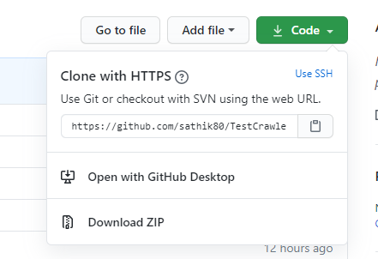

# Step 2:

Extract the zip in your local machine for instance D:\GitProjects\

This will give D:\GiiProjects\TestCrawler-master\ that has the Eclipse Project with source.

# Step 3:

From Eclipse, File -> Import -> General-> Existing Projects into workspace

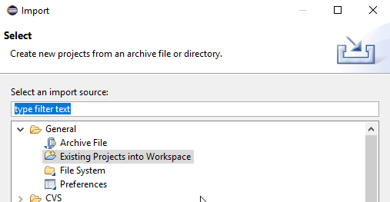

# Step 4:

Choose the extracted Folder that will show the eclipse project file , select it and click finish.

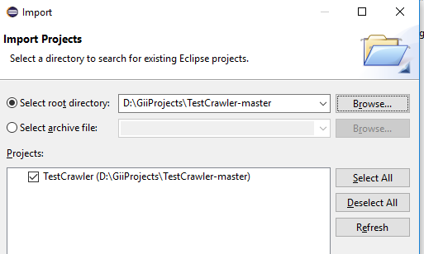

# Step 5:

Now we should see a Project in eclipse

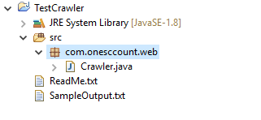

# Step 6:

Right click on Crawler.java ->Run As -> Java Application

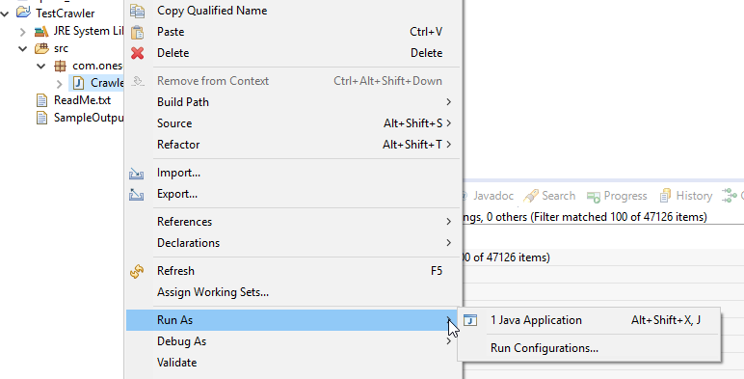

That should ask for the search term In the console “Please enter the search term :” Please type the term and press enter. Program should crawl and print the top5 java scrips.