**Background of the business :**

This is a business that collects tea leaves....In this busness, the owner of this business uses his employees to go to people's houses and collect tea leaves and send them to the factory.

**No of Employee:**

1

**Main business processes:**

The customer's tea leaves are sent to the factory by the business owner, and the factory allocates a monthly price for per kilogram of tea leaves and the factory pays for the total tea leaves provided by the business owner at that price.

The customer’s tea leaves are sent to the factory through business owner daily basis, and the factory decides and fix a price for per kilogram of tea leaves at the end of each month. Based on the fixed price the factory pays to the business owner for the total tea leaves supplied by him for the relevant month.

The businessman sets a price for the month for per kilogram of of tea considering the amount given for per kilogram of tea leaves by the factory.

Customers have a bill book in their name, and all transactions are written in that book.

The business owner pays the customer at the end of the month for the total tea leaves (in Kg’s) given by the customer during the month.

If the customer has purchased any fertilizer or tea leaves (tea packets for home use) during the month then the cost of those will be deducted from the customer’s monthly bill and the balance will be paid by the business owner. Also if the customer has taken any money advances during month it too will be deducted from the final bill.

Finally, the business owner finds his net profit by deducting the amounts paid to the customer’s from the total amount he received from the factory.

**My IT solution:**

Maintaining the customers' bill books and giving them a bill at the end of the month stating all their transactions

Also, the business owner can auto generate his net profit

**ER DIGRAm**

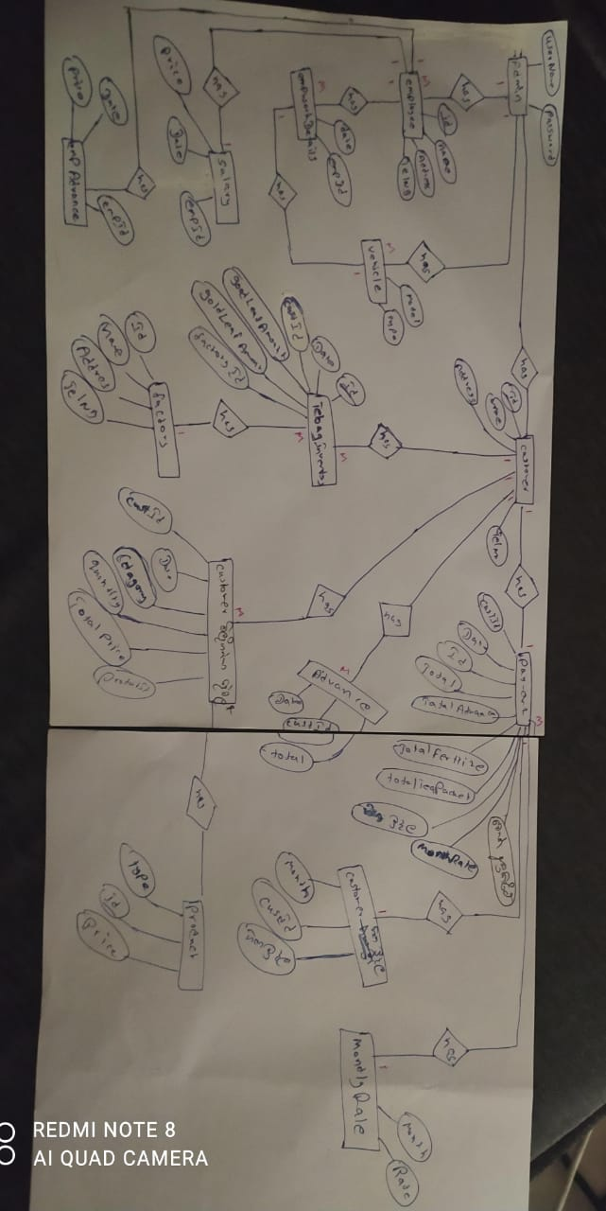

**use case diagram:**

