Assignment 2

# Customization to CNN model

For this CNN model, Dataset was FER 2013 from Kaggle. Dataset format was CSV. But within FER2013 dataset, Disgust emotion has only 513 pictures, that effect CNN model’s accuracy. I created my own dataset, this dataset include FER2013 data and pictures taken from CDAP research. My added code below.

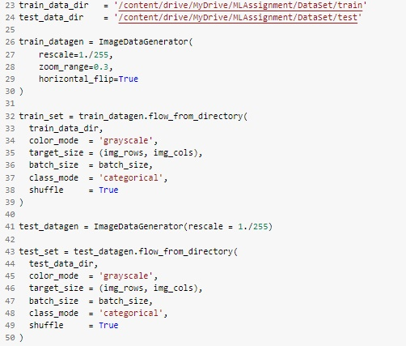

For CNN model, I added two more two more modules for increase accuracy and reduce over fitting in the model. Added code below.

