**iGamer**

**Project ID: 4**

**Report**

P.P.G.S.H.A.Guruge - IT17042352

N.J.Pathiranage - IT17129404

B.Sc. Special (Hons.) Degree in Information Technology

Department of Software Engineering

Sri Lanka Institute of Information Technology

Sri Lanka

March 2020

**Table of Contents**

**No table of contents entries found.**

**App Icon**

The name “iGamer” is chosen for the app name and orange is the theme colour chosen for the iGamer app. The launcher icon is a picture of a game console.

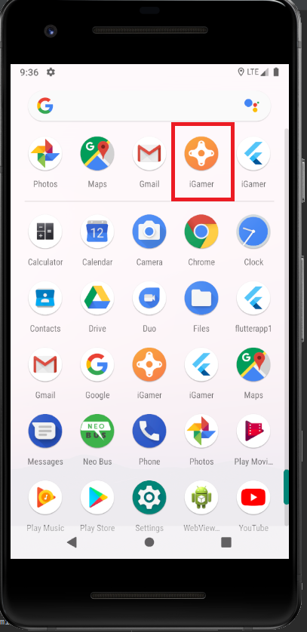

AndroidManifest.xml

In the following AndroidManifest.xml file, the app name is set in **android:name** and app launcher icon is set in **android:icon** values.

<**manifest xmlns:android="http://schemas.android.com/apk/res/android"**

**package="com.example.igamer"**>

*<!-- io.flutter.app.FlutterApplication is an android.app.Application that*

*calls FlutterMain.startInitialization(this); in its onCreate method.*

*In most cases you can leave this as-is, but you if you want to provide*

*additional functionality it is fine to subclass or reimplement*

*FlutterApplication and put your custom class here. -->*

<**application**

**android:name="io.flutter.app.FlutterApplication"**

**android:label="iGamer"**

**android:icon="@mipmap/ic_launcher"**>

<**activity**

**android:name=".MainActivity"**

**android:launchMode="singleTop"**

**android:theme="@style/LaunchTheme"**

**android:configChanges="orientation|keyboardHidden|keyboard|screenSize|smallestScreenSize|locale|layoutDirection|fontScale|screenLayout|density|uiMode"**

**android:hardwareAccelerated="true"**

**android:windowSoftInputMode="adjustResize"**>

<**intent-filter**>

<**action android:name="android.intent.action.MAIN"**/>

<**category android:name="android.intent.category.LAUNCHER"**/>

</**intent-filter**>

</**activity**>

*<!-- Don't delete the meta-data below.*

*This is used by the Flutter tool to generate GeneratedPluginRegistrant.java -->*

<**meta-data**

**android:name="flutterEmbedding"**

**android:value="2"** />

</**application**>

</**manifest**>

**Splash Screen**

The app consists of a Splash Screen showing the app icon and app name before starting the app.

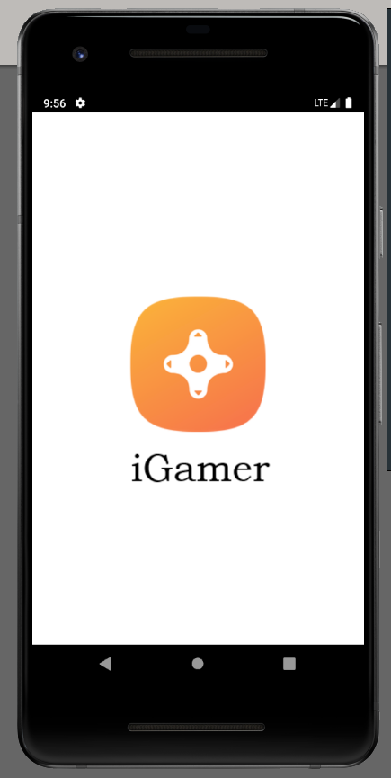

launch_background.xml

The splash screen is implemented as follows.

*<?****xml version="1.0" encoding="utf-8"****?>*

*<!-- Modify this file to customize your launch splash screen -->*

<**layer-list xmlns:android="http://schemas.android.com/apk/res/android"**>

<**item android:drawable="@android:color/white"** />

<**item android:bottom="12dp"**>

<**bitmap**

**android:gravity="center"**

**android:src="@drawable/icon"**/>

</**item**>

<**item android:top="250dp"**>

<**bitmap**

**android:gravity="center"**

**android:src="@drawable/imagetext"**/>

</**item**>

</**layer-list**>

**Folder Structure**

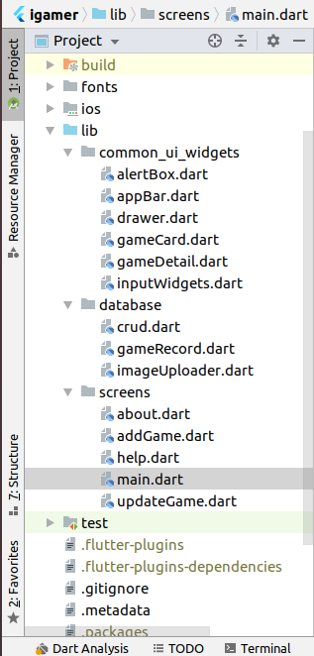

**Main page**

iGamer flutter app runs if only internet connection is available. If network connection is not available, it is notified to the user as follows.

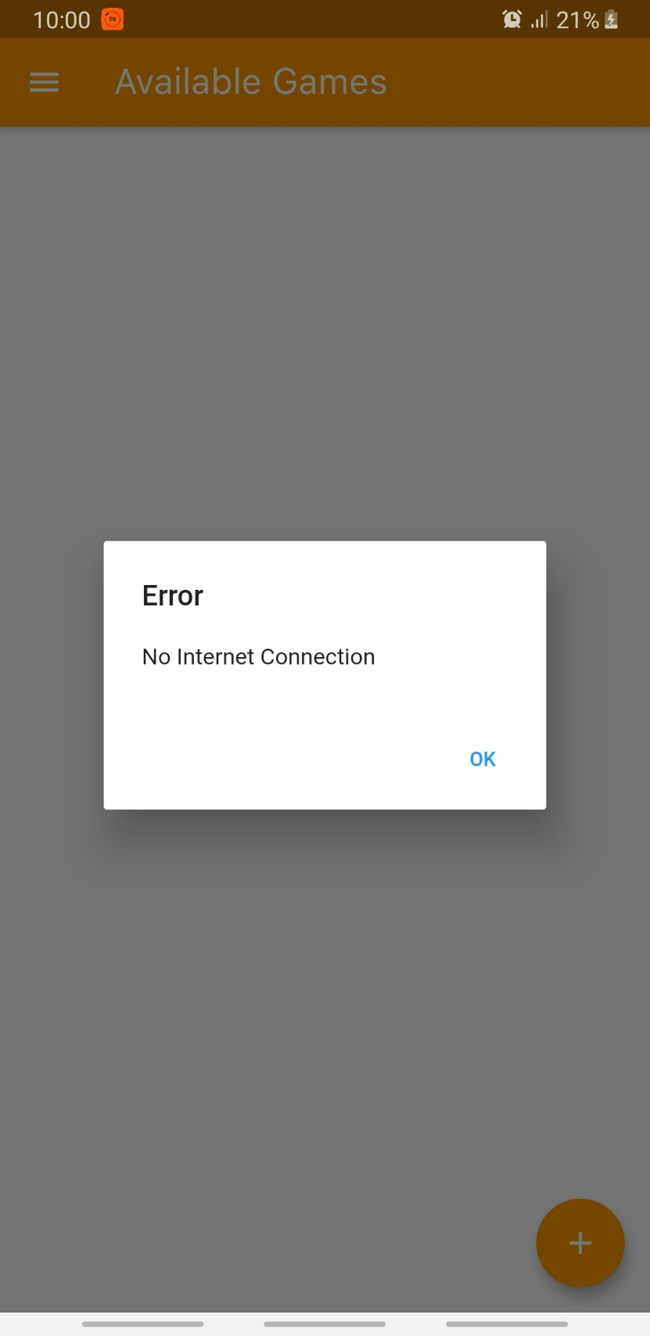

The functionality of checking the internet connection is implemented in main.dart as follows.

*// this function checks active internet connection*

*// if not, it will popup an Alert Box*

_checkInternetConnection(BuildContext context) **async** {

**try** {

**await** InternetAddress.*lookup*(**'google.com'**);

} **on** SocketException **catch** (_) {

**new** AppAlertBox(context, **"Error"**, **"No Internet Connection"**, **"OK"**)

.showAlertDialog();

}

}

The images of each game which are stored in Firebase store are network images. If network connection is unavailable, those images are not loaded.

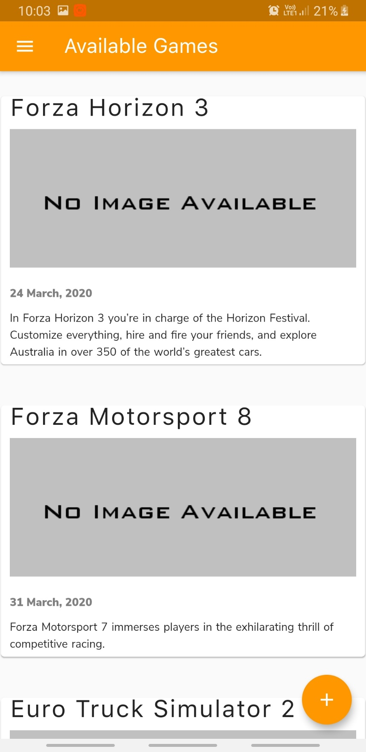

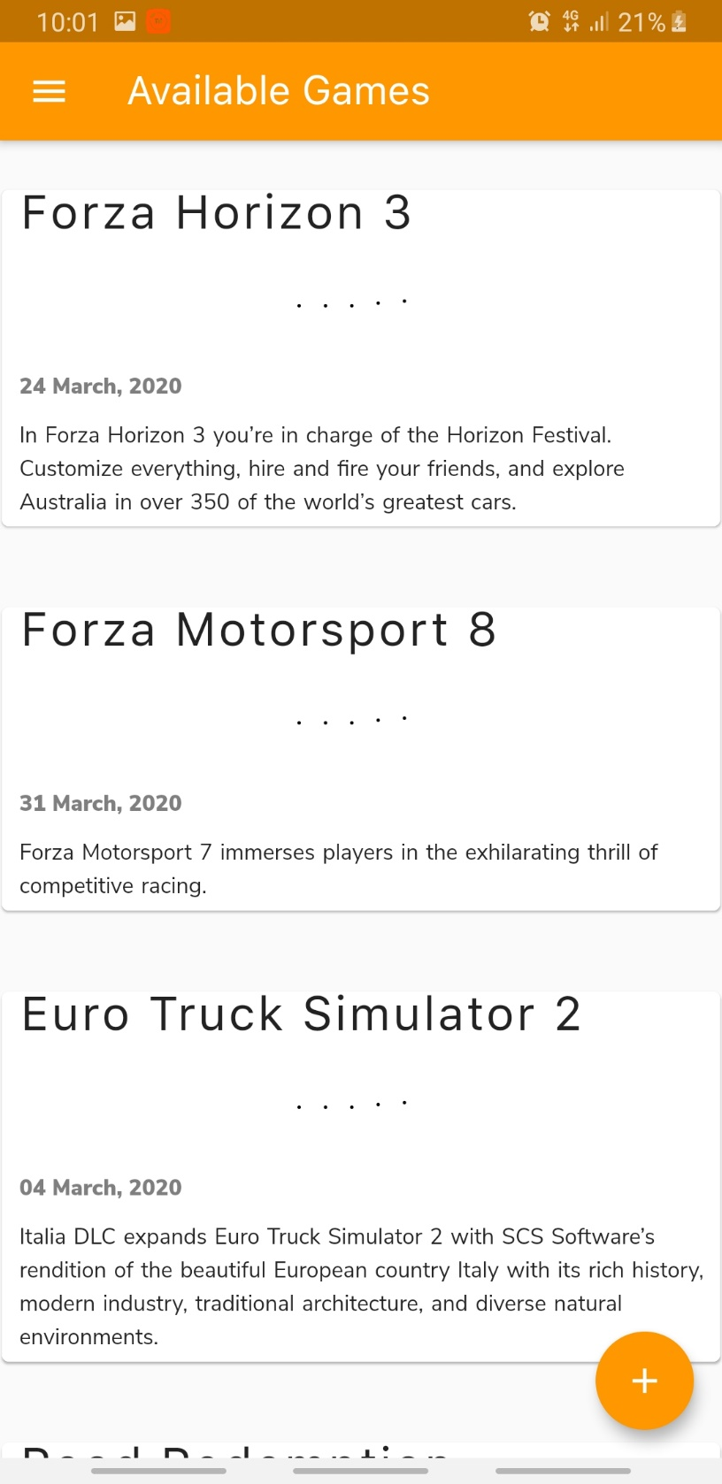With the availability of the network connection, the user can successfully view the home page of iGamer app.

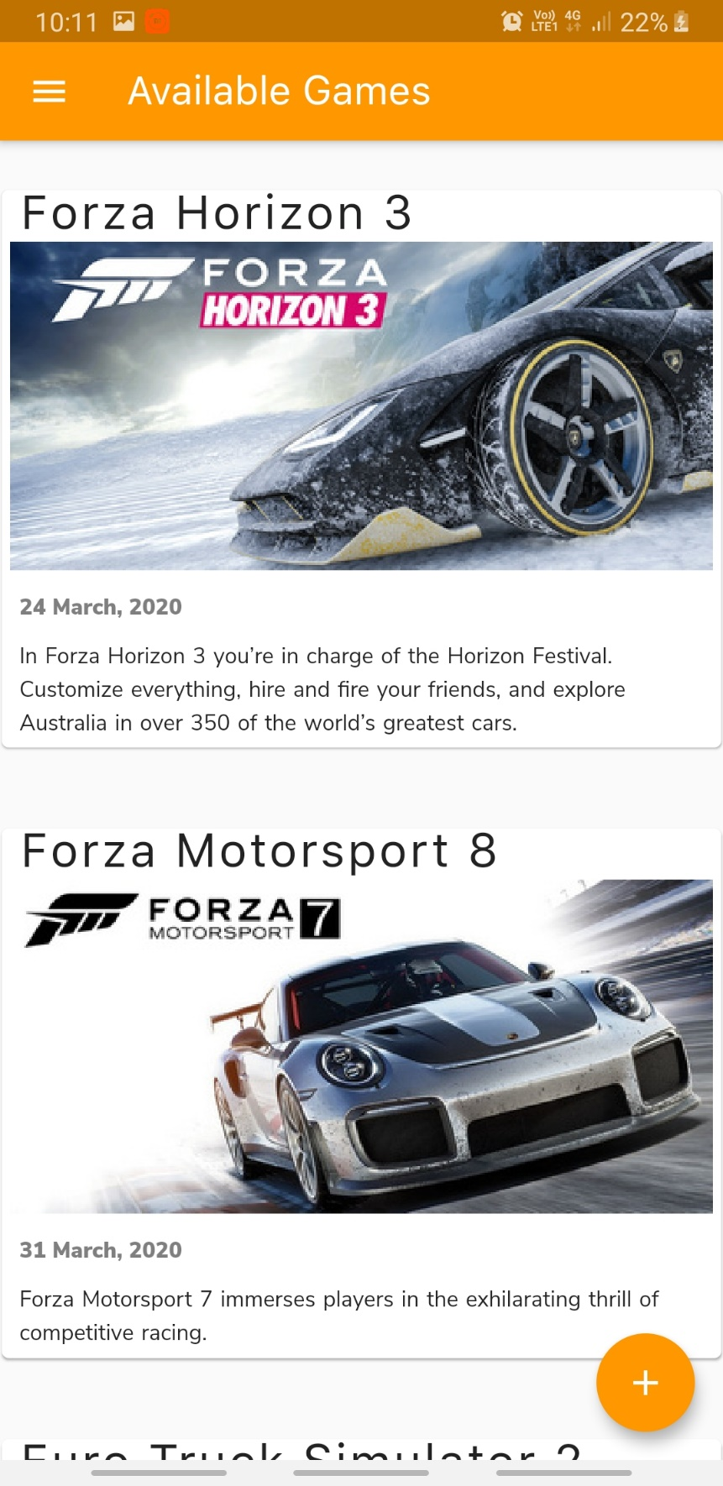

main.dart

**import 'package:flutter/material.dart'**;

**import 'package:cloud_firestore/cloud_firestore.dart'**;

**import 'package:igamer/database/crud.dart'**;

**import '../database/gameRecord.dart'**;

**import '../common_ui_widgets/appBar.dart'**;

**import '../common_ui_widgets/drawer.dart'**;

**import '../common_ui_widgets/gameCard.dart'**;

**import '../common_ui_widgets/alertBox.dart'**;

**import 'addGame.dart'**;

**import 'dart:io'**;

*// Name of the page*

**final** pageTitle = **"Available Games"**;

*// Main method*

**void** main() => runApp(MyApp());

**class** MyApp **extends** StatelessWidget {

@override

Widget build(BuildContext context) {

**return** MaterialApp(

title: pageTitle,

home: MyHomePage(title: pageTitle),

);

}

}

**class** MyHomePage **extends** StatefulWidget {

MyHomePage({Key key, **this**.**title**}) : **super**(key: key);

**final** String **title**;

@override

_MyHomePageState createState() => _MyHomePageState();

}

**class** _MyHomePageState **extends** State<MyHomePage> {

*// this function checks active internet connection*

*// if not, it will popup an Alert Box*

_checkInternetConnection(BuildContext context) **async** {

**try** {

**await** InternetAddress.*lookup*(**'google.com'**);

} **on** SocketException **catch** (_) {

**new** AppAlertBox(context, **"Error"**, **"No Internet Connection"**, **"OK"**)

.showAlertDialog();

}

}

@override

**void** initState() {

**super**.initState();

_checkInternetConnection(**context**);

}

@override

Widget build(BuildContext context) {

**return** Scaffold(

appBar: **new** CustomizedAppBar(pageTitle).getAppBar(), *// Calling Custom build app bar*

body: _buildBody(context),

floatingActionButton: FloatingActionButton(

onPressed: () {

Navigator.*push*(

context, MaterialPageRoute(builder: (context) => AddGame())); *// Navigates to Add Game screen*

},

tooltip: **'Increment'**,

child: Icon(Icons.*add*),

backgroundColor: Colors.*orange*,

),

drawer: **new** CustomizedDrawer(context).getDrawer(),

);

}

Widget _buildBody(BuildContext context) {

**return** StreamBuilder<QuerySnapshot>(

stream: **new** CRUD().getGames(), *// getting a list of games*

builder: (context, snapshot) {

*// checking if data exists*

**if** (snapshot.**hasError** || !snapshot.**hasData**)

*// if no data a Circular Progress Indicator shows up in the middle of the screen*

**return** Center(

child: **new** Column(

mainAxisAlignment: MainAxisAlignment.**center**,

children: <Widget>[

Container(

height: 50,

width: 50,

child: CircularProgressIndicator(),

),

Container(

margin: **const** EdgeInsets.only(top: 10),

child: Text(

**"Loading"**,

style: TextStyle(fontSize: 18),

),

)

],

));

*// if data exist build a list*

**return** _buildList(context, snapshot.**data**.**documents**);

},

);

}

*// this function returns a ListView based on snapShot data*

Widget _buildList(BuildContext context, List<DocumentSnapshot> snapShot) {

**return** ListView(

padding: **const** EdgeInsets.only(top: 20),

children: snapShot.map((data) => _buildListItem(context, data)).toList(),

);

}

*// this function returns a Card embedded with Padding*

Widget _buildListItem(BuildContext context, DocumentSnapshot data) {

**final** gameRecord = GameRecord.fromSnapshot(data);

**return** Padding(

key: ValueKey(gameRecord.**title**),

padding: **const** EdgeInsets.symmetric(horizontal: 1, vertical: 8),

child: GameCard(game: gameRecord));

}

}

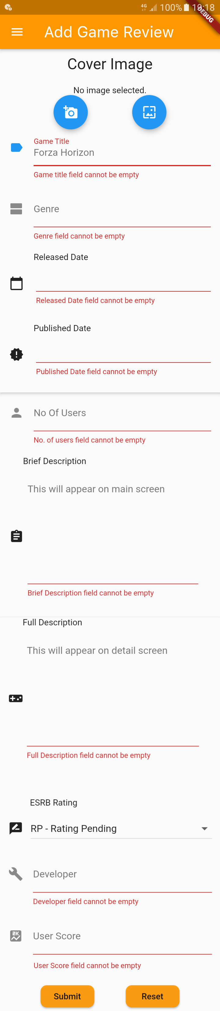**Add Game**

The game reviewers can add a new game to the app.

An image of the game can be uploaded, either selecting from the gallery, or via capturing through the phone camera. The app has been linked with camera.

Also, all the fields are auto-validated, in order for the users to make it easy to do that functionality.

After a new game is added successfully, the user gets a confirmation message.

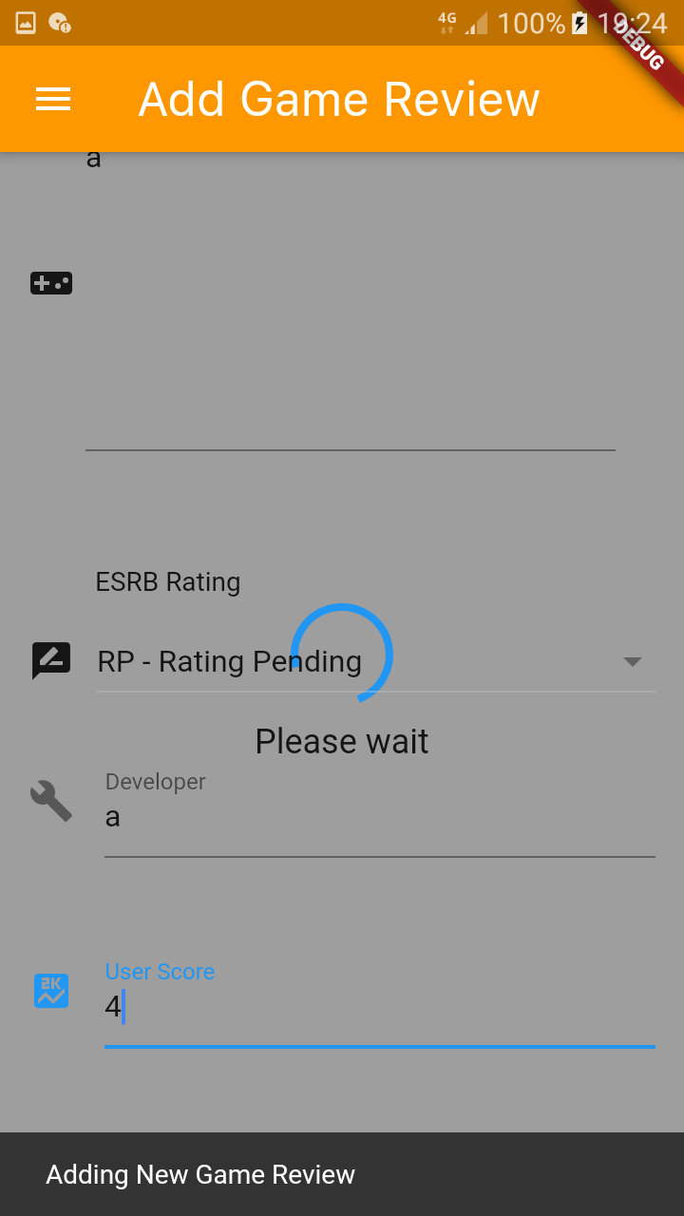

**addGame.dart**

**import 'dart:async'**;

**import 'dart:math'**;

**import 'package:flutter/material.dart'**;

**import 'package:igamer/common_ui_widgets/drawer.dart'**;

**import 'package:igamer/common_ui_widgets/inputWidgets.dart'**;

**import 'package:igamer/database/crud.dart'**;

**import 'package:igamer/database/gameRecord.dart'**;

**import 'package:igamer/database/imageUploader.dart'**;

**import '../common_ui_widgets/appBar.dart'**;

**import 'dart:io'**;

**import 'package:image_picker/image_picker.dart'**;

**import 'main.dart'**;

*// Name of the page*

**final** title = **'Add Game Review'**;

*// Main method*

**void** main() => runApp(AddGame());

**class** AddGame **extends** StatelessWidget {

@override

Widget build(BuildContext context) {

**return** MaterialApp(

title: title,

home: Scaffold(

appBar: **new** CustomizedAppBar(title).getAppBar(),

*//getting custom built app bar*

body: AddGameForm(title: title),

drawer: **new** CustomizedDrawer(context)

.getDrawer(), *//getting custom built app drawer*

),

);

}

}

*// Create a Form widget.*

**class** AddGameForm **extends** StatefulWidget {

**final** String **title**;

*//Constructor*

AddGameForm({Key key, **this**.**title**}) : **super**(key: key);

@override

AddGameFormState createState() {

**return** AddGameFormState();

}

}

**class** AddGameFormState **extends** State<AddGameForm> {

**final _formKey** = GlobalKey<FormState>();

FocusNode **focusNode**;

List<DropdownMenuItem<String>> **_dropDownMenuItems**;

String **_selectedESRBRating**;

File **_image**;

bool **_greyOutBackground** = **false**;

*//Initializing text editing controllers*

TextEditingController **_titleController** = **new** TextEditingController();

TextEditingController **_genreController** = **new** TextEditingController();

TextEditingController **_relDateController** = **new** TextEditingController();

TextEditingController **_pubDateController** = **new** TextEditingController();

TextEditingController **_noOfUsersController** = **new** TextEditingController();

TextEditingController **_briefDescController** = **new** TextEditingController();

TextEditingController **_fullDescController** = **new** TextEditingController();

TextEditingController **_developerController** = **new** TextEditingController();

TextEditingController **_userScoreController** = **new** TextEditingController();

*//Initializing an object from CommonInputWidgets class*

CommonInputWidgets **_commonInputWidgets** = **new** CommonInputWidgets();

*//Initializing drop down values for ESRB Ratings*

List **_ratings** = [

**"RP - Rating Pending"**,

**"EC - Early Childhood"**,

**"E - Everyone"**,

**"E10+ - Everyone 10+"**,

**"T - Teen"**,

**"M - Mature"**,

**"AO - Adults Only"**

];

*// initializing local variables at the beginning of the screen*

@override

**void** initState() {

**super**.initState();

**focusNode** = FocusNode();

**_dropDownMenuItems** = _buildAndGetDropDownMenuItems(**_ratings**);

**_selectedESRBRating** = **_dropDownMenuItems**[0].**value**;

**_image** = **null**;

**_greyOutBackground** = **false**;

}

@override

Widget build(BuildContext context) {

**return new** Scaffold(

backgroundColor:

**_greyOutBackground** == **true** ? Colors.*grey* : Colors.*transparent*,

body: **new** GestureDetector(

onTap: (){

FocusScope.*of*(context).requestFocus(**new** FocusNode());

},

child: Stack(

children: <Widget>[

**if** (**_greyOutBackground**) _getCircularProgressIndicator(),

*//display an empty form*

Form(

key: **_formKey**,

child: SingleChildScrollView(

padding: **const** EdgeInsets.only(left: 15, right: 15, top: 10),

child: Column(

crossAxisAlignment: CrossAxisAlignment.**start**,

children: <Widget>[

_getImagePicker(),

*//Title field*

**_commonInputWidgets**.getTextField(

**"Game Title"**,

**"Forza Horizon"**,

Icons.*label*,

**_titleController**,

**"Game title field cannot be empty"**,

**focusNode**),

*//Genre field*

**_commonInputWidgets**.getTextField(

**"Genre"**,

**"Racing, Simulation, Automobile"**,

Icons.*view_agenda*,

**_genreController**,

**"Genre field cannot be empty"**,

**focusNode**),

*//Released Date field*

**_commonInputWidgets**.getDatePicker(

**"Released Date"**,

Icons.*calendar_today*,

**_relDateController**,

**"Released Date field cannot be empty"**,

**focusNode**),

*//Published Date field*

**_commonInputWidgets**.getDatePicker(

**"Published Date"**,

Icons.*new_releases*,

**_pubDateController**,

**"Published Date field cannot be empty"**,

**focusNode**),

*//No. of users field*

**_commonInputWidgets**.getNumberTextField(

**"No Of Users"**,

**"2"**,

Icons.*person*,

**true**,

**_noOfUsersController**,

**"No. of users field cannot be empty"**,

**focusNode**),

*//Brief Description field*

**_commonInputWidgets**.getTextArea(

**"Brief Description"**,

**"This will appear on main screen"**,

Icons.*assignment*,

**_briefDescController**,

**"Brief Description field cannot be empty"**,

**focusNode**),

*//Full Description field*

**_commonInputWidgets**.getTextArea(

**"Full Description"**,

**"This will appear on detail screen"**,

Icons.*videogame_asset*,

**_fullDescController**,

**"Full Description field cannot be empty"**,

**focusNode**),

*//ESRB Rating dropdown field*

_getDropDown(**"ESRB Rating"**, Icons.*rate_review*),

*//Developer field*

**_commonInputWidgets**.getTextField(

**"Developer"**,

**"Playground Games"**,

Icons.*build*,

**_developerController**,

**"Developer field cannot be empty"**,

**focusNode**),

*//User score field*

**_commonInputWidgets**.getNumberTextField(

**"User Score"**,

**"7.8"**,

Icons.*score*,

**false**,

**_userScoreController**,

**"User Score field cannot be empty"**,

**focusNode**),

**new** Row(

mainAxisAlignment: MainAxisAlignment.**spaceEvenly**,

children: <Widget>[

**new** RaisedButton(

padding: **const** EdgeInsets.all(10.0),

onPressed: () **async** {

setState(() {

**_greyOutBackground** = **true**;

});

*//if the form fields are validated*

**if** (**_formKey**.**currentState**.validate()) {

Scaffold.*of*(context).showSnackBar(SnackBar(

content: Text(**'Adding New Game Review'**),

));

*//uploads the image*

ImageUploader uploader = **new** ImageUploader(

**_titleController**.**text** +

**"-"** +

_generateID().toString(),

**_image**);

**var** imageURL = **await** uploader.uploadFile();

GameRecord game = **new** GameRecord(

_generateID(),

**_titleController**.**text**,

**_pubDateController**.**text**,

**_briefDescController**.**text**,

imageURL,

**_genreController**.**text**,

**_developerController**.**text**,

**_relDateController**.**text**,

**_fullDescController**.**text**,

**_selectedESRBRating**,

**_userScoreController**.**text**,

**_noOfUsersController**.**text**,

**null**);

**await** CRUD().addGame(game);

setState(() {

**_greyOutBackground** = **false**;

});

Navigator.*push*(

context,

MaterialPageRoute(

builder: (context) => MyHomePage()));

}

},

*//Submit button*

child: **new** Text(**'Submit'**),

color: Colors.*orange*.withOpacity(0.9),

shape: RoundedRectangleBorder(

borderRadius: **new** BorderRadius.circular(10.0))),

*//reset button*

**new** RaisedButton(

padding: **const** EdgeInsets.all(10.0),

onPressed: () {

**_formKey**.**currentState**.reset();

_clearImage();

**_titleController**.clear();

**_genreController**.clear();

**_relDateController**.clear();

**_pubDateController**.clear();

**_noOfUsersController**.clear();

**_briefDescController**.clear();

**_fullDescController**.clear();

_getlist();

**_developerController**.clear();

**_userScoreController**.clear();

},

child: **new** Text(**'Reset'**),

color: Colors.*orange*.withOpacity(0.9),

shape: RoundedRectangleBorder(

borderRadius: **new** BorderRadius.circular(10.0)))

],

),

],

),

),

)

],

),

)

);

}

*// this function returns a random integer between 0 and 10000*

int _generateID() {

**var** random = Random();

**return** random.nextInt(10000);

}

*// this function brings the drop down list to its initial state*

Future _getlist() **async** {

**return** setState(() {

**_dropDownMenuItems** = _buildAndGetDropDownMenuItems(**_ratings**);

**_selectedESRBRating** = **_dropDownMenuItems**[0].**value**;

});

}

*// this function gets an image from the camera and set to _image*

Future _getImageFromCamera() **async** {

**return** ImagePicker.*pickImage*(source: ImageSource.**camera**).then((file) {

setState(() {

**_image** = file;

});

});

}

*// this function picks an image from the gallery and set to _image*

Future _getImageFromGallery() **async** {

**return** ImagePicker.*pickImage*(source: ImageSource.**gallery**).then((file) {

setState(() {

**_image** = file;

});

});

}

*// the function removes the selected image from the gallery*

Future _clearImage() **async** {

setState(() {

**_image** = **null**;

});

}

*// this function returns a Column having an Image Picker*

Column _getImagePicker() {

**return** (**new** Column(

children: <Widget>[

Container(

margin: **const** EdgeInsets.only(bottom: 20),

child: Text(

**'Cover Image'**,

style: TextStyle(fontSize: 25),

),

),

**_image** == **null** ? **new** Text(**'No image selected.'**) : Image.file(**_image**, height: 187, width: 400, fit: BoxFit.**fitWidth**,),

*// if no image is selected show Text else show the image*

**_image** == **null** *// if no image is selected, show Choose Image button*

? **new** Row(

mainAxisAlignment: MainAxisAlignment.**spaceEvenly**,

children: <Widget>[

FloatingActionButton(

heroTag: **'btn_camera'**,

onPressed: _getImageFromCamera,

tooltip: **'Pick Image'**,

child: Icon(Icons.*add_a_photo*),

),

FloatingActionButton(

heroTag: **'btn_gallery'**,

onPressed: _getImageFromGallery,

tooltip: **'Pick Image'**,

child: Icon(Icons.*wallpaper*),),],)

: Container(),

**_image** != **null** *// if image is selected, show Remove Button*

? **new** Container(

margin: **const** EdgeInsets.only(top: 10, bottom: 20),

child: **new** RaisedButton(

child: Container(

width: 85,

height: 40,

child: Row(

children: <Widget>[Icon(Icons.*delete*), Text(**'Remove'**)],

mainAxisAlignment: MainAxisAlignment.**center**,

),

),

onPressed: () {

setState(() {

_clearImage();

});

},

color: Colors.*red*.withOpacity(0.80),

elevation: 0,

shape: RoundedRectangleBorder(

borderRadius: **new** BorderRadius.circular(10.0))),

)

: Container()

],

));

}

*// this function adds items in the ratings list to the Drop down menu item*

List<DropdownMenuItem<String>> _buildAndGetDropDownMenuItems(List ratings) {

List<DropdownMenuItem<String>> items = List();

**for** (String rating **in** ratings) {

items.add(DropdownMenuItem(value: rating, child: Text(rating)));

}

**return** items;

}

*// this function returns a dropdown list*

Container _getDropDown(String label, IconData icon) {

**return** (Container(

margin: **const** EdgeInsets.only(bottom: 20),

child: Column(

children: <Widget>[

Container(

alignment: Alignment(-1, -1),

margin: **const** EdgeInsets.only(top: 30, bottom: 10, left: 35),

child: Text(label),

),

Row(

children: <Widget>[

Container(

child: Icon(icon),

),

Container(

width: 330,

margin: **const** EdgeInsets.only(left: 12),

child: DropdownButton(

value: **_selectedESRBRating**,

items: **_dropDownMenuItems**,

onChanged: (pickedValue) {

setState(() {

**_selectedESRBRating** = pickedValue;

});

},

isExpanded: **true**,

),

)

],

)

],

),

));

}

*//function which returns Circular Progress Indicator*

Center _getCircularProgressIndicator() {

**return** Center(

child: **new** Column(

mainAxisAlignment: MainAxisAlignment.**center**,

children: <Widget>[

Container(

height: 50,

width: 50,

child: CircularProgressIndicator(),

),

Container(

margin: **const** EdgeInsets.only(top: 10),

child: Text(

**"Please wait"**,

style: TextStyle(fontSize: 18),

),

)

], ));}}

**List Game**

After a new game is added succesfully, the particular game can be viewed in the home page as a card.

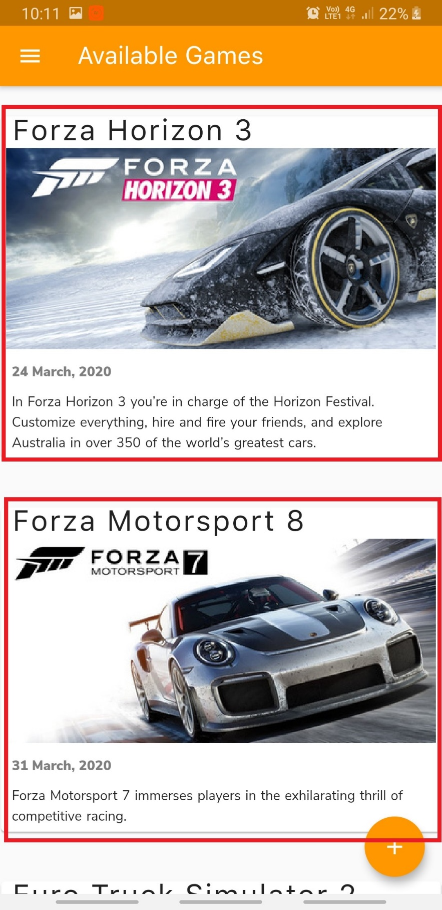

**Card**

**gameCard.dart**

**import 'package:cached_network_image/cached_network_image.dart';**

**import 'package:flutter/material.dart'**;

**import 'package:progress_indicators/progress_indicators.dart'**;

**import '../database/gameRecord.dart'**;

**import 'gameDetail.dart'**;

*// this class contains methods and attributes used for Card in the List in the app*

**class** GameCard **extends** StatelessWidget {

*//Constructor*

**const** GameCard({Key key, **this**.**game**, **this**.**selected**: **false**}) : **super**(key: key);

**final** GameRecord **game**;

**final** bool **selected**;

@override

Widget build(BuildContext context) {

TextStyle textStyle = Theme.*of*(context).**textTheme**.**display1**;

*//if the option is selected, returning a card*

**if** (**selected**)

textStyle = textStyle.copyWith(color: Colors.*lightGreenAccent*[400]);

**return new** Container(

decoration: **new** BoxDecoration(

boxShadow: [

**new** BoxShadow(

color: Colors.*transparent*,

blurRadius: 50

)

]

),

child : **new** Card(

margin: **const** EdgeInsets.only(bottom: 30),

color: Colors.*white*,

child: **new** InkWell(

*// if the card is pressed navigate to Detailed Screen*

onTap: () => {

Navigator.*push*(context,

MaterialPageRoute(builder: (context) => GameDetailPage(**game**),),),

},

child: Column(

children: <Widget>[

*// Title*

**new** Container(

margin: **const** EdgeInsets.only(left: 10),

child: **new** Text(**game**.**title**,

style: **new** TextStyle(

fontSize: 30, letterSpacing: 1.5, height: 1, fontFamily: **'SanFrancisco'**),),

),

*// Image of the Game*

**new** Container(

*// child: Image.network(game.imageLink),*

child: CachedNetworkImage(

imageUrl: **game**.**imageLink**, width: 400, height: 187, fit: BoxFit.**fitWidth**,

placeholder: (context, url) => Center(

child: Padding(

padding: **const** EdgeInsets.all(8.0),

child: Container(

margin: **const** EdgeInsets.only(top: 10, bottom: 10),

child: Column(

children: <Widget>[

Container(

child: JumpingDotsProgressIndicator(fontSize: 20, numberOfDots: 5, dotSpacing: 10, milliseconds: 250,),

),

],

),

),

),

),

errorWidget: (context, url, error) => Container(

margin: **const** EdgeInsets.only(top: 10, bottom: 10, left: 10, right: 10),

child: Center(

child: Image.asset(**"assets/images/no-image-available.png"**),

),

),

),

),

*//Published Date*

**new** Container(

padding: **const** EdgeInsets.all(10.0),

child: Column(

mainAxisAlignment: MainAxisAlignment.**spaceEvenly**,

crossAxisAlignment: CrossAxisAlignment.**start**,

children: <Widget>[

**new** Column(

children: <Widget>[

Text(**game**.**publishedDate**,

style: TextStyle(

color: Colors.*black*.withOpacity(0.5), fontFamily: **'NunitoSansBlack'**)),

],

)

],

),

),

*// Game Description*

Container(

margin: **const** EdgeInsets.only(left: 10, bottom: 5),

child: **new** Text(

**game**.**gameDescription**,

style: **new** TextStyle(wordSpacing: 1, height: 1.5, fontFamily: **'NunitoSans'**),

),

)

],

crossAxisAlignment: CrossAxisAlignment.**stretch**,

),

)));

}

}

After tapped on the card, the user is able to see the detailed description of the particular game.

Game Detail

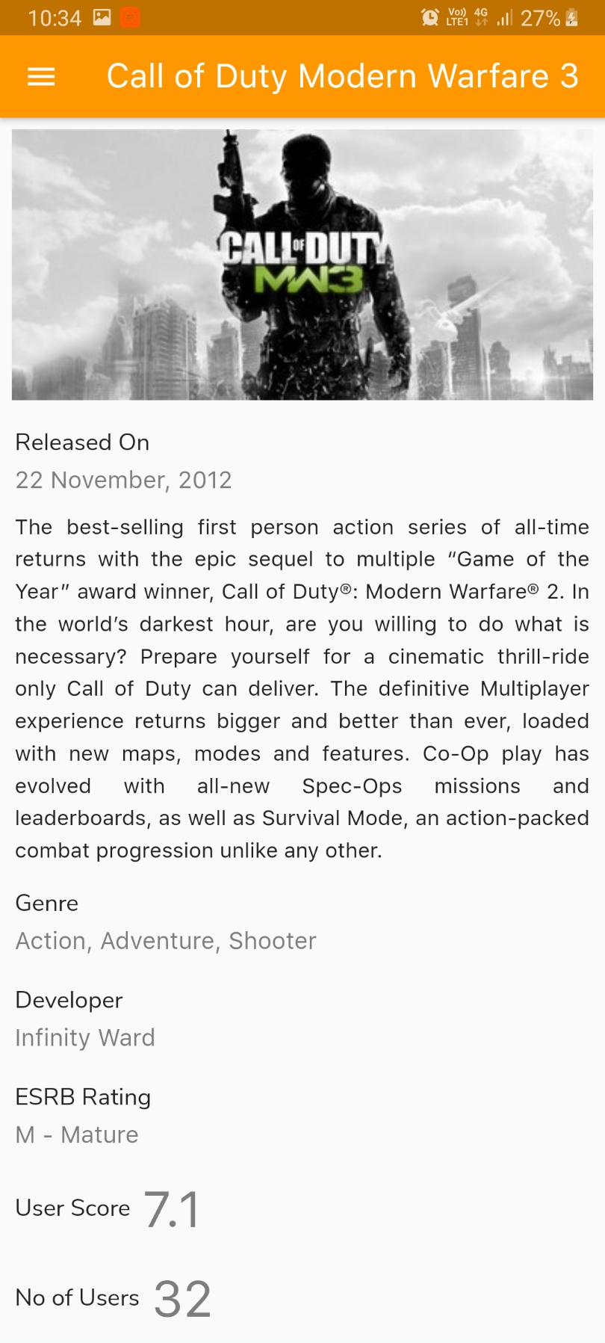

gameDetail.dart

**import 'package:cached_network_image/cached_network_image.dart'**;

**import 'package:flutter/material.dart'**;

**import 'package:igamer/screens/updateGame.dart'**;

**import 'package:progress_indicators/progress_indicators.dart'**;

**import 'appBar.dart'**;

**import '../database/gameRecord.dart'**;

**import 'drawer.dart'**;

*//main method of GameDetailPage*

**void** main() {

runApp(GameDetailPage(**null**));

}

*// ignore: must_be_immutable*

**class** GameDetailPage **extends** StatelessWidget {

GameRecord **game**;

GameDetailPage(**this**.**game**);

@override

Widget build(BuildContext context) {

**return** MaterialApp(

title: **game**.**title**, *//returns game title in the Appbar*

home: Scaffold(

appBar: **new** CustomizedAppBar.fromGameDetail(**game**.**title**, context, **this**.**game**).getAppBar(),

*// get customized app bar*

drawer: **new** CustomizedDrawer(context).getDrawer(),

*// get customized app drawer*

body: SingleChildScrollView(

child: Column(

children: <Widget>[

*// Image*

**new** Container(

padding: **const** EdgeInsets.all(8.0),

child: CachedNetworkImage(

imageUrl: **game**.**imageLink**,

width: 400,

height: 187,

fit: BoxFit.**fitWidth**,

placeholder: (context, url) => Center(

child: Padding(

padding: **const** EdgeInsets.all(8.0),

child: Container(

margin: **const** EdgeInsets.only(top: 10, bottom: 10),

child: Column(

children: <Widget>[

Container(

child: JumpingDotsProgressIndicator(

fontSize: 20,

numberOfDots: 5,

dotSpacing: 10,

milliseconds: 250,

),

),

],

),

),

),

),

errorWidget: (context, url, error) => Container(

margin: **const** EdgeInsets.only(

top: 10, bottom: 10, left: 10, right: 10),

child: Center(

child: Image.asset(**"assets/images/no-image-available.png"**),

),

),

),

),

*// Released Date*

getDetailRow(**"Released On"**, **game**.**releaseDate**),

*// Full Description*

**new** Container(

margin: **const** EdgeInsets.only(left: 10, bottom: 5, right: 10),

child: **new** Text(

**game**.**fullDescription**,

style: **new** TextStyle(

fontSize: 16, height: 1.5, fontFamily: **'SanFrancisco'**),

textAlign: TextAlign.**justify**,

),

),

*// Genre*

getDetailRow(**"Genre"**, **game**.**genre**),

*// Developer*

getDetailRow(**"Developer"**, **game**.**developer**),

*// ESRB Rating*

getDetailRow(**"ESRB Rating"**, **game**.**esrbRating**),

*// User Score*

getDetailRowHorizontal(**"User Score"**, **game**.**userScore**),

*// No of Users*

getDetailRowHorizontal(**"No of Users"**, **game**.**noOfUsers**),

],

crossAxisAlignment: CrossAxisAlignment.**start**,

)),

*//update option*

floatingActionButton: FloatingActionButton(

onPressed: () {

Navigator.*push*(

context,

MaterialPageRoute(

builder: (context) =>

UpdateGame(game: **game**))); *// Navigates to Add Game screen*

},

tooltip: **'Increment'**,

child: Icon(Icons.*edit*),

backgroundColor: Colors.*orange*,

),

),

);

}

*// this function returns a Row in which the label is on top and the value is at bottom*

Widget getDetailRow(String label, String value) {

**return new** Container(

padding: **const** EdgeInsets.all(10.0),

child: Column(

mainAxisAlignment: MainAxisAlignment.**spaceEvenly**,

crossAxisAlignment: CrossAxisAlignment.**start**,

children: <Widget>[

**new** Container(

child: **new** Text(

label,

style: **new** TextStyle(fontSize: 18, fontFamily: **'NunitoSans'**),

),

margin: **const** EdgeInsets.only(bottom: 5),

),

**new** Column(

children: <Widget>[

Text(value,

style: TextStyle(

color: Colors.*black*.withOpacity(0.5),

fontSize: 18,

fontFamily: **'SanFrancisco'**))

],

)

],

),

);

}

*// this function returns a Row in which the value is place next to the label*

Widget getDetailRowHorizontal(String label, String value) {

**return new** Container(

padding: **const** EdgeInsets.all(10.0),

child: Row(

mainAxisAlignment: MainAxisAlignment.**start**,

crossAxisAlignment: CrossAxisAlignment.**center**,

children: <Widget>[

**new** Container(

child: **new** Text(

label,

style: **new** TextStyle(fontSize: 18, fontFamily: **'NunitoSans'**),

),

margin: **const** EdgeInsets.only(right: 8),

),

**new** Column(

children: <Widget>[

Text(value,

style: TextStyle(

color: Colors.*black*.withOpacity(0.5),

fontSize: 38,

fontFamily: **'SanFrancisco'**))

],

)

],

),

);

}

}

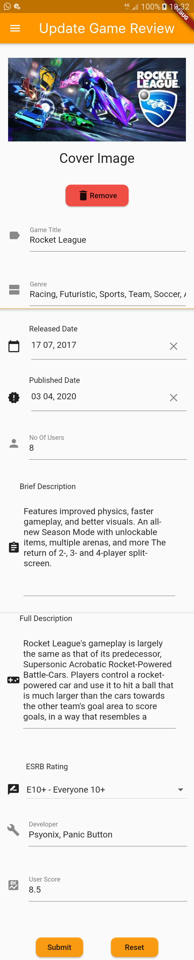**Update Game**

The game reviewers can hopefully update an existing game in the app.

After the game is updated successfully, the user gets a confirmation message.

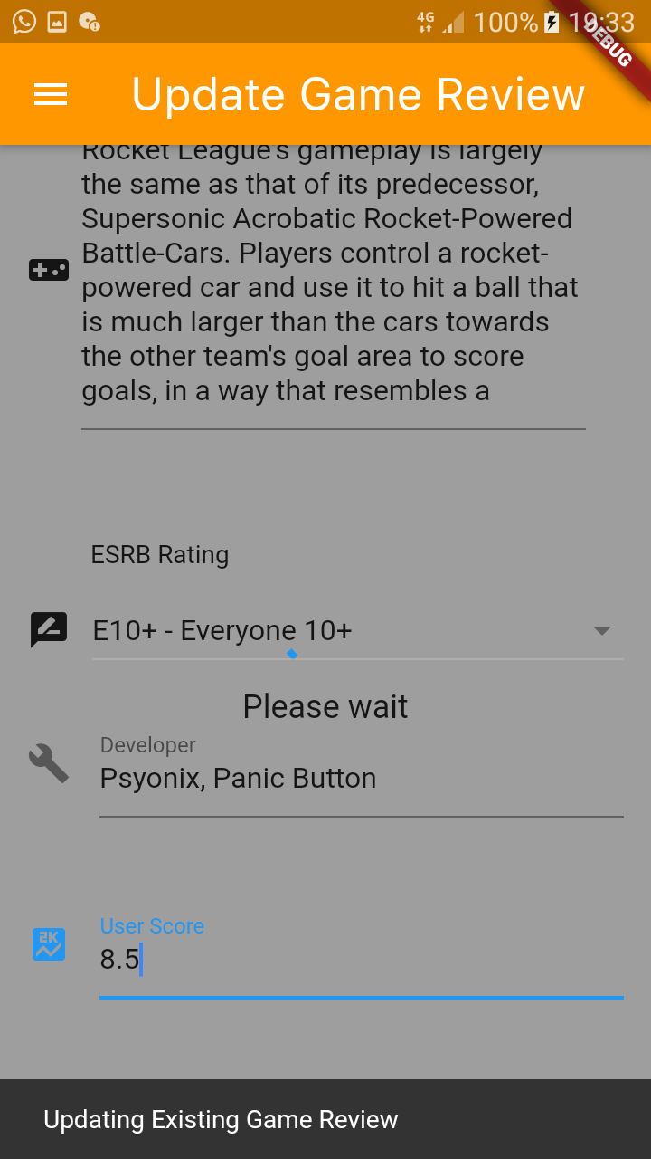

updateGame.dart

**import 'dart:async'**;

**import 'package:cached_network_image/cached_network_image.dart'**;

**import 'package:flutter/cupertino.dart'**;

**import 'package:flutter/material.dart'**;

**import 'package:flutter/widgets.dart'**;

**import 'package:igamer/common_ui_widgets/drawer.dart'**;

**import 'package:igamer/common_ui_widgets/inputWidgets.dart'**;

**import 'package:igamer/database/crud.dart'**;

**import 'package:igamer/database/gameRecord.dart'**;

**import 'package:igamer/database/imageUploader.dart'**;

**import 'package:progress_indicators/progress_indicators.dart'**;

**import '../common_ui_widgets/appBar.dart'**;

**import 'dart:io'**;

**import 'package:image_picker/image_picker.dart'**;

**import 'main.dart'**;

*// Name of the page*

**final** title = **'Update Game Review'**;

*// Main method*

**void** main() => runApp(UpdateGame());

**class** UpdateGame **extends** StatelessWidget {

**final** GameRecord **game**;

*//Constructor*

**const** UpdateGame({Key key, **this**.**game**}) : **super**(key: key);

@override

Widget build(BuildContext context) {

**return** MaterialApp(

title: title,

home: Scaffold(

appBar: **new** CustomizedAppBar(title).getAppBar(),

*//getting custom built app bar*

body: UpdateGameForm(title: title, gameRecord: **game**),

drawer: **new** CustomizedDrawer(context)

.getDrawer(), *//getting custom built app drawer*

),

);

}

}

*// Create a Form widget.*

**class** UpdateGameForm **extends** StatefulWidget {

**final** String **title**;

**final** GameRecord **gameRecord**;

*//Constructor*

UpdateGameForm({Key key, **this**.**title**, **this**.**gameRecord**}) : **super**(key: key);

@override

UpdateGameFormState createState() {

**return** UpdateGameFormState();

}

}

**class** UpdateGameFormState **extends** State<UpdateGameForm> {

**final _formKey** = GlobalKey<FormState>();

FocusNode **focusNode**;

List<DropdownMenuItem<String>> **_dropDownMenuItems**;

String **_selectedESRBRating**;

File **_image**;

bool **_greyOutBackground** = **false**;

bool **_showOriginalImage** = **true**;

*//Initializing text editing controllers for update operation*

TextEditingController **_titleController** = **new** TextEditingController();

TextEditingController **_genreController** = **new** TextEditingController();

TextEditingController **_relDateController** = **new** TextEditingController();

TextEditingController **_pubDateController** = **new** TextEditingController();

TextEditingController **_noOfUsersController** = **new** TextEditingController();

TextEditingController **_briefDescController** = **new** TextEditingController();

TextEditingController **_fullDescController** = **new** TextEditingController();

TextEditingController **_developerController** = **new** TextEditingController();

TextEditingController **_userScoreController** = **new** TextEditingController();

CommonInputWidgets **_commonInputWidgets** = **new** CommonInputWidgets();

*//Initializing drop down values for ESRB Ratings*

List **_ratings** = [

**"RP - Rating Pending"**,

**"EC - Early Childhood"**,

**"E - Everyone"**,

**"E10+ - Everyone 10+"**,

**"T - Teen"**,

**"M - Mature"**,

**"AO - Adults Only"**

];

*// initializing local variables at the beginning of the screen*

@override

**void** initState() {

**super**.initState();

**focusNode** = FocusNode();

**_dropDownMenuItems** = _buildAndGetDropDownMenuItems(**_ratings**);

**_selectedESRBRating** = **widget**.**gameRecord**.**esrbRating**;

**_greyOutBackground** = **false**;

*//setting value of image link through File Constructor for image removal operation*

**_image** = **new** File(**widget**.**gameRecord**.**imageLink** != **null** ? **widget**.**gameRecord**.**imageLink** : **''**);

Image.file(**_image**);

*//setting values through Text Editing Controllers*

**_titleController** = TextEditingController(

text: **widget**.**gameRecord**.**title** != **null** ? **widget**.**gameRecord**.**title** : **''**);

**_genreController** = TextEditingController(

text: **widget**.**gameRecord**.**genre** != **null** ? **widget**.**gameRecord**.**genre** : **''**);

**_relDateController** = TextEditingController(

text: **widget**.**gameRecord**.**releaseDate** != **null**

? **widget**.**gameRecord**.**releaseDate**

: **''**);

**_pubDateController** = TextEditingController(

text: **widget**.**gameRecord**.**publishedDate** != **null**

? **widget**.**gameRecord**.**publishedDate**

: **''**);

**_briefDescController** = TextEditingController(

text: **widget**.**gameRecord**.**gameDescription** != **null**

? **widget**.**gameRecord**.**gameDescription**

: **''**);

**_fullDescController** = TextEditingController(

text: **widget**.**gameRecord**.**fullDescription** != **null**

? **widget**.**gameRecord**.**fullDescription**

: **''**);

**_noOfUsersController** = TextEditingController(

text: **widget**.**gameRecord**.**noOfUsers** != **null**

? **widget**.**gameRecord**.**noOfUsers**

: **''**);

**_developerController** = TextEditingController(

text: **widget**.**gameRecord**.**developer** != **null**

? **widget**.**gameRecord**.**developer**

: **''**);

**_userScoreController** = TextEditingController(

text: **widget**.**gameRecord**.**userScore** != **null**

? **widget**.**gameRecord**.**userScore**

: **''**);

}

@override

Widget build(BuildContext context) {

**return new** Scaffold(

backgroundColor:

**_greyOutBackground** == **true** ? Colors.*grey* : Colors.*transparent*,

body: Stack(

children: <Widget>[

**if** (**_greyOutBackground**) _getCircularProgressIndicator(),

*//display a form with pre-filled fields*

Form(

key: **_formKey**,

child: SingleChildScrollView(

padding: **const** EdgeInsets.only(left: 15, right: 15, top: 10),

child: Column(

crossAxisAlignment: CrossAxisAlignment.**start**,

children: <Widget>[

*//Displays previously uploaded image in the AddForm*

**_showOriginalImage** == **true**

? CachedNetworkImage(

imageUrl: **widget**.**gameRecord**.**imageLink**,

width: 400,

height: 187,

fit: BoxFit.**fitWidth**,

placeholder: (context, url) => Center(

child: Padding(

padding: **const** EdgeInsets.all(8.0),

child: Container(

margin:

**const** EdgeInsets.only(top: 10, bottom: 10),

child: Column(

children: <Widget>[

Container(

child: JumpingDotsProgressIndicator(

fontSize: 20,

numberOfDots: 5,

dotSpacing: 10,

milliseconds: 250,

),

),

],

),

),

),

),

errorWidget: (context, url, error) => Container(

margin: **const** EdgeInsets.only(

top: 10, bottom: 10, left: 10, right: 10),

child: Center(

child: Image.asset(

**"assets/images/no-image-available.png"**),

),

),

)

: Container(),

_getImagePicker(),

*//Title field*

**_commonInputWidgets**.getTextField(

**"Game Title"**,

**"Forza Horizon"**,

Icons.*label*,

**_titleController**,

**"Game title field cannot be empty"**,

**focusNode**),

*//Genre field*

**_commonInputWidgets**.getTextField(

**"Genre"**,

**"Racing, Simulation, Automobile"**,

Icons.*view_agenda*,

**_genreController**,

**"Genre field cannot be empty"**,

**focusNode**),

*//Released Date field*

**_commonInputWidgets**.getDatePicker(

**"Released Date"**,

Icons.*calendar_today*,

**_relDateController**,

**"Released Date field cannot be empty"**,

**focusNode**),

*//Published Date field*

**_commonInputWidgets**.getDatePicker(

**"Published Date"**,

Icons.*new_releases*,

**_pubDateController**,

**"Published Date field cannot be empty"**,

**focusNode**),

*//No. of users field*

**_commonInputWidgets**.getNumberTextField(

**"No Of Users"**,

**"2"**,

Icons.*person*,

**true**,

**_noOfUsersController**,

**"No. of users field cannot be empty"**,

**focusNode**),

*//Brief Description field*

**_commonInputWidgets**.getTextArea(

**"Brief Description"**,

**"This will appear on main screen"**,

Icons.*assignment*,

**_briefDescController**,

**"Brief Description field cannot be empty"**,

**focusNode**),

*//Full Description field*

**_commonInputWidgets**.getTextArea(

**"Full Description"**,

**"This will appear on detail screen"**,

Icons.*videogame_asset*,

**_fullDescController**,

**"Full Description field cannot be empty"**,

**focusNode**),

*//ESRB Rating dropdown field*

_getDropDown(**"ESRB Rating"**, Icons.*rate_review*),

*//Developer field*

**_commonInputWidgets**.getTextField(

**"Developer"**,

**"Playground Games"**,

Icons.*build*,

**_developerController**,

**"Developer field cannot be empty"**,

**focusNode**),

*//User score field*

**_commonInputWidgets**.getNumberTextField(

**"User Score"**,

**"7.8"**,

Icons.*score*,

**false**,

**_userScoreController**,

**"User Score field cannot be empty"**,

**focusNode**),

**new** Row(

mainAxisAlignment: MainAxisAlignment.**spaceEvenly**,

children: <Widget>[

**new** RaisedButton(

padding: **const** EdgeInsets.all(10.0),

onPressed: () **async** {

setState(() {

**_greyOutBackground** = **true**;

});

*//if the form fields are validated*

**if** (**_formKey**.**currentState**.validate()) {

Scaffold.*of*(context).showSnackBar(SnackBar(

content: Text(**'Updating Existing Game Review'**),

));

**var** imageURL ;

*//uploads the image if the image is updated only*

**if** (**_showOriginalImage** == **false**) {

ImageUploader uploader = **new** ImageUploader(

**_titleController**.**text** +

**"-"** +

**widget**.**gameRecord**.**gameID**.toString(),

**_image**);

imageURL = **await** uploader.uploadFile();

}

*//keeps the previously added image*

**else** {

imageURL = **widget**.**gameRecord**.**imageLink**;

}

GameRecord game = **new** GameRecord(

**widget**.**gameRecord**.**gameID**,

**_titleController**.**text**,

**_pubDateController**.**text**,

**_briefDescController**.**text**,

imageURL,

**_genreController**.**text**,

**_developerController**.**text**,

**_relDateController**.**text**,

**_fullDescController**.**text**,

**_selectedESRBRating**,

**_userScoreController**.**text**,

**_noOfUsersController**.**text**,

**widget**.**gameRecord**.**reference**);

**await** CRUD().editGame(game, game.**reference**);

setState(() {

**_greyOutBackground** = **false**;

});

Navigator.*push*(

context,

MaterialPageRoute(

builder: (context) => MyHomePage()));

}

setState(() {

**_greyOutBackground** = **false**;

});

},

*//Submit button*

child: **new** Text(**'Submit'**),

color: Colors.*orange*.withOpacity(0.9),

shape: RoundedRectangleBorder(

borderRadius: **new** BorderRadius.circular(10.0))),

*//reset button*

**new** RaisedButton(

padding: **const** EdgeInsets.all(10.0),

onPressed: () {

**_formKey**.**currentState**.reset();

_clearImage();

**_titleController**.clear();

**_genreController**.clear();

**_relDateController**.clear();

**_pubDateController**.clear();

**_noOfUsersController**.clear();

**_briefDescController**.clear();

**_fullDescController**.clear();

_getlist();

**_developerController**.clear();

**_userScoreController**.clear();

},

child: **new** Text(**'Reset'**),

color: Colors.*orange*.withOpacity(0.9),

shape: RoundedRectangleBorder(

borderRadius: **new** BorderRadius.circular(10.0)))

],

),

],

),

),

)

],

),

);

}

*// this function brings the drop down list to its initial state*

Future _getlist() **async** {

**return** setState(() {

**_dropDownMenuItems** = _buildAndGetDropDownMenuItems(**_ratings**);

**_selectedESRBRating** = **_dropDownMenuItems**[0].**value**;

});

}

*// this function gets an image from the camera and set to _image*

Future _getImageFromCamera() **async** {

**return** ImagePicker.*pickImage*(source: ImageSource.**camera**).then((file) {

setState(() {

**_image** = file;

});

});

}

*// this function picks an image from the gallery and set to _image*

Future _getImageFromGallery() **async** {

**return** ImagePicker.*pickImage*(source: ImageSource.**gallery**).then((file) {

setState(() {

**_image** = file;

});

});

}

*// the function removes the selected image from the gallery*

Future _clearImage() **async** {

setState(() {

**_image** = **null**;

});

}

*// this function returns a Column having an Image Picker*

Column _getImagePicker() {

**return** (**new** Column(

children: <Widget>[

Container(

margin: **const** EdgeInsets.only(bottom: 20),

child: Text(

**'Cover Image'**,

style: TextStyle(fontSize: 25),

),

),

**_image** == **null** ? **new** Text(**'No image selected.'**) : Image.file(**_image**),

*// if no image is selected show Text else show the image*

**_image** == **null** *// if no image is selected, show Choose Image button*

? **new** Row(

mainAxisAlignment: MainAxisAlignment.**spaceEvenly**,

children: <Widget>[

FloatingActionButton(

heroTag: **'btn_camera'**,

onPressed: _getImageFromCamera,

tooltip: **'Pick Image'**,

child: Icon(Icons.*add_a_photo*),

),

FloatingActionButton(

heroTag: **'btn_gallery'**,

onPressed: _getImageFromGallery,

tooltip: **'Pick Image'**,

child: Icon(Icons.*wallpaper*),

)

],

): Container(),

**_image** != **null** *// if image is selected, show Remove Button*

? **new** Container(

margin: **const** EdgeInsets.only(top: 10, bottom: 20),

child: RaisedButton(

child: Container(

width: 85,

height: 40,

child: Row(

children: <Widget>[Icon(Icons.*delete*), Text(**'Remove'**)],

mainAxisAlignment: MainAxisAlignment.**center**,

),

),

onPressed: () {

setState(() {

_clearImage();

**_showOriginalImage** = **false**;

});

},

color: Colors.*red*.withOpacity(0.9),

shape: RoundedRectangleBorder(

borderRadius: **new** BorderRadius.circular(10.0))),

)

: Container()

],

));

}

*// this function adds items in the ratings list to the Drop down menu item*

List<DropdownMenuItem<String>> _buildAndGetDropDownMenuItems(List ratings) {

List<DropdownMenuItem<String>> items = List();

**for** (String rating **in** ratings) {

items.add(DropdownMenuItem(value: rating, child: Text(rating)));

}

**return** items;

}

*// this function returns a dropdown list*

Container _getDropDown(String label, IconData icon) {

**return** (Container(

margin: **const** EdgeInsets.only(bottom: 20),

child: Column(

children: <Widget>[

Container(

alignment: Alignment(-1, -1),

margin: **const** EdgeInsets.only(top: 30, bottom: 10, left: 35),

child: Text(label),

),

Row(

children: <Widget>[

Container(

child: Icon(icon),

),

Container(

width: 330,

margin: **const** EdgeInsets.only(left: 12),

child: DropdownButton(

value: **_selectedESRBRating**,

items: **_dropDownMenuItems**,

onChanged: (pickedValue) {

setState(() {

**_selectedESRBRating** = pickedValue;

});

},

isExpanded: **true**,

),

)

],

)

],

),

));

}

*//function which returns Circular Progress Indicator*

Center _getCircularProgressIndicator() {

**return** Center(

child: **new** Column(

mainAxisAlignment: MainAxisAlignment.**center**,

children: <Widget>[

Container(

height: 50,

width: 50,

child: CircularProgressIndicator(),

),

Container(

margin: **const** EdgeInsets.only(top: 10),

child: Text(

**"Please wait"**,

style: TextStyle(fontSize: 18),

),

)

],

));

}

}

**Delete Game**

A game reviewer can delete an existing game by tapping on the delete icon in the app bar of a particular game.

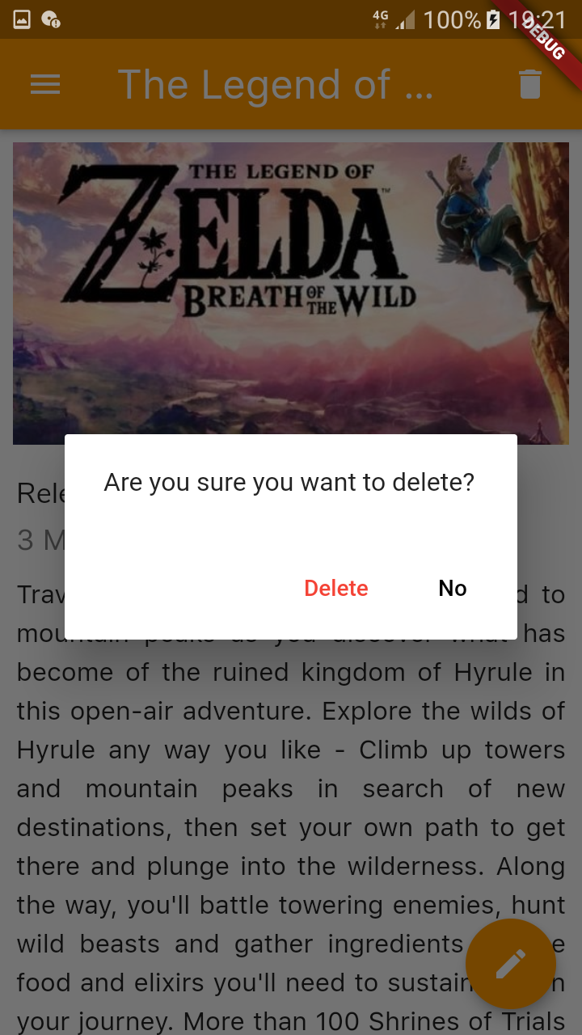

**Database**

crud.dart

**import 'package:cloud_firestore/cloud_firestore.dart'**;

**import 'package:flutter/cupertino.dart'**;

**import 'package:flutter/material.dart'**;

**import 'package:igamer/database/gameRecord.dart'**;

*// gameID|this.title|publishedDate|gameDescription|imageLink|genre|developer|releaseDate|fullDescription|esrbRating|userScore|noOfUsers*

*// This class contains the necessary CRUD actions and attributes for the games used in the app*

**class** CRUD {

*//makes singleton*

**static final** CRUD *_crud* = CRUD._internal();

Firestore **_db** = Firestore.*instance*;

*//internal constructor*

CRUD._internal();

**factory** CRUD(){

**return** *_crud*;

}

*// Collection name*

**final** String **_collection** = **"games"**;

*// Add a new game*

Future<**void**> addGame(GameRecord gameRecord) **async** {

**await _db**.collection(**"games"**).add(gameRecord.toMap()).then(

(documentReference) {

print(documentReference.**documentID**);

}).catchError((e) {

print(**"Execution terminated with the Exception : "** + e);

});

}

*// Get all games*

Stream<QuerySnapshot> getGames(){

**return _db**.collection(**_collection**).snapshots();

}

*// Update an existing game*

Future<**void**> editGame(GameRecord gameRecord, DocumentReference reference) **async** {

**await _db**.collection(**"games"**).document(reference.**documentID**).updateData(gameRecord.toMap()).then(

(documentReference) {

print(reference.**documentID**);

}).catchError((e) {

print(**"Execution terminated with the Exception : "** + e);

});

}

*//Delete an existing game*

Future<**void**> deleteGame(BuildContext context, DocumentReference reference) **async** {

**if** (**await** showConfirmationDialog(context)) {

**try** {

**await _db**.collection(**"games"**).document(reference.**documentID**).delete();

} **catch** (e) {

print(e);

}

}

}

*//show confirmation box when deleting*

Future<bool> showConfirmationDialog(BuildContext context) **async** {

**return** showDialog(

context: context,

barrierDismissible: **true**,

builder: (context) => AlertDialog(

content: Text(**'Are you sure you want to delete?'**),

actions: <Widget>[

FlatButton(

textColor: Colors.*red*,

child: Text(**'Delete'**),

onPressed: () => Navigator.*pop*(context, **true**),

),

FlatButton(

textColor: Colors.*black*,

child: Text(**'No'**),

onPressed: () => Navigator.*pop*(context),

)

],

)

);

}

}

**Game Record**

gameRecord.dart

**import 'package:cloud_firestore/cloud_firestore.dart'**;

*// This class contains attributes and relevant methods for the Game entity*

**class** GameRecord {

**final** int **gameID**;

**final** String **title**;

**final** String **publishedDate**;

**final** String **gameDescription**;

**final** String **imageLink**;

**final** String **genre**;

**final** String **developer**;

**final** String **releaseDate**;

**final** String **fullDescription**;

**final** String **esrbRating**;

**final** String **userScore**;

**final** String **noOfUsers**;

**final** DocumentReference **reference**;

*// Constructor*

GameRecord(**this**.**gameID**, **this**.**title**, **this**.**publishedDate**, **this**.**gameDescription**,

**this**.**imageLink**, **this**.**genre**, **this**.**developer**, **this**.**releaseDate**,

**this**.**fullDescription**, **this**.**esrbRating**, **this**.**userScore**, **this**.**noOfUsers**, **this**.**reference**);

*// this function maps the attributes received from map to GameRecord class*

*// meanwhile this function also asserts if the all the mapping attributes are null*

GameRecord.fromMap(Map<String, **dynamic**> map, {**this**.**reference**}):

**assert**(map[**'gameID'**] != **null**),

**assert**(map[**'title'**] != **null**),

**assert**(map[**'publishedDate'**] != **null**),

**assert**(map[**'gameDescription'**] != **null**),

**assert**(map[**'imageLink'**] != **null**),

**assert**(map[**'genre'**] != **null**),

**assert**(map[**'developer'**] != **null**),

**assert**(map[**'releaseDate'**] != **null**),

**assert**(map[**'fullDescription'**] != **null**),

**assert**(map[**'esrbRating'**] != **null**),

**assert**(map[**'userScore'**] != **null**),

**assert**(map[**'noOfUsers'**] != **null**),

**gameID** = map[**'gameID'**],

**title** = map[**'title'**],

**publishedDate** = map[**'publishedDate'**],

**gameDescription** = map[**'gameDescription'**],

**imageLink** = map[**'imageLink'**],

**genre** = map[**'genre'**],

**developer** = map[**'developer'**],

**releaseDate** = map[**'releaseDate'**],

**fullDescription** = map[**'fullDescription'**],

**esrbRating** = map[**'esrbRating'**],

**userScore** = map[**'userScore'**],

**noOfUsers** = map[**'noOfUsers'**];

*// this function maps the attributes received to map to GameRecord class*

Map<String, **dynamic**> toMap(){

**return** {

**'gameID'**: **gameID**,

**'title'**: **title**,

**'publishedDate'**: **publishedDate**,

**'gameDescription'**: **gameDescription**,

**'imageLink'**: **imageLink**,

**'genre'**: **genre**,

**'developer'**: **developer**,

**'releaseDate'**: **releaseDate**,

**'fullDescription'**: **fullDescription**,

**'esrbRating'**: **esrbRating**,

**'userScore'**: **userScore**,

**'noOfUsers'**: **noOfUsers**,

};

}

*//used for listing games*

GameRecord.fromSnapshot(DocumentSnapshot snapshot):

**this**.fromMap(snapshot.**data**, reference: snapshot.**reference**);

@override

String toString() => **"Record<**$**title:**$**title>"**;

}

Image Uploader

This is a separate class implemented to perform the uploading of an image in the add/update game.

imageUploader.dart

**import 'package:firebase_storage/firebase_storage.dart'**; *// For File Upload To Firestoreker*

**import 'package:path/path.dart' as** Path;

**import 'dart:io'**;

*// This class is used for uploading an Image to firebase*

**class** ImageUploader {

String **_imagePath**;

File **_image**;

String **__uploadedFileURL** = **"null"**;

**final** String **_remotePath** = **"images/"**;

*// Constructor*

ImageUploader(**this**.**_imagePath**, **this**.**_image**);

*// this function upload the image to the firebase a returns the downloadable image link in return*

Future<String> uploadFile() **async** {

StorageReference storageReference = FirebaseStorage.*instance*

.ref()

.child(**'**$**_remotePath/**${Path.basename(**_imagePath**)}**'**);

StorageUploadTask uploadTask = storageReference.putFile(**_image**);

**await** uploadTask.**onComplete**;

**await** storageReference.getDownloadURL().then((fileURL) {

**this**.**__uploadedFileURL** = fileURL;

});

**return this**.**__uploadedFileURL**;

}

}

About

The user can view the About page of the iGamer app.

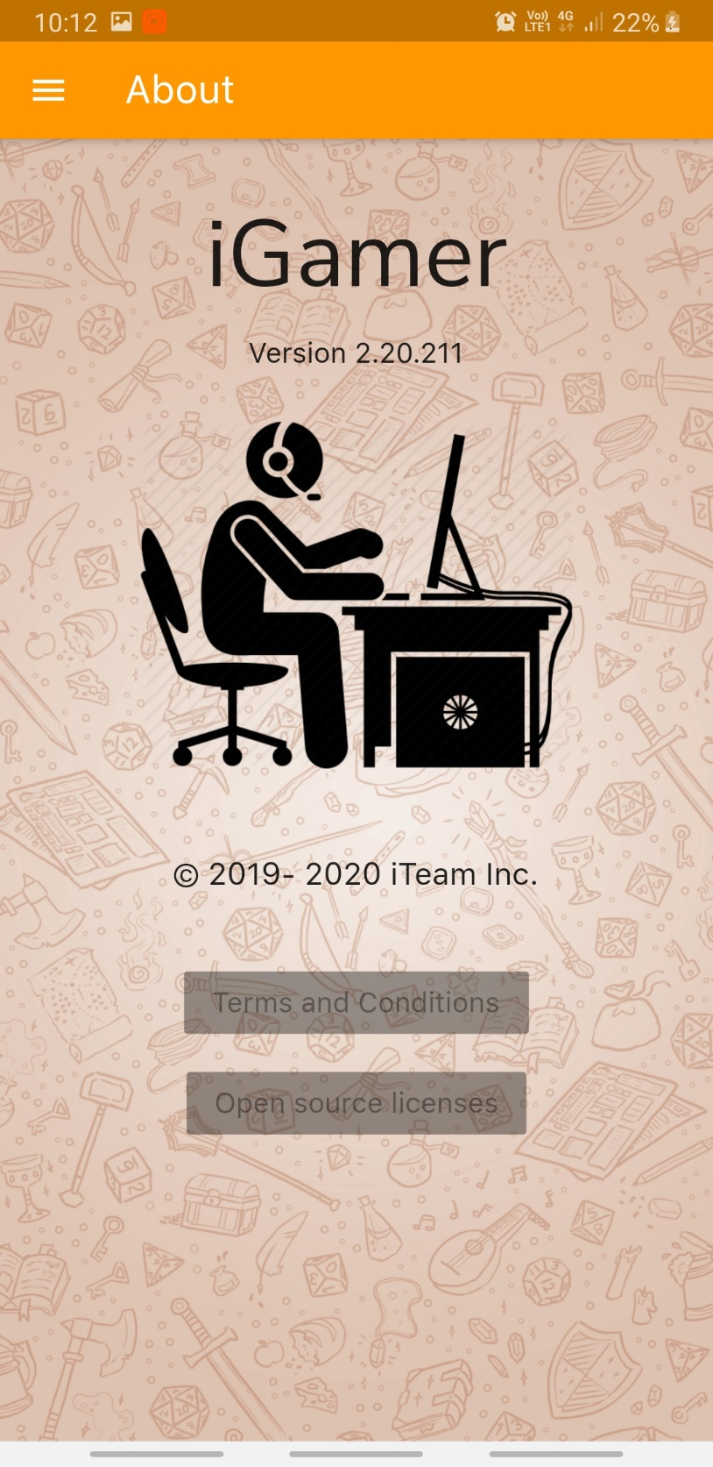

about.dart

**import 'package:flutter/cupertino.dart'**;

**import 'package:flutter/material.dart'**;

**import 'package:igamer/common_ui_widgets/appBar.dart'**;

**import 'package:igamer/common_ui_widgets/drawer.dart'**;

*// Page Title*

**final** String pageTitle = **"About"**;

*// Main method*

**void** main() {

runApp(MaterialApp(

home: AboutScreenPage(),

theme: ThemeData(fontFamily: **'SanFrancisco'**),

));

}

*//About us page*

**class** AboutScreenPage **extends** StatelessWidget {

@override

Widget build(BuildContext context) {

**return new** Scaffold(

body: **new** Stack(

children: <Widget>[

*// background image*

**new** Container(

decoration: **new** BoxDecoration(

image: **new** DecorationImage(

image: **new** AssetImage(**"assets/images/aboutus.png"**),

fit: BoxFit.**cover**,

colorFilter: **new** ColorFilter.mode(

Colors.*black*.withOpacity(0.1), BlendMode.**softLight**)),

),

),

*//returns the title*

SingleChildScrollView(

child: Column(

children: <Widget>[

Container(

margin: **const** EdgeInsets.only(top: 30),

alignment: Alignment.*center*,

child: Text(

**"iGamer"**,

style: TextStyle(fontSize: 60, fontFamily: **'NunitoSans'**),

),

),

*//returns the version of the app*

Container(

margin: **const** EdgeInsets.only(top: 10),

alignment: Alignment.*center*,

child: Text(

**"Version 2.20.211"**,

style: TextStyle(fontSize: 18, fontFamily: **'SanFrancisco'**),

),

),

*//returns image*

Container(

alignment: Alignment.*center*,

margin: **const** EdgeInsets.only(top: 30, bottom: 20),

height: 200,

child: Image.asset(**'assets/images/gamer.png'**),

),

Container(

margin: **const** EdgeInsets.only(top: 30, bottom: 20),

child: Text(

**'© 2019- 2020 iTeam Inc.'**,

style: TextStyle(fontSize: 20, fontFamily: **'SanFrancisco'**),

),

),

Container(

margin: **const** EdgeInsets.only(top: 30),

child: RaisedButton(

child: Text(

**'Terms and Conditions'**,

style: TextStyle(fontSize: 18, fontFamily: **'SanFrancisco'**),

),

),

),

Container(

margin: **const** EdgeInsets.only(top: 20),

child: RaisedButton(

child: Text(

**'Open source licenses'**,

style: TextStyle(fontSize: 18, fontFamily: **'SanFrancisco'**)),

),

),

],

),

),

],

),

drawer: **new** CustomizedDrawer(context).getDrawer(),

appBar: **new** CustomizedAppBar(pageTitle).getAppBar(),

);

}

}

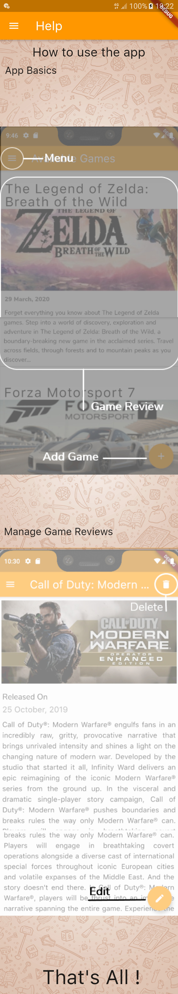Help Screen

With this page, a new user can learn how to use the iGamer app and about it’s basic functionalities.

help.dart

**import 'package:flutter/cupertino.dart'**;

**import 'package:flutter/material.dart'**;

**import 'package:igamer/common_ui_widgets/appBar.dart'**;

**import 'package:igamer/common_ui_widgets/drawer.dart'**;

*// Name of the page*

**final** String pageTitle = **"Help"**;

*// Main method*

**void** main() {

runApp(MaterialApp(home: HelpScreenPage()));

}

**class** HelpScreenPage **extends** StatelessWidget {

@override

Widget build(BuildContext context) {

**return new** Scaffold(

body: **new** Stack(

children: <Widget>[

*// Background Image*

**new** Container(

decoration: **new** BoxDecoration(

image: **new** DecorationImage(

image: **new** AssetImage(**"assets/images/aboutus.png"**),

fit: BoxFit.**cover**,

colorFilter: **new** ColorFilter.mode(

Colors.*black*.withOpacity(0.1), BlendMode.**softLight**)),

),

),

SingleChildScrollView(

child: Column(

mainAxisAlignment: MainAxisAlignment.**start**,

crossAxisAlignment: CrossAxisAlignment.**start**,

children: <Widget>[

Container(

alignment: Alignment.*center*,

margin: **const** EdgeInsets.all(10),

child: Text(

**"How to use the app"**,

style: TextStyle(fontFamily: **'SanFrancisco'**, fontSize: 25),

),

),

Container(

alignment: Alignment.*centerLeft*,

margin: **const** EdgeInsets.only(left: 10),

child: Text(

**"App Basics"**,

style: TextStyle(fontFamily: **'SanFrancisco'**, fontSize: 20),

),

),

Container(

alignment: Alignment.*center*,

child: Image.asset(

**'assets/images/help_one.png'**,

width: 400,

height: 900,

fit: BoxFit.**fitWidth**,

),

),

Container(

alignment: Alignment.*centerLeft*,

margin: **const** EdgeInsets.only(left: 10),

child: Text(

**"Manage Game Reviews"**,

style: TextStyle(fontFamily: **'SanFrancisco'**, fontSize: 20),

),

),

Container(

alignment: Alignment.*center*,

child: Image.asset(

**'assets/images/help_two.png'**,

width: 400,

height: 900,

fit: BoxFit.**fitWidth**,

),

),

Container(

alignment: Alignment.*center*,

margin: **const** EdgeInsets.only(left: 10, bottom: 10),

child: Text(

**"That's All !"**,

style: TextStyle(fontFamily: **'SanFrancisco'**, fontSize: 40),

),

),

],

),

)

],

),

drawer: **new** CustomizedDrawer(context).getDrawer(),

*// getting Custom Built Drawer*

appBar: **new** CustomizedAppBar(pageTitle)

.getAppBar(), *// getting Custom Built App Bar*

);

}

}

**Common UI Widgets**

**App Bar**

appBar.dart

**import 'package:flutter/material.dart'**;

**import 'package:igamer/database/crud.dart'**;

**import 'package:igamer/database/gameRecord.dart'**;

**import 'package:igamer/screens/main.dart'**;

*// This class contains attributes and methods for a Customized App Bar*

**class** CustomizedAppBar {

**final** Color **backgroundColor** = Colors.*orange*;

String **title**;

BuildContext **context**;

GameRecord **game**;

*// Constructor*

CustomizedAppBar(**this**.**title**);

CustomizedAppBar.fromGameDetail(String title, BuildContext context, GameRecord game) {

**this**.**title** = title;

**this**.**context** = context;

**this**.**game** = game;

}

*// this function returns the Customized App Bar*

Widget getAppBar() {

**return new** AppBar(

title: Text(**title**, style: TextStyle(fontSize: 25, fontFamily: **'SanFrancisco'**),),

backgroundColor: **backgroundColor**,

actions: <Widget>[

*//delete option*

**game** != **null** ?

Padding(

padding: EdgeInsets.only(right: 20.0),

child: GestureDetector(

onTap: () **async** {

**await new** CRUD().deleteGame(**context**, **game**.**reference**);

Navigator.*push*(

**context**,

MaterialPageRoute(builder: (context) => MyHomePage()),

); *//*

},

child: Icon(

Icons.*delete*

),

)

) : Container(),

],

);

}

}

Drawer

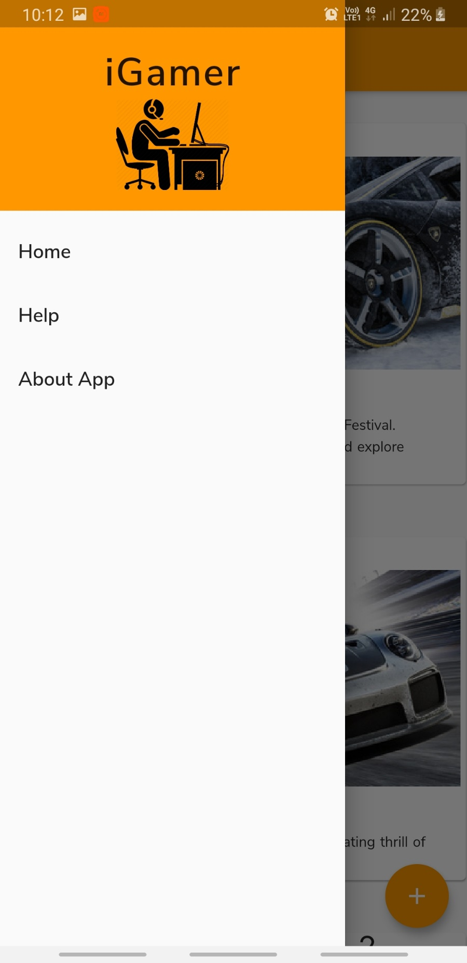

drawer.dart

**import 'package:flutter/material.dart'**;

**import 'package:igamer/screens/about.dart'**;

**import 'package:igamer/screens/help.dart'**;

**import 'package:igamer/screens/main.dart'**;

*// this class contains attributes and methods for App Drawer*

**class** CustomizedDrawer {

**final** Color **backgroundColor** = Colors.*orange*;

BuildContext **context**;

CustomizedDrawer(**this**.**context**);

*// this function returns a Customized App Drawer*

Widget getDrawer() {

**return new** Drawer(

child: ListView(

padding: EdgeInsets.*zero*,

children: <Widget>[

DrawerHeader(

child: **new** Column(

children: <Widget>[

**new** Container(

child: Text(**'iGamer'**,

style: TextStyle(fontSize: 38, letterSpacing: 1.5 , fontFamily: **'NunitoSansSemiBold'**),),

),

**new** Container(

child: **new** Image.asset(**'assets/images/gamer.png'**),

height: 80,

width: 100,

)

],

),

decoration: BoxDecoration(color: Colors.*orange*),

),

ListTile(

title: Text(**'Home'**, style: TextStyle(fontFamily: **'NunitoSansSemiBold'**, fontSize: 19),),

onTap: () => {

Navigator.*push*(**context**, MaterialPageRoute(builder: (context) => **new** MyHomePage()))},

),

ListTile(

title: Text(**'Help'**, style: TextStyle(fontFamily: **'NunitoSansSemiBold'**, fontSize: 19),),

onTap: () => {

Navigator.*push*(**context**, MaterialPageRoute(builder: (context) => **new** HelpScreenPage()))},

),

ListTile(

title: Text(**'About App'**, style: TextStyle(fontFamily: **'NunitoSansSemiBold'**, fontSize: 19),),

onTap: () => {Navigator.*push*(**context**, MaterialPageRoute(builder: (context) => **new** AboutScreenPage()))},

)

],

),

);

}}

inputWidgets.dart

**import 'package:flutter/cupertino.dart'**;

**import 'package:flutter/material.dart'**;

**import 'package:flutter/services.dart'**;

**import 'package:datetime_picker_formfield/datetime_picker_formfield.dart'**;

**import 'package:igamer/screens/addGame.dart'**;

**import 'package:intl/intl.dart'**;

*// this class contains all the common input widgets used in the app*

**class** CommonInputWidgets {

*// this function returns a TextField*

Container getTextField(String labelText, String hintText, IconData icon,

TextEditingController controller, String validator, FocusNode focusNode) {

**return** (Container(

height: 100,

child: TextFormField(

*//focus node*

textInputAction: TextInputAction.**next**,

onEditingComplete: (){

FocusScope.*of*(**new** AddGameFormState().**context**).requestFocus(focusNode);

},

focusNode: **new** AddGameFormState().**focusNode**,

*//decoration to the field*

decoration: InputDecoration(

labelText: labelText, hintText: hintText, icon: Icon(icon)),

controller: controller,

autocorrect: **true**,

autofocus: **true**,

*//validations*

autovalidate: **true**,

validator: (value){

**if**(value == **null** || value.**isEmpty**){

**return** validator;

}

**if**(value.trim() == **""**){

**return "Only Space is Not Valid !!!"**;

}

**return null**;

},

),

));

}

*// this function return a date picker*

Container getDatePicker(

String label, IconData icon, TextEditingController controller, String validator, FocusNode focusNode) {

*//date format*

**final** format = DateFormat(**"dd MM, yyyy"**);

**return** Container(

margin: **const** EdgeInsets.only(bottom: 30),

child: Column(children: <Widget>[

Container(

alignment: Alignment(-1, -1),

child: Text(label),

margin: **const** EdgeInsets.only(left: 40),

),

Row(

children: <Widget>[

Container(

child: **new** Icon(icon),

),

Container(

width: 335,

margin: **const** EdgeInsets.only(left: 20),

child: DateTimeField(

format: format,

*//uses datepicker option*

onShowPicker: (context, currentValue) {

**return** showDatePicker(

context: context,

firstDate: DateTime(1900),

initialDate: currentValue ?? DateTime.now(),

lastDate: DateTime(2100));

},

controller: controller,

autocorrect: **true**,

autofocus: **true**,

*//validations*

autovalidate: **true**,

validator: (value) {

**if** (value.toString() == **null**) {

**return** validator;

}

**else** {

**return null**;

}

}

),

)

],

)

]),

);

}

*// this function returns a Number Text Field*

*// if the parameter onlyDigits is true , only digits can be entered (not point values)*

Container getNumberTextField(String labelText, String hintText, IconData icon,

bool onlyDigits, TextEditingController controller, String validator, FocusNode focusNode ) {

**return** (Container(

height: 100,

child: TextFormField(

*//focus node*

textInputAction: TextInputAction.**next**,

onEditingComplete: (){

FocusScope.*of*(**new** AddGameFormState().**context**).requestFocus(focusNode);

},

focusNode: **new** AddGameFormState().**focusNode**,

*//field decorations*

decoration: InputDecoration(

labelText: labelText, hintText: hintText, icon: Icon(icon)),

controller: controller,

autocorrect: **true**,

autofocus: **true**,

*//validations*

autovalidate: **true**,

validator: (value){

**if**(value == **null** || value.**isEmpty**){

**return** validator;

}

**if**(value.trim() == **""**){

**return "Only Space is Not Valid !!!"**;

}

**return null**;

},

keyboardType: TextInputType.*number*,

inputFormatters: <TextInputFormatter>[

**if** (onlyDigits) WhitelistingTextInputFormatter.*digitsOnly*

],

),

));

}

*// this function returns a Text Area*

Container getTextArea(String labelText, String hintText, IconData icon,

TextEditingController controller, String validator, FocusNode focusNode) {

**return** (Container(

margin: **const** EdgeInsets.only(bottom: 30),

child: Column(

children: <Widget>[

Container(

alignment: Alignment(-.8, -1),

child: Text(labelText),

margin: **const** EdgeInsets.only(bottom: 15),

),

Row(

children: <Widget>[

Container(

child: **new** Icon(icon),

),

Container(

width: 335,

child: Card(

color: Colors.*transparent*,

elevation: 0,

margin: **const** EdgeInsets.only(left: 5),

child: Padding(

padding: EdgeInsets.all(1.0),

child: TextFormField(

maxLines: 8,

*//focus node*

textInputAction: TextInputAction.**next**,

onEditingComplete: (){

FocusScope.*of*(**new** AddGameFormState().**context**).requestFocus(focusNode);

},

focusNode: **new** AddGameFormState().**focusNode**,

*//field decorations*

decoration: InputDecoration(hintText: hintText),

controller: controller,

autocorrect: **true**,

autofocus: **true**,

*//validations*

autovalidate: **true**,

validator: (value){

**if**(value == **null** || value.**isEmpty**){

**return** validator;

}

**if**(value.trim() == **""**){

**return "Only Space is Not Valid !!!"**;

}

**return null**;

},

),

)),

)

],

)

],

)));

}

}

alertBox.dart

**import 'package:flutter/material.dart'**;

*// this class contains attributes and method for an Alert Box*

**class** AppAlertBox {

BuildContext **context**;

String **title**;

String **message**;

String **buttonText**;

*// Constructor*

AppAlertBox(**this**.**context**, **this**.**title**, **this**.**message**, **this**.**buttonText**);

*// this function pops up Alert Box*

showAlertDialog() {

Widget okButton = FlatButton(

child: Text(**this**.**buttonText**),

onPressed: () {

Navigator.*pop*(**this**.**context**);

},

);

*// set up the AlertDialog*

AlertDialog alert = AlertDialog(

title: Text(**this**.**title**),

content: Text(**this**.**message**),

actions: [

okButton,

],

);

*// show the AlertDialog*

showDialog(

context: **this**.**context**,

builder: (BuildContext context) {

**return** alert;

},

);

}

}