**DS Assignment 2 – Online Train Reservation System**

Module: Distributed Systems

Assignment: 2 - Rest API, WSO2 EI

Software Engineering Weekend Batch

Name

P.P.G.S.H.A.Guruge

Registration No

IT17042352

**Introduction**

This is a Web Application where the user can reserve train tickets based on the trains which are available. The Online Train Reservation is made using HTML, JavaScript, Java, jQuery and AJAX technologies. The services are integrated using WSO2 EI.

First the user should select the required train, and then the system shows the details of the selected train, then the user can enter the number of tickets that the user wishes to purchase, then after calculating the Total Bill, the user can select the Payment method.

If the user wishes to pay using Credit Card the user should enter Credit Card Details or if the user wishes to pay using Mobile Credit the should enter his mobile details.

After successfully enter the payment details, if the user is a Government employee the user can enter his NIC number and get a discount.

If the payment is successful, the user is prompted to enter his email and an email is sent to the user confirming the booking is confirmed.

**High Level Architectural Diagram**

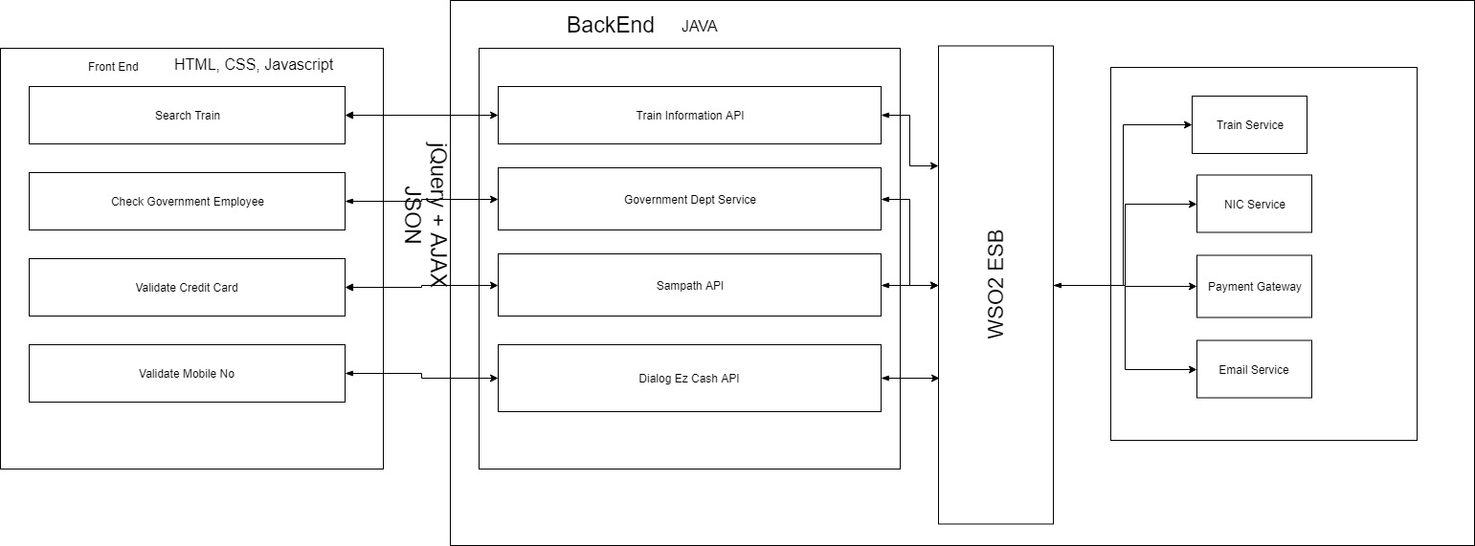

**Workflow**

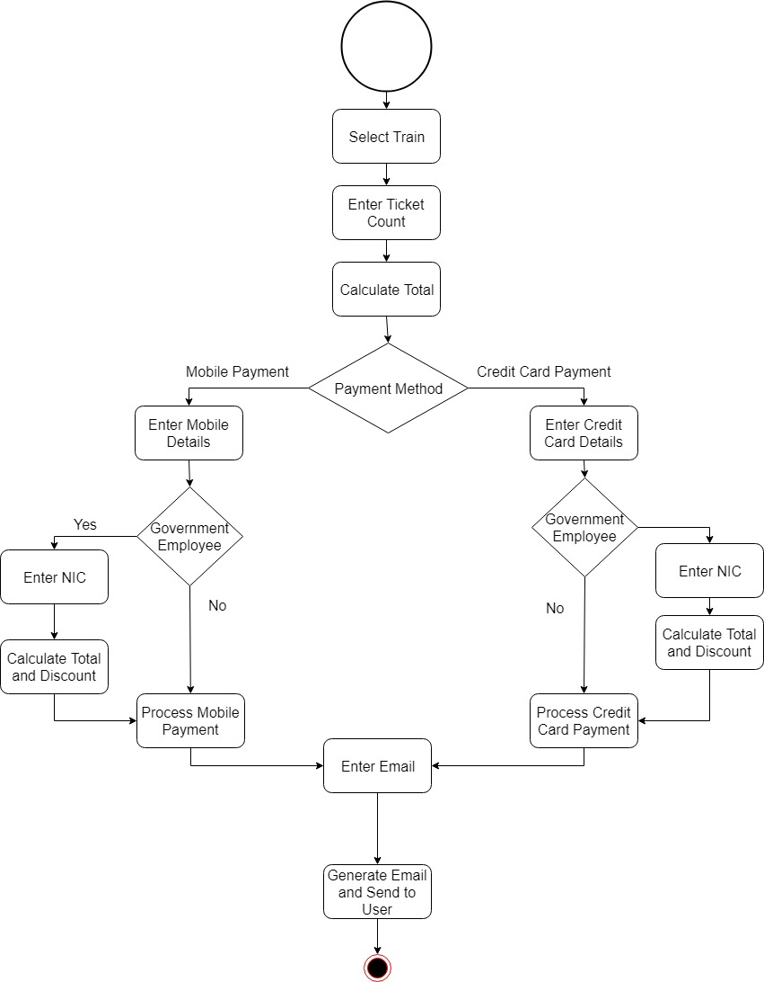

1. User Selects Train from the drop-down List
2. User Enters the Ticket Count and clicks Calculate Total
3. User Select Mobile as Payment Method in the dropdown
4. User clicks Book
5. Tickets

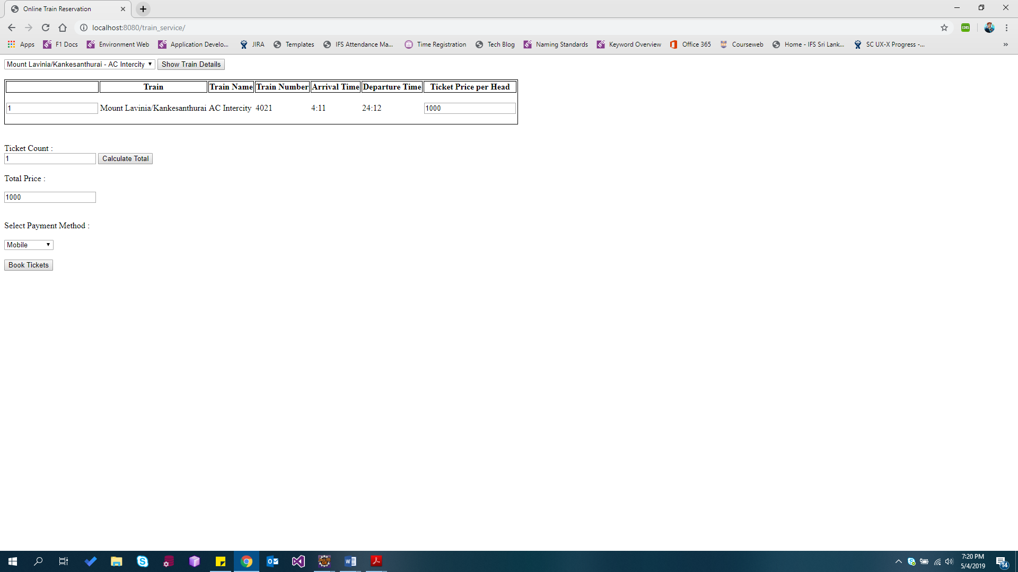

6. User Enters Mobile No and 4-digit pin no

7. User is a government Employee so, he selects Yes from the dropdown

8. User enters his NIC and clicks Validate NIC button and system displays the status of the NIC (Verified or Not)

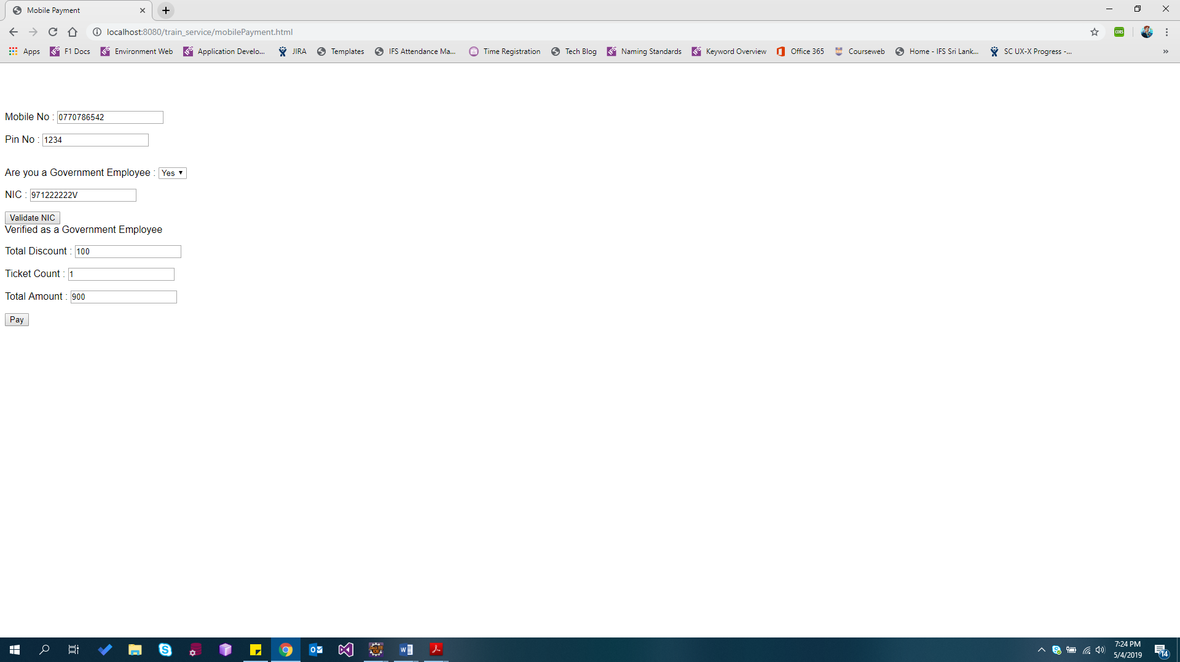

9. System displays payment status in alert box.

10. System prompts the user to enter his email address

11. System display email status in alert box.

12. System sends the email to the user’s email address

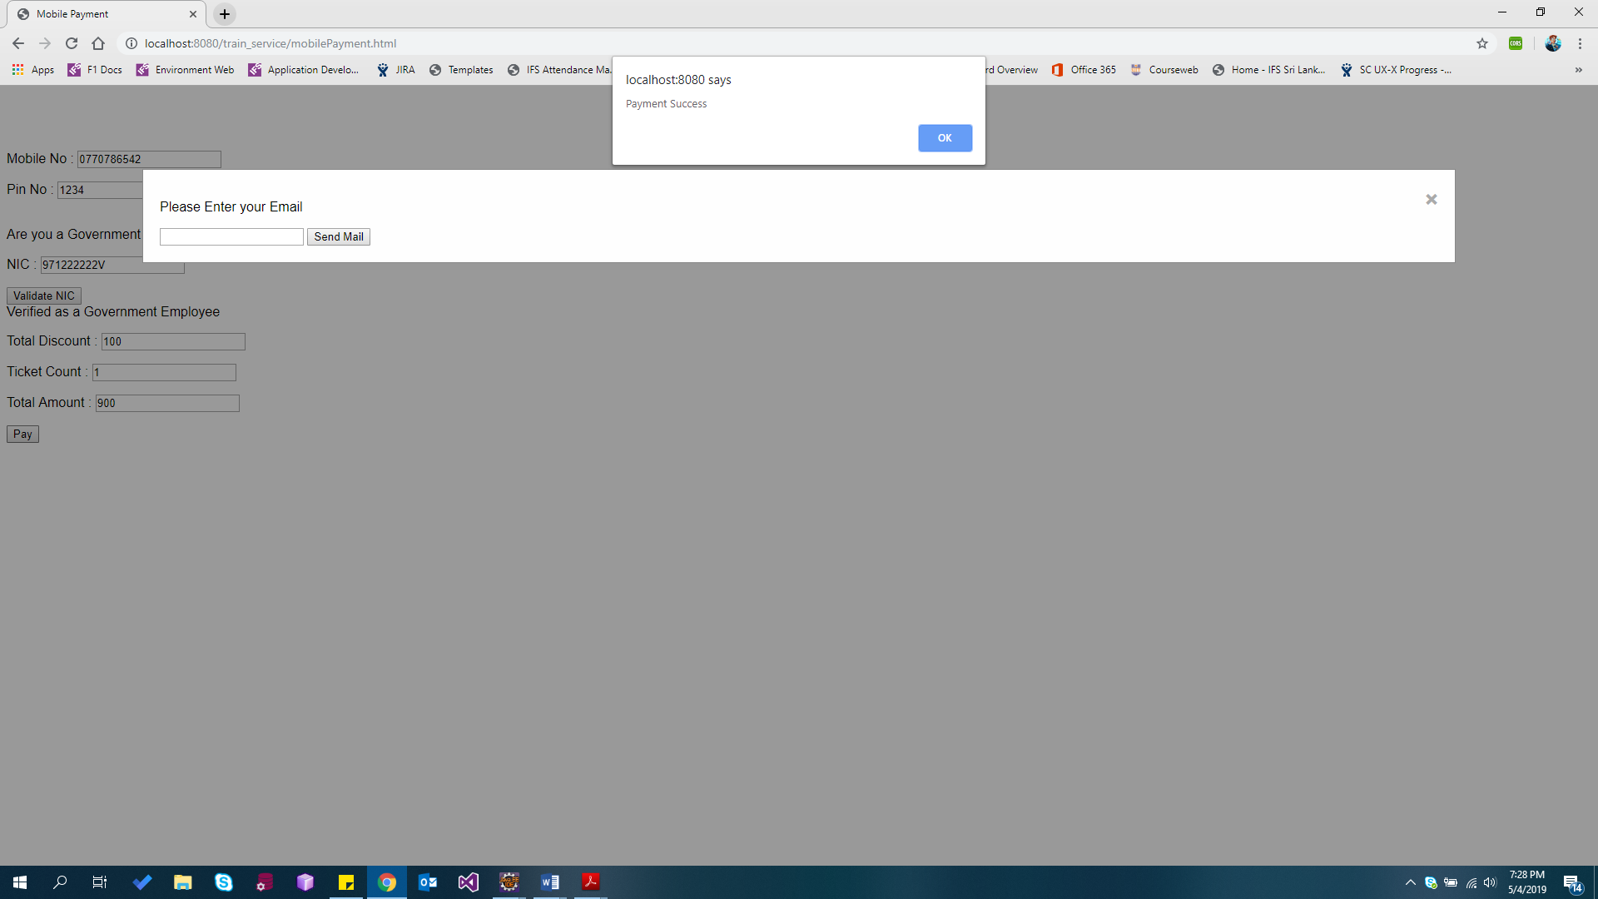

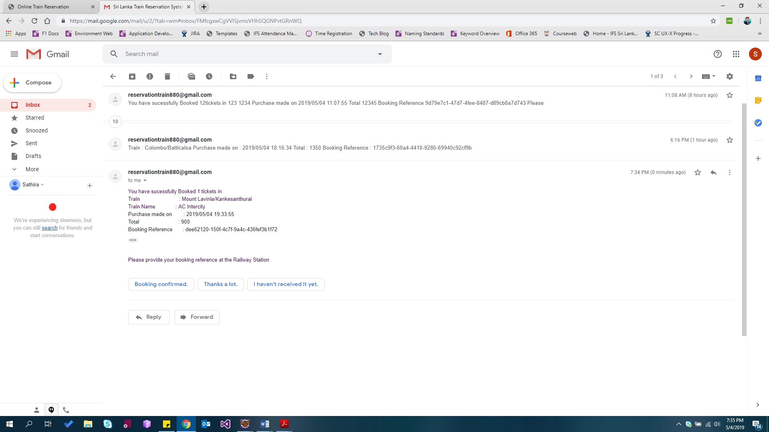

**Credit Card Validation and Payment Gateway**

1. The Credit Card Number, CVC no and holder’s name is matched against the provided Credit Card Details by the User.
2. After the validation, before processing the payment, credit card balance is checked ensuring that the credit card limit has not been exceeded.
3. Then the credit card balance is compared with ticket price ensuring that credit card has enough credit to complete the purchase.
4. Then the ticket amount is deducted from the credit card

The following code explains the above scenario

**function** payCreditCard() {

jQuery

.ajax({

url : "http://localhost:8280/paymentGateway/processCard/"

+ $("#cardNo").val()

+ "/"

+ $("#cvcNo").val()

+ "/"

+ $("#holderName").val(),

type : "GET",

contentType : "application/json",

dataType : 'json',

success : **function**(data, textStatus, errorThrown) {

**var** cardNo = data.creditCardNo;

**var** limit = data.limit;

**var** currentAmount = data.currentAmount;

**var** availableBalance = limit - currentAmount;

**var** ticketPrice = $("#total").val();

**if** (availableBalance > 0) {

**if** (availableBalance >= ticketPrice) {

updateBalance(cardNo, ticketPrice);

**var** modal = document.getElementById('myModal');

modal.style.display = "block";

} **else**

alert("Credit Card Balance not Sufficient");

} **else**

alert("Card Limit has Exceeded, Contact your Bank");

},

error : **function**(jqXHR, textStatus, errorThrown) {

alert("Payment Failed, Invalid Card Details");

},

timeout : 12000,

});

};

**Mobile Payment Validation and Mobile Payment Gateway**

1. The Mobile No, and 4-digit PIN is matched against the provided Mobile Details by the User.
2. After the validation, before processing the payment, mobile balance is checked ensuring that the mobile balance is not zero.
3. Then the credit card balance is compared with ticket price ensuring that mobile has enough credit to complete the purchase.
4. Then the ticket amount is deducted from the mobile

The following code explains the above scenario

**function** payMobile() {

jQuery

.ajax({

url : "http://localhost:8280/dialogPayment/processMobilePayment/"

+ $("#mobileNo").val() + "/" + $("#pin").val(),

type : "GET",

contentType : "application/json",

dataType : 'json',

success : **function**(data, textStatus, errorThrown) {

**var** mobileNo = data.mobileNo;

**var** mobileBalance = data.balance;

**var** ticketPrice = $("#total").val();

**if** (mobileBalance > 0) {

**if** (mobileBalance >= ticketPrice) {

updateMobileBalance(mobileNo, ticketPrice);

**var** modal = document.getElementById('myModal');

modal.style.display = "block";

} **else**

alert("Mobile Balance not Sufficient");

} **else**

alert("Insufficient Mobile Balance !");

},

error : **function**(jqXHR, textStatus, errorThrown) {

alert("Payment Failed, Invalid Mobile Details");

},

timeout : 12000,

});

};

**Appendix**

**Front End**

AJAX Request – Process Mobile Payments

**function** payMobile() {

jQuery

.ajax({

url:"http://localhost:8280/dialogPayment/processMobilePayment/"

+ $("#mobileNo").val() + "/" + $("#pin").val(),

type : "GET",

contentType : "application/json",

dataType : 'json',

success : **function**(data, textStatus, errorThrown) {

**var** mobileNo = data.mobileNo;

**var** mobileBalance = data.balance;

**var** ticketPrice = $("#total").val();

**if** (mobileBalance > 0) {

**if** (mobileBalance >= ticketPrice) {

updateMobileBalance(mobileNo, ticketPrice);

**var** modal = document.getElementById('myModal');

modal.style.display = "block";

} **else**

alert("Mobile Balance not Sufficient");

} **else**

alert("Insufficient Mobile Balance !");

},

error : **function**(jqXHR, textStatus, errorThrown) {

alert("Payment Failed, Invalid Mobile Details");

},

timeout : 12000,

});

};

**Routing**

Mobile Payments Routing

**public** **class** DialogService {

List<Phone> dialogPhones;

**public** DialogService() {

dialogPhones = DialogPhones.*getPhones*();

}

@GET

@Produces(MediaType.***APPLICATION_JSON***)

**public** List<Phone> getPhones() {

**return** dialogPhones;

}

@Path("{mobileNo}/{pin}")

@GET

@Produces(MediaType.***APPLICATION_JSON***)

**public** Phone getMobille(@PathParam("mobileNo") String mobileNo, @PathParam("pin") **int** pin) {

**for** (Phone b : dialogPhones) {

**if** (b.getMobileNo().equals(mobileNo) && b.getPin() == pin)

**return** b;

}

**throw** **new** NotFoundException();

}

@Path("/updateMobileAmount/{mobileNo}/{amount}/")

@POST

@Produces(MediaType.***APPLICATION_JSON***)

**public** Phone updateAmount(@PathParam("mobileNo") String mobileNo, @PathParam("amount") **double** amount) {

**for** (Phone b : dialogPhones) {

**if** (b.getMobileNo().equals(mobileNo)) {

b.setBalance(b.getBalance() - amount);

**return** b;

}

}

**throw** **new** NotFoundException();

}

}

**Web.xml – Configuration, mapping**

<servlet>

<servlet-name>dialog_service</servlet-name>

<servlet-class>org.glassfish.jersey.servlet.ServletContainer</servlet-class>

<init-param>

<param-name>jersey.config.server.provider.packages</param-name>

<paramvalue>dialogservice,com.jersey.jaxb,com.fasterxml.jackson.jaxrs.json

</param-value>

</init-param>

<load-on-startup>1</load-on-startup>

</servlet>

<servlet-mapping>

<servlet-name>dialog_service</servlet-name>

<url-pattern>/rest/mobilepaymentgateway/*</url-pattern>

</servlet-mapping>

**Database**

Government’s Database of NICs

The third parameter in the constructor is the government Employee flag.

**private** **static** ArrayList<NIC> *nicCards* = **new** ArrayList<>();

**static** {

*nicCards*.add(**new** NIC(1, "971222222V", **true**));

*nicCards*.add(**new** NIC(2, "866652121V", **true**));

*nicCards*.add(**new** NIC(3, "121212123V", **false**));

*nicCards*.add(**new** NIC(4, "787232131V", **true**));

*nicCards*.add(**new** NIC(5, "984324344V", **false**));

*nicCards*.add(**new** NIC(6, "837233123V", **true**));

*nicCards*.add(**new** NIC(7, "232323223V", **true**));

}

Dialog’s Database of Dialog Mobile Numbers

**private** **static** ArrayList<Phone> *phoneNumbers* = **new** ArrayList<>();

**static** {

*phoneNumbers*.add(**new** Phone("0770786542", "Tom", 5000, 1234));

*phoneNumbers*.add(**new** Phone("0770721542", "Jerry", 51000, 1111));

*phoneNumbers*.add(**new** Phone("0770123542", "Alan", 61000, 6543));

*phoneNumbers*.add(**new** Phone("0770745542", "David", 9000, 6523));

*phoneNumbers*.add(**new** Phone("0770786542", "Marie", 1000, 9876));

*phoneNumbers*.add(**new** Phone("0770124542", "Daniel", 100, 1123));

*phoneNumbers*.add(**new** Phone("0770098542", "Nicolson", 500, 8876));

}

Sampath’s Database of Credit Cards

**private** **static** ArrayList<CreditCard> *cards* = **new** ArrayList<>();

**static** {

*cards*.add(**new** CreditCard("4024007155211112", "123", "YaraLuna", 5000, 0, "22/08"));

*cards*.add(**new** CreditCard("4929570311913059", "423", "Ace Morin", 85000, 1000, "23/09"));

*cards*.add(**new** CreditCard("4024007195367999", "543", "Darlene Timms", 57000, 1000, "23/09"));

*cards*.add(**new** CreditCard("4916107452462243", "323", "Amiya Romero", 56000, 1000, "23/09"));

*cards*.add(**new** CreditCard("4916286362099228", "873", "Daryl Mccullough", 55000, 1000, "23/09"));

*cards*.add(**new** CreditCard("5153705312725508", "433", "Lilia Mcfarland", 2000, 1000, "23/09"));

*cards*.add(**new** CreditCard("5578824892969357", "443", "Cruz Weaver", 23000, 1000, "23/09"));

}

Train Service’s Database of Trains

**private** **static** ArrayList<Train> *trains* = **new** ArrayList<>();

**static** {

*trains*.add(**new** Train(1, "Mount Lavinia/Kankesanthurai", "AC Intercity", "4021", "4:11", "24:12", 1000));

*trains*.add(**new** Train(2, "Colombo/Kandy", "Night Mail", "1009", "4:11", "24:12", 2000));

*trains*.add(**new** Train(3, "Colombo/Batticaloa", "Udaya Devi", "6011", "4:11", "24:12", 2500));

*trains*.add(**new** Train(4, "Colombo/Batticaloa", "Night mail Express", "6079", "4:11", "24:12", 1500));

*trains*.add(**new** Train(5, "Colombo/Badulla", "Udarata Manike", "3011", "4:11", "24:12", 1000));

*trains*.add(**new** Train(6, "Colombo/Badulla", "Night mail Express", "5021", "4:11", "24:12", 3500));

*trains*.add(**new** Train(7, "Colombo/Kandy", "AC Intercity", "4009", "4:11", "24:12", 1500));

}