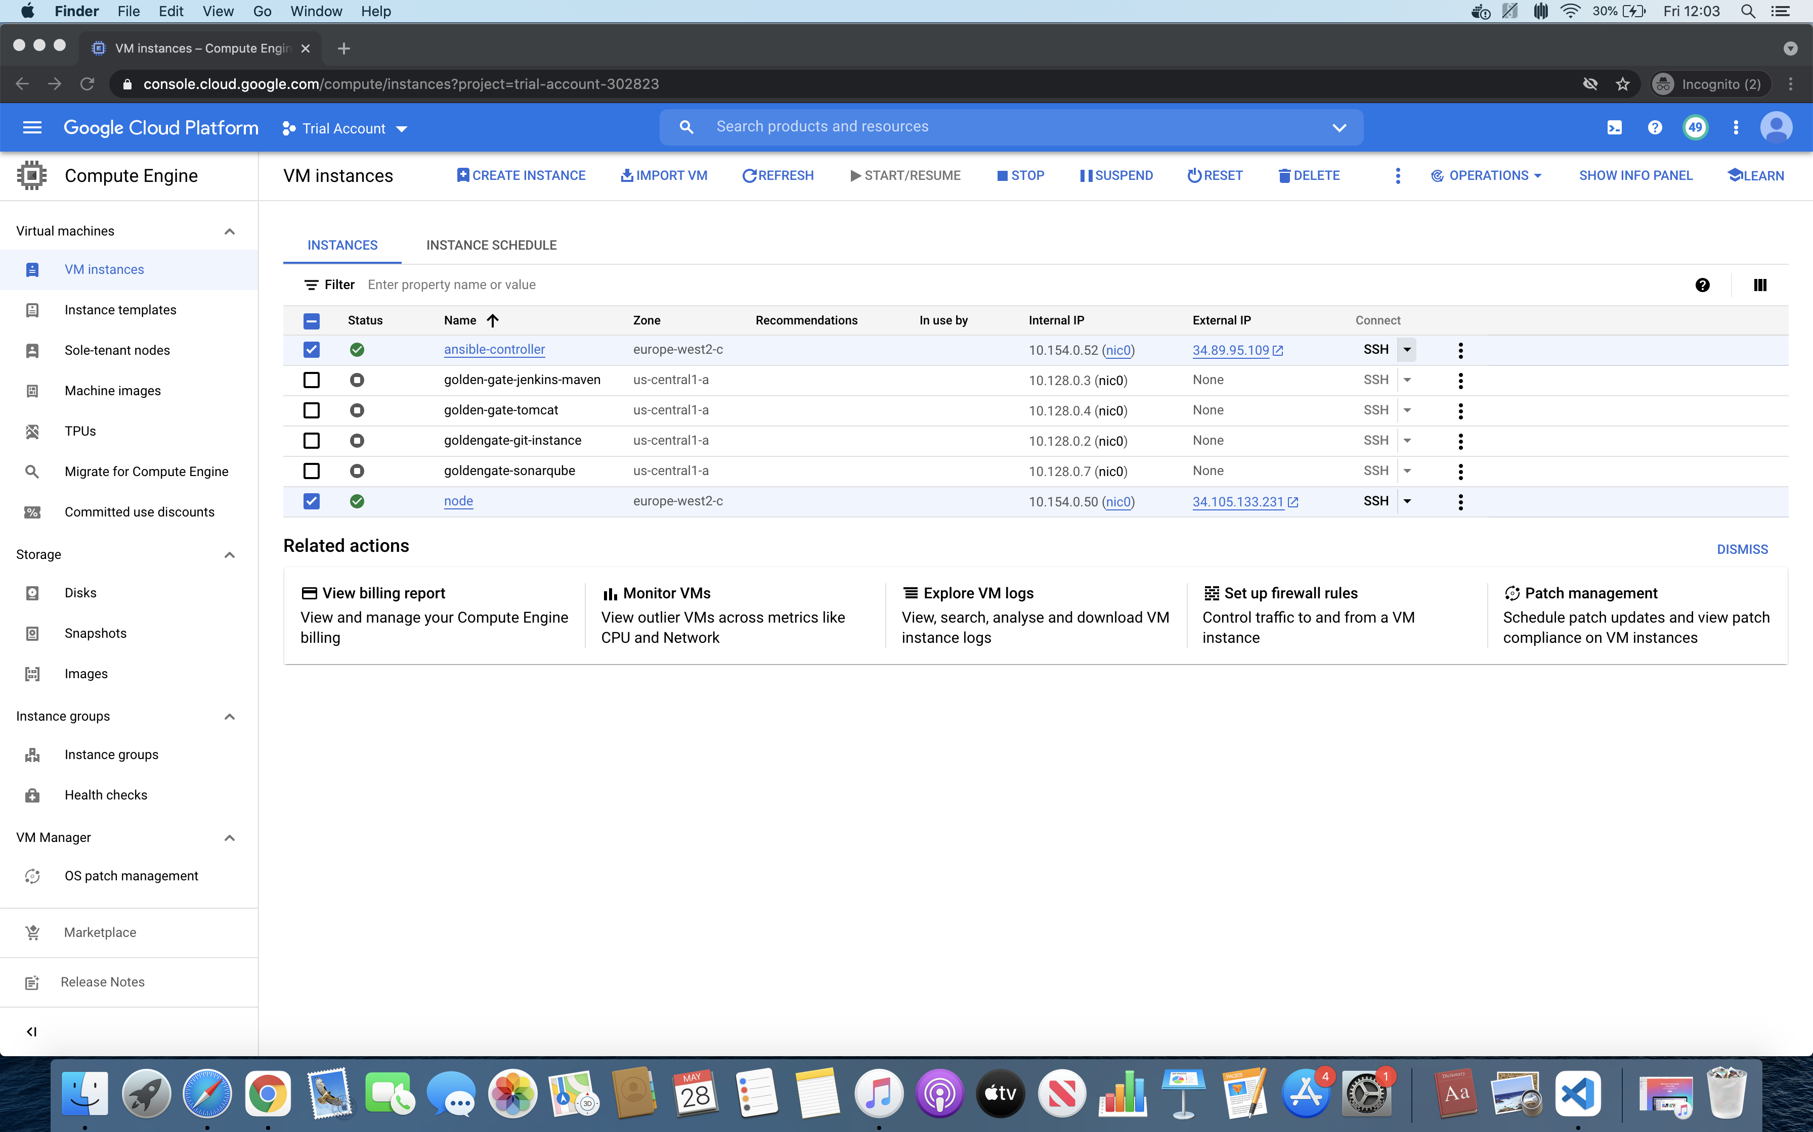

GCP VMs for Ansible controller and Slave