EXTENDING NETWORK LIFETIME THROUGH FAIR ROUTING WITH SYNCHRONIZATION STRATEGIES IN HETEROGENEOUS WIRELESS SENSOR NETWORKS

M.Jayanthi¹, S.Madhavi²

¹PG scholar, Department of CSE, K.S.Rangasamy college of technology, Tiruchengode.
Mail-id: jayanthicseksr@gmail.com
²Professor, Department of CSE, K.S.Rangasamy college of technology, Tiruchengode.

Abstract

The wireless detector network presents all detector nodes to get associate degree equal quantity of information packets in a very WSN. The nodes around a sink have to be compelled to relay additional packets and have a tendency to die ahead of alternative nodes as a result of the energy consumption of detector nodes therefore, the full network lifespan are often prolonged by equalization the communication load around a sink. This downside is named the load equalization downside and is one amongst the foremost vital problems for WSNs. The study proposes to deal with the energy potency downside by synchronizing the transmission times of all the nodes within the system. the most contribution consists then of a collection of synchronization protocols, designed on prime of CPMP (Content gift Multicast Protocol). Specifically, within the project presents a Weight primarily based Synchronization (WBS) protocol that uses the scale of synchronal node clusters as a catalyst for synchronization. whereas economical, it shows that WBS’s reliance on info contained in CPMP updates makes it liable to straightforward attacks.

I.Introduction
It is spatially distributed autonomous sensors to watch physical or environmental conditions like temperature, sound, pressure, etc. To hand and glove pass their knowledge through the network to different locations lot of fashionable networks are bi-directional, co-jointly sanctioning management of device activity. the event of wireless device networks was driven by military applications like parcel surveillance; nowadays such networks are employed in several industrial and shopper applications, like process observance and management, machine health observance, and so on.

II Related Works

Pedro O.S. Vaz American state Melo , Felipe D. Cunha , Antonio A.F. Loureiro [1]stated that, once 2 or a lot of WSNs ar deployed within the same place and their sensors join forces with the opposite networks, they improve their operability, by extending its period by mercantilism routing favors or increasing knowledge the information} entropy by a standard data aggregation. Despite being obvious and straightforward, this idea brings with it several implications that hinder cooperation between the networks. Whereas a WSN features a rational and egotistical character, it'll solely join forces with another WSN if this provides services that justify the cooperation. The goal of this work is to gift the Virtual Cooperation Bond (VCB) protocol, that may be a distributed protocol that produces completely different WSNs to join forces, facultative cooperation if and providing, and every one the various WSNs profit with the cooperation.

M.J. Hossein Gharaee, Sahba [2] explained in some applications of detector networks, multi-domain exists and cooperation among domains may lead to longer period for heterogeneous multi-domain detector networks. It implies that networks belong to different domains and sensors are deployed at a similar physical location and their topology is heterogonous. Apparently, domains life time will be exaggerated by

suggests that of cooperation in packet forwarding; but miserliness is inevitable from rational perspective. They seen the cooperation of authorities whereas their sensors are energy aware. once sensors cooperation cannot occur. they conferred the reconciling Energy Aware strategy, a completely unique rule that's supported TIT-FOR-TAT, starts with generosity and winds up with conservative behavior. Their simulation results showed that this rule may prolong its network period in competition with alternative networks.

Large-scale networks with an outsized range of detector nodes, multiple sink nodes ought to be deployed, not solely to extend the managing of network, however co-jointly to scale back the energy dissipation at every node. They centered on the multiple sink location issues in large-scale wireless detector networks. completely different issues counting on the planning criteria square measure given. They think about locating sink nodes to the detector surroundings, wherever they're given a time constraint that states the minimum needed operational time for the detector network. Wireless detector nodes square measure combining the wireless communication infrastructure with the sensing technology. rather than sending the perceived knowledge to the centre through wired links, unintentional communication ways square measure used and therefore the knowledge packets square measure transmitted exploitation multi-hop connections. The potency of the detector network investment is directly connected with the length of the reliable observation length of the sector.

Gaurav Gupta associate degreed Mohamed Younis[4] investigated the performance of an algorithmic rule to network these sensors in to well outline clusters with less energy-constrained entry nodes acting as cluster heads and balance load among these gateways. Load balanced cluster will increase the system stability and improves the communication between completely different nodes within the system. to judge the potency of their approach and performance of detector networks applying numerous completely different routing protocols. Sensors square measure usually equipped with processing and communication capabilities. The sensing circuit measures parameters from the surroundings encompassing the detector and transforms them into an electrical signal. process such a symbol reveals some properties regarding objects settled and/or events happening within the neck of the woods of the sensors.

Junko Nagata, Kazuhiko Kinoshita, Koso Murakami[5] planned a routing methodology for cooperative forwarding in such multiple WSNs which will extend their period. For multiple WSNs, every sink location can disagree from the others, and a few nodes around a sink in one WSN is also aloof from a sink in another WSN. It centered on the difficulty within the planned methodology, with a node that's aloof from a sink in its own network and close to a sink in another network having the ability to forward packets from a node in another WSN to the corresponding sink. during this case, the energy of such nodes can exhaust ahead of that of alternative nodes, inflicting associate degree “energy hole” to seem round the sink. No additional knowledge is delivered to the sink when the outlet seems. The planned methodology decides what proportion alternative WSNs with completely different sink locations will facilitate such “heavy-load” things situations.

III. FAIR ROUTING MODEL

In this paper, enforced honest routing from choose WSN node structure. WSNs operate completely different applications severally, hence, heterogeneous characteristics, like battery capability, operation begin time, the quantity of nodes, nodes locations, energy consumption, packet size and/or information transmission temporal order. However, most existing cooperation strategies don't think about this heterogeneousness. as an example, once batteries capacities on sensing element nodes ar quite completely different by a WSN, a cooperative routing technique supported residual energy isn't applicable since a WSN that has the most battery capability invariably forwards packets from alternative WSNs.

the present system results bound WSNs prolong their time period, the opposite WSNs could shorten their time period. In such a scenario, fairness of cooperation could be a extremely vital drawback for energy allocation in WSN. additionally, for correct programming between PUs and genus Sus, techniques for synchronizing WSN nodes ar bestowed that sporadically identifies the appropriate genus Sus for the given PUs so the sub channel assignment is healthier than existing system. Best SU Detection algorithmic rule is projected to avoid the inflation attack that is created by causing false most weight among the genus Sus.

The new system eliminates the matter by shrewd the transmission schedule victimization the burden data supported the projected algorithmic rule steps. additionally, synchronizing all the neighbor nodes that belong to varied clusters is should to achieve the stable state of the network. The projected approach presents the techniques for synchronizing nodes that sporadically content Associate the presence updates to collocated nodes over an WSN network. rather than orienting duty cycles, the new algorithms synchronize the periodic transmissions of nodes. this permits nodes to save lots of battery power by switch off their network cards while not missing updates from their neighbors.

IV. METHODOLOGY

In a sensing field, m completely different WSNs are created, and completely different applications are in operation on every WSN severally. The fig 4.1shows example wherever 2 WSNs are created. If serious loaded nodes are in several places among the WSNs as indicated within the example, it's attainable that knowledge packets via serious loaded nodes are forwarded by different nodes in another WSN. However, every network adopts completely different channel, thence detector nodes are unable to speak with a node happiness to a different WSN. to beat this limitation, letter shared nodes, that are high-end nodes with multi-channel communication unit, are deployed within the space. Shared nodes and sinks are able to communicate with any nodes happiness to all or any WSNs.

Route Discovery

Each detector node creates its routing table supported a routing protocol. during this project, used circumstantial on-demand distance vector (AODV) as a routing protocol, as a result of AODV was developed for wireless circumstantial networks and was adopted for a few WSN protocols like Zigbee.In route discovery, every detector node discovers its routes not solely to the sink in its WSN however conjointly to all or any the opposite sinks within the completely different WSNs for opportunities to forward knowledge packets from nodes in several WSNs to their sink. Therefore, the routing table detector node has m routes comparable to each sink all told WSN.

A shared node discovers its route with a rather completely different mechanism. A shared node creates m routes via m completely different WSNs to a sink. There are m sinks, in total, comparable to m WSNs. Therefore, a shared node has m × m routes. In AODV route discovery, every node chooses a route that has the minimum range of hops to the sink. However, the projected technique uses not the quantity of hops however a value calculated by straightforward accumulation, in order that a lot of routes are established via shared nodes. are often} as a result of completely different WSNs can be used solely via shared nodes as various routes. Specifically, we tend to set one because the price of browsing a detector node and that we set x(0 < x < 1) because the price of browsing a shared node.Every node discovers a route, it chooses a route that has the minimum price calculated because the add of traversing nodes. Another advantage of the projected route discovery is that mistreatment shared nodes that have sufficiently massive batteries or power offer, is anticipated to cut back power consumption of different detector nodes.
Li = min L_{ij} (1 ≤ j ≤ | N_{i}|).
n_{ij} ∈ N_{i}

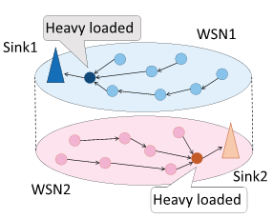
Fig: 4.1 Two WSNs deployed at the same area
Obtaining Lifetime Information

For cooperation considering the fairness among multiple WSNs, shared node sink maintains calculable period of time info, network period of time Li, minimum period of time L0i and route period of time LRikl. tend to justify the way to acquire this info as follows. At the time of sending an information packet, device node law enforcement agency adds the values of its network period of time Li and route period of time LRikl to the raincoat frame header of the packet. If the node doesn't have any info on network period of time or route period of time nevertheless, for example at the time straight off when making or change the route, its own node period of time Lij is value-added or else. every node updates this info by overhearing knowledge packets from alternative nodes. Specifically, once node law enforcement agency overhears an information packet, it compares the worth of the network period of time within the knowledge packet and Li in its own info, and updates its own Li to the smaller worth between them. additionally, if the packet is from a node that is contained in Riji, the route from law enforcement agency to BSi, it checks the worth of route period of time within the packet header, and updates its route period of time by the smaller worth as within the case of change Li at that time, the overhearing node discards the packet straight off if the destination of the packet isn't itself.

V. ALGORITHMS

A. WBS ALGORITHM [WEIGHT BASED SYNCHRONIZATION

An algorithmic rule is represented 1st that uses the dimensions of synchronization clusters as a catalyst for synchronization. The algorithmic rule is termed WBS weight primarily based synchronization. As mentioned antecedently, at the tip of every active interval, a node uses the slotArray structure to choose its next TRM. The slotArray structure has s entries, one for every slot of consequent (sleep) interval. The node should opt for one amongst these slots, known as winner slot, and synchronize with it. That is, the node should advertise the time of its next transmission (its Lone-Star State price within the CPMP update packet) such the update packet are going to be placed into that winner slot by its neighbors.
WBS needs every node to regionally maintain a variable observation the dimensions of the cluster of synchronization that contains the node. The variable is termed the burden of the node/cluster. Initially, the burden of every node is one. every node includes its weight all told its CPMP updates. Certainly, nodes cannot maintain globally correct weights. Instead, every node has to use solely native knowledge—extracted from packets received from neighbors to update the worth of this variable. throughout every active interval, a node keeps track of the most important cluster weight seen among all the received packets, as well as its own. At the tip of the active interval, the node chooses the winner slot to be the one storing the packet advertising the most important weight.
That is, each node chooses to synchronize with the largest synchronization cluster in its vicinity. When a node joins a cluster, the weight of the cluster increases, thus increasing the cluster’s potential to attract even more members. Algorithm describes the details of WBS, instantiating the generic solution shown in Algorithm 1. The initState method (lines 4-7), executed at the beginning of each active interval, resets each entry of the slotArray structure. The process Packets method (lines 24-30) is executed periodically and uses the network interface’s input queue inQ to retrieve all the packets received before its call time (line 25).

For each such packet, the node computes the next transmission time as promised by the TX field. It then determines the slot corresponding to that future time (line 27) and adds it to the entry in slotArray corresponding to that slot (line 28). WBS: Weight Based Synchronization. initState resets the local structures. processPackets updates the local structures for each received packet. setTX determines the winner slot to be the one containing the packet from the largest neighboring cluster of synchronization.

Algorithm 1
1. Object implementation WBS extends GENERIC;
2. maxW : int; #max weight over active interval
3. weight : int; #weight advertised in CPMP packets
4. Operation initState()
5. for (i:= 0; i < s; i ++) do
6. slotArray[i] : = new pkt[]; od
7. end
8. Operation setTX()
#compute the maxW value
9. maxW := 0;
10. for (i:= 0; i < s; i ++) do
11. for (j:= 0; j < slotArray[i]:size();j ++) do
12. if (slotArray[i][j]:weight > maxW) then
13. winnerSlot := i;
14. maxW := slotArray[i][j]:weight; fi
15. od od
#determine new TX and weight values
16. if (winnerSlot!= nextSendCPMP % ta) then
17. TX:= winnerSlot;
18. nextSendCPMP := tcurr þ TX;
19. weight := maxW + 1;
20. else
21. weight := maxW;
22. fi 23. end
24. Operation processPackets(t_{curr}: int)
25. pktList := inq:getAllPackets(slotLen);
26. for (i:= 0; i < pktList:size();i ++) do
27. index :=((t_{curr} + pktList[i]:TX) mod t_{a})/ts);
28. slotArray[index]:add(pktList[i]);
29. od
30. end
At the end of the current active interval, the setTX method (lines 8-23) selects as winner the slot storing the packet containing the largest weight field. For this, it first determines the largest weight seen in any packet in the active interval and records the slot winners lot (lines 9-15). If the winner slot does not coincide with its current transmission slot (line 16), the node synchronizes with the winner slot and correspondingly updates the time of the node’s next transmission (lines 17-18). The next Send CPMP value encodes the absolute time when the node will transmit its next CPMP update. To save space, the actual transmission is not shown in pseudocode In addition, the node sets its weight to one over the largest weight seen (line 19), to reflect the operation of joining this cluster. However, if the node is already synchronized with the largest neighboring cluster (line 20), the node’s weight is set to be the current weight of the cluster.

This operation needs to be explicitly performed, since from the last packet received from that cluster, the size of the cluster may have increased the cluster may have incorporated other nodes. Let n be the number of nodes in a connected network.

B. Future Peak Detection algorithm
.The Future Peak Detection algorithmic program is projected to deal with the inflation attack. rather than counting on subjective info (the weight price contained in CPMP updates), exploitation solely objective info derived from observation.the time of update receptions. FPD works by investigating the amount of packets that area unit hold on in every slot of this active interval.

Note that every packet received throughout this active interval is hold on within the slot comparable to the packet sender’s next TRM. FPD then makes a greedy alternative for the winner slot, by selecting the slot x whose | slotArray[x] | = maxsi=1 | slotArrap[i]|. | slotArray[x] | denotes the amount of packets hold on within the xth entry of slotArray. This alternative ensures that the node’s next transmission is in set with most of its neighbors. just in case of ties, N chooses the earliest slot to set. algorithmic program a pair of extends WBS (see algorithmic program 1). The initState and process P area unit hereditary from WBS and area unit excluded for area concerns.

Algorithm 2. Future Peak Detection Algorithm. setTX finds the slot storing the maximum number of packets and synchronizes with it.
1. Object implementation FPD extends WBS;
2. maxC : int; #max nr: of packets per slot
3. Operation setTX()
#compute the maxC value
4. maxC :¼ 0;
5. for (i := 0; i < s; i++) do
6. if (slotArray[i]:size() > maxC) then
7. maxC :¼ slotArray[i]:size();
8. winnerSlot := i; fi
9. od
#update the TX value
10. if (winnerSlot! = nextSendCPMP % ta) then
11. TX:= winnerSlot;
12. nextSendCPMP := tcurr + TX;
13. fi
14. end
Executed at the end of each active interval, the setTX method (lines 3-14) first determines the maximum number of packets stored in any slot of the interval and marks that slot as the winner slot (lines 5-9). If the winner slot is different from the node’s current transmission slot (line 10), the node synchronizes with the winner slot, by setting the node’s TX value to the winnerSlot value (line 11) and correspondingly updating the time of the node’s next transmission (line 12).

5.4 RFPD [Randomized Future Peak Detection] Algorithm

This rule shows that for identical networks FPD is unable to utterly synchronize, matters changes once imperfect channel conditions are thought of. Specifically, for a network of a hundred nodes with fifteen packet loss rates, FPD synchronizes the complete network in twenty one,000 s. whereas during a network with excellent channel conditions clusters created by FPD are stable, packet loss will build nodes move from one cluster of synchronization to a different, so breaking the steadiness. If enough nodes switch, clusters could engulf different clusters in their neck of the woods, eventually making one cluster of synchronization.

However, relying solely on packet loss is insufficient.It needs is that a network synchronize in a timely manner. to realize this, we have a tendency to extend FPD with randomization: The rule is named irregular future peak detection. This rule presents the main points of the FPDR rule, that extends WBS (see rule WBS algorithm). The initState and process Packets ways also are genetic from WBS.

VI.EXPERIMENTAL RESULTS

The performance of the proposed fair cooperative routing method with shared nodes is evaluated using the sample datasets. It is observed that the receiving rate, which is the rate of sensor nodes that send data packets to their sinks successfully. Therefore, in the performance analysis process, it counted a node that cannot communicate with its sink as a dead node, in spite of its remaining battery.

The Table 6.1 shows the results and performance of the existing cooperative routing and proposed flexible channel allocation approaches. The efficiency of the proposed method is compared with the existing cooperative routing method with the number of nodes communicated for sending and receiving the packets. The table data describes the number of sensor nodes and number of nodes involved in the routing process of existing and proposed methods.

WSN Nodes List (N) | Existing Approach (Cooperative Routing) | Proposed Approach  (Flexible Channel Allocation)
100 | 30 | 25
150 | 45 | 58
200 | 80 | 71
250 | 96 | 84
300 | 112 | 102
350 | 146 | 129
400 | 250 | 212
450 | 299 | 273
500 | 415 | 401
Table 6.1 Comparison of Cooperative Routing & Flexible Channel Allocation

The Figure 6.1 shows the results and performance of the existing cooperative routing and proposed flexible channel allocation approaches. The figure describes the number of sensor nodes and the nodes involved in the routing and data transmission process of existing and proposed methods.

The sensor network nodes sent 256 bytes data packets asynchronously at intervals of 10 minutes. It is assumed that sinks and shared nodes had a adequate energy of battery. Table 5.2 show the receiving rate as a function of elapsed time for each WSN. The analysis is made based on the energy capacity of the nodes.

The sensor nodes have different battery capacities, the lifetime of them without cooperation are also different. Even if the total amount of extended lifetime is equal, the life improving ratio may take larger value with smaller battery capacity. Figures 5.2 show the receiving rate as a function of elapsed time for each WSN.

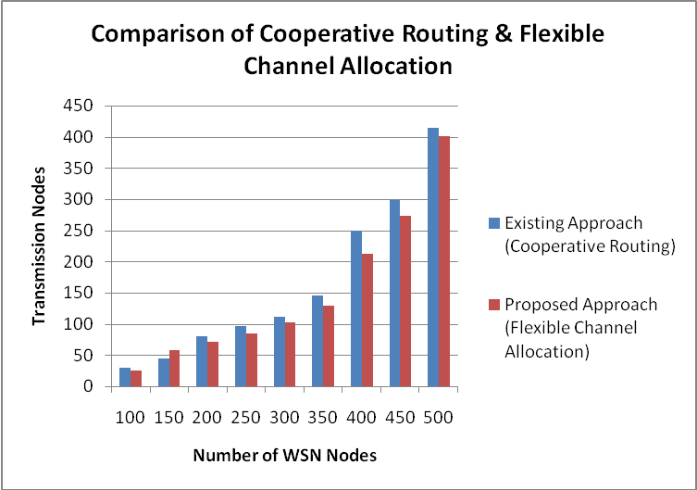

Fig 6.1 Comparison of Cooperative Routing & Flexible Channel Allocation

WSN Nodes List (N) | Time  (Minutes) | Packet Receiving Rate in Bytes
WSN Nodes List (N) | Time  (Minutes) | Cooperative Routing | Flexible Channel Allocation
100 | 10 | 100 | 150
150 | 20 | 150 | 220
200 | 30 | 200 | 305
250 | 40 | 250 | 356
300 | 50 | 320 | 380
350 | 60 | 350 | 415
400 | 70 | 365 | 478
450 | 80 | 410 | 512
500 | 90 | 545 | 629

Table 6.2 Packet Receiving Rate of Cooperative Routing & Flexible Channel Allocation

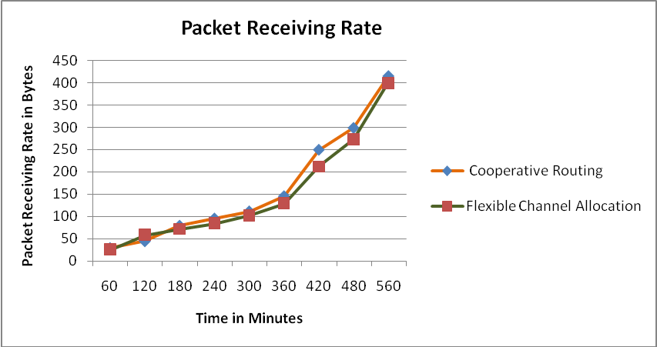
Fig 6.2 Packet Receiving Rate - Cooperative Routing & Flexible Channel Allocation

VI.CONCLUSION

To avoid unfair improvement solely on sure networks, heterogeneousness of networks and a good cooperative routing methodology is projected and analyzed. one or a couple of shared nodes that may use multiple channels to relay knowledge packets. The sinks and shared nodes will communicate with any WSNs node, completely different WSNs will use cooperative routing with one another since shared nodes permit sensing element nodes to forward knowledge from another WSN because the operate of interchange points among individual WSN planes. once receiving a packet, a shared node selects the route to send the packet, in step with projected route choice strategies. This cooperation prolongs the period of every network equally as doable. specially, Pool-based cooperation achieved quite tiny variance of period improvement, that is, it provided quite honest cooperation. As a future work, implement the projected methodology on Associate in Nursing experimental system and assess its practicability. And conjointly to handle the energy potency downside by synchronizing the transmission times of all the nodes within the system is explored within the future works.

REFERENCES

[1] P. O. S. Vaz de Melo, F. D. Cunha, and A. A. F. Loureiro, “A distributed protocol for cooperation among different wireless sensor networks,” in Proc. IEEE Int. Conf. Commun. (ICC), Jun. 2013, pp. 6035–6039.

[2] M. J. Shamani, H. Gharaee, S. Sadri, and F. Rezaei, “Adaptive energy aware cooperation strategy in heterogeneous multi-domain sensor networks,” Procedia Comput. Sci., vol. 19, pp. 1047–1052, 2013.

[3] E. I. Oyman and C. Ersoy, “Multiple sink network design problem in large scale wireless sensor networks,” in Proc. IEEE Int. Conf. Commun. (ICC), vol. 6, Jun. 2004, pp. 3663–3667.

[4] G. Gupta and M. Younis, “Performance evaluation of load-balanced clustering of wireless sensor networks,” in Proc. 10th Int. Conf. Telecommun. (ICT), Mar. 2003, pp. 1577–1583.

[5] J. Nagata, Y. Tanigawa “A routing method for cooperative forwarding in multiple wireless sensor networks,” in Proc. 8th Int. Conf. Netw. Services (ICNS), Mar. 2012, pp. 43–46.

[6] K. Bicakci and B. Tavli, “Prolonging network lifetime with multi-domain cooperation strategies in wireless sensor networks,” Ad Hoc Netw., vol. 8, no. 6, pp. 582–596, Aug. 2010.

[7] L. Buttyán, T. Holczer, and P. Schaffer, “Spontaneous cooperation in multi-domain sensor networks,” in Proc. 2nd Eur. Workshop Secur. Privacy Ad-Hoc Sensor Netw., Jul. 2005, pp. 42–53.

[8] J. Li and P. Mohapatra, “Analytical modeling and mitigation techniques for the energy hole problem in sensor networks,” Pervasive Mobile Comput. J., vol. 3, no. 3, pp. 233–254, Jun. 2007.

[9] I. Dietrich and F. Dressler, “On the lifetime of wireless sensor networks,” ACM Trans. Sensor Netw., vol. 5, no. 1, Feb. 2009, Art. no. 5.

[10]A. A. Abbasi and M. Younis, “A survey on clustering algorithms for wireless sensor networks,” Comput. Commun., vol. 30, nos. 14–15, pp. 2826–2841, Oct. 2007.

[11] D. Helbing and W. Yu, “The Outbreak of Cooperation Among SuccessDriven Individuals Under Noisy Conditions,” Proc. of the National Academy of Sciences of the USA, 106(10):3680–3685, 2009.

[12] Liu Hua. Cooperation in wireless networks with selfish users. PhD thesis, Southern California Univ; 2010.

[13] A. Nasipuri, and K. Li, “A Directionality based Location Discovery Scheme for Wireless Sensor Networks,” Proceedings of the First ACM International Workshop on WSNs and Applications, pp. 105-111, Atlanta, Sept. 28, 2002.

[14] M. Elhawary and Z. J. Haas, “Energy-Efficient Protocol for Cooperative Networks,” IEEE/ACM Transactions on Networking, Vol. 19, No. 2, Apr. 2011.

[15] L. Butty´and J.-P. Hubaux. Stimulating Cooperation in Self-Organizing Mobile Ad Hoc Networks. ACM/Kluwer Mobile Networks and Applications (MONET), 8(5), October 2003.

[16] L. Mottola and G. P. Picco, “MUSTER:Adaptive EnergyAware Multi-Sink Routing in Wireless Sensor Networks,” IEEE Transactions on Mobile Computing, Vol. 10, pp. 1694–1709, 2010.

[17] M. Elhawary and Z. J. Haas, “Energy-Efficient Protocol for CooperativeNetworks,” IEEE/ACM Transactions on Networking, Vol. 19, No. 2, Apr. 2011.

[18] J. Li and P. Mohapatra. An analytical model on the energy hole problem in many-to-one sensor networks. In Proc. Of IEEE VTC Fall 2005.

[19] Kumar, S., Lai, T. H., and Arora, A. 2007. Barrier coverage with wireles.ACM/Springer Wireless Networks 13, 6 (December), 817–834.

[20] R. Khanna, H. Liu, H.H. Chen, Self-organization of sensor networks using genetic algorithms, in: Proceedings of the 32nd IEEE International Conference on Communications (ICC’06), Istanbul, Turkey, Jun. 2006

