**Student Performance Based Training**

R.Manikandan,

Department of Computer Science and Engineering,

K.S.R College of Engineering,

Tiruchengode, Tamilnadu.

Manikandan.r1413057@ksrce.ac.in

R.Nandha gopal,

Department of Computer Science and Engineering,

K.S.R College of Engineering,

Tiruchengode, Tamilnadu.

Nandhagopal.rcse@ksrce.ac.in

G.Navaneethakrishnan,

Department of Computer Science and Engineering,

K.S.R College of Engineering,

Tiruchengode, Tamilnadu.

Navaneethakrishnan.gcse@ksrce.ac.in

R.Naveen,

Department of Computer Science and Engineering,

K.S.R College of Engineering,

Tiruchengode, Tamilnadu.

Naveen.rcse@ksrce.ac.in

Dr. M. Somu, M.E., Ph.d., Assistant Professor,

Department of Computer Science and Engineering,

K.S.R College of Engineering,

Tiruchengode, Tamilnadu.

somumurugesan@ksrce.ac.in

**Abstract**

The project described within this document is an **Student’s performance based** **training** system designed with the specific goal of reducing the hectic job of assessing the answers given by the candidates manually.Responses by the candidates will be checked automatically and instantly. It will reduce paper work to be an integrated Online Examination

stem. The result will be shown immediately to the participating students reducing anxiety. It can generate various reports and graphs for evaluation purpose almost instantly when and where required.

1. **Introduction**

The project entitled **STUDENT PERFORMANCE BASED TRAINING** is a web based application development system using integrated development environment. We planned to develop this application to decrease the paper work and easier record maintenance by having a particular website for placement process. It create various reports and graphs for evaluation purpose almost instant when and where required.

**2. Existing System**

* Existing system is manually which requires a lot of paper work and it requires a lot of time for processing.This system has to prepare registration\application form,question paper for the students and required to print a lot of number manually.
* The whole process of assigning test and evaluating their scores after the test,was done manually till date.Processing the test paper,checking and distributing respective scores used to take when the software was not installed.

**3. Existing System Disadvantages**

* Time consumption is high.
* Difficult to data maintenance and search.
* It taken more memory space.
* Data can be loss.
* To take exam of more candidates more invigilators are required.

**4. Proposed System**

Proposed system is the automation of existing procedure.Fast retrieval and data accuracy will be the major benefits of the system.Also errors can be minimized to protect the system from unauthorized access to data.Password protection facility is also incorporated to protect the system from unauthorized access to data.

**5. System Specification**

**5.1 Hardware Specification**

* Processor Speed : 2 GHz or above
* RAM Capacity : 2 GB or above
* Hard Disk : 20 GB or above

**5.2 Software Specification**

* Operating System : Windows 7 or above
* Browser : Chrome, Mozilla, IE
* Web/Application Server : Tomcat, SMTP, XAMPP
* Database Server : MySql
* Database Connectivity : JDBC
* Technologies Used : J2EE, HTML, CSS, JS
* IDE : Eclipse (EE)
* Other Tools : JDK 1.8

**6. Software Specification**

**6.1 Front End**

**6.1.1 HTML**

HTML is the standard markup language for creating Web pages.

* HTML stands for Hyper Text Markup Language
* HTML describes the structure of Web pages using markup
* HTML elements are the building blocks of HTML pages
* HTML elements are represented by tags
* HTML tags label pieces of content such as "heading", "paragraph", "table", and so on
* Browsers do not display the HTML tags, but use them to render the content of the page

**Hyper Text:** Hyper Text simply means "Text within Text". A text has a link within it, is a hypertext. Every time when you click on a word which brings you to a new webpage, you have clicked on a hypertext.

**Markup language:** A markup language is a programming language that is used make text more interactive and dynamic. It can turn a text into images, tables, links etc. An HTML document is made of many HTML tags and each HTML tag contains different content.

**6.1.2 CSS**

* CSS stands for Cascading Style Sheets
* CSS describes how HTML elements are to be displayed on screen, paper, or in other media
* CSS saves a lot of work. It can control the layout of multiple web pages all at once
* External style sheets are stored in CSS files

Cascading Style Sheets, fondly referred to as CSS, is a simple design language intended to simplify the process of making web pages presentable.

CSS handles the look and feel part of a web page. Using CSS, you can control the color of the text, the style of fonts, the spacing between paragraphs, how columns are sized and laid out, what background images or colors are used, layout designs and variations in display for different devices and screen sizes as well as a variety of other effects. CSS is easy to learn and understand but it provides powerful control over the presentation of an HTML document.

**6.1.3 JAVASCRIPT**

As a multi-paradigm language, JavaScript supports event-driven, functional, and imperative programming style. It has an API for working with text, array, dates, regular expression, and basic manipulation of the DOM, but does not include any I/O such as networking, storage, or graphics facilities, relying for these upon the host environment in which it is embedded.

Initially only implemented client-side in web browsers, JavaScript engines are now embedded in many other types of host software, including server-side in web servers and database, and non-web programs such as word processors and PDF software, and in runtime environments that make JavaScript available for writing mobile and desktop application, including desktop widgets.

**6.2 BACK END**

**6.2.1 J2EE**

* J2EE is a platform-independent, Java-centric environment from Sun for developing, building and deploying Web-based enterprise applications online.
* The J2EE platform consists of a set of services, APIs, and protocols that provide the functionality for developing multitier, Web-based applications.
* At the client tier, J2EE supports pure HTML, as well as Java applets or applications. It relies on Java Server Pages and servlet code to create HTML or other formatted data for the client.
* Enterprise JavaBeans (EJBs) provide another layer where the platform's logic is stored. An EJB server provides functions such as threading, concurrency, security and memory management. These services are transparent to the author.
* Java Database Connectivity (JDBC), which is the Java equivalent to ODBC, is the standard interface for Java databases.
* The Java servlet API enhances consistency for developers without requiring a graphical user interface.

**6.2.2 SQL**

SQL consists of a data definition language, data manipulation language and data control language. The scope of SQL includes data insert, query, update and delete, schema creation and modification, and data control. SQL is a standard language for storing, manipulating and retrieving data in databases.

**7. Modules**

1. Administrator
2. Examiner
3. Candidate

**7.1 Administrator**

The administrator module having all privileges about this entire project, he can update, delete, and modify the details about job seeker, job provider, client and Job Search details. Administrator maintain the client and job seeker database, where ever client is releasing their requirements(vacancies) with particular primary skills and experience, on that time administrator search for job seekers, who are having that primary skills and experience. Administrator sends the message for selected candidates.

**7.2 Examiner**

This module having information about job provider and requirement details, which client recruiting the employees, and what based them recruiting the employees. Here client releasing the primary skills, experience, no. of vacancies, opening date, closing and closing date.

**7.3 Candidate**

This module contains details about Job Seeker, i.e. student details. Like student name, email, skills, experience. Here students can do create, update and modify resume. They can update experience and skills details also.

**8. System Design**

**8.1 Data Flow Diagram**

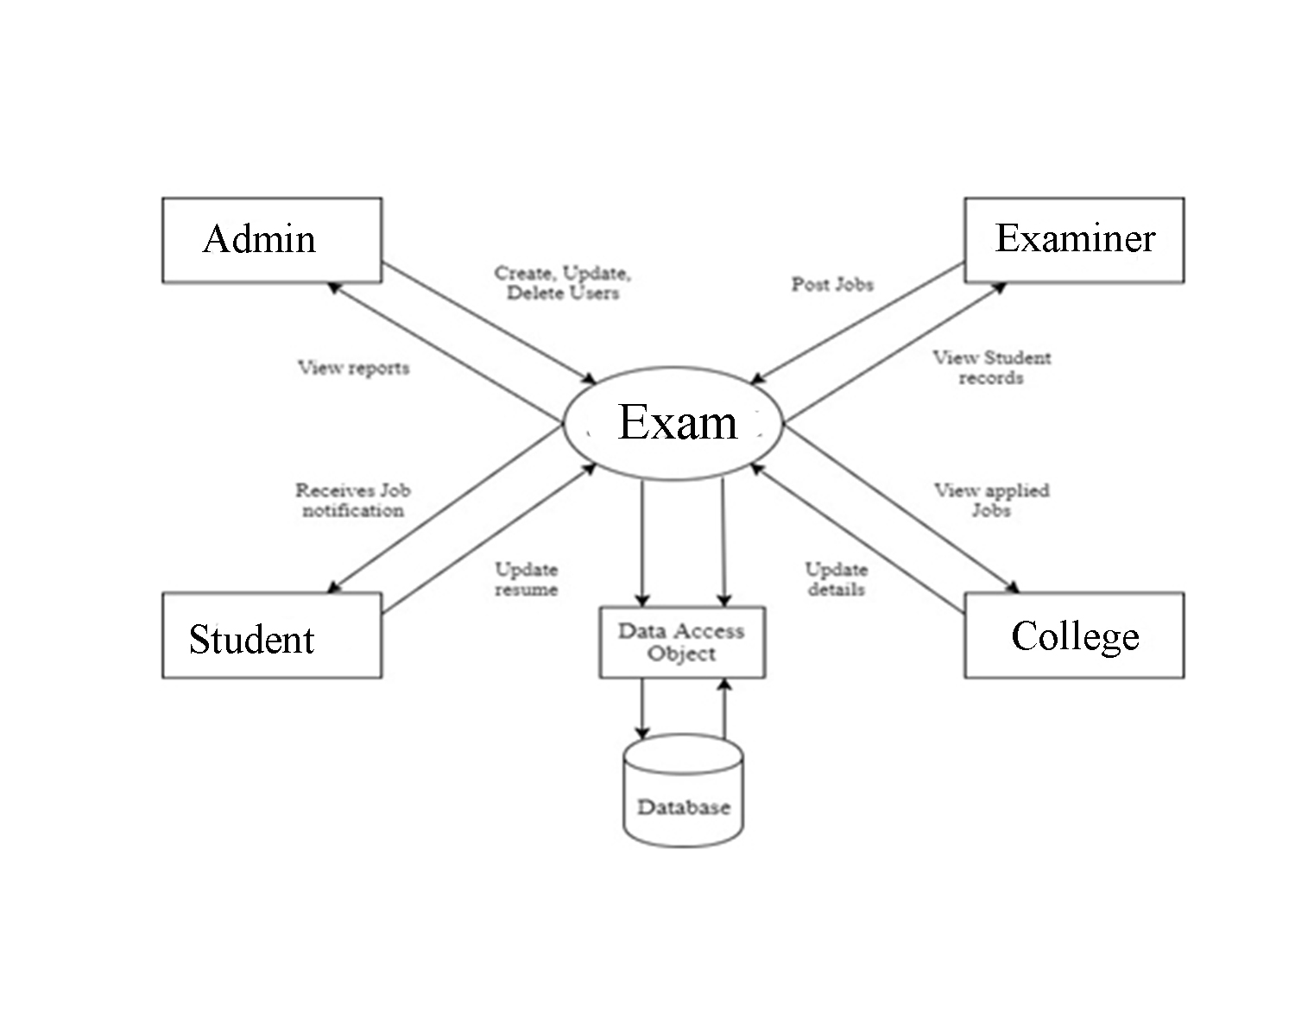

**8.2 Use Case Diagram**

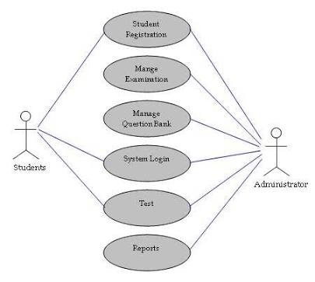

**9. References**

[1] Rafter, R. Bradley, K. & Smyth, B. (2016). Automated collaborative filtering applications for online recruitment services. Proceedings of the International Conference on Adaptive Hypermedia and Adaptive Web-based Systems, 363- 368.

[2] Rob, P. & Coronel, C. (2015). Database Systems: Design, implementation and management, Eight edition. Boston: Course Technology.

[3] Sellami,S., Benharkat,A. & Amghar,Y. (2017). Study of challenges and techniques in large scale. In ICEIS:10th International Conference on Enterprise Information Systems, Barcelona, Spain

[4] ACCENTURE (2017): How Much Are Customer Relationship Management Capabilities Really Worth? What Every CEO Should Know. http://www.accenture.com/.

[5] Herbert Schildt, Java – The Complete Reference, Tenth Edition.

[6] http://www.w3schools.com

[7]http://www.javatpoint.com/java

[8] http://www.tutorialspoint.com/java

[9] https://www.javatpoint.com/java-jdbc

[10] http://www.servlets.com

[11] http://www.stackoverflow.com

[12] https://dev.mysql.com