|  |  |  |
| --- | --- | --- |
| **Name** | : | Sathish Kumar Rajendiran |
| **Current Date** | : | 02/21/2020 |
| **Lab Number** | : | 06 |

**Part 1 – Filling our tables with Data**

* ***First VidCast***

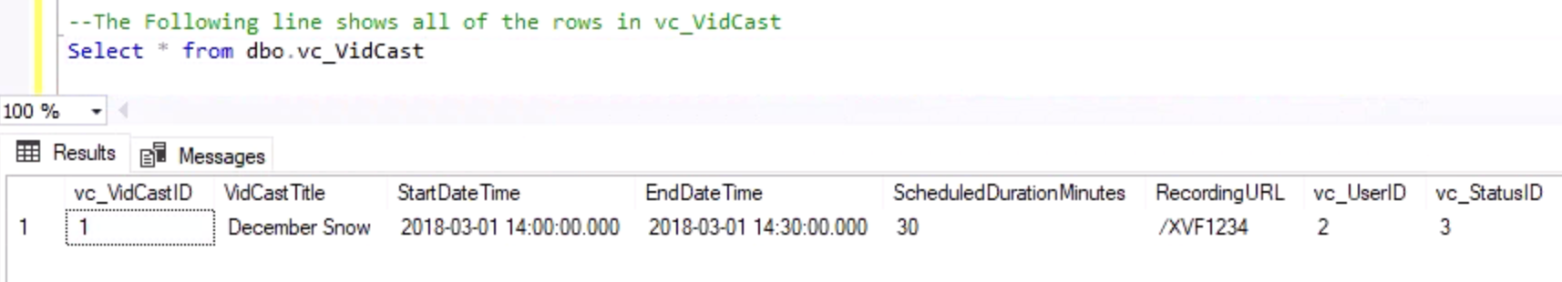

* ***Saul’s First VidCast***

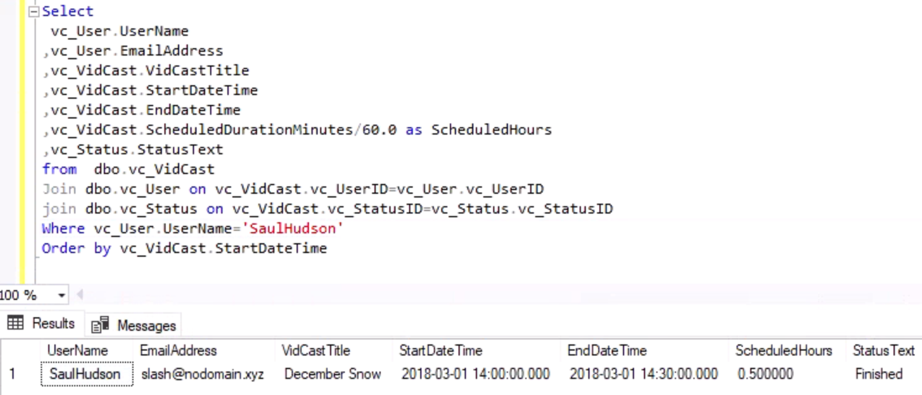

* ***Update a User***

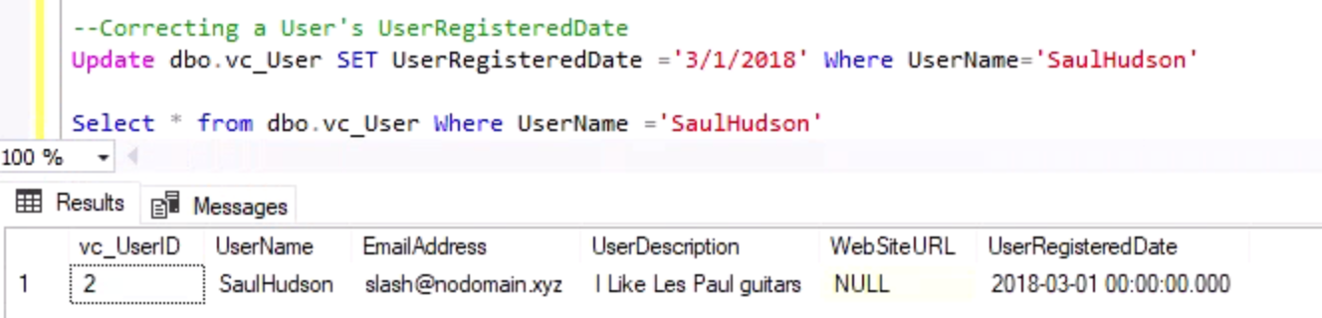

* ***No more on time***

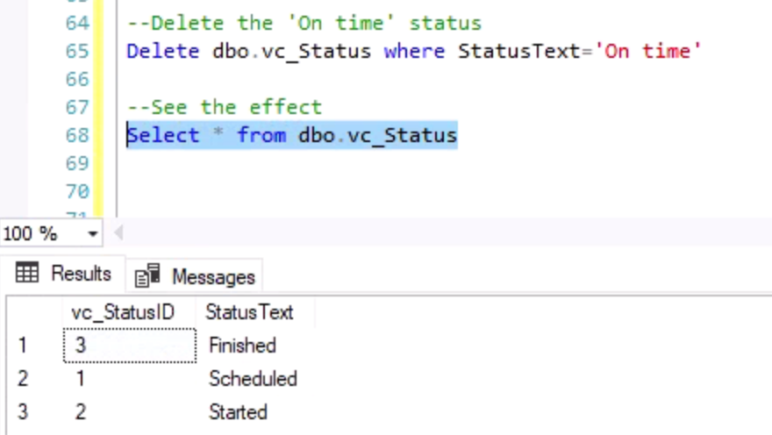

**Part 2 – Putting all Together**

* ***Tags***

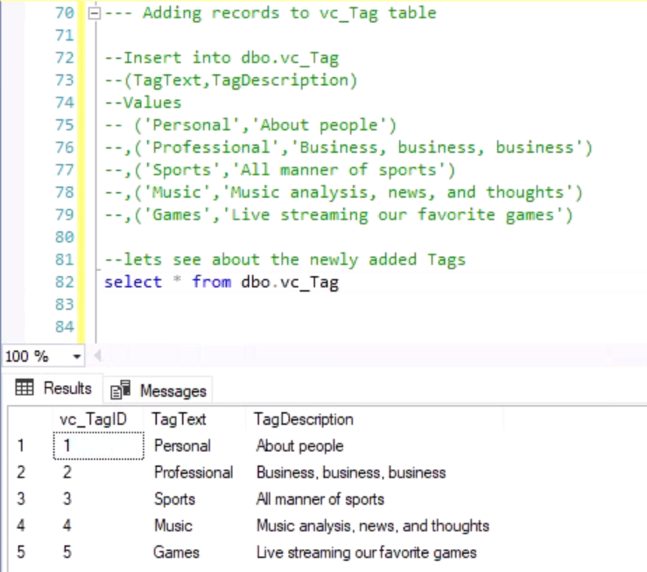

* ***Users***

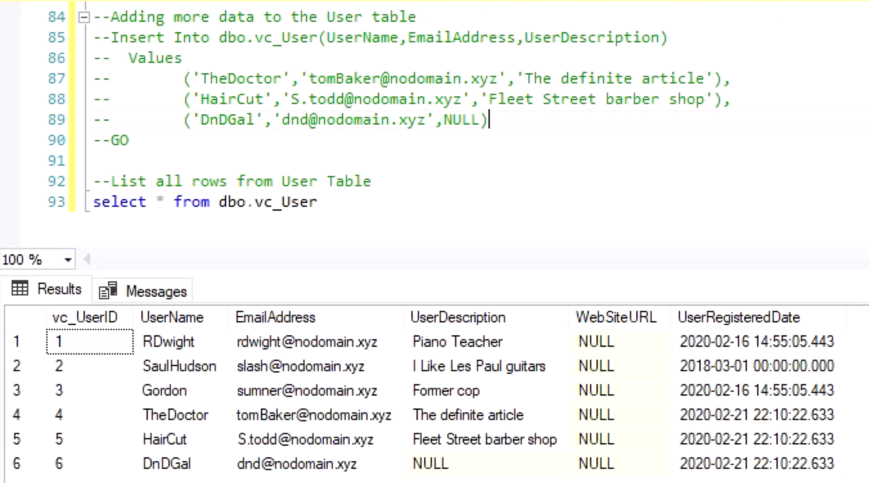

* ***User Tag List***

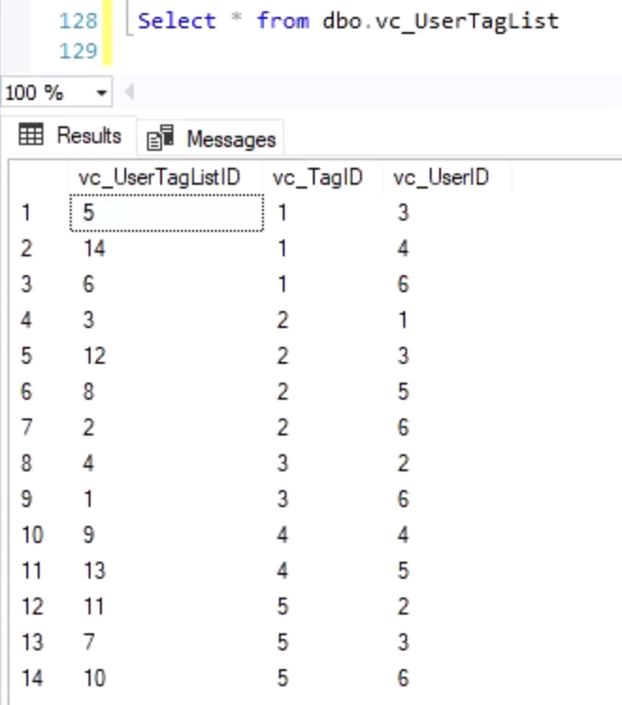

* ***User Tags Report***

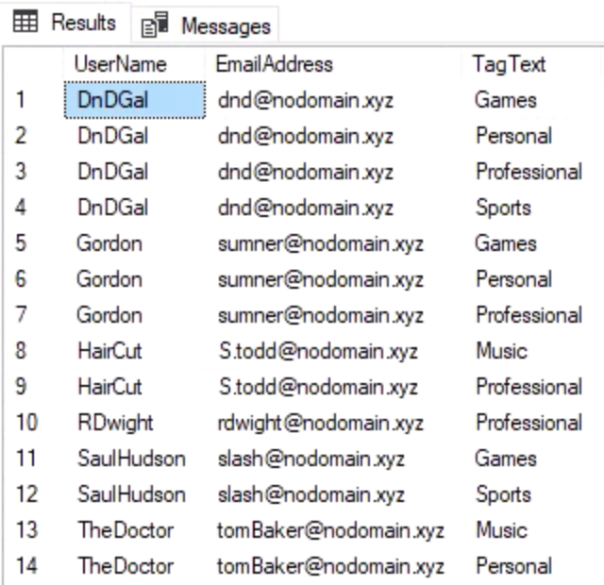

--SQL Script

USE [IST659_M406_srajendi]

GO

/*

Title : Lab 06 -SQL Scripts

Author : Sathish Kumar Rajendiran

Course : IST659 M406

Term : February, 2020

*/

--The Following line shows all of the rows in vc_Status

Select * from dbo.vc_Status

-- Adding a row to the vc_Status table

--Insert into dbo.vc_Status (StatusText)

--Values('Scheduled')

--GO

-- Adding three more rows to the vc_Status table

--Insert into dbo.vc_Status (StatusText)

--Values('Started'),('Finished'),('On time')

--GO

select * from dbo.vc_User where UserName ='SaulHudson'

Select * from dbo.vc_Status where StatusText ='Finished'

--Adding a vidcast record to the VidCast Table

--Insert into vc_VidCast

--(VidCastTitle,StartDateTime,EndDateTime,ScheduledDurationMinutes,RecordingURL,vc_UserID,vc_StatusID)

--Values

--('December Snow','3/1/2018 14:00','3/1/2018 14:30',30,'/XVF1234',2,3)

--GO

--The Following line shows all of the rows in vc_VidCast

Select * from dbo.vc_VidCast

--The Following line shows Saul's First VidCast

Select

vc_User.UserName

,vc_User.EmailAddress

,vc_VidCast.VidCastTitle

,vc_VidCast.StartDateTime

,vc_VidCast.EndDateTime

,vc_VidCast.ScheduledDurationMinutes/60.0 as ScheduledHours

,vc_Status.StatusText

from dbo.vc_VidCast

Join dbo.vc_User on vc_VidCast.vc_UserID=vc_User.vc_UserID

join dbo.vc_Status on vc_VidCast.vc_StatusID=vc_Status.vc_StatusID

Where vc_User.UserName='SaulHudson'

Order by vc_VidCast.StartDateTime

--GO

--Correcting a User's UserRegisteredDate

--Update dbo.vc_User SET UserRegisteredDate ='3/1/2018' Where UserName='SaulHudson'

--Go

Select * from dbo.vc_User Where UserName ='SaulHudson'

--See What Rows we have in Status

Select * from dbo.vc_Status

--Delete the 'On time' status

--Delete dbo.vc_Status where StatusText='On time'

--GO

--See the effect

Select * from dbo.vc_Status

--- Adding records to vc_Tag table

--Insert into dbo.vc_Tag

--(TagText,TagDescription)

--Values

-- ('Personal','About people')

--,('Professional','Business, business, business')

--,('Sports','All manner of sports')

--,('Music','Music analysis, news, and thoughts')

--,('Games','Live streaming our favorite games')

--GO

--lets see about the newly added Tags

select * from dbo.vc_Tag

--Adding more data to the User table

--Insert Into dbo.vc_User(UserName,EmailAddress,UserDescription)

-- Values

-- ('TheDoctor','tomBaker@nodomain.xyz','The definite article'),

-- ('HairCut','S.todd@nodomain.xyz','Fleet Street barber shop'),

-- ('DnDGal','dnd@nodomain.xyz',NULL)

--GO

--List all rows from User Table

select * from dbo.vc_User

---Insert to User Tag List as in Appendix B

--INSERT INTO dbo.vc_UserTagList (vc_UserID, vc_TagID)

--VALUES

--((SELECT vc_UserID FROM vc_User WHERE UserName='DnDGal'),

--(SELECT vc_TagID FROM vc_Tag WHERE TagText='Sports')),

--((SELECT vc_UserID FROM vc_User WHERE UserName='DnDGal'),

--(SELECT vc_TagID FROM vc_Tag WHERE TagText='Professional')),

--((SELECT vc_UserID FROM vc_User WHERE UserName='RDwight'),

--(SELECT vc_TagID FROM vc_Tag WHERE TagText='Professional')),

--((SELECT vc_UserID FROM vc_User WHERE UserName='SaulHudson'),

--(SELECT vc_TagID FROM vc_Tag WHERE TagText='Sports')),

--((SELECT vc_UserID FROM vc_User WHERE UserName='Gordon'),

--(SELECT vc_TagID FROM vc_Tag WHERE TagText='Personal')),

--((SELECT vc_UserID FROM vc_User WHERE UserName='DnDGal'),

--(SELECT vc_TagID FROM vc_Tag WHERE TagText='Personal')),

--((SELECT vc_UserID FROM vc_User WHERE UserName='Gordon'),

--(SELECT vc_TagID FROM vc_Tag WHERE TagText='Games')),

--((SELECT vc_UserID FROM vc_User WHERE UserName='HairCut'),

--(SELECT vc_TagID FROM vc_Tag WHERE TagText='Professional')), ((SELECT vc_UserID FROM vc_User WHERE UserName='TheDoctor'),

--(SELECT vc_TagID FROM vc_Tag WHERE TagText='Music')),

--((SELECT vc_UserID FROM vc_User WHERE UserName='DnDGal'),

--(SELECT vc_TagID FROM vc_Tag WHERE TagText='Games')),

--((SELECT vc_UserID FROM vc_User WHERE UserName='SaulHudson'),

--(SELECT vc_TagID FROM vc_Tag WHERE TagText='Games')),

--((SELECT vc_UserID FROM vc_User WHERE UserName='Gordon'),

--(SELECT vc_TagID FROM vc_Tag WHERE TagText='Professional')),

--((SELECT vc_UserID FROM vc_User WHERE UserName='HairCut'),

--(SELECT vc_TagID FROM vc_Tag WHERE TagText='Music')),

--((SELECT vc_UserID FROM vc_User WHERE UserName='TheDoctor'),

--(SELECT vc_TagID FROM vc_Tag WHERE TagText='Personal'))

--GO

Select * from dbo.vc_UserTagList

--The Following line shows User Tags Report

Select

vc_User.UserName

,vc_User.EmailAddress

,vc_Tag.TagText

from dbo.vc_UserTagList

Join dbo.vc_Tag on vc_Tag.vc_TagID = vc_UserTagList.vc_TagID

Join dbo.vc_User on vc_User.vc_UserID=vc_UserTagList.vc_UserID

Order by vc_User.UserName,vc_Tag.TagText

--GO