Academy’s Wiki Channel – Analytics
IST659 - Project Milestone 1

Sathish Kumar Rajendiran

Table of Contents
Executive Summary 2
A. Project Summary 2
B. Rules 2
C. Stakeholders 3
D. Glossary 3
E. Major Data Questions 4
F. Conceptual Model 5
G. Logical Model 6
Conclusion 6

Executive Summary
Academy team has a Wiki Channel (online application) that contains number of articles on various topics having greater number of audiences. As the platform usage has been significantly increasing, it has become difficult to scale and meet growing demands of the audiences. In addition, Academy director also wanted to analyze and explore the usage to invest further on the expansion of this platform for both internal and external usage. However, there are no analytics on the platform usage to support the investing needs. Hence, Academy team has been seeking a database solution to track, analyze and improve the knowledge base and provide a seamless experience to the audiences (authors & followers).

Project Summary
Build a relational data model (knowledge base) and an application to track, analyze and manage the usage of their Wiki channel.
This application should be easy to use, well-defined, controllable, scalable, robust and should increase stability, performance, reusability and maintainability. In addition, document the underlying data model and all of its components thoroughly.

Rules
This section talks about the overall completeness, accuracy, reliability, timeliness and consistency of data stored in the database by ensuring below traits,

- Entity Integrity
  - Make sure every table must have its own primary key and that each has to be unique and not null
- Referential Integrity
  - Foreign Keys - whose values are required to match those of the primary key of some other relation
- Normalization
  - Minimize data redundancy
  - Normalize the tables to eliminate insert, delete and update anomalies
  - Remove any functional dependencies among attributes
- Data Types
  - Avoid using Integer for Postal Code/Phone Numbers
  - Use datetime for date and time
  - Use Varchar instead of Char; Avoid text if possible
- Naming Convention
  - Do not use Space, Number or special characters other than “_” as table/column names

Stakeholders
Below list provides various stakeholders involved in the success of this project.

Executive Sponsor: Sr Director, Academy
Project Owner: Sathish Kumar Rajendiran
Developer: Sathish Kumar Rajendiran
Database Admin: Sathish Kumar Rajendiran
Report Builder: Sathish Kumar Rajendiran
Application Development: Sathish Kumar Rajendiran
QA: TBD
Business Users for UAT: Dr. Block

Glossary
In order to build the analytics, we may need to have the following entities
- Author/User
- Article
- Category
- UserInfo
- TierLevel
- UserArticle
- Time
- AuthorProfile
- VisitorType
Assumptions:
- Let us assume that we receive web analytics/traffic information from tools like Google Analytics and it gets loaded into these tables.
- Separate User Registration form that captures when User/Author subscribe to our WikiChannel.
- Every article’s content is reviewed before published for viewers
- Admin Team, manages and categorizes articles
Author table contains detail of author’s personal details including first name, last name, email address, Username and other public profile entries such as LinkedIn, Facebook, YouTube, blog etc.
Article table contains detail such as Article name, reference url (s3 location), category, published date, current approval rating/tier-level etc. Author to Article table shares 1:M relationship.
Category table contains detail such as respective category of an article that can be classified. ex. Programming, Business Intelligence, Data warehousing, Project management etc. Article to Category shares 1:1 (one article can be grouped under one category)
Time dimension to capture weekly level granular details, it can also easily customize for hourly traffic etc. Every article to time may have 1:M relationship as there can be different events like published time, last modified, viewed etc.
UserInfo table to include User/Subscriber details. It’s possible that User can also be an author and may have followers.
In addition, few other tables will be created for the purpose of keeping the data model in 3NF. Entities such as TierLevel, AuthorProfile, VisitorType allowing the model to be in 3NF. Example TierLevel being a separate entity allows for easy inert/update, AuthorProfile allows having social account details in separate table than having multi valued attribute in UserInfo table.

Major Data Questions
- Most viewed articles
  - Monthly
  - Quarterly
  - Yearly
- Most viewed articles by category
- Most viewed articles by author
- Authors with a greater number of followers
- List top 10 contributors in month, quarter and year
- List number of articles by category
- Analyze trend over
  - Weekly traffic
  - Hourly traffic
  - YTD Number of viewers
  - YoY Number of viewers

Conceptual Model

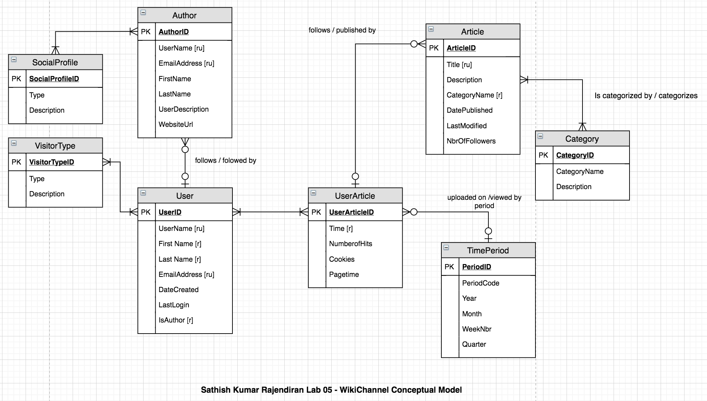

Logical Model
After considering, it has been decided to keep both Author and User info in same table; however, create bridge tables to avoid many to many relations thus normalizing the base tables.
In addition, UserActivity table to keep the transactional data that help build analytics expected out of this project.
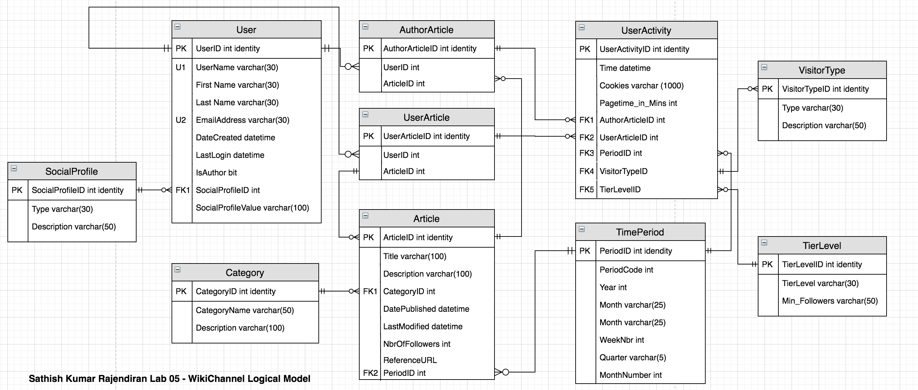

Conclusion
At the End, we would help build an analytics solution to track, analyze and improve the academy’s knowledge base (Wiki Channel) usage to benefit its growing audiences.

