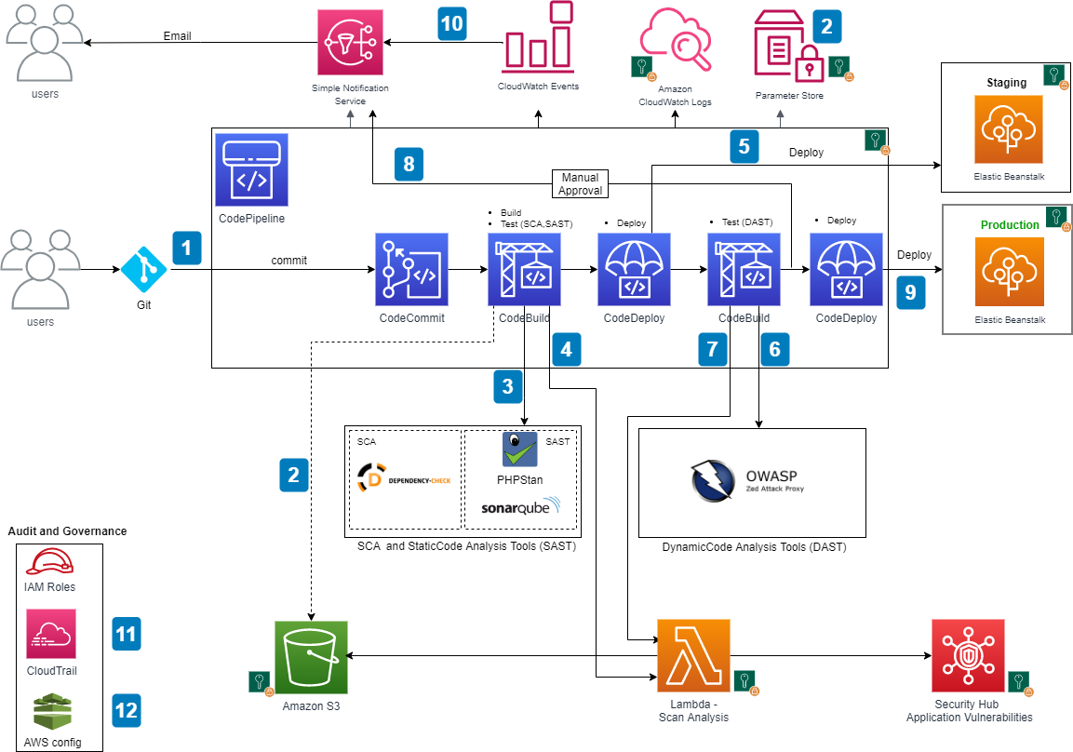

Here's a high-level overview of the architecture:

1. **GitHub Repository:** This is where the source code of your application resides. Developers push their code changes to this repository.
2. **CodePipeline:** AWS CodePipeline is a continuous integration and continuous delivery (CI/CD) service that automates the build, test, and deployment phases of your release process. It integrates with GitHub and orchestrates the flow of code changes through different stages.
3. **Source Stage:** CodePipeline is triggered whenever there is a new code commit in the GitHub repository. The source stage retrieves the source code from GitHub.
4. **Build Stage:** After the source stage, the code is built using tools like AWS CodeBuild or any other build service. The built artifact is then passed to the next stage.
5. **SonarQube:** SonarQube is used for static code analysis and to ensure code quality. The built artifact is analyzed by SonarQube for code smells, bugs, vulnerabilities, and code duplications.
6. **Quality Gates:** SonarQube enforces quality gates, which are predefined criteria that the code must meet to pass. If the code meets the quality gate criteria, it proceeds to the next stage; otherwise, the pipeline stops, and developers are notified to address the issues.
7. **Deployment Stage:** Once the code passes the quality gates, it is deployed to ECS (Elastic Container Service), which is a fully managed container orchestration service provided by AWS.
8. **ECS:** ECS runs and manages Docker containers on a cluster of EC2 instances or Fargate. It provides scalability, availability, and security for deploying containerized applications.
9. **Auto Scaling:** ECS can be configured to automatically scale the number of running tasks based on resource utilization metrics like CPU and memory usage.
10. **Application Load Balancer (ALB):** The ECS service is typically fronted by an ALB to distribute incoming traffic among the running tasks.
11. **Monitoring and Logging:** AWS CloudWatch can be used for monitoring ECS clusters, auto scaling activities, and application logs.