How to Connect an On-Premise SAP System to SAP BTP
Step-by-step guide with screenshots
Based on: Shankar Gomare — https://youtu.be/IgjEEKvjygU
Duration: ~12 minutes | Topic: SAP Cloud Connector + Business Application Studio

1. Overview
This document explains how to securely connect an on-premise SAP system (e.g. SAP S/4HANA) to SAP Business Technology Platform (BTP) using SAP Cloud Connector, expose backend OData resources, create a destination, and consume the system from SAP Business Application Studio (BAS) by generating a Fiori List Report application.
Components required
- SAP Cloud Connector (on-premise / network edge)
- SAP BTP subaccount (Trial or productive)
- On-premise SAP backend (example: S/4HANA 1909 with Gateway / OData)
- SAP Business Application Studio (to consume and build a Fiori app)
Architecture (simple)
Cloud Connector acts like a private VPN tunnel between BTP and your on-premise network. BTP never needs inbound firewall openings to your landscape; the Cloud Connector establishes an outbound connection to BTP, then maps selected systems and URL paths.
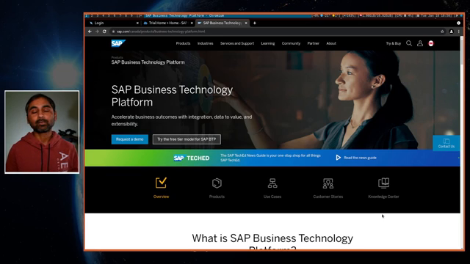
Figure 1 — Tutorial overview: connect on-premise SAP to SAP BTP
2. Start SAP Cloud Connector
In the demo, Cloud Connector is available with the SAP Developer Edition (e.g. Docker). Start the Cloud Connector service, then open the Cloud Connector Administration UI.
- Default first-time user: Administrator (uppercase A)
- Default first-time password: manage
Note: Change the default password immediately after first login in real landscapes. Follow SAP's install guide for your Cloud Connector / Developer Edition setup.
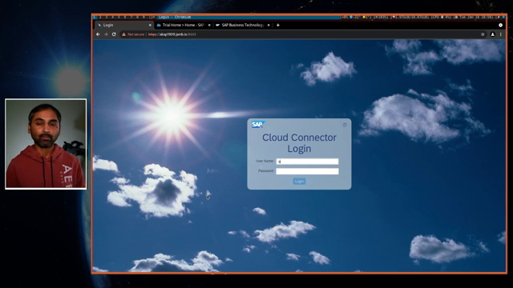
Figure 2 — Cloud Connector Administration login / landing
3. Collect BTP subaccount connection details
In the BTP Cockpit, open your Trial (or global) account, then select the subaccount. You will need these values when defining the subaccount in Cloud Connector:
- Region (from API endpoint / region display — e.g. US East (VA) – AWS / us10)
- Subaccount ID
- Login e-mail of a subaccount user
- Password for that user
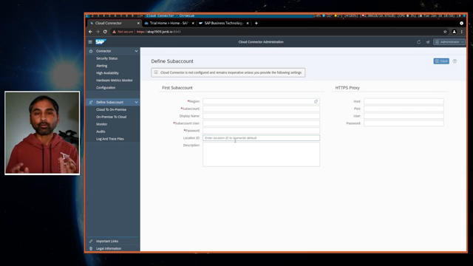
Figure 3 — BTP Cockpit: navigate to your subaccount
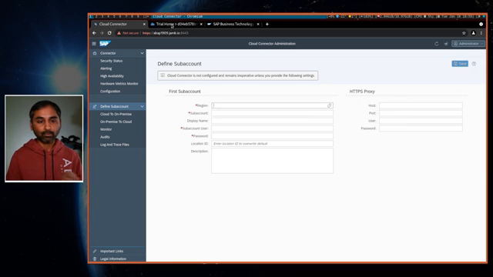
Figure 4 — Subaccount Overview: note Region and Cloud Foundry API Endpoint (e.g. us10)
4. Connect Cloud Connector to the BTP subaccount
4.1 Define Subaccount in Cloud Connector
In Cloud Connector, open Define Subaccount and enter:
- Region — select the region matching your subaccount (e.g. US East (VA) – AWS)
- Subaccount — paste the Subaccount ID from BTP
- Display Name — any label (demo used "BTPConnect"; you can connect multiple subaccounts)
- Login E-Mail — BTP subaccount user
- Password — user password
- Location ID / Description — optional
Click Save. If the values are correct, the connector status becomes Connected.
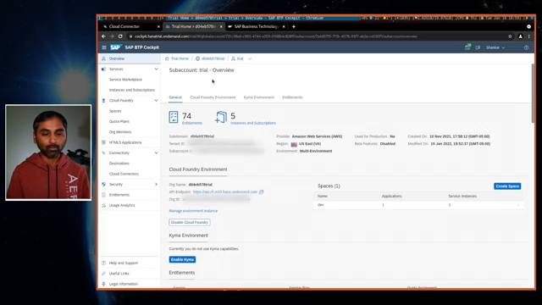
Figure 5 — Cloud Connector: Define Subaccount form
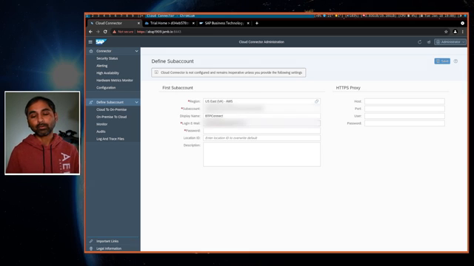
Figure 6 — Cloud Connector shows Connected status
4.2 Verify connection in BTP
In BTP Cockpit go to Connectivity → Cloud Connectors. You should see the Cloud Connector with status Connected. At this stage there may be no exposed backend systems yet — you have only established the tunnel.
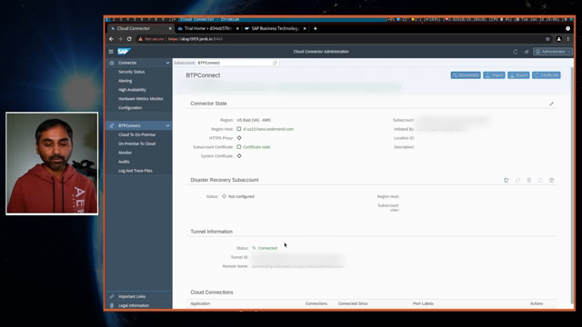
Figure 7 — BTP: Cloud Connectors view (Connected; backend still not mapped)
5. Map the on-premise backend system
Next, expose the backend so BTP can reach it through the tunnel. In Cloud Connector: Cloud To On-Premise → Add.
5.1 Add system mapping
- Back-end Type: SAP Gateway (to expose OData services)
- Protocol: HTTPS (as used in the demo)
- Internal Host / Port: your real system hostname and HTTPS port
- Virtual Host / Port: keep or change (recommended different from internal in production)
- Principal Type: None (as in demo) unless you need principal propagation
- Host in Request Header: Internal Host (demo preference)
- Optionally check availability of the internal host — result should be Reachable
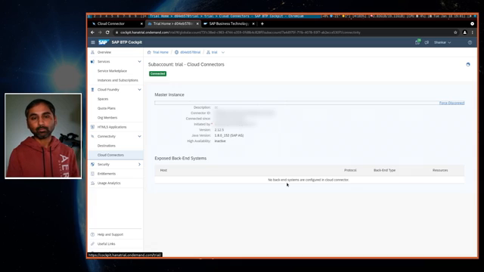
Figure 8 — Cloud Connector: Cloud To On-Premise
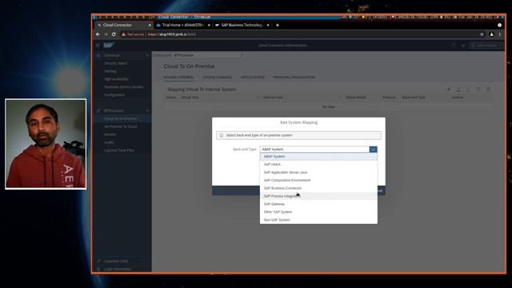
Figure 9 — Add System Mapping: choose SAP Gateway / HTTPS
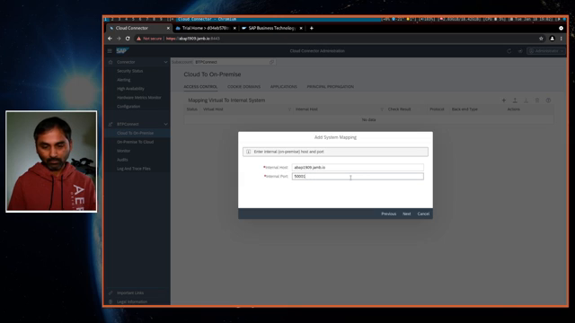
Figure 10 — Set virtual/internal host and port
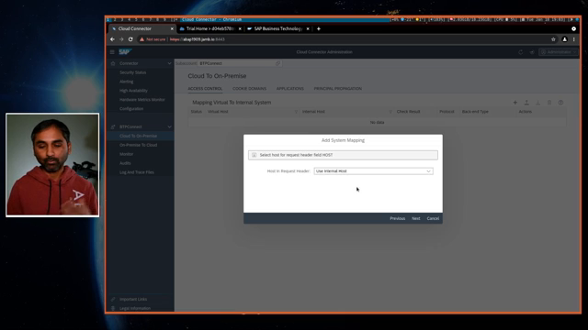
Figure 11 — Internal host check: Reachable
5.2 BTP view after mapping (no resources yet)
Back in BTP Cloud Connectors, the exposed backend system appears, but Resources may still show as None until you map URL paths.
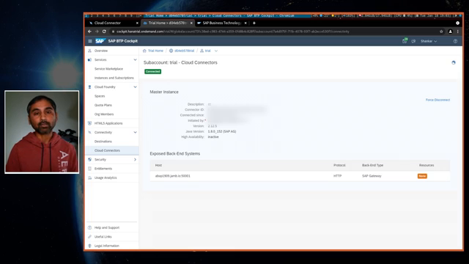
Figure 12 — BTP lists the exposed system; resources not mapped yet
6. Expose resources (URL paths)
Cloud Connector provides granular control: mapping a system does not expose everything. You must add resources (paths) that BTP is allowed to call.
Demo approach (broad)
In Cloud Connector → Resources → Add:
- URL Path: /sap
- Access Policy: Path and all sub-paths
This allows anything under the /sap namespace (convenient for demos). Both system mapping and resource status should be green when complete.
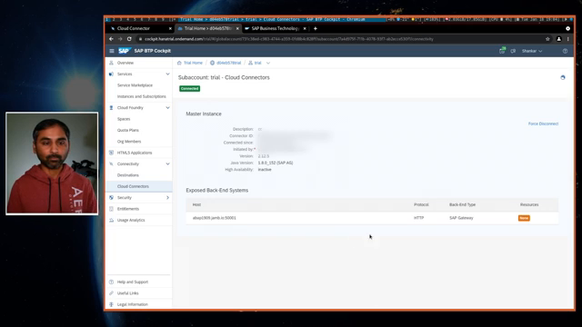
Figure 13 — Add resource path /sap (Path and all sub-paths)
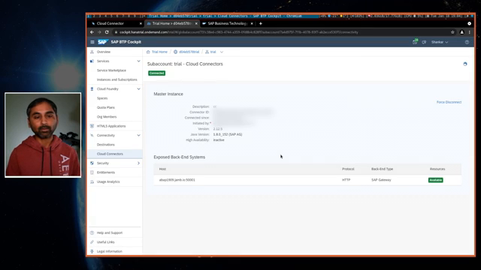
Figure 14 — BTP: exposed system with resources available
Note: For production, prefer specific paths (individual OData service URLs) instead of a broad /sap wildcard.
7. Consume the connection in Business Application Studio
7.1 Open / start BAS
In BTP: Instances and Subscriptions → launch SAP Business Application Studio. If no subscription exists, enable it from Service Marketplace. Idle trial instances may stop automatically — start the instance again if needed.
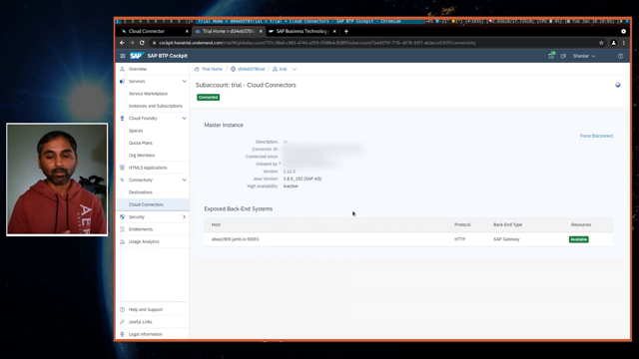
Figure 15 — BTP: Instances and Subscriptions / BAS
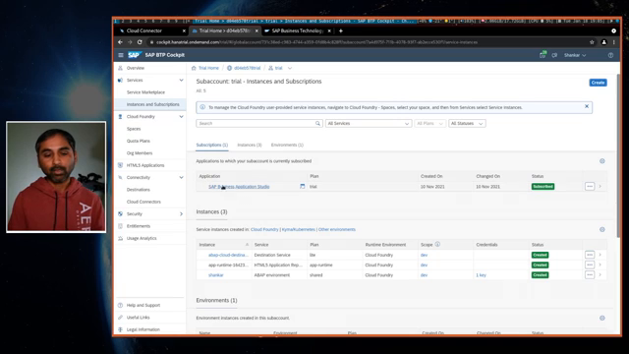
Figure 16 — Business Application Studio welcome / workspace
7.2 Alternative: create Destination only in BTP Cockpit
You can create a Destination under Connectivity → Destinations and use it from BAS or other runtimes. The video prefers creating the system connection from BAS Service Center because required destination settings are added automatically.
7.3 Add SAP system via Service Center
In BAS, open Service Center → Subaccount → Add SAP System. Demo values:
- Name: abap1909
- URL: HTTPS URL of the virtual host exposed via Cloud Connector
- System type: e.g. Web Service Catalog / ABAP
- Proxy Type: OnPremise
- Authentication: Basic
- User / Password: backend developer user
- Product: SAP S/4HANA (as applicable)
After adding, BTP creates a destination (e.g. abap1909). Expanding the system in Service Center loads OData services from the backend.
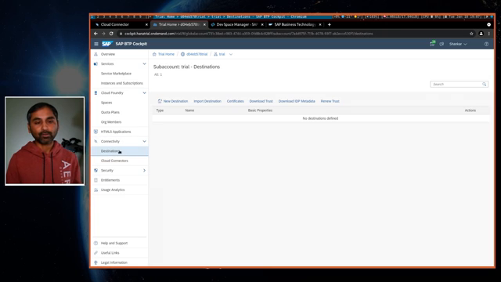
Figure 17 — BAS Service Center: Add SAP system
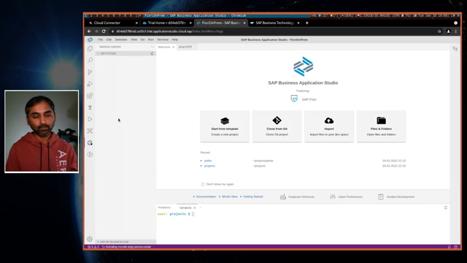
Figure 18 — BTP Destinations: destination created for the system
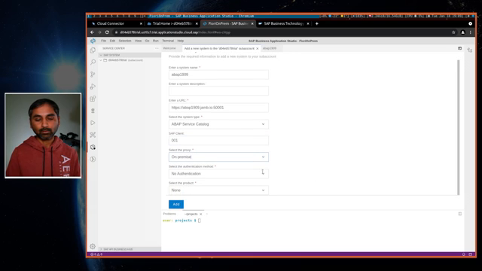
Figure 19 — OData services listed from the backend via the tunnel
8. Create a Fiori app that uses backend data
From the BAS welcome page: New project from template → SAP Fiori application.
- Floorplan: List Report Object Page
- Data source: Connect to a System → select abap1909 (or your destination)
- Service: choose an easy service (demo used an Approvals / PO related service)
- Main entity: Purchase Order; navigation entity: to_Items (as applicable)
- Application name example: PO List
- Deployment configuration: Yes/No as needed (demo shows Cloud Foundry option)
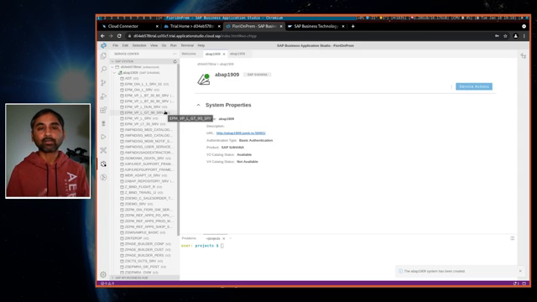
Figure 20 — Fiori application template wizard
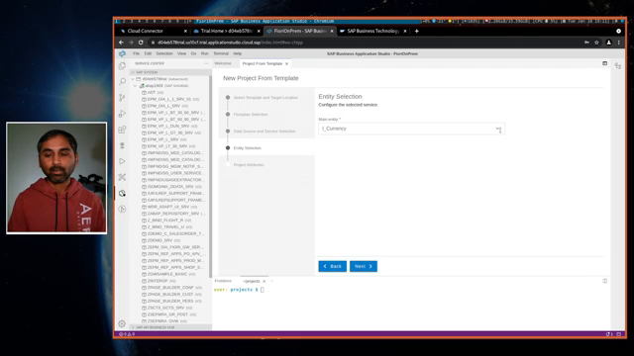
Figure 21 — Entity selection / deployment configuration
When generation finishes, use File → Open Workspace and select the new project. For a local test without full deployment, run npm start. The List Report should load purchase order (or selected) data from the on-premise system.
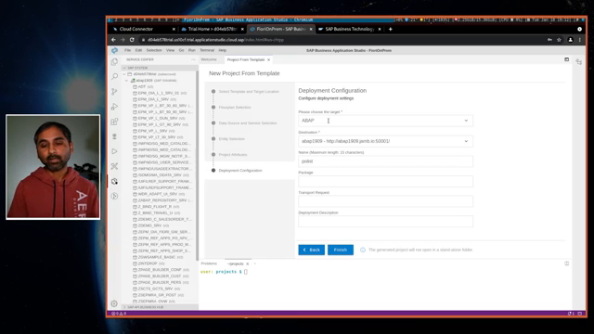
Figure 22 — Project generated: open workspace
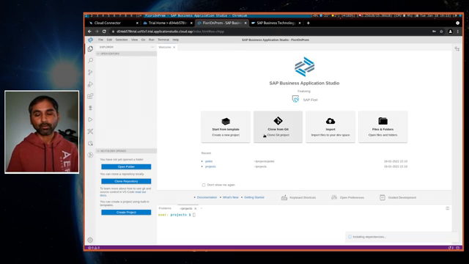
Figure 23 — Local run: backend data visible in the Fiori app
9. Best practices mentioned in the video
- You can connect multiple backend systems through the same Cloud Connector / BAS Service Center.
- Prefer fine-grained resource paths over exposing /sap with all sub-paths in production.
- Cloud Connector is a controlled private link — only mapped systems and paths are reachable from BTP.
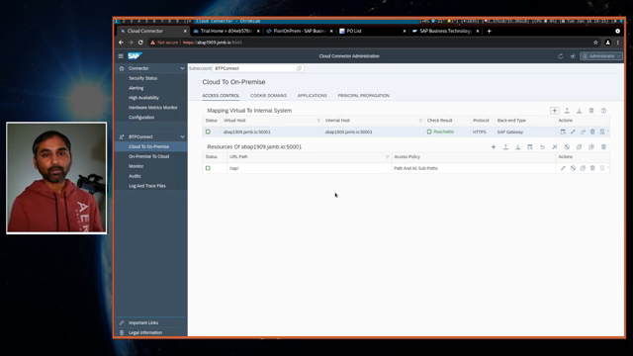
Figure 24 — Closing guidance: multiple systems and granular path control
10. End-to-end checklist
- Cloud Connector running; Administrator logged in
- Subaccount defined (Region + Subaccount ID + user) → Connected
- Verified in BTP → Connectivity → Cloud Connectors
- Cloud To On-Premise system mapping (SAP Gateway / HTTPS) → Reachable
- Resource path(s) added (e.g. /sap or specific OData paths)
- Resources visible in BTP
- BAS Service Center system / Destination created (Proxy = OnPremise)
- OData services listed; Fiori app created and tested (npm start)
11. Source
Video title: How to connect On-Premise system to SAP BTP
Author / channel: Shankar Gomare
URL: https://youtu.be/IgjEEKvjygU
Screenshots in this document were captured from the video for training documentation. UI labels and trial account IDs may differ in your landscape.

