Class - 29-02.06.2026

Unmanaged Scenarios:
Particularly when we trying to implement crud operations/BAPI implementation in this scenario we can implement the unmanaged sceanario... Managed and unmanaged both are same related to functionality wise. but we can add some additional functionality to add in unamanged scenario with our custom code.
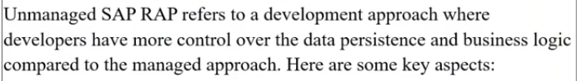
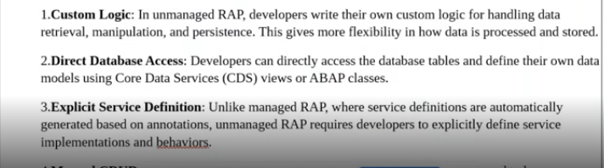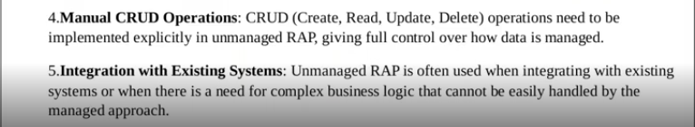
1. in managed scenario we have defined the persistent table, where data to store. but in the unmanaged it is not like managed scenario, because when you specifically mention the your implementation type as un-managed at managed place- immediately it throws an error, because we mentioned the persistent table in managed scenario.
in managed scenario this persistency has to be maintained by the developer when it implemented.
2. Now compare this point with abap side, if you want to create a single record -- what so ever, what you are doing first. first prepare dummy data(Handler phase)- you are preparing some data after that you will go for save phase( insert query )-in unamanaged also same, when come into managed handler thing , saver thing and everything handled by the RAP framework.
in unmanaged you have to handle the record that means to prepare the record and you have to save the record.-- means unmanaged completely developer prospective.
here unmanaged whatso ever the types of the implementation you wanted to do whether it was create/update/delete for all these operations --> it generates specific method.
- lets say if you want to perform a create operation --> then it generates create method
- lets say if you want to perform a update operation --> then it generates update method
- lets say if you want to perform a delete operation --> then it generates delete method
then whatso ever the operation which you are doing every method, which it triggers the SAVE method .
lets say for example : I want to insert a new record in my table through the unmanaged applications. now what i am going to do .
- i have prepare the record and every time when you perform a create/update/delete --> the save method will be trigger. - means when you go for the save phase of that particular record, the save sequence will be triggered .
in this we have managed with unmanaged save as well. --> means, type of implementation was managed but when it comes to the save phase. it was unmanaged --> there single method you can implement the multiple operation .
in the unmanaged save, their it is generates the specific method which is save modified. in that save modified- it is having create/update/delete, that means in a single method itself you can implement all those CRUD operations.

lets implement the practical part of unmanaged.
Create table:ZUNTRAVEL
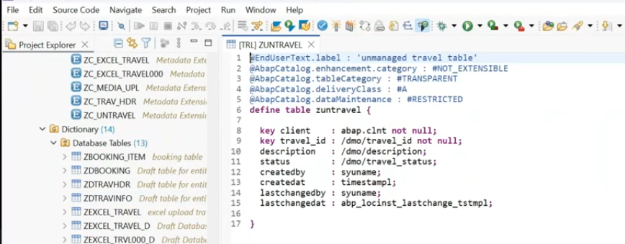
rather than create from scratch we will go for the Repository objects as we know go for the repository object --> by default it generates managed kind of applications, even though if you are behavior definition as managed still you can change from managed to unmanaged as well.

Generate ABAP repository:
right click on DB table: ZUNTRAVEL
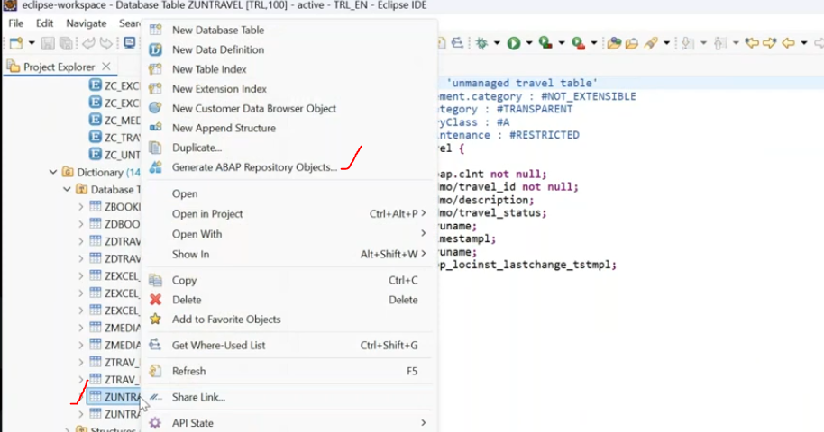
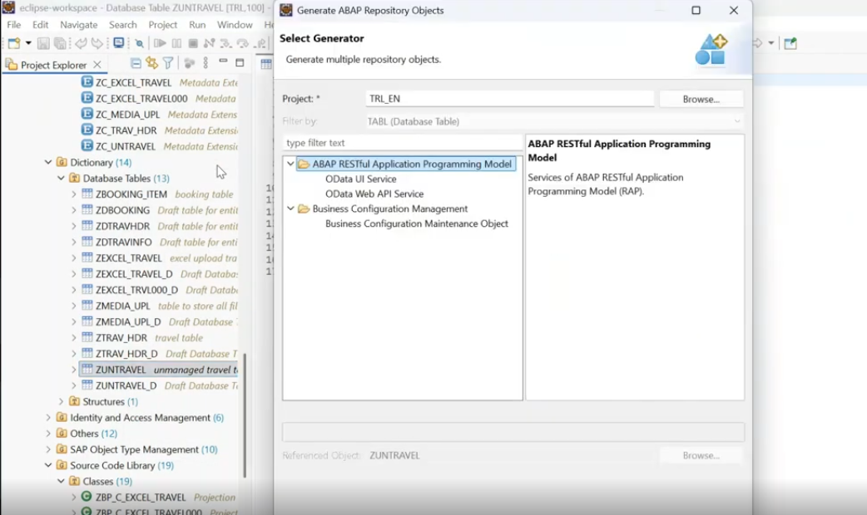
select the ODATA UI service
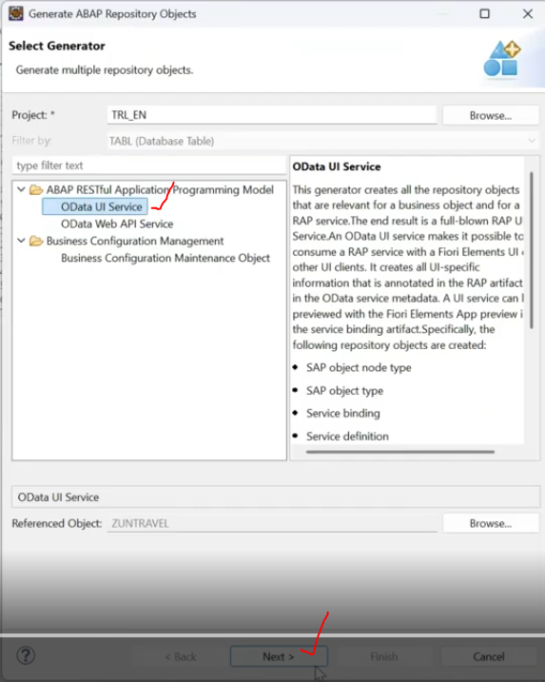
Save in package.--> NEXT
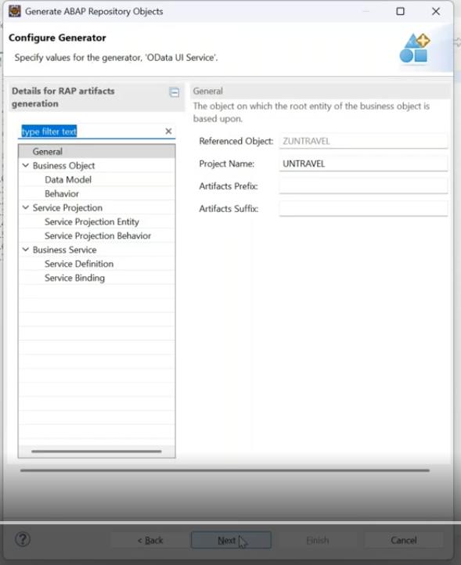
Select data model - change the alias name.
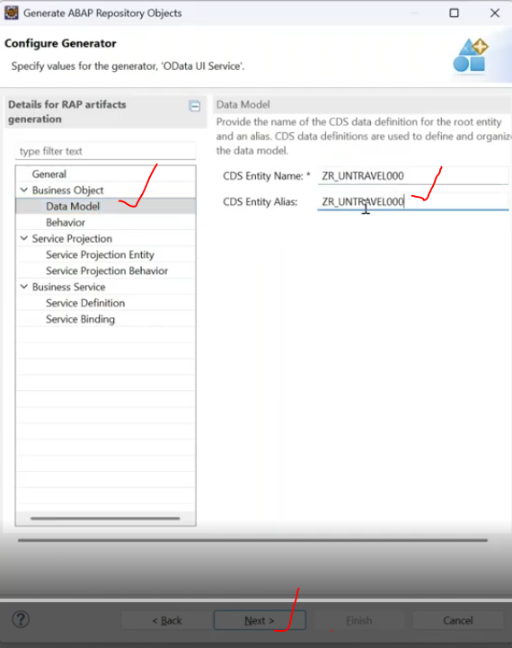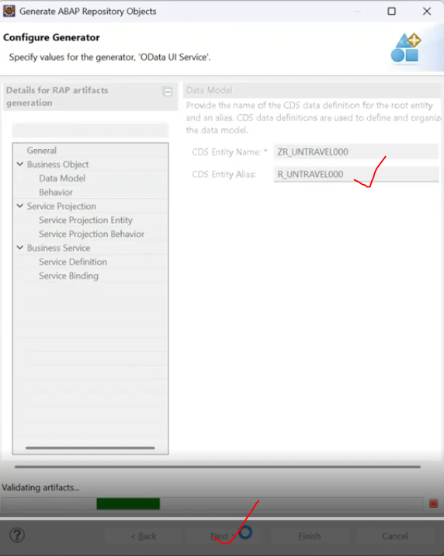
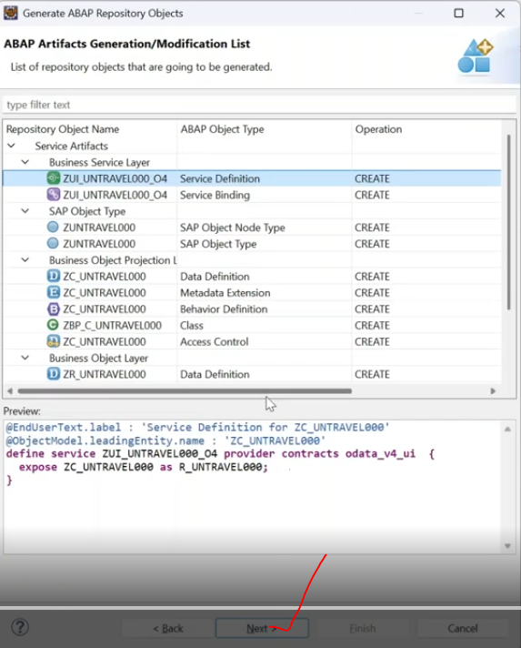
and click finish.
wait for some time to generate the objects.
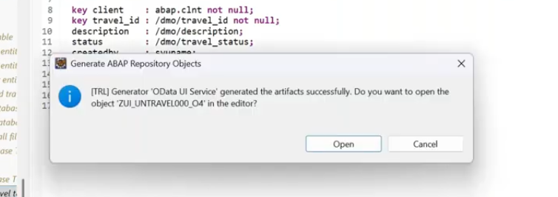
click on open
once done..
Now delete the dependency objects- Classes.ZBP_R_UNTRAVEL000, because we are trying to go for the unmanaged
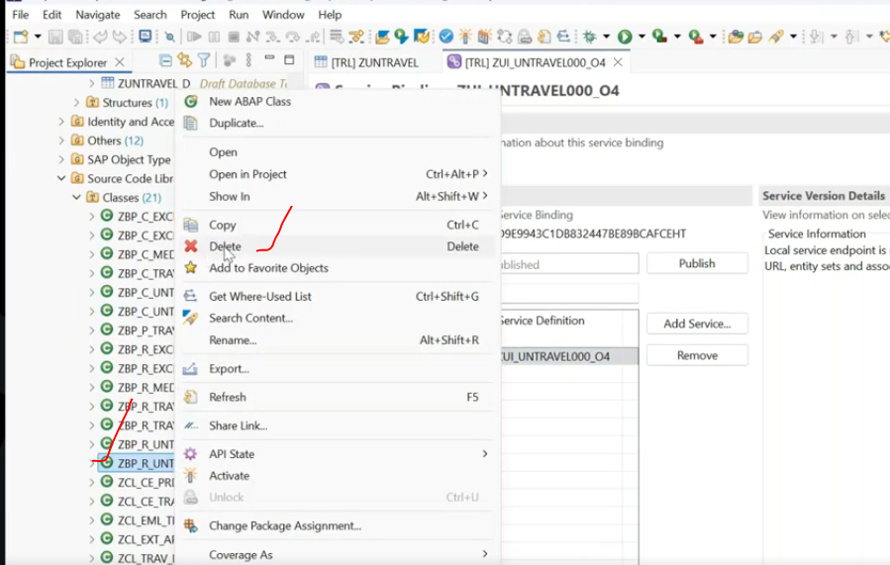
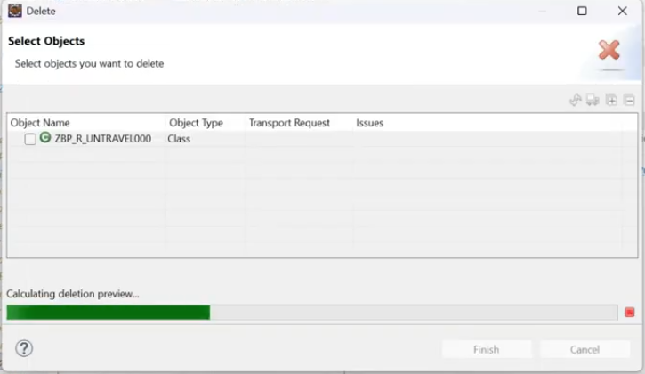
Now change the behavior definition- managed to unmanaged.
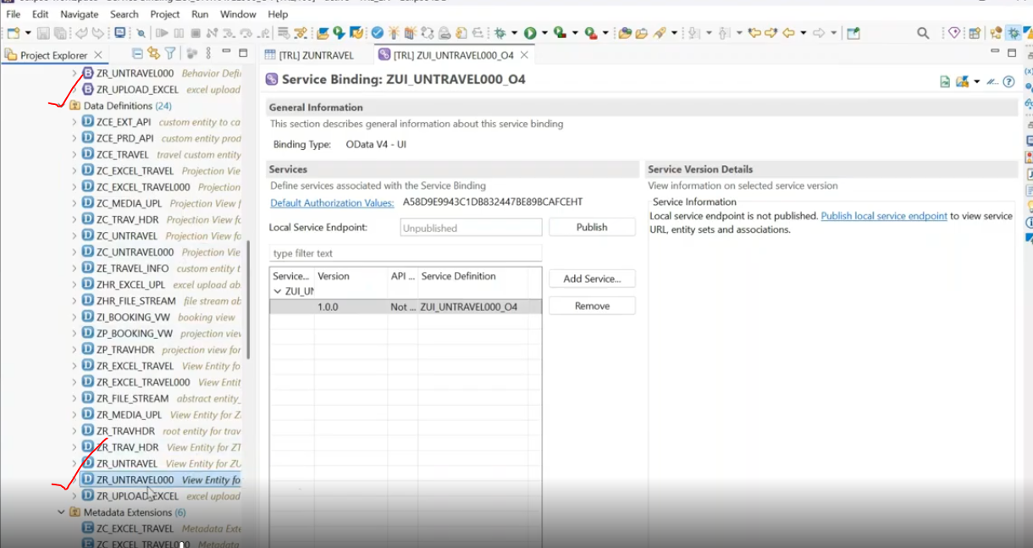
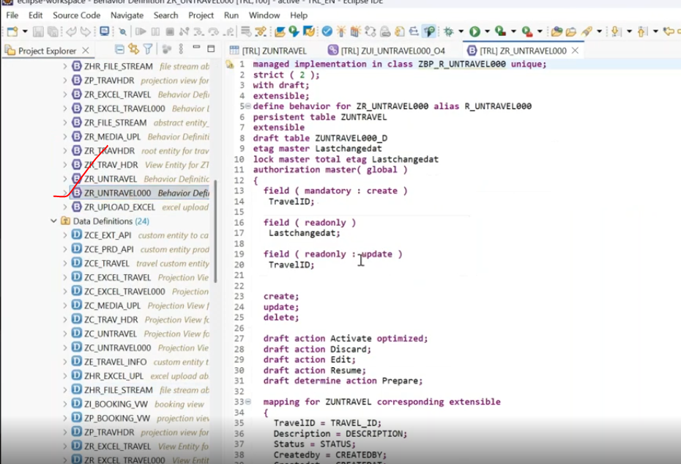
now this is managed and currently it allowing the persistent table --> now when i put in un in front of the managed--> immediately it will throws an errors.
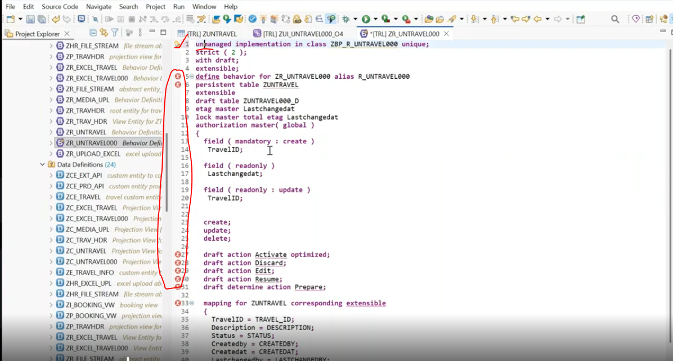
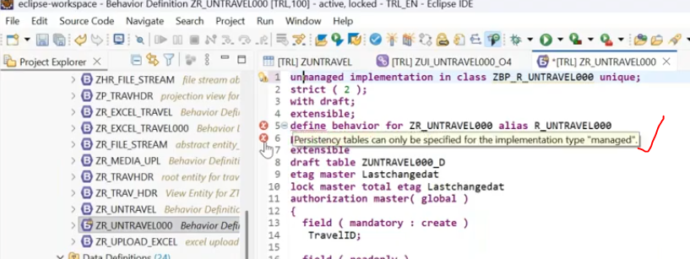
Persistent table only be specified in managed scenario..
Now i put comment --> it will works.
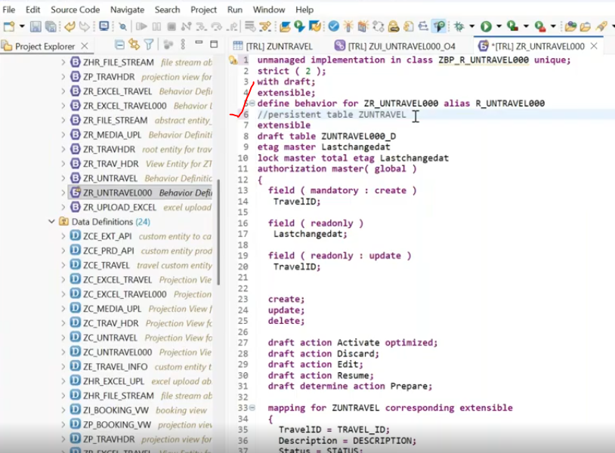
all errors are gone.
Activate.
Now create the new class for unmanaged implementation of the class.
put the cursor --> press ctrl + 1(Quick Fix).
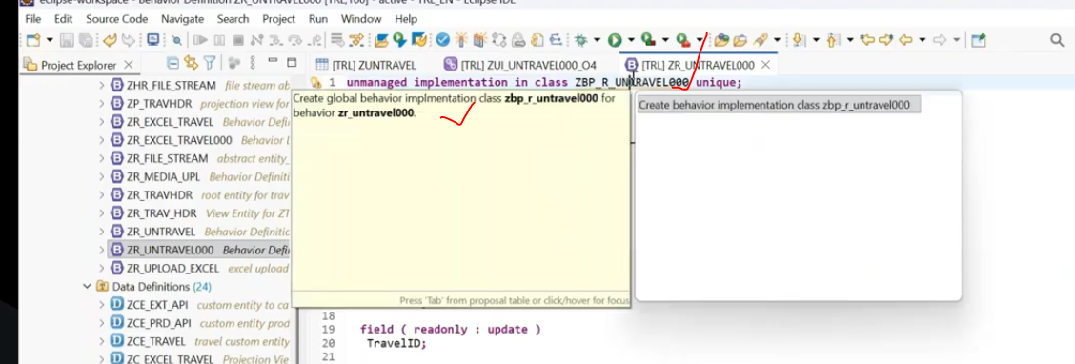
13:00
Create the unmanaged implementation class:
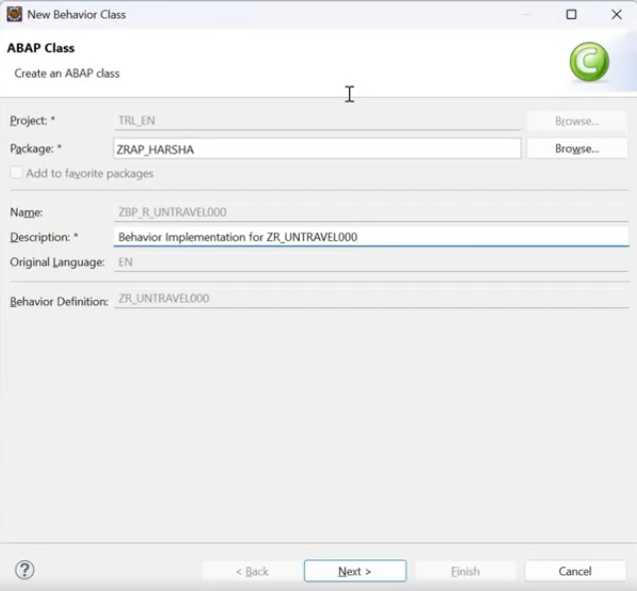
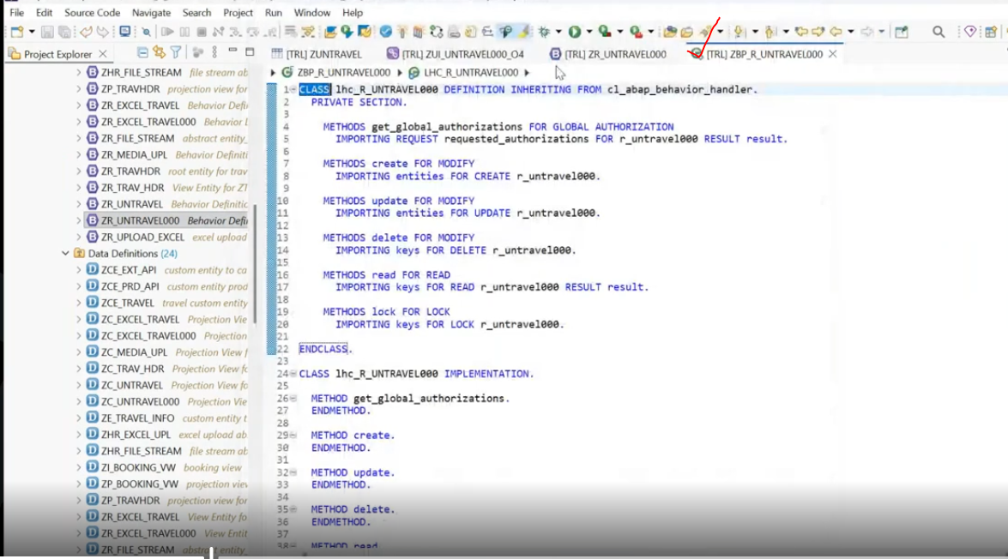
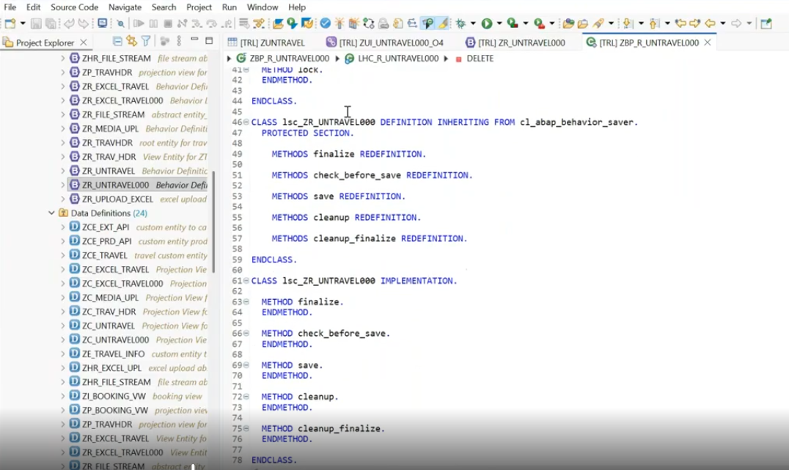
class created.
Now you can see big difference when generate method in managed and unmanaged scenario.
Handler class:
1. class name starts with "lhc_" --> local handler class, this class inherited from cl_abap_behavior_handler.
2. in local handler class redefining methods from cl_abap_behavior _handler methods. like create/update/delete. and whatever the operation which you are implementing every time the save phase will trigger and save phase is not related to the handler phase.
in every operation method we have the entities -the type of the entities similar to our root entity.
in the handler phase only prepare the data- you can't save the data.
for save phase- another class also created - that is prefix with lsc_--> local saver clause and it is inheriting from cl_abap_behavior_Saver.
Saver class:
3. Local saver class has - below methods are redefined .
methods : finalize/check_before_Save/save/cleanup/cleanup_finalize.
use of local saver class:
is a local class and it is responsible for the save sequence and it is exclusively called by RAP runtime engine to persist business object data.
and we discussed previous classes, you need to go for the save phase for saving of the record. but when you see in the save method, except the "reported", we don't have anything.
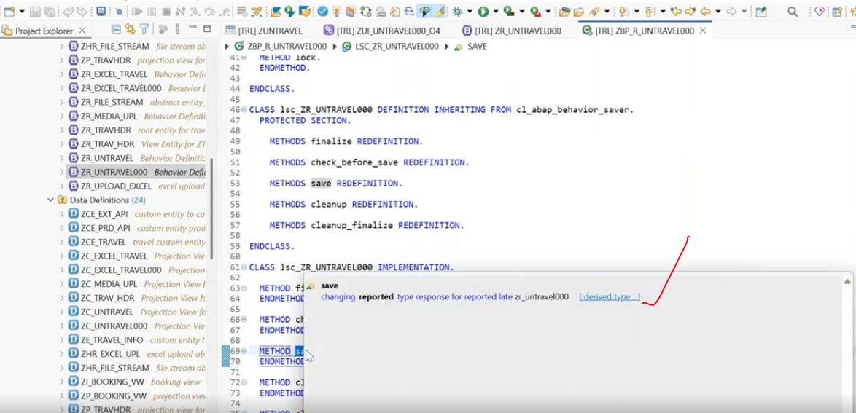
in save method we have the reported internal table only, in this case whatever the records which I prepared during the create operation, where i got in the entities and how can i pass that entities data into the save phase.- How can i pass data into the save phase.?- SOlution for this we have to declare the global internal table i.e in global class.
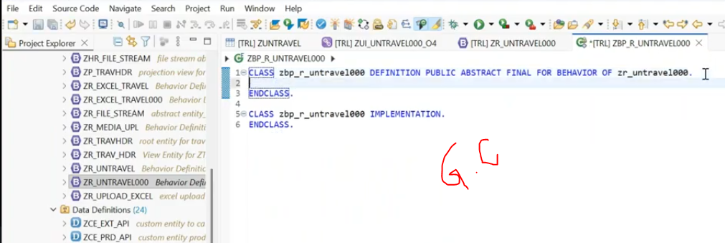
here global class is - ZBP_R_UNTRAVEL000
in global class, whatever declaring in global class -- those are considering as global declarations.
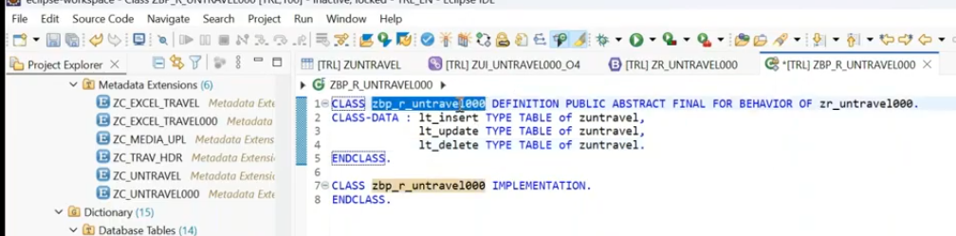
How to access global attributes in local class - <class name>-<global attribute>.( those are statis attributes )
whatever you prepare the data, everything those will coming in the entities.
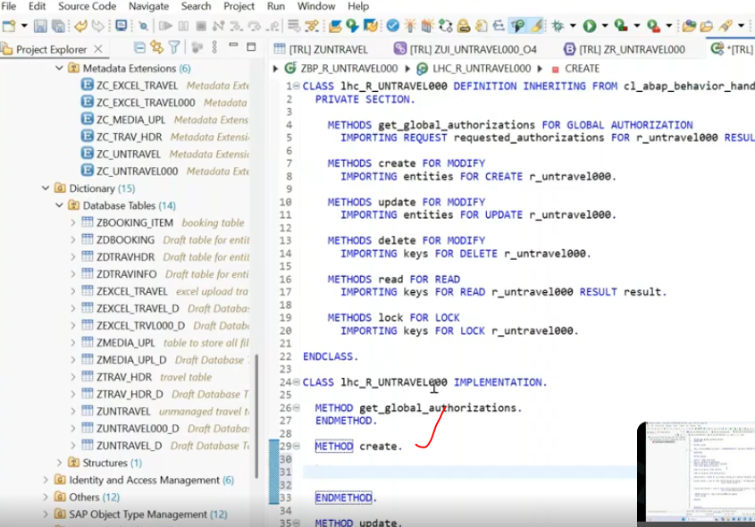
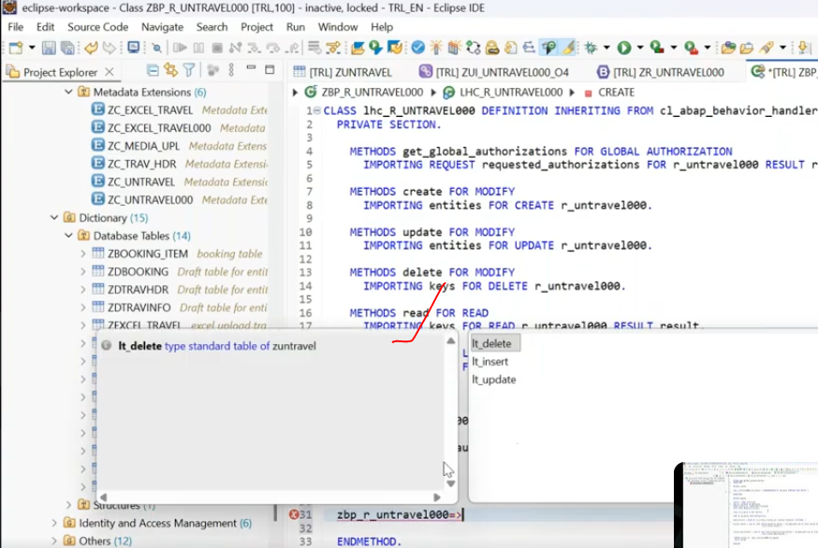
Now declared variables are available in local handler class.
Now fill the data to internal table -
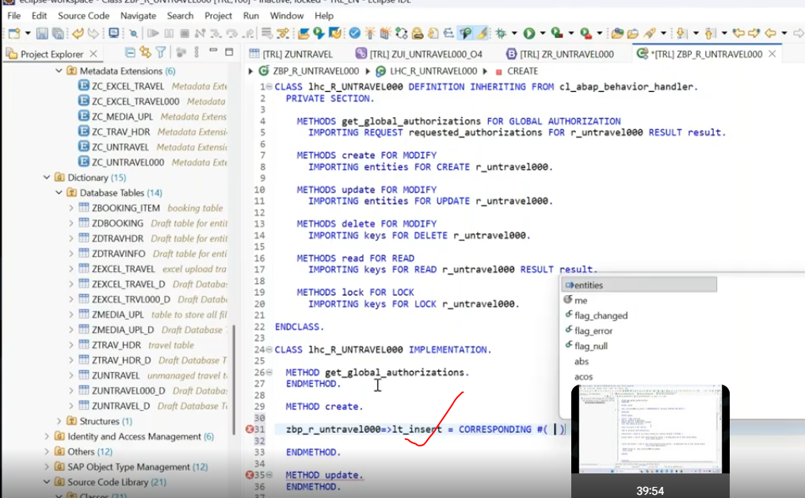
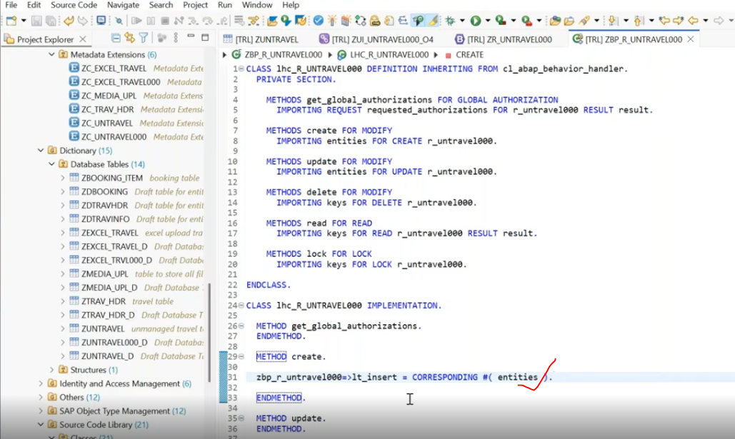
if user is trying to create - Now i have to go for save phase in saver class.
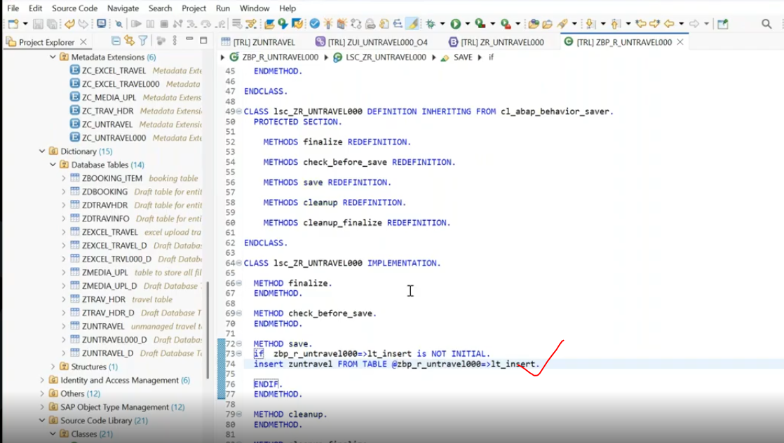
check and activate all the objectives.
Now publish the service:
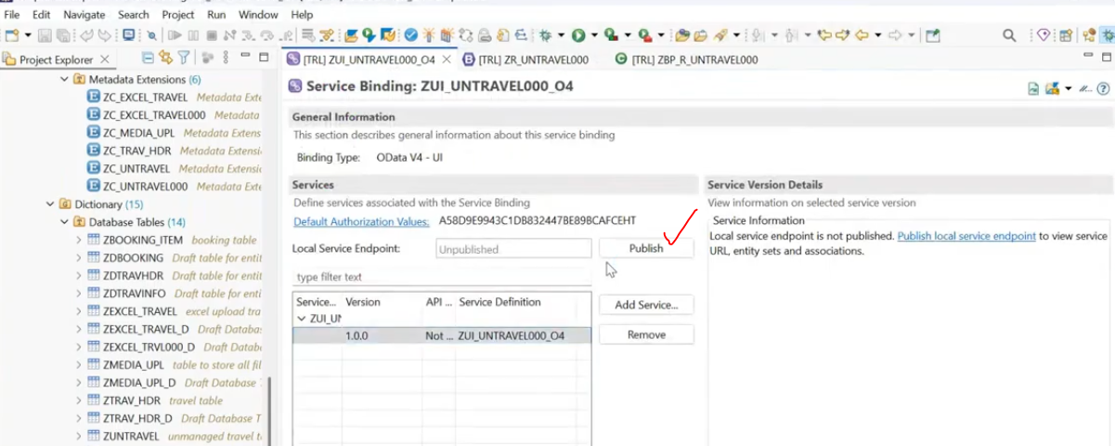
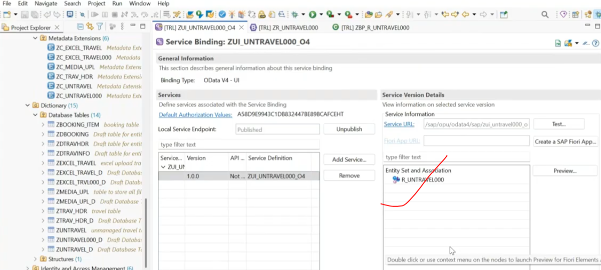
Service published.
Now test from frontend after add the breakpoint create and saver method.
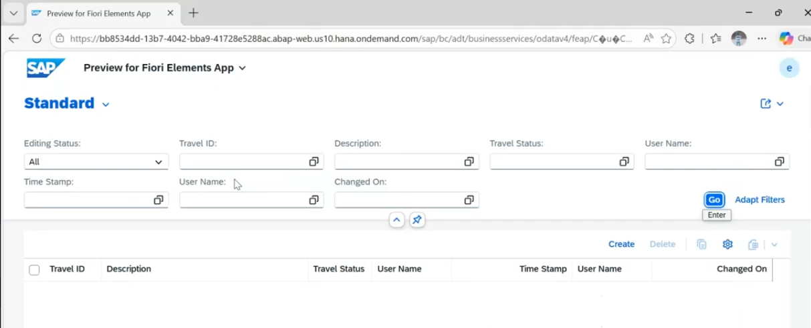
click on create.
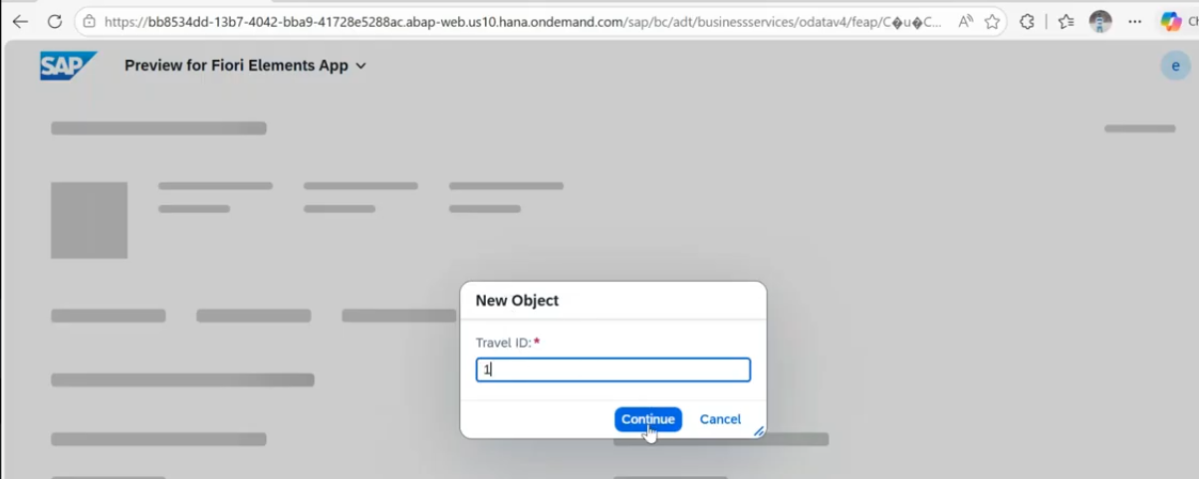
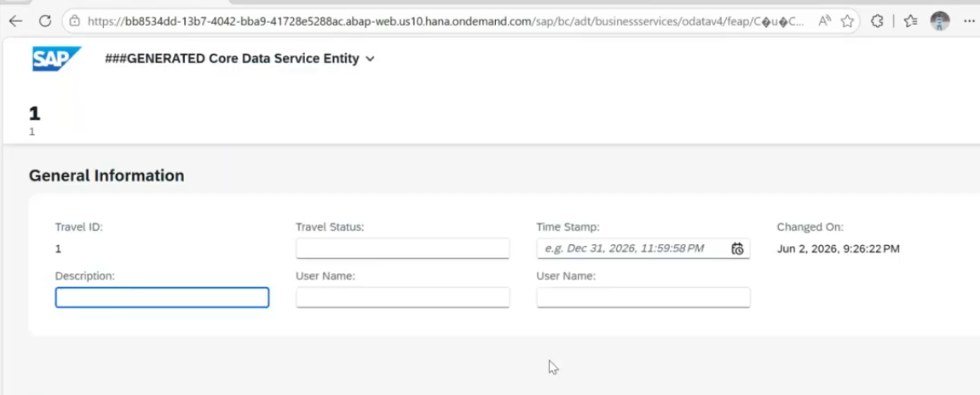
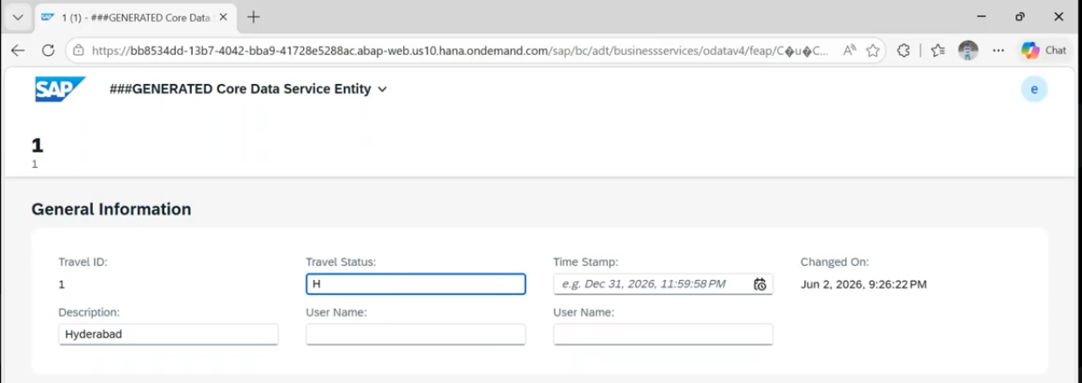
click on create.
whatever you providing, those will coming into the "entities" parameter.
Now cursor will stop at create method in handler class.
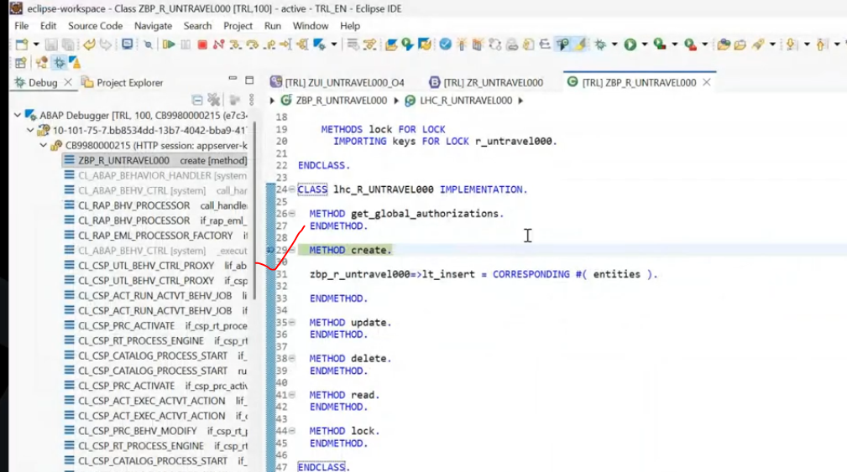
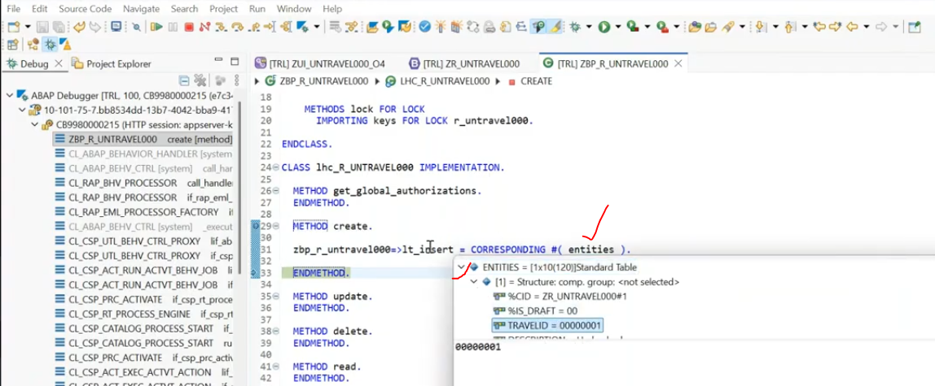
now data received to the create-entities. but lt_insert have also one record but not populated properly. lt_Create table travelid only blank remaining records are populated why?
Why travel id is blank?- because lt_insert- internal table filed name is travel_id and entities field name is there is under score- travelid.- that's why data not trasfrered.- here mapping of the fields has done correctly. means( lt_travel-travel_id and entities-trvelid, here both are different that's why not transferred)
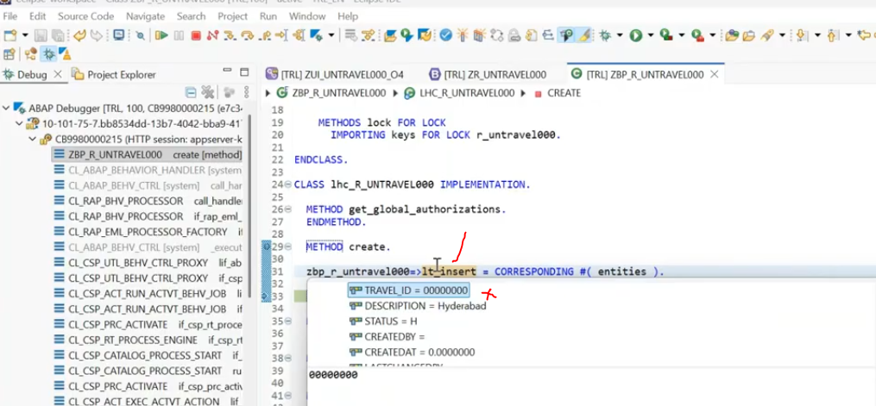
24:30
when i press f8 -- save phase immediate will trigger. - once the hander phase completed .. immediately it turn into saver class- save method and executed the save method data inserted into the DB with the travel id is 0.
25:29
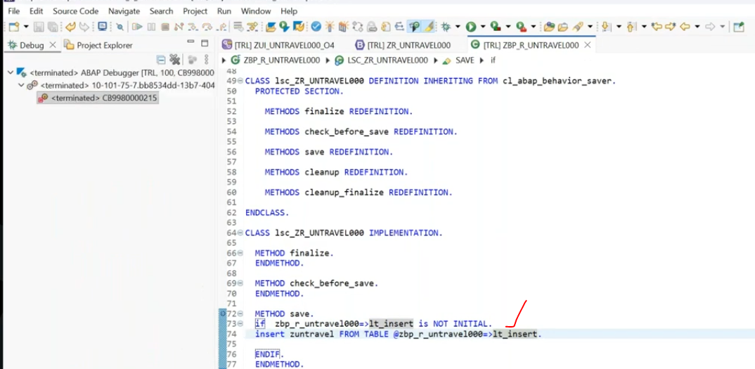
Output:
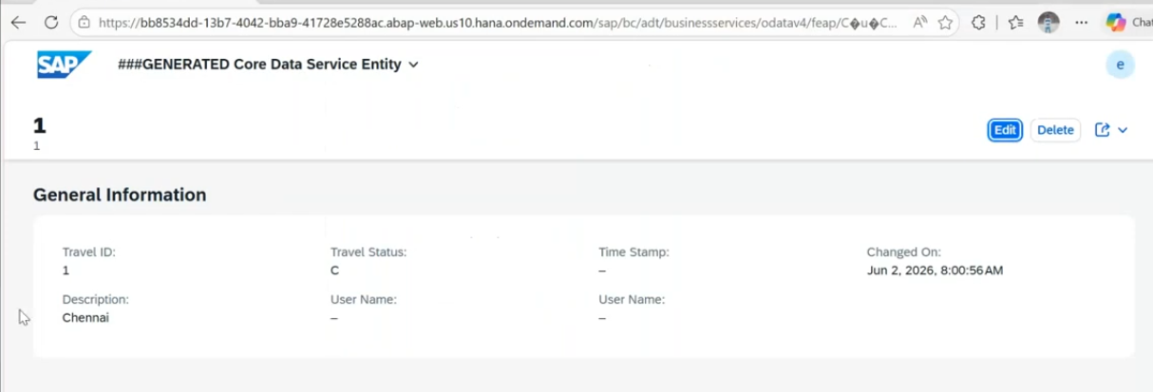
But frontend is travel Id seems to 1- but backend updated as 0. so if you want to real time data, go back to the screen again click on go button.
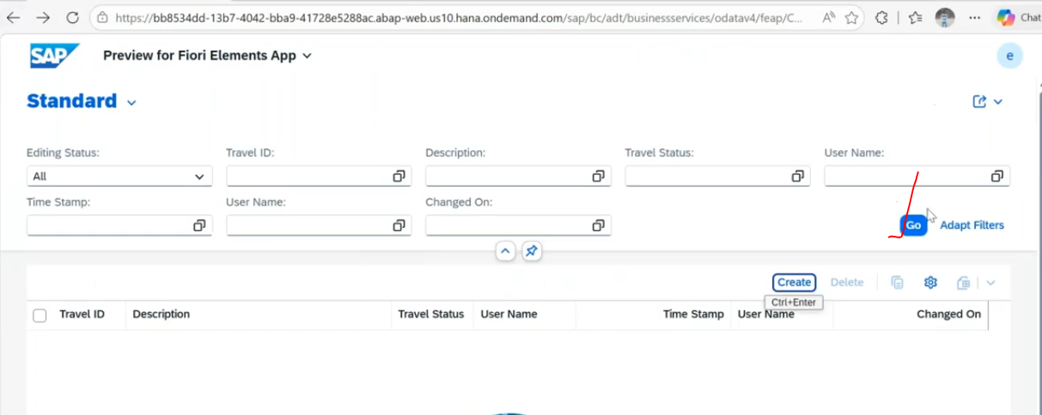
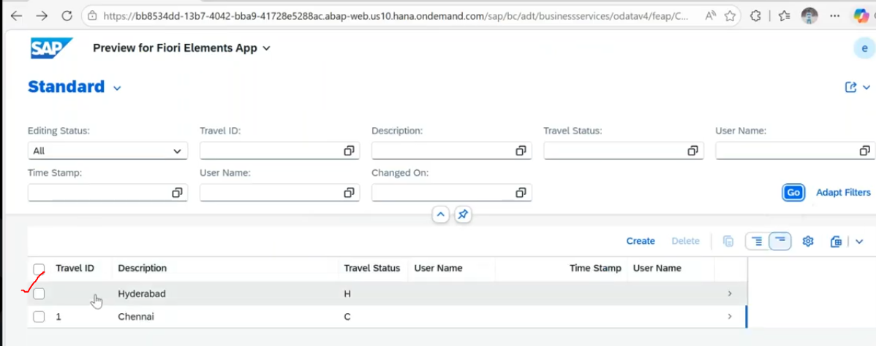
See here Travelid is blank updated.
lets correct our code in create phase- use the "corresponding" with "mapping".
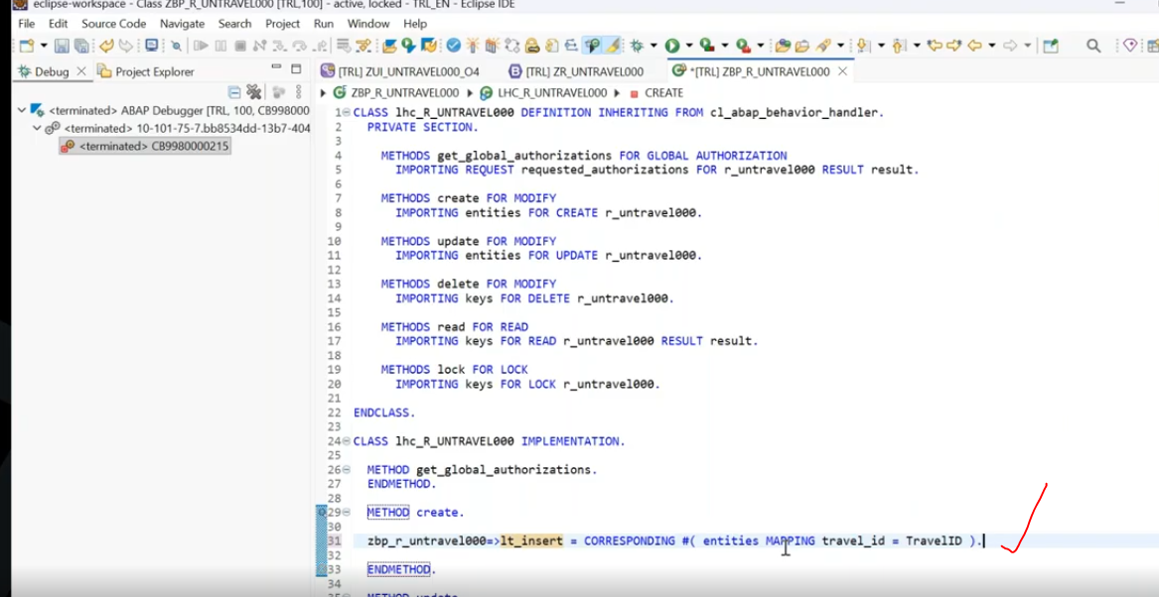
above are manual mapping.
for automate mapping -use the "corresponding" with the "mapping from entity".( this is one or two fields are fine )
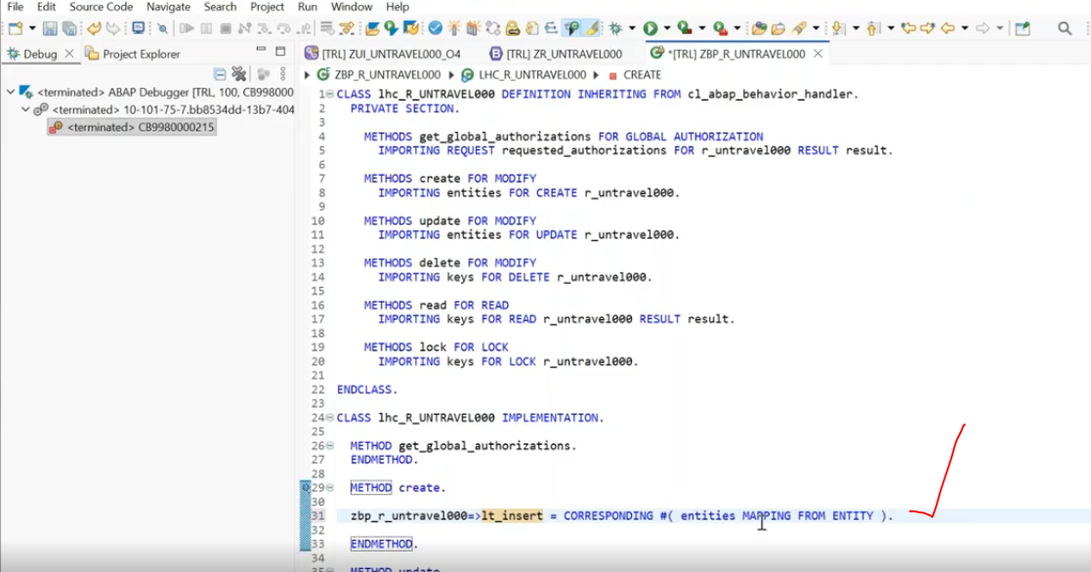
mapping from entity means: whatever the mapping which you did from the behavior definition, those mapping will be captured.( means already we have done the database and root entity mapping done in behavior definition those mapping will captured).
In handler phase: implement the Update method also.
method update: when you try to perform update operation you need to remember two things
1. We don't know what is the column user wants to update. --> we have to capture that updated value. when it is updated we have to capture that updated value. and user not updated the description field- so here we have to update with the previous value.
so here we have to get the previous updated data.( select on db)
if record found only then only update the data.
2. We have to update the fields conditionally : by checking the control structure(%control), if the control structure is the returning will return the '0'(not update) or '1'(Update)- indicate user trying to update. the control structure(%control) of that particular field if it is returning as '00' user is not updated.
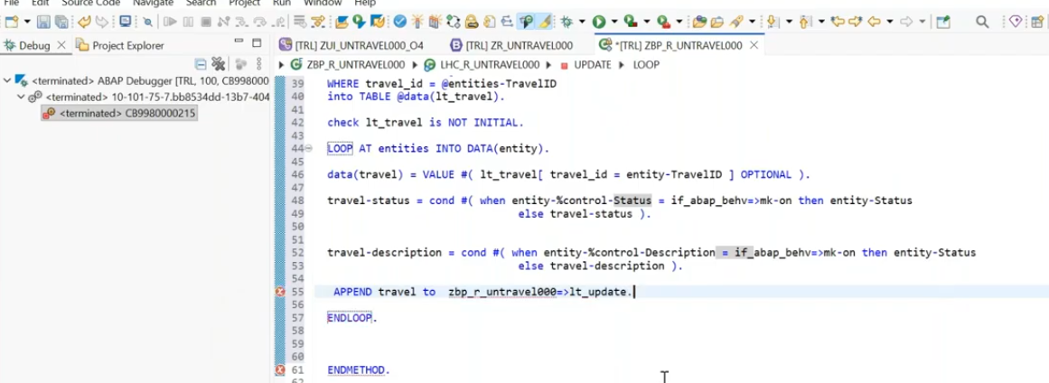
then i can handle in the update save class to update the data.
To delete method in handler class: to delete, we need the key to delete the data.
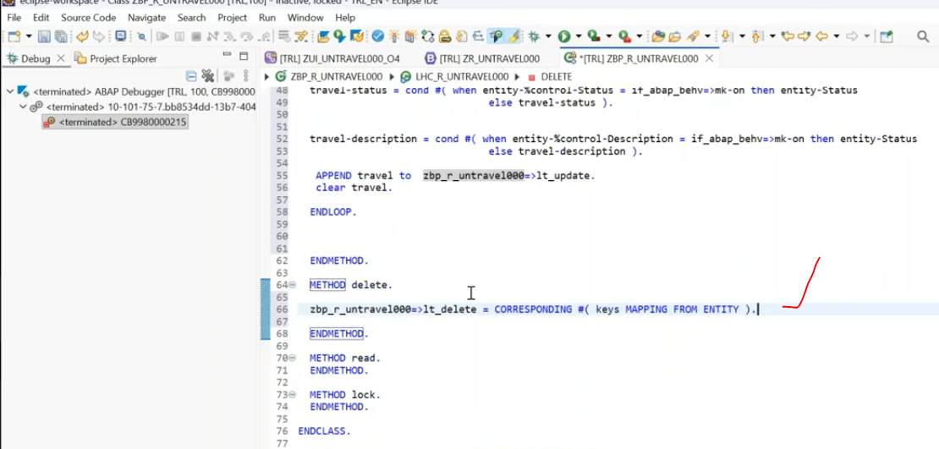
For update and delete we captured to the internal tables(lt_update and lt_delete).
Now update the data in save phase:
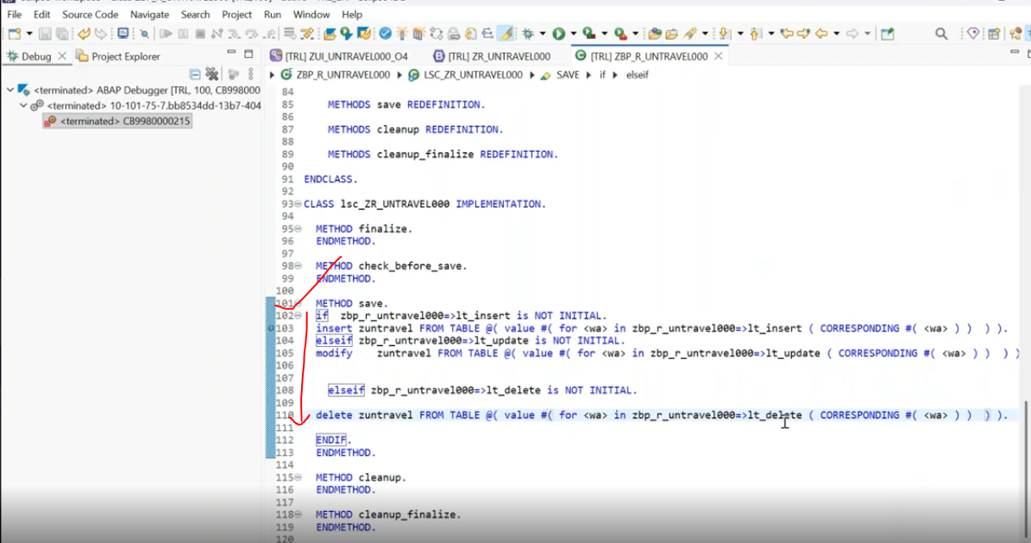
read method - will trigger at the time edit/ delete button from front end. --> next pick the data from db and send it to front end --> once done the changes when click on save --> save phase will trigger.
save button- save clause will trigger.
during the update or delete -> this unmanaged framework should not able to understand what is the record you are trying to update /delete, unless or until you will not implemented the "read" method.-> then it could be identify what is the record you are trying to update/delete..
read method will trigger after crud operation and send the captured record to the "result" parameter. -> "result"- parameter is update the data to front end system.
read method in handler class:
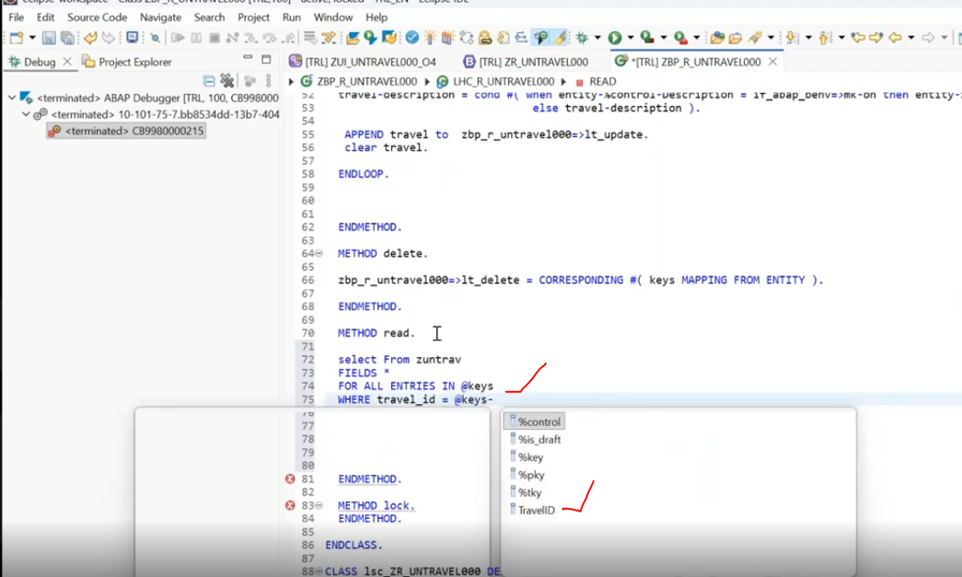
%keys- is the internal table to captured the key field- which is send from frontend.
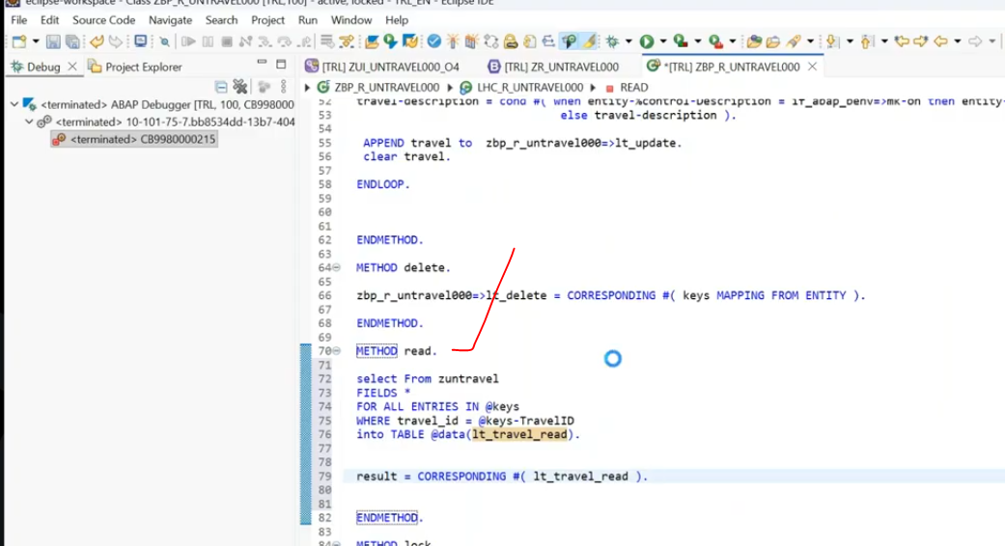
put break-point, check operation has performed user.
lets refresh our app at browser.
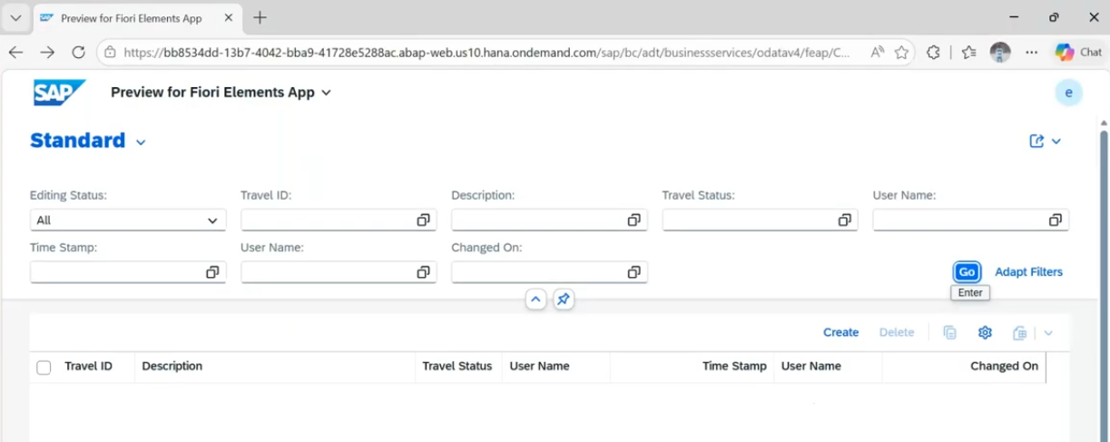
click on go
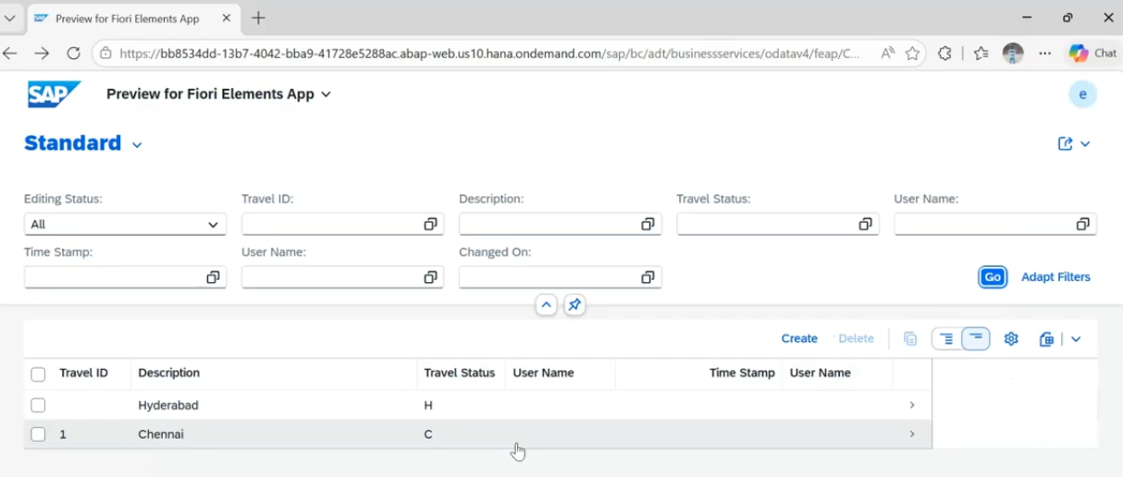
Now i want to delete the trvelid is blank record - click on it.
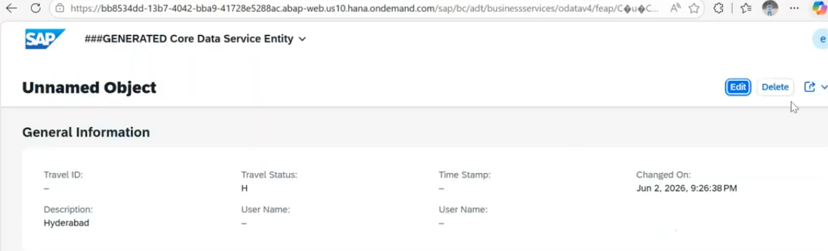
Delete it.
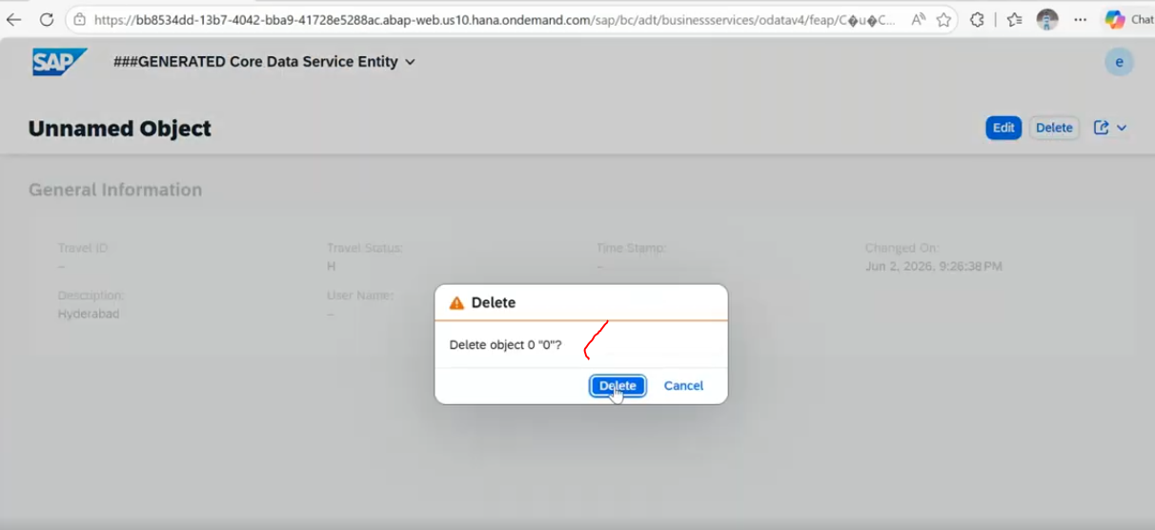
read method will trigger in debug mode after delete the record - and refresh the front end screen with result parameter..
1. reading the that particular record based on key and which record are you are trying to delete.
data deleted .. and checking that data deleted or not in read method- again update to result parameter.
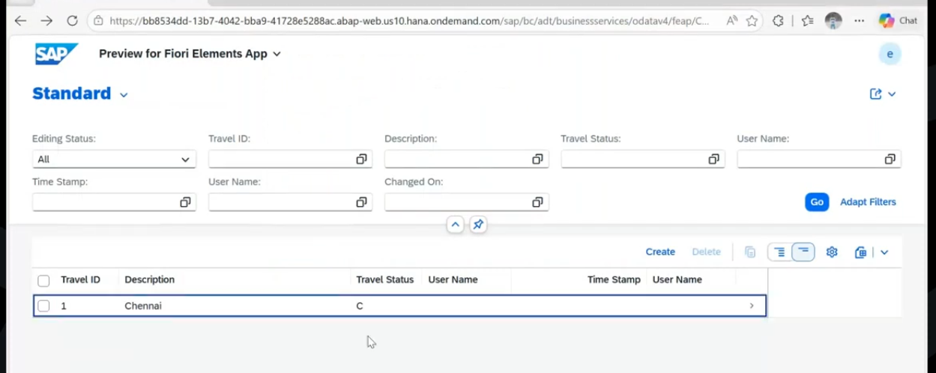
record is deleted and update to the front end.
Update the record:1
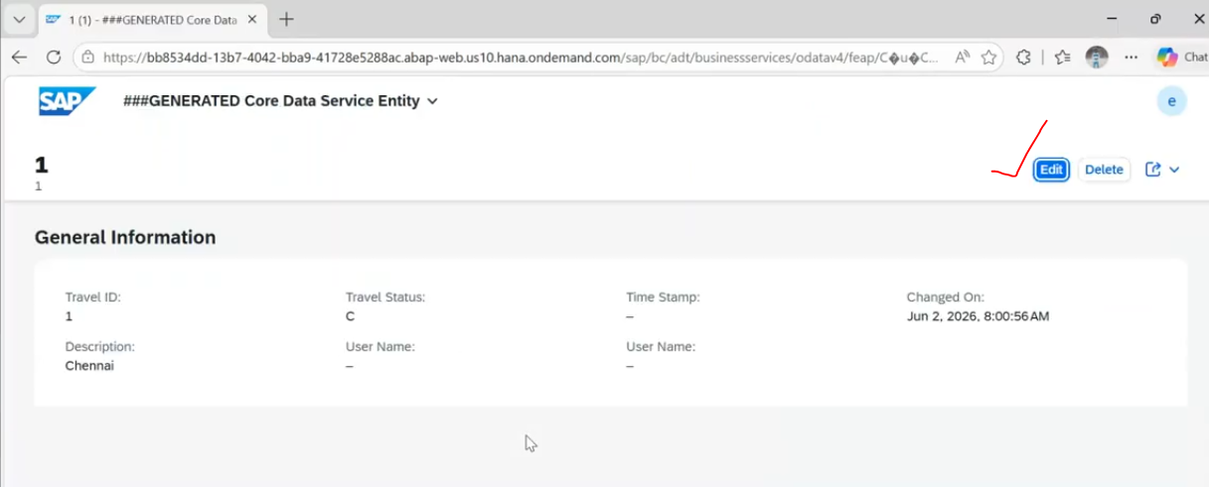
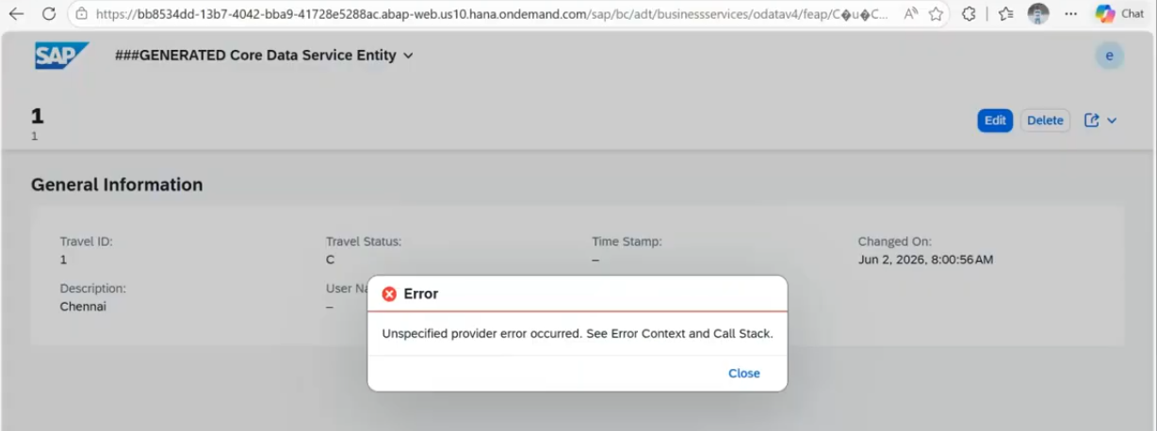
error : comes because of read statement, our internal table -travel_id and result internal table travelId are different fields. so that is why trave id not transferred . so result parameter not updated properly.
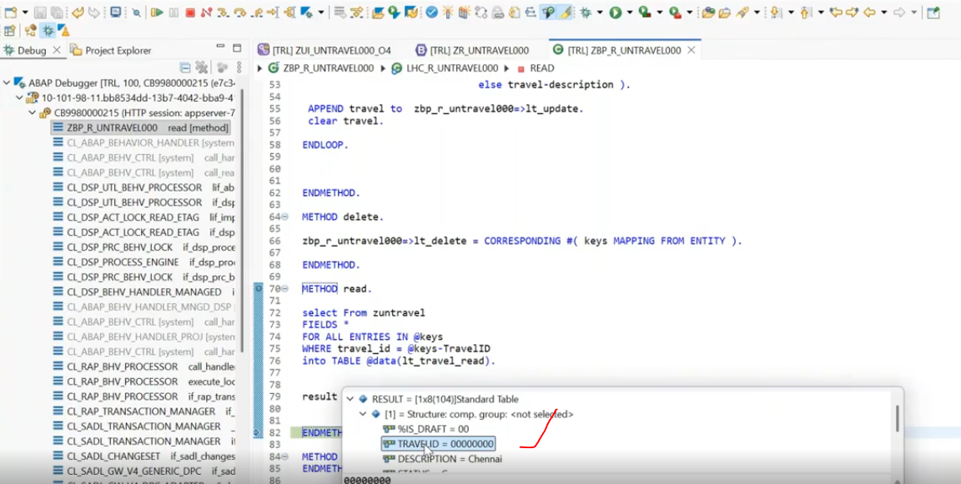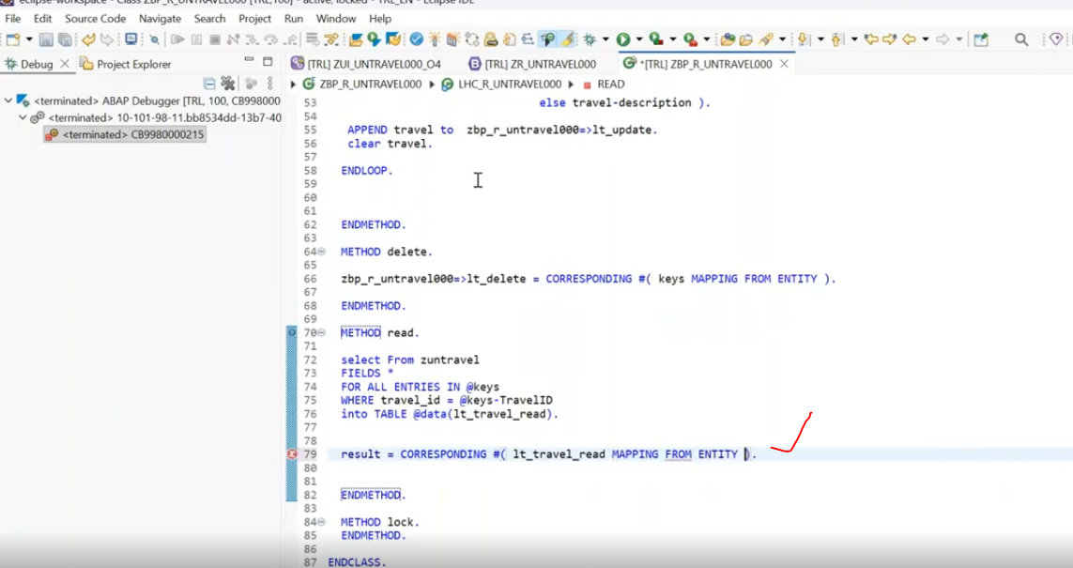
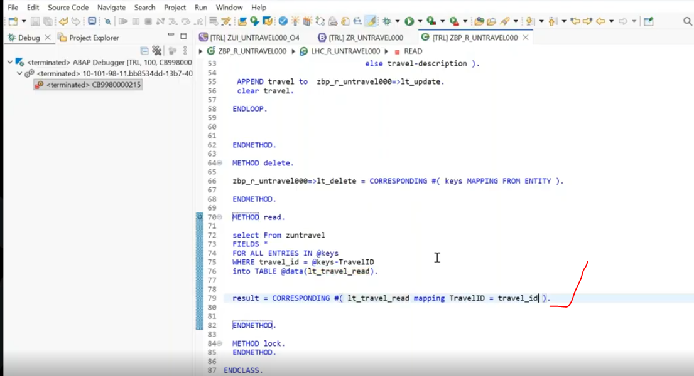
Now issue resolved.
again try to update.
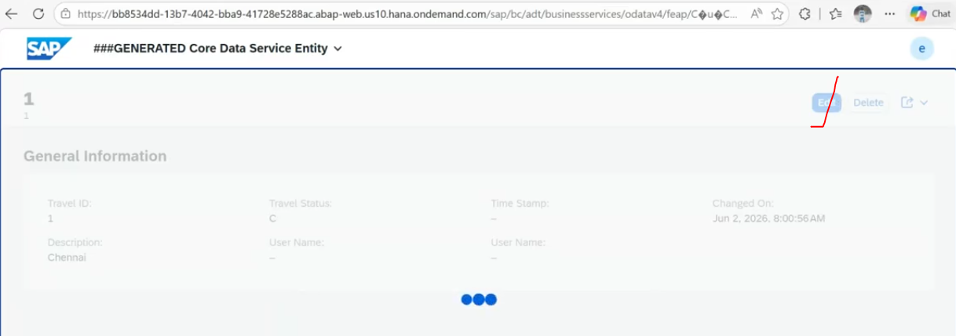
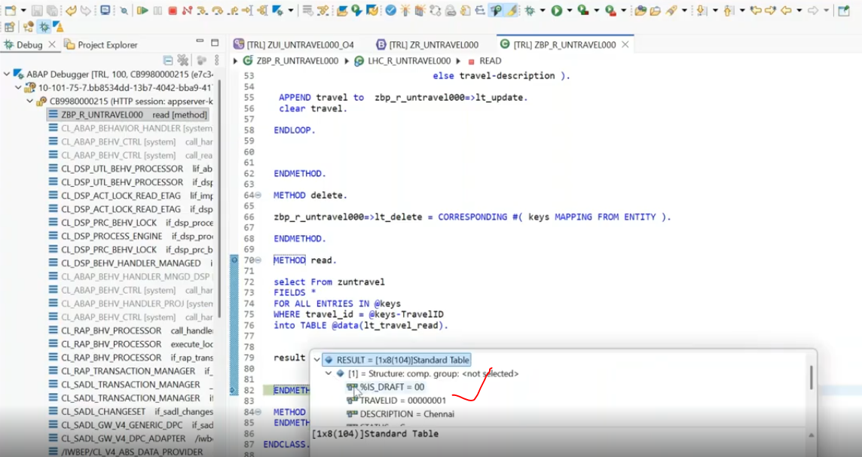
Display the record at front end and change the record and click on save.
47:00
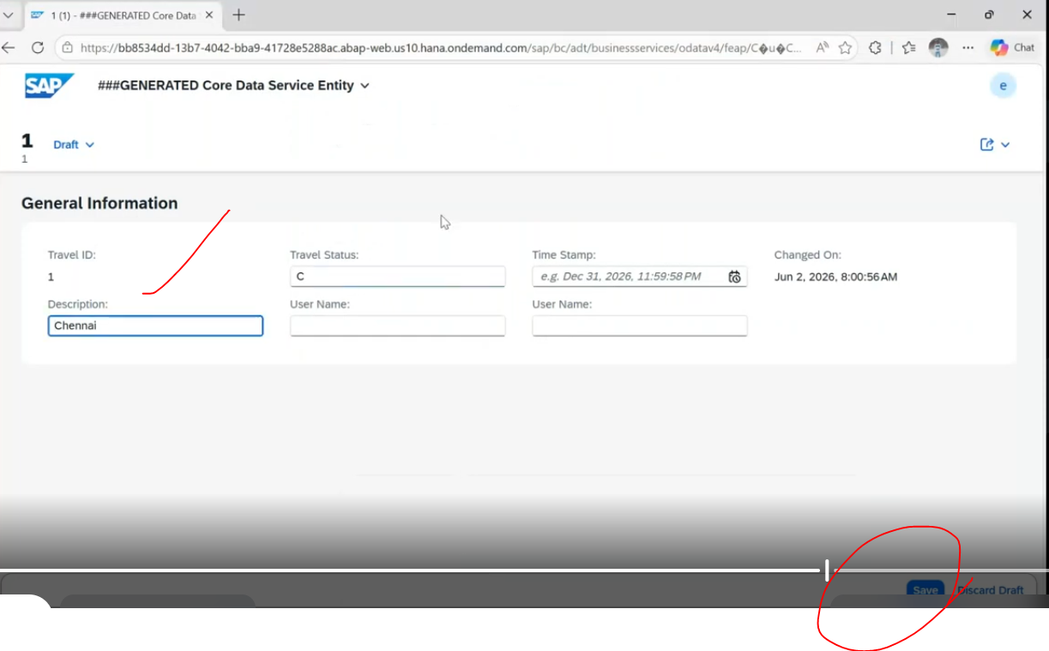
lets change the travel status to T.
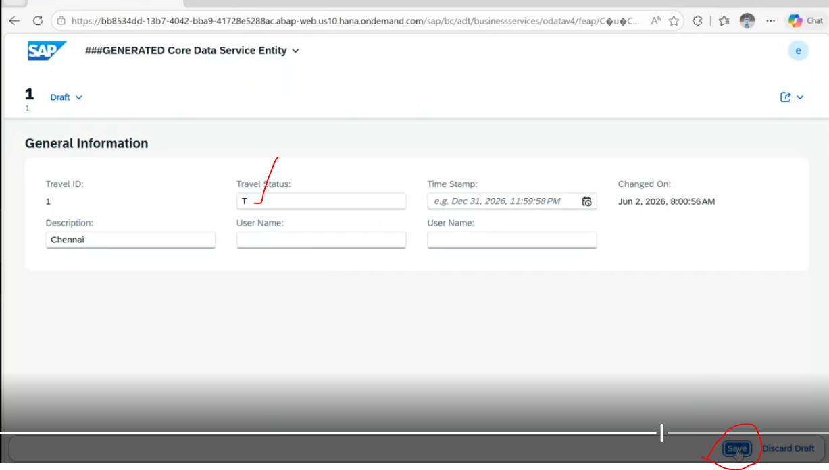
click on save.
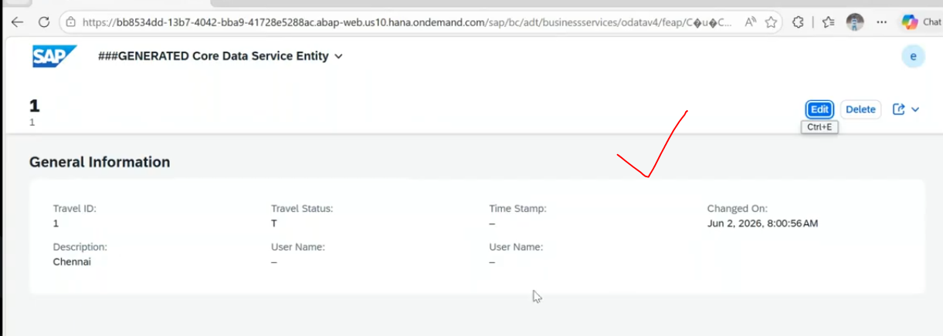
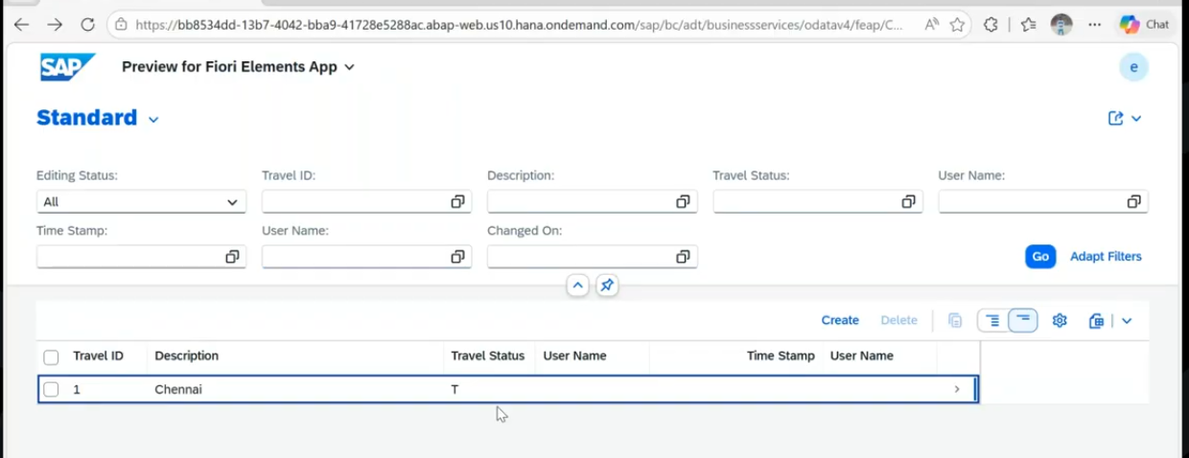
click on edit --> read( ) (Front end display the data(Result) )--> change mode - change the data
--> click on save --> update( ) method and save () method will trigger.
entities from all CRUD operation methods: entities: internal table received from UI.

Unmanaged scenario- Validations:
Validation: where you can raise an error message- where the data is in-consistency.
for validations - we can use the method as "check_before_Save" method.
the final check could happen- check_before_Save method.
check_before_save: it is not related to any specific CRUD operations. it is the generic method means specific to all and this method will trigger during the save sequence. and in this method if it returns any error message in the failed parameter, the save sequence is terminated and it calls the method - cleanup_ finalize.
cleanup_finalize : will trigger, when return the error in the check_before_Save( ) then the method will trigger -cleanup_Finalize( ) after the save( ) method will terminate. because of we raised an validation. but when it not return this check_before_Save() will be called, if data is consistency in method-check_before_Save, and will not call the cleanup_finalize( ) the method.
if any errors found --> immediately through the error message.
check_before_save: signature:
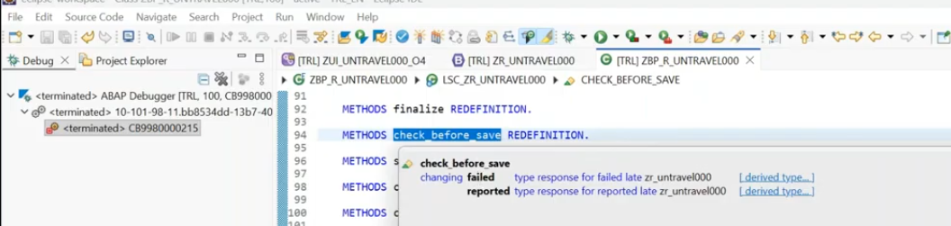
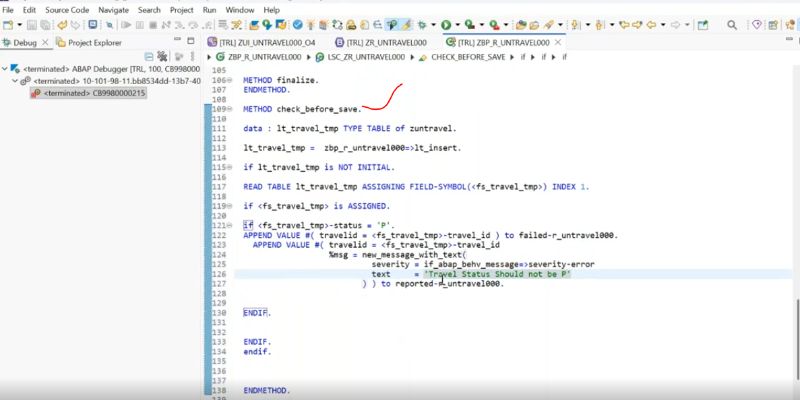
save and activate.
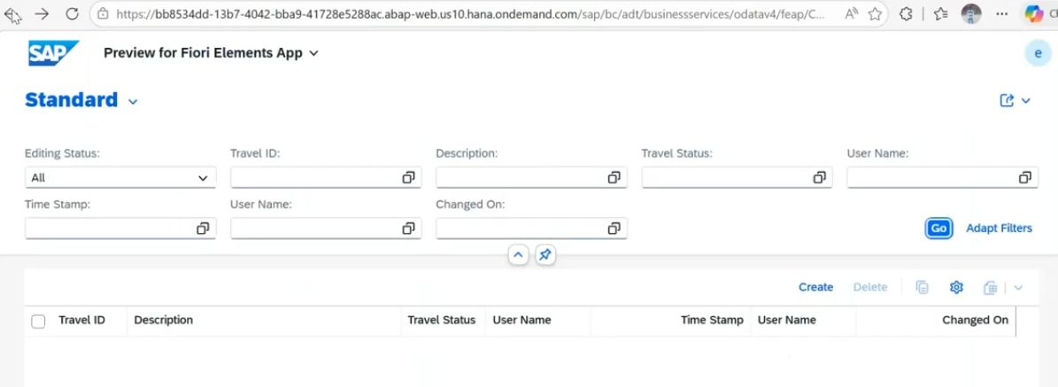
click on create button..
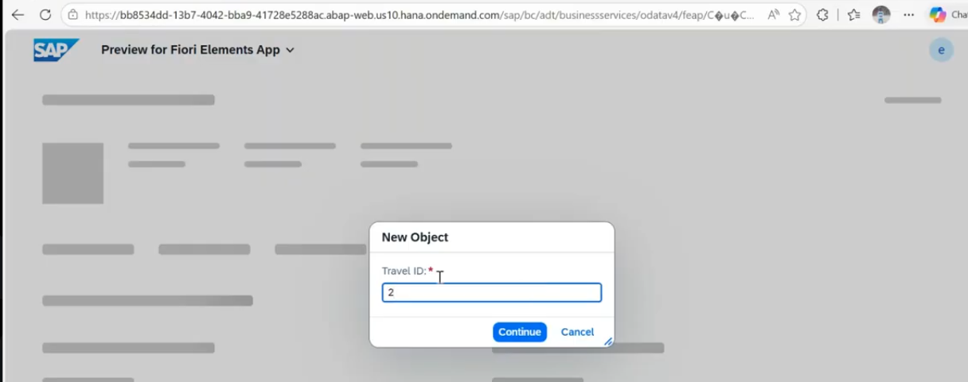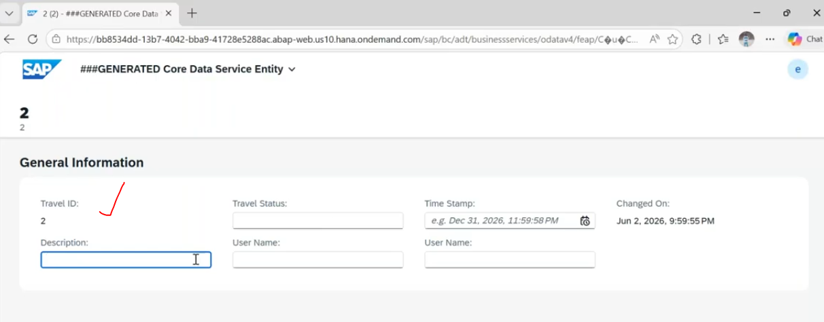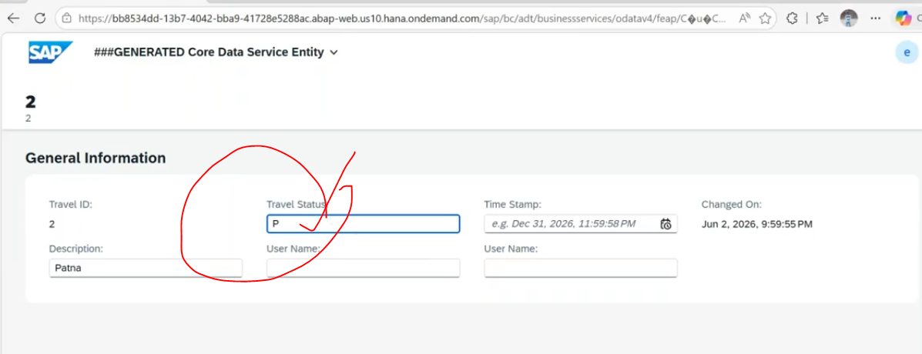
Travel Status as 'P', we are raising error: -->click on create button.
before the save( ) method- check_before_Save( ) method will trigger. -- raise the error message.
and next hitting the method- cleanup_finalize( ) method will trigger.
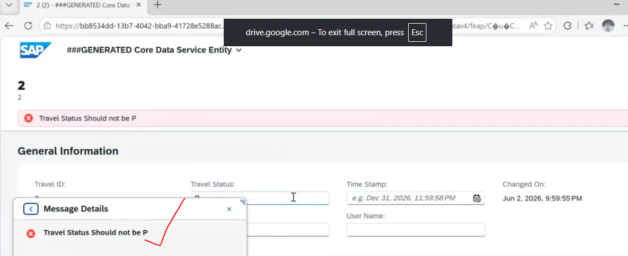
Create button --> check_before_SAve( ) --> no errors -->save () method triggers
-->later cleanup_finalize() method will call
-->errors found--> directly cleanup_Finalize() method will call.

What is the sequence of the method.?

