Emax- RAP-Day-30- 03.06.2026(last class)

Managed with unmanaged SAVE
03:00
What is the unmanaged save?
in some of the cases, user might be requested to prevent the business object from the managed runtime only from the saving but by default managed scenarios save the all the changed instances of a business object entity. However, you can define each entity how it is ha s to be act? but the type of implementation as managed but when it go for the persistence phase unmanaged and it helps to integrate the BAPI/Our function Modules. whatsoever you wanted to call, you can call through unmanaged save.
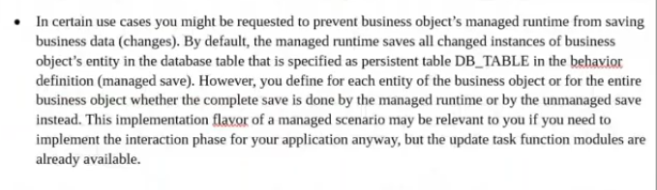
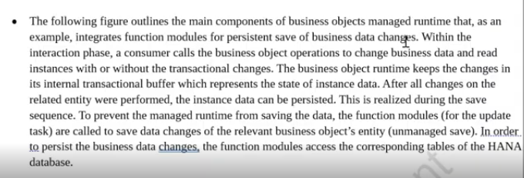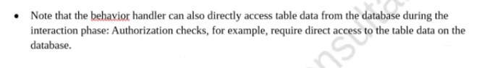

Unmanaged Diagram:
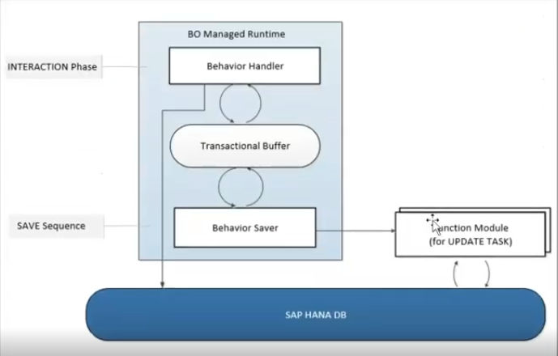

Behavior handler/Interaction Phase:
Firstly whatever the behavior handler thing: all the front end manipulation/send data to bapi structure/send data to Save db tables and validations we can handled here. --> once you given any data those stored in transactional buffer -->after storing the transaction buffer --> it comes into the save phase. here it will generates a specific method called as "save_modify", in this method we will be having each of the operations one is create/update/delete, so whatever the operations we have, which is automatically inherited in that "Save_modify" method.
in unmanaged, each of the operations it generates separate method for create/update/delete.. means there is no conflict on operations.
when it comes with managed with unmanaged save, it only generates one method that is save_modify method, in that method give parameters like create/update/delete operation nad in those whatsoever the operations which you are implementing those will be trigger in this, at least you have to go for the some condition base logic- if create is not initial/update is not initial/Delete is not initial like that we have to go..- this is unmanaged save.

Example:10:00
Banking related transaction will saved on BNKA table.
1. Create entities first.
Root entity: ZHR_R_BANK_VW
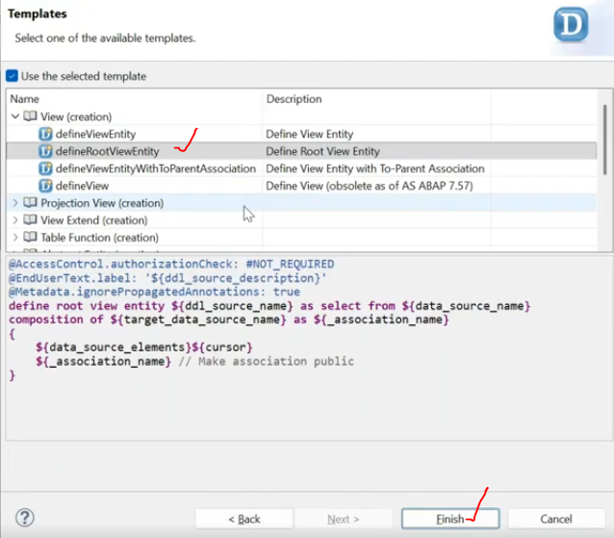
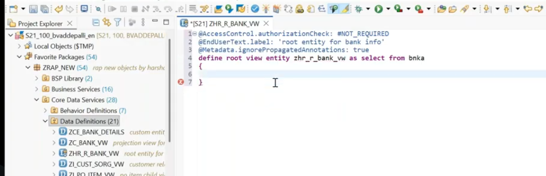
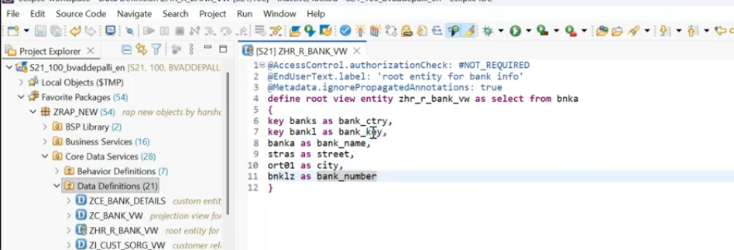
save , check syntax check and activate.
2. Create projection view on top of the root entity.
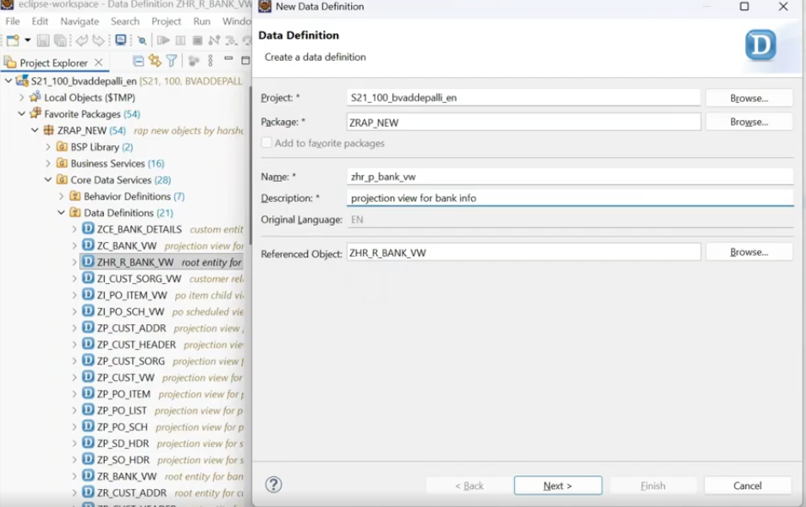
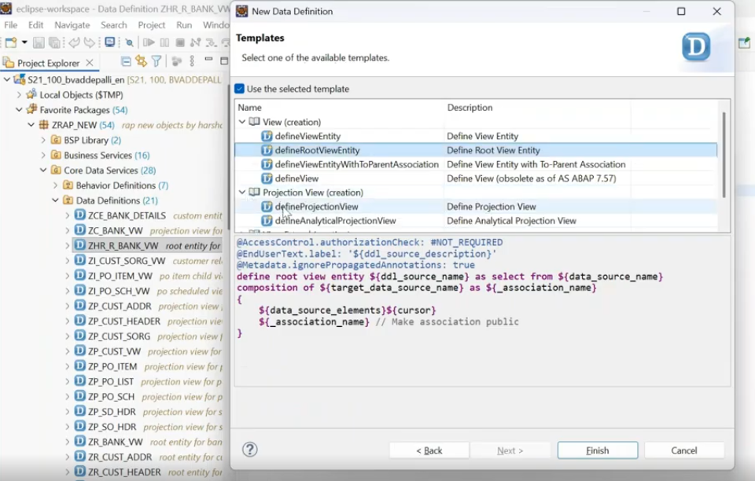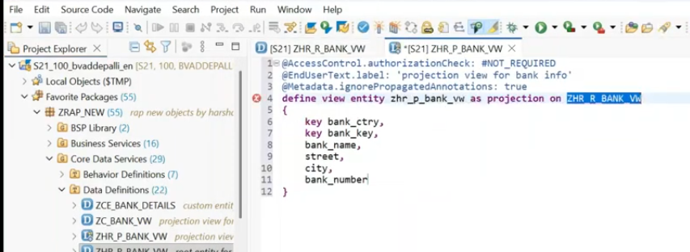
add root to projection view and apply the ui annotations.
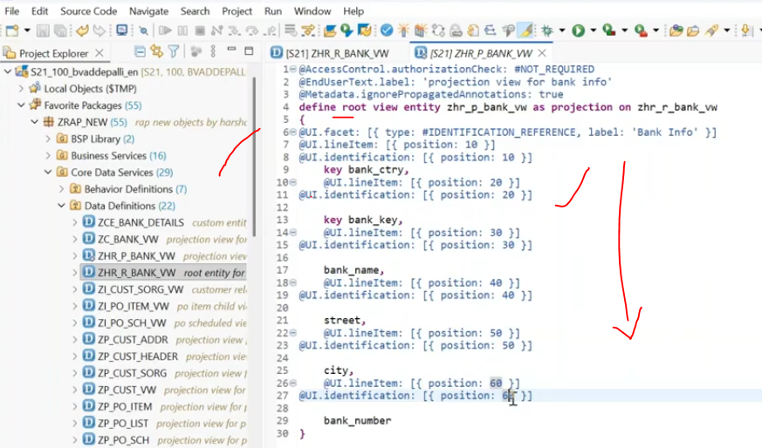save, check the syntax and activate.
Projection view also done..
3. Create the behavior defintion on top of the root entity.
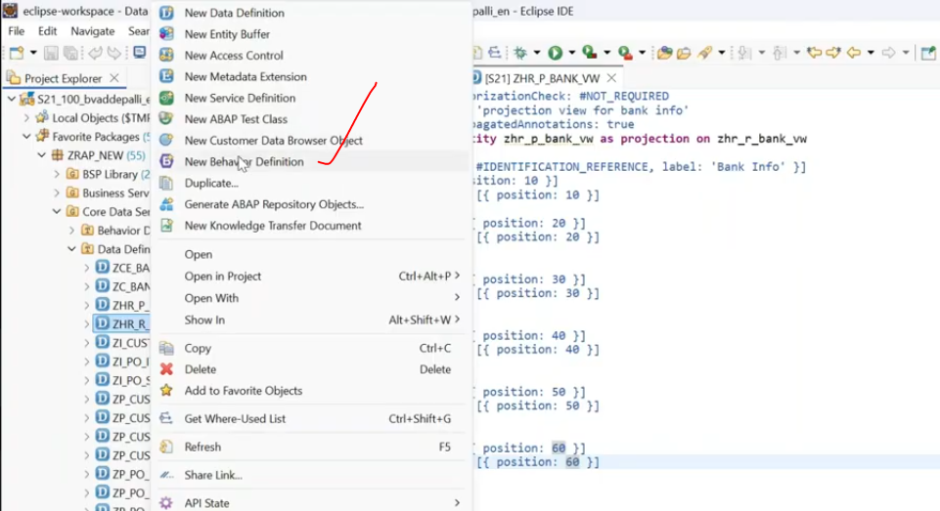
initial i will implement with the managed scenario, after implementation- will change to unmanaged..( managed to unmanaged ).
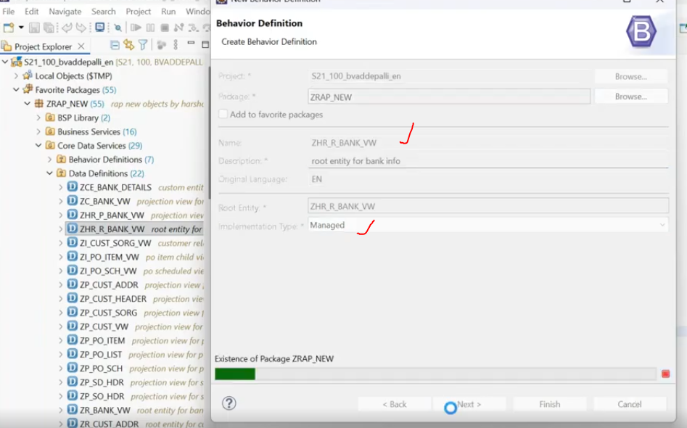
here behavior definition- with managed, after creation of the behavior definition then i can make the changes - managed with unmanaged save..
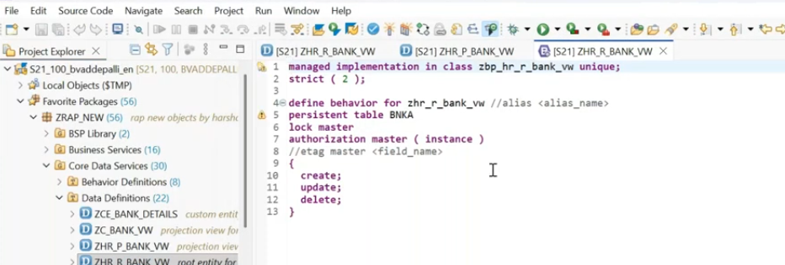
now add the extra piece of code after managed keyword.
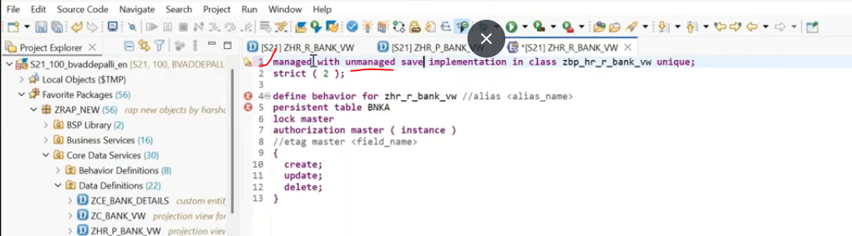
here immediately we will get the error on persistent table, because this persistence once you go for the save - this persistency explicitly can be handled by the developer not this framework.
and again when we go for the unmanaged- the responsibility of the data save, which is not handed by the framework, which is handled by the developer.
comment the persistent table bnka.
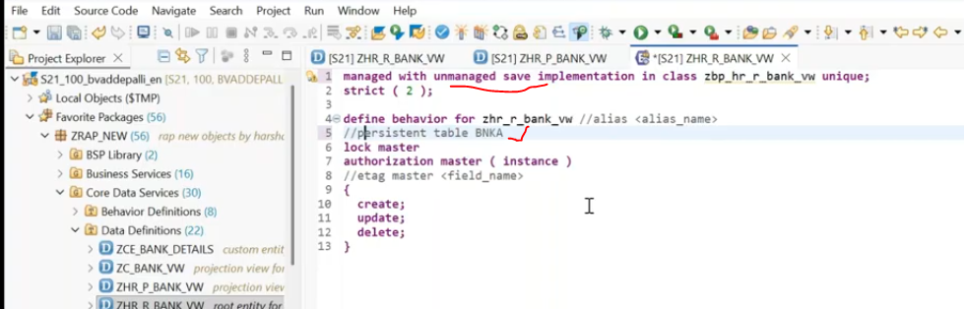
no errors right- lets do the mapping
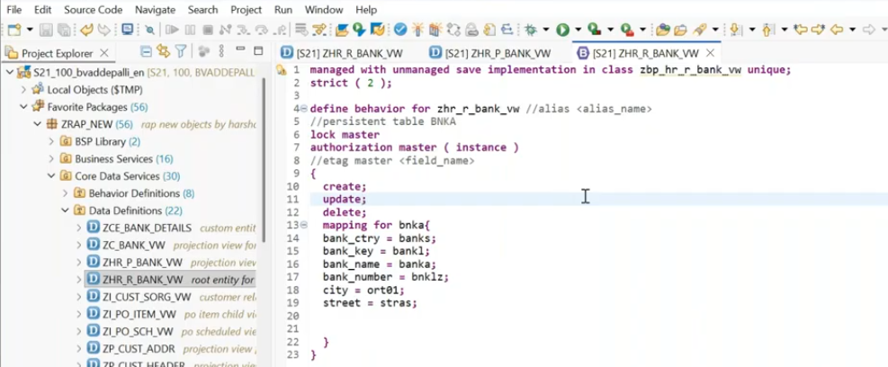
save, check the syntax error and activate.
Now it generates the specific methods to be implemented for this.
put the cursor on class- ZBP_HR_R_BNK_VW class and press- ctrl + 1.
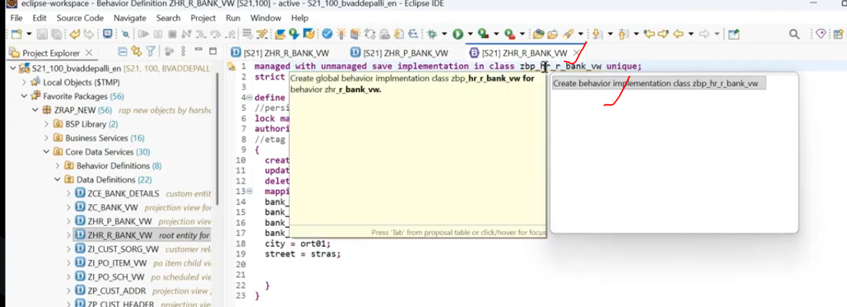
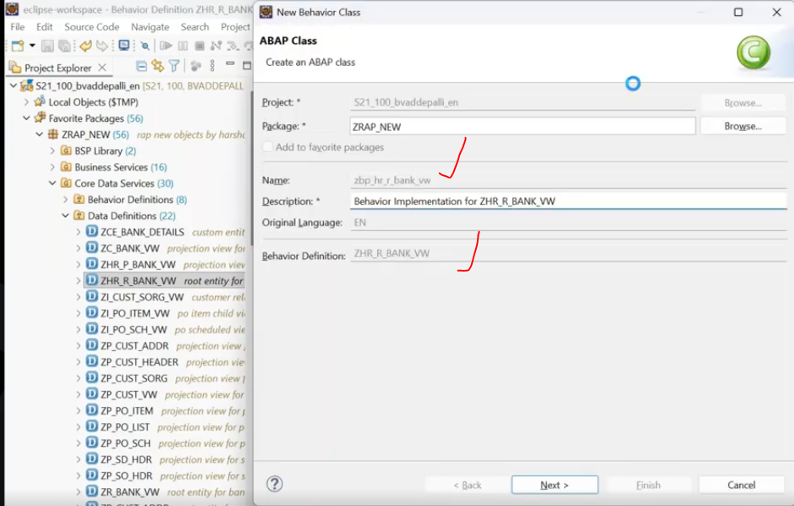
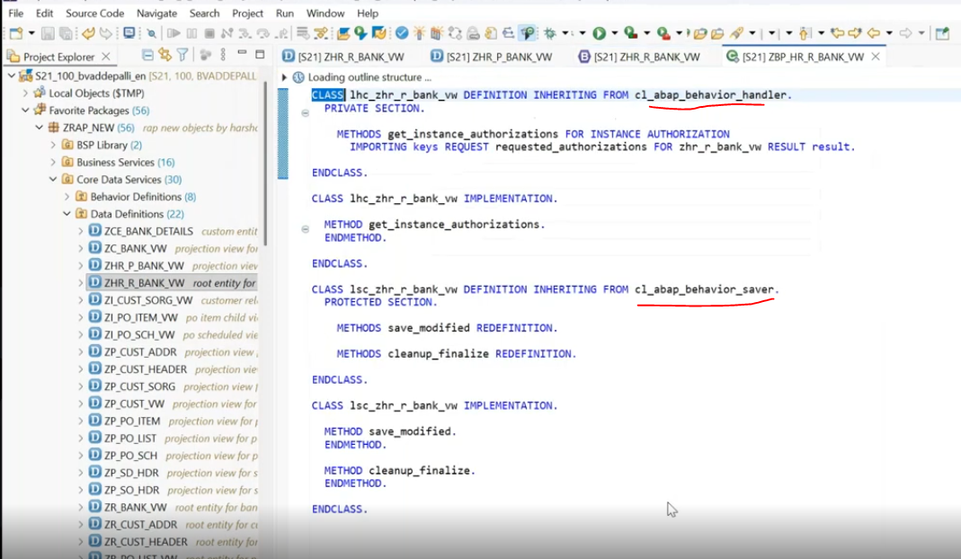
saver phase- created method -save_modified method.
save_modified - signature of the method.
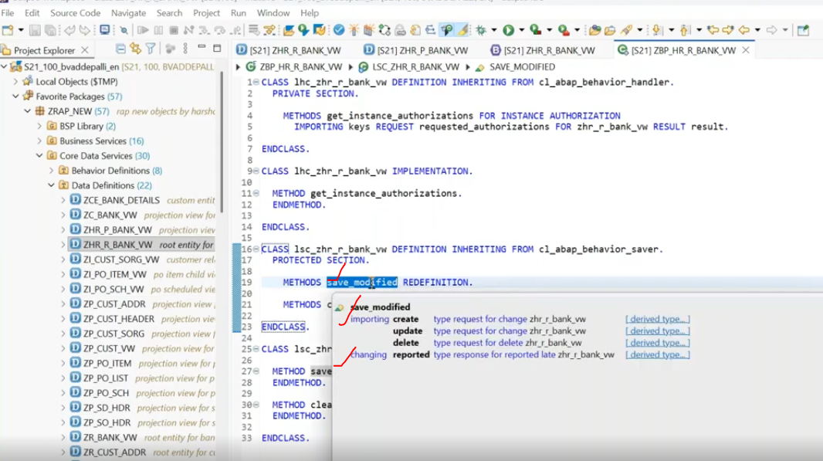
create/update/delete- these are not just parameters- those are opertions- create opertaion, update operation and delete operation.
Now you have to implement this particular method -save_modified, when you want to implement.
in save_modified- firstly i am going to written as a condition.- on a condition based, you have to handle this, if you are not maintained on conditional based, so every time it will trigger it. when user creates a record then only my logic has to be triggered.
20:00
1. create the internal table to capture the ui data.
2. transfer the data entity to internal table.
For Create:
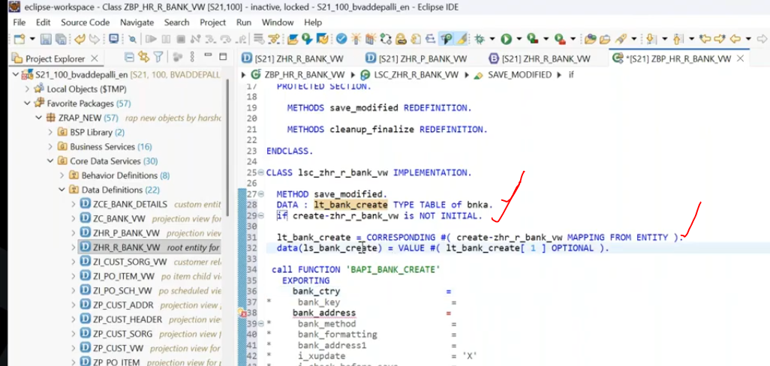
ctrl + space bar --> display the FM after display- select the FM, press shift + enter.
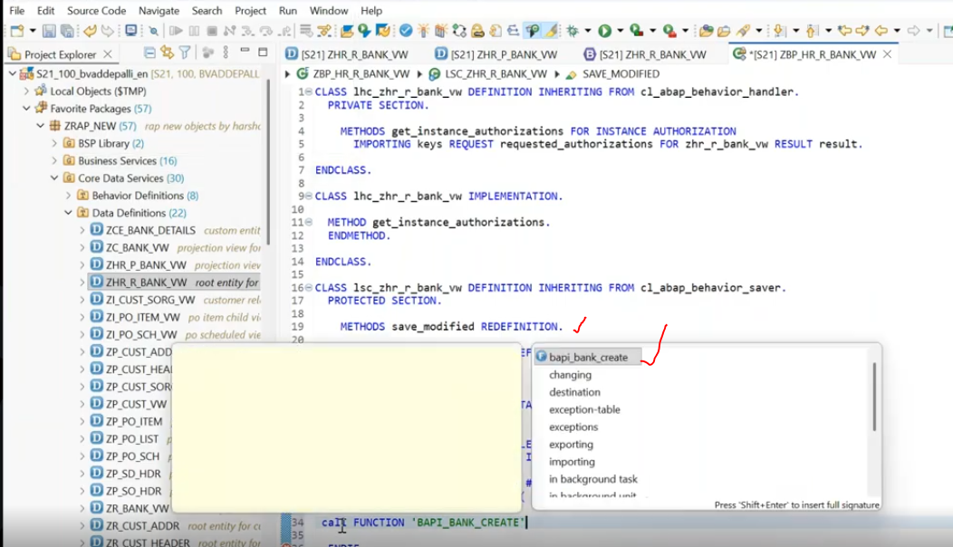
F3 - navigting.. bapi/ tables/data element/ views.. etc
Now pass the internal table data to the bapi to create the bank info..
25:00
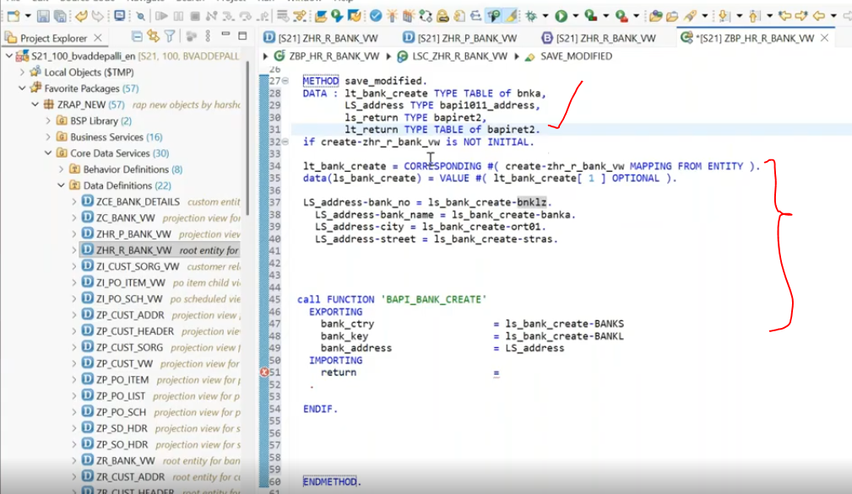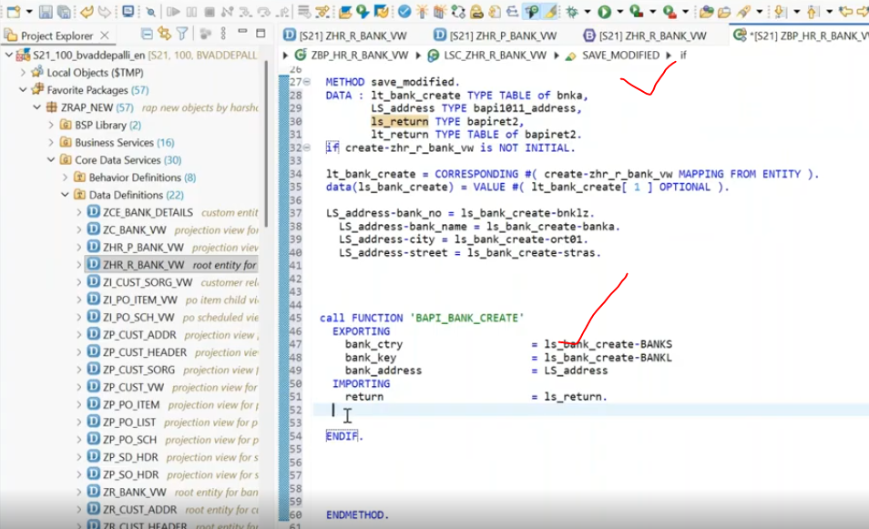
BAPI successful executed .
if i get the return-type = 'E', no need to commit the data to DB.

If your bapi contains, bapi_transaction_Commit- main bapi itself.( means bapi inside calling the commit work ).- when commit maintained inside the bapi( commit already maintained inside the bapi)- Call 'BAPI' DESTINAtION 'NONE'.( commit already written inside)
some times- success case also, we will receive the return internal table is blank -- so in that case we can trigger the commit..- when the commit is maintained inside the bapi. we have to put the destination 'NONE' at the time of calling the bapi_tranasaction_commit. - because inside bapi commit work will not handled by RAP frame work.
if bapi doesn't have transaction_Commit- in this case destination 'NONE' we have to use for BAPI_TARNASACTION_COMMIT. --> we are using the explicit transaction commit.( we have written the explicit transaction commit )- so we have to write the destination 'NONE'.
you are calling any function module/ any bapi, which it contain updated function module, inside the bapi, some where they called the Updated function module, in that point also when you put the destination 'NONE'- it will not allow.--> so for this we have to create seperate RFC fm, what ever your rap based logic -you have to keep inside the new RFC - and call this new RFC into the RAP implementations.
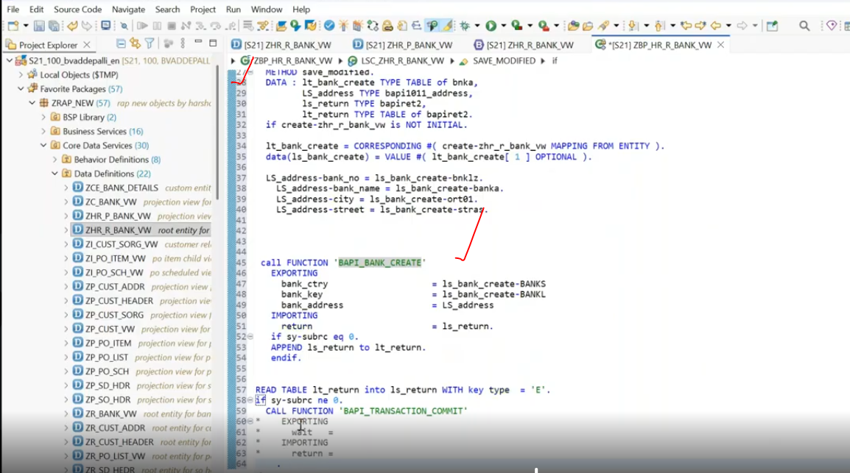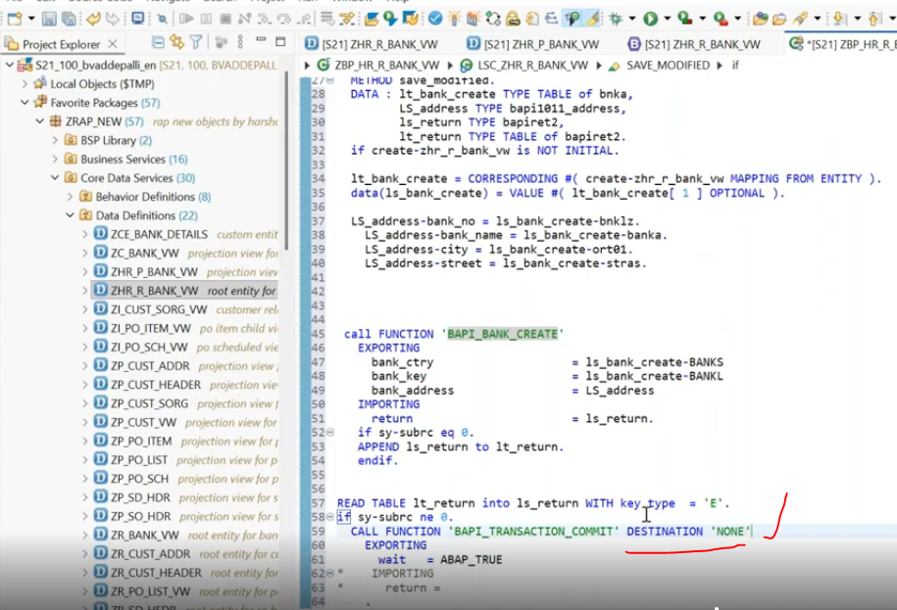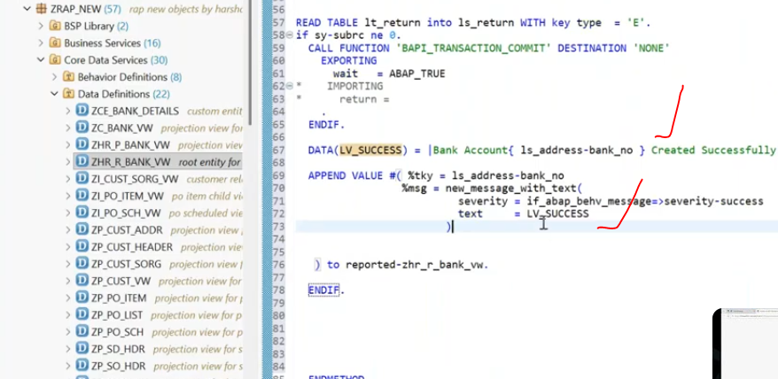
lets activate all the created objects.
now create the projection behavior definition on top of root projection behavior definition.
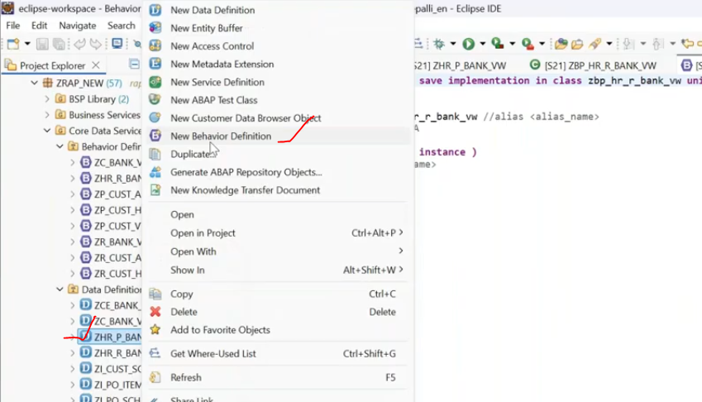
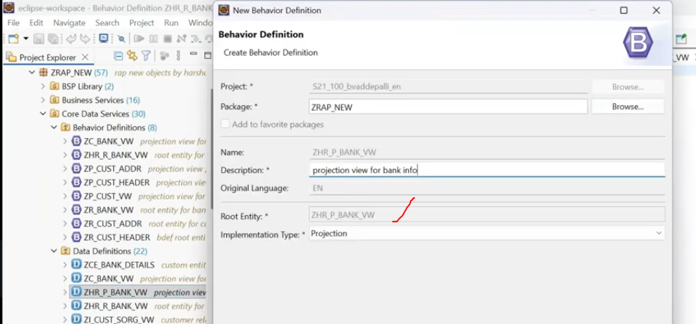
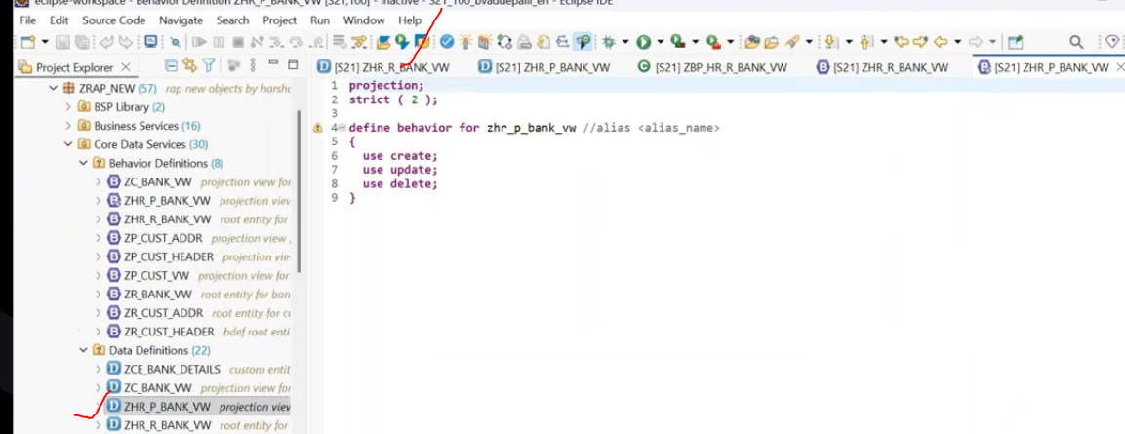
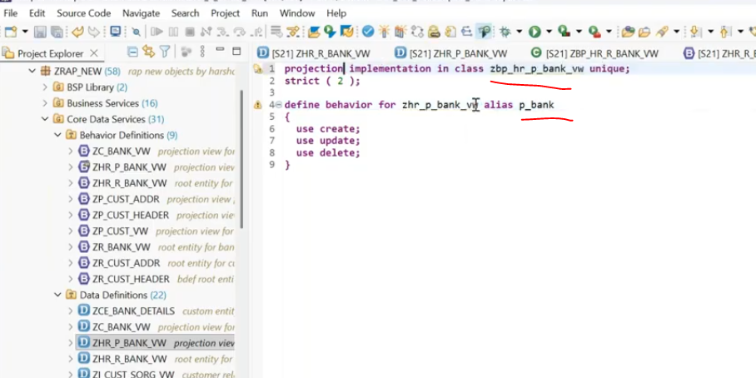
lets create the implementation class.
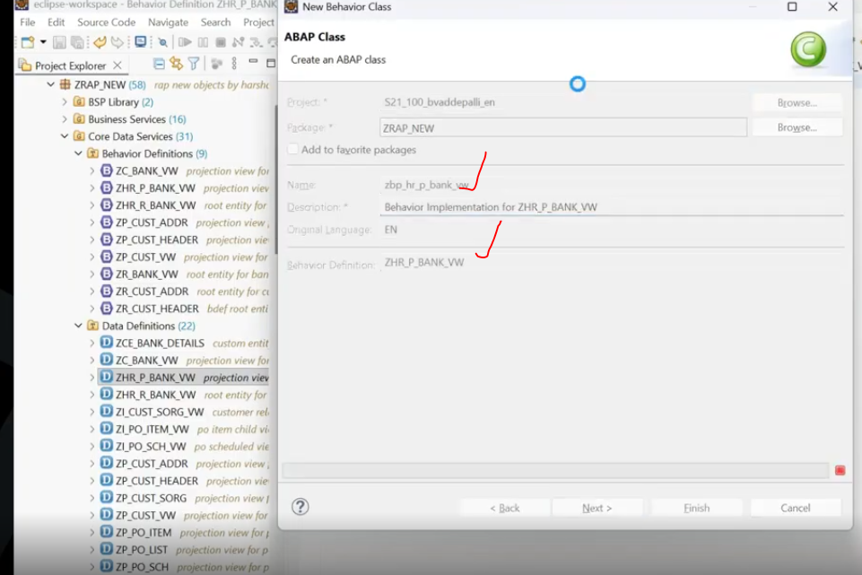
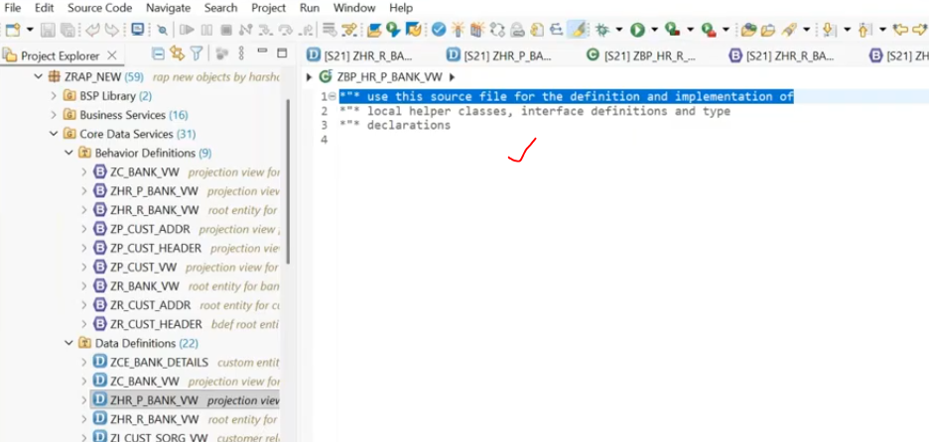
activate.
create service definition on top of projection behavior.
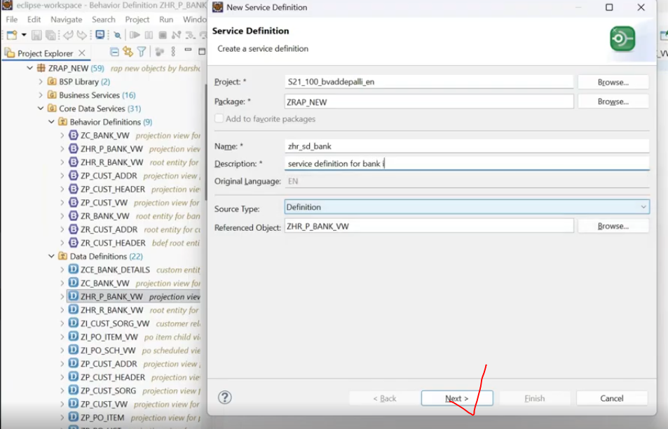
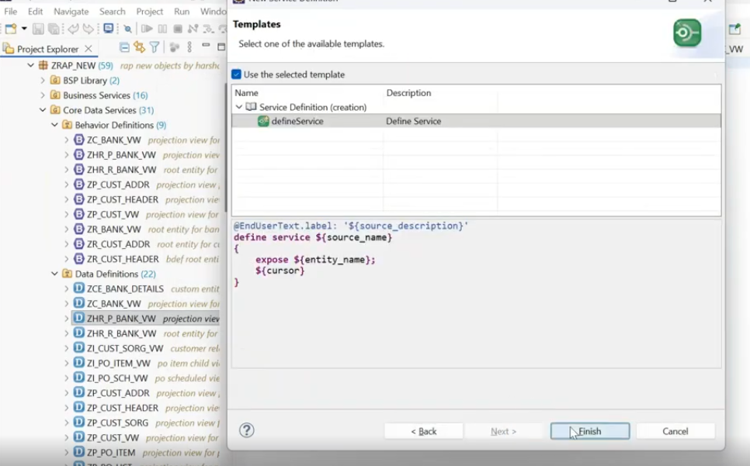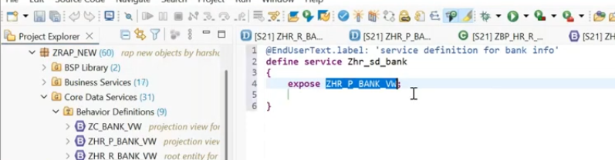
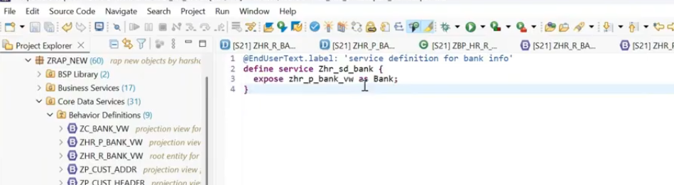
Crete service Binding on top of the service definition.
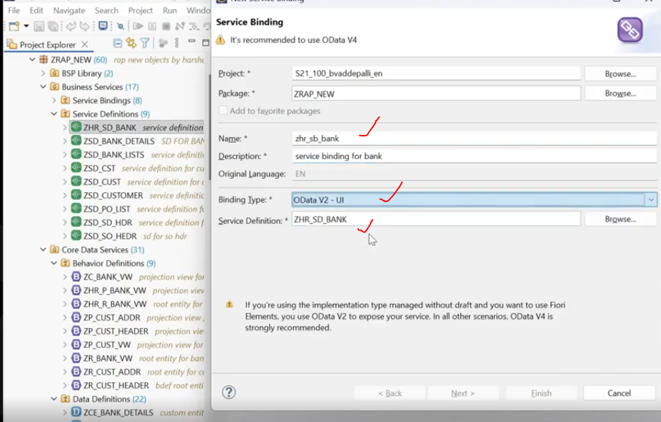
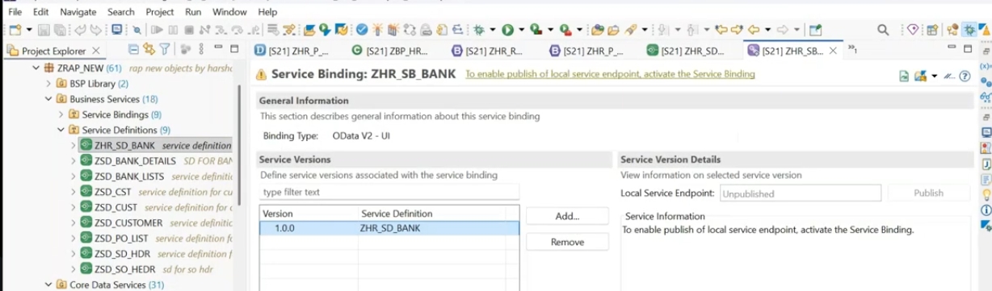
aactivate and publish the service.
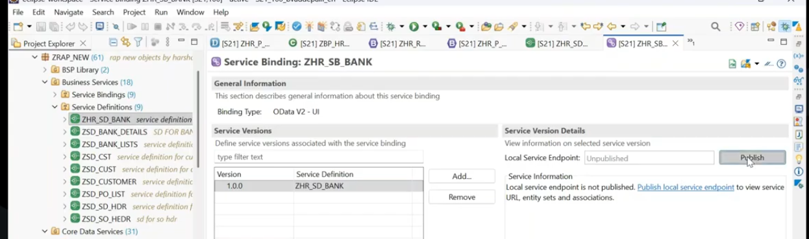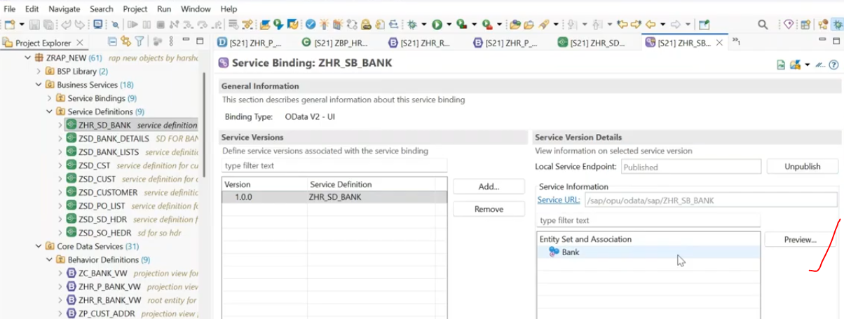
Test our application.--> click on preview button.
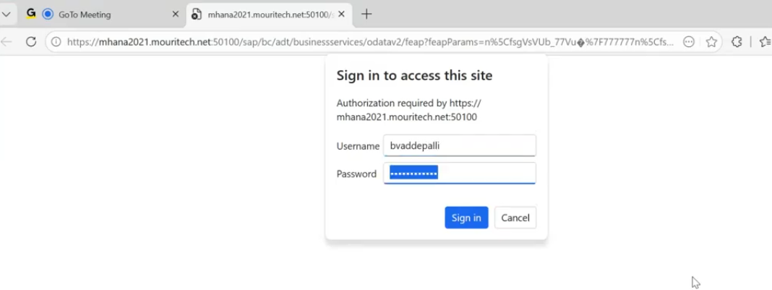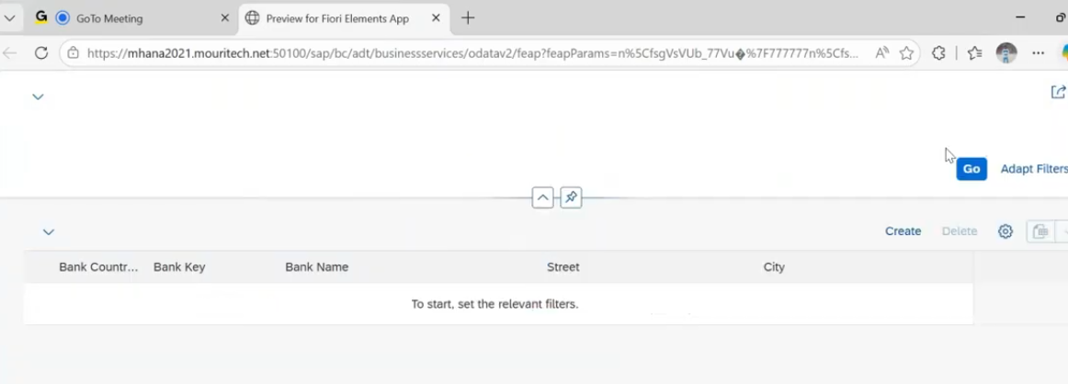
click on GO for data.
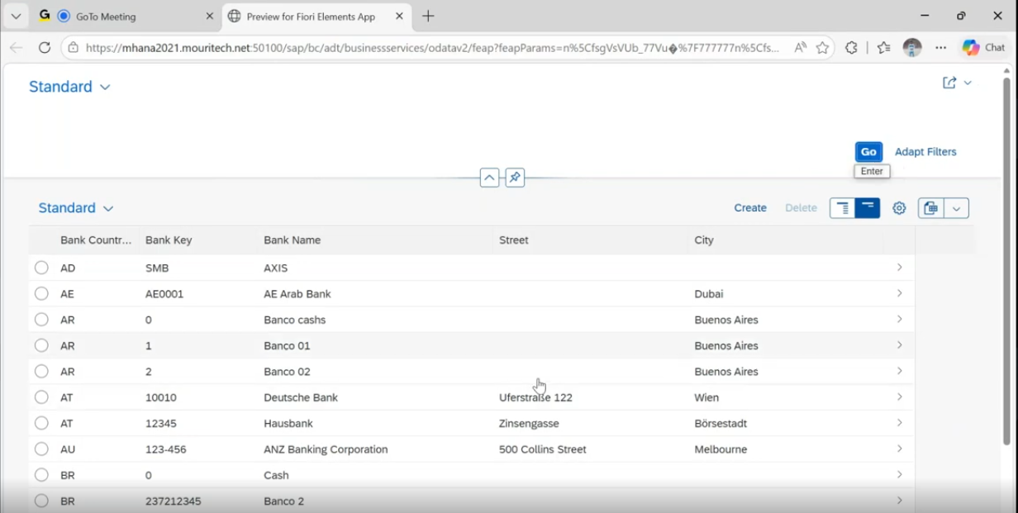
Click on Create.
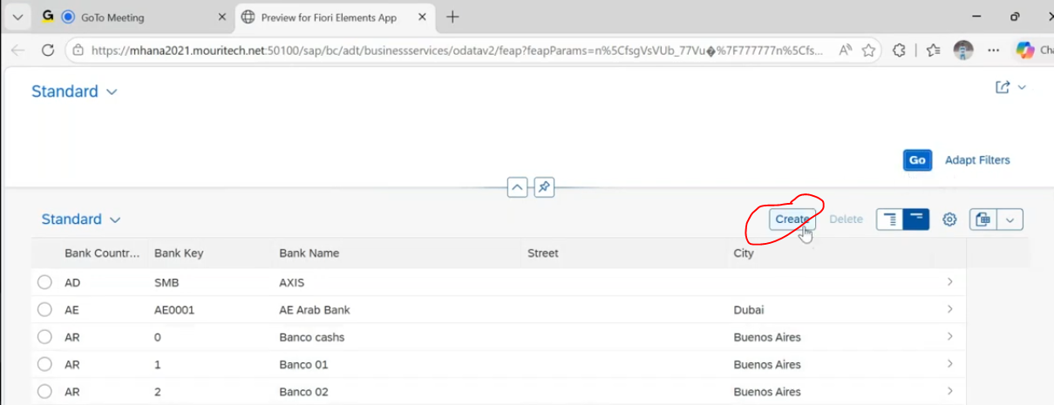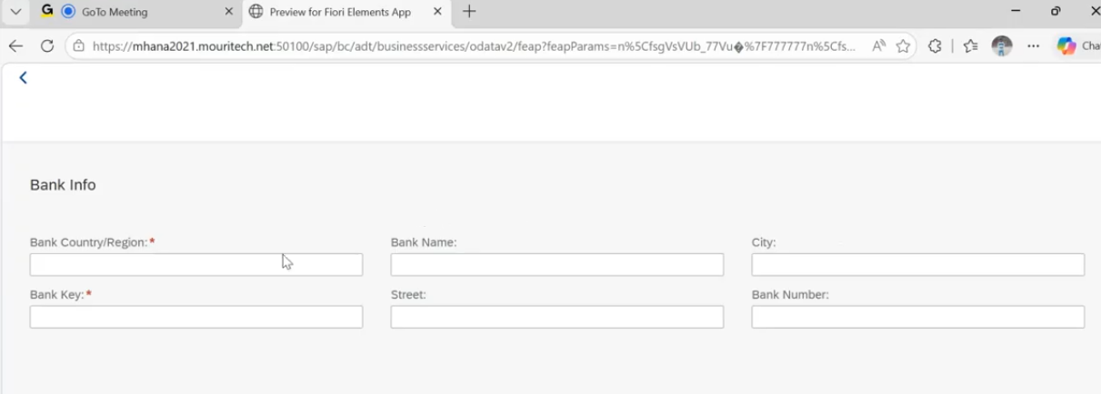
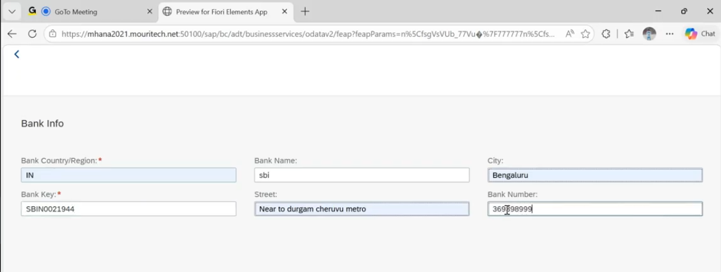
click on create button.
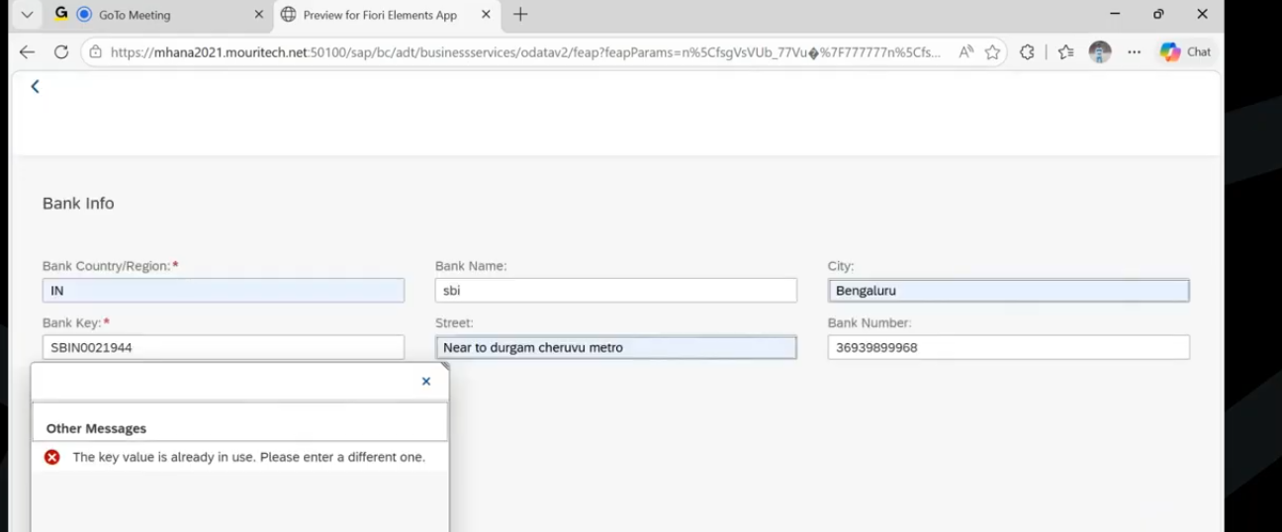
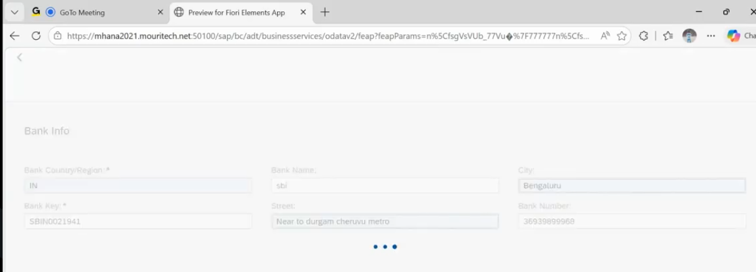
bank key must be unique.
debugging triggered.
