Session-1 Adobe forms Intriduction:

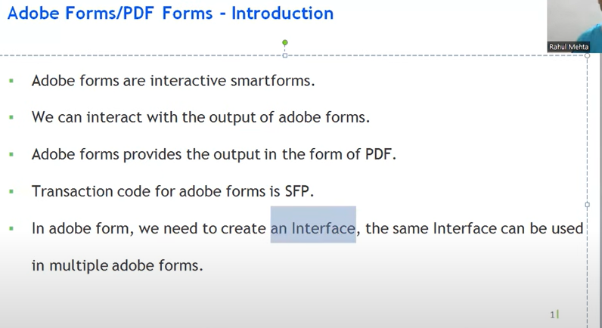

ADLC- required to design the layout

# Difference between Adobe and smart forms:

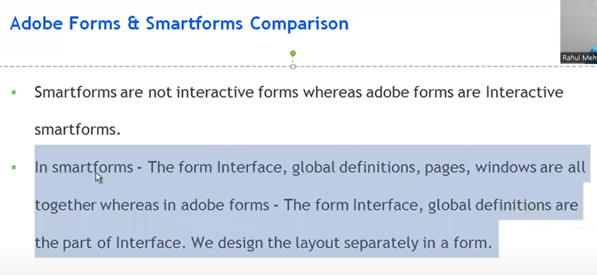

## Smartforms:

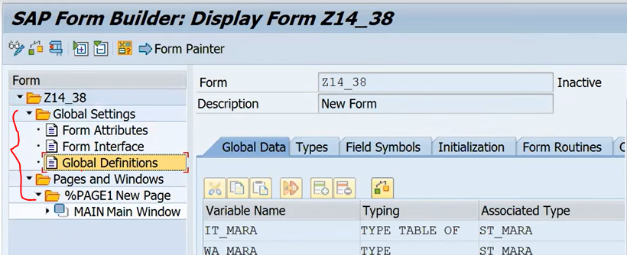

## Adobe forms:

If you want to declare the internal table and those work areas and etc sap has given the part as the interface.

## To design the adobe forms:

Tcode : SFP 🡪 define the interface and Form.

## Interfaces: Declaration + Lgic

1. When create the adobe form, first create the interface.

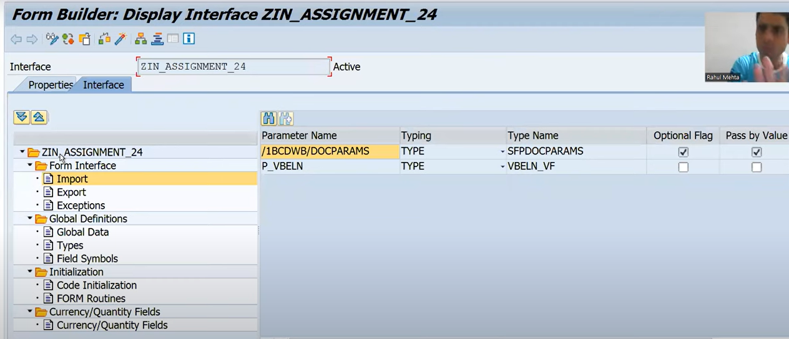

1. Above interface seems to like as smartform interfaces.
2. Interface only for declarations and logic also implementing here only.

## Form: only layout

1. Whenever you are designing the form, you have separately create the form by using the interface.
2. Layout design only in from, no code. no declaration here.