ITR-1 salaried employees
How to check the TAX paid amount credit or not in IT dept ?
- Once login go to my account view form 26AS(tax credit)
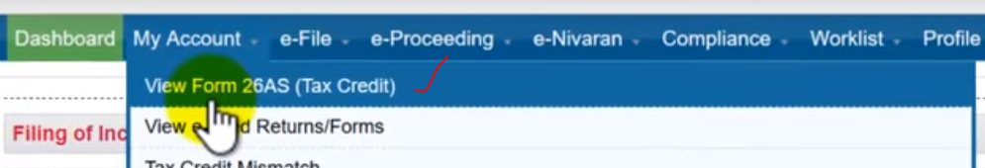
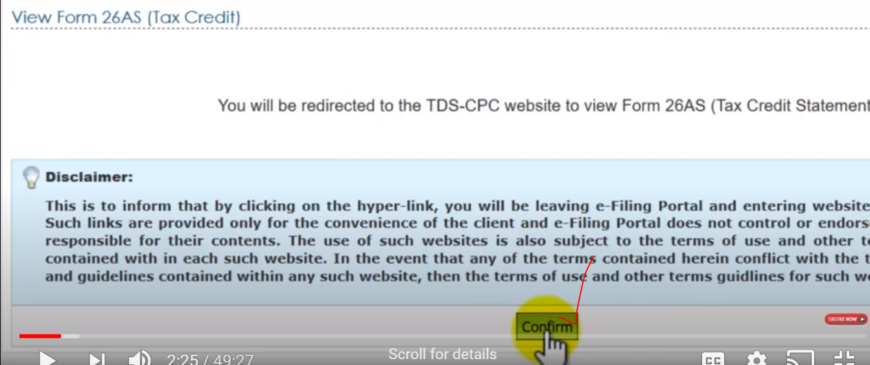
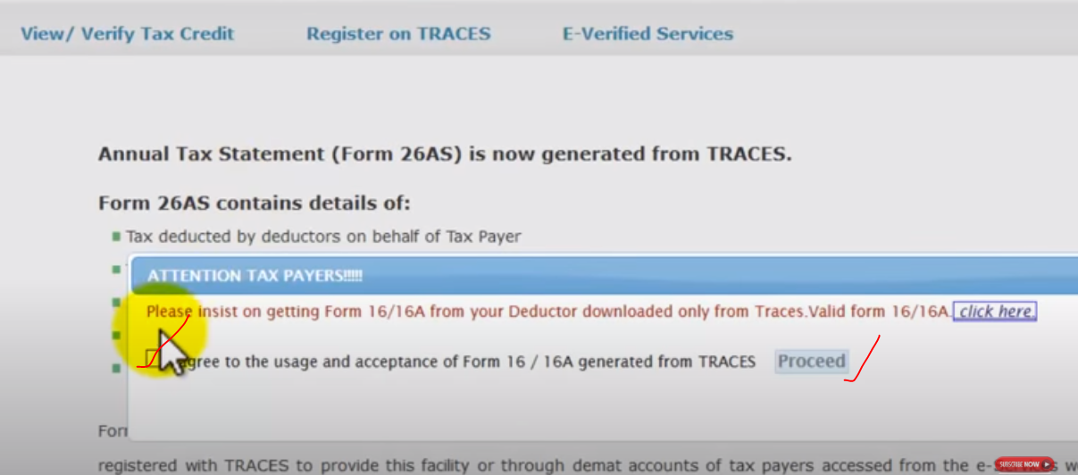

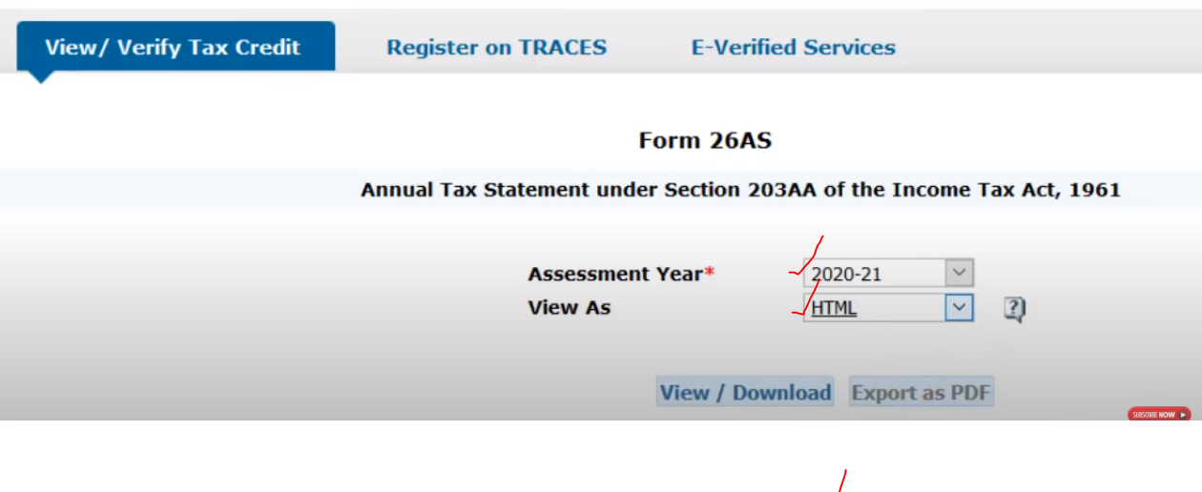
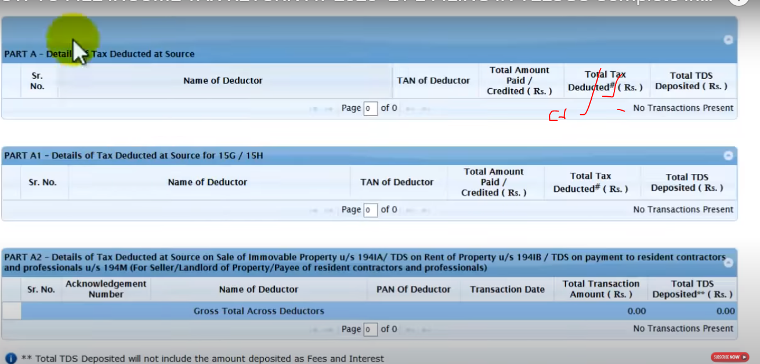
PART-A total tax amount paid to IT, NO transaction Not paid..(if it is cut from salary)
If tax paid.. but it is showing as no tax paid then.. not done the TDS.. once complete TDS then go for the efilling(ITR).

