**ZCL_REST_LOGGER**

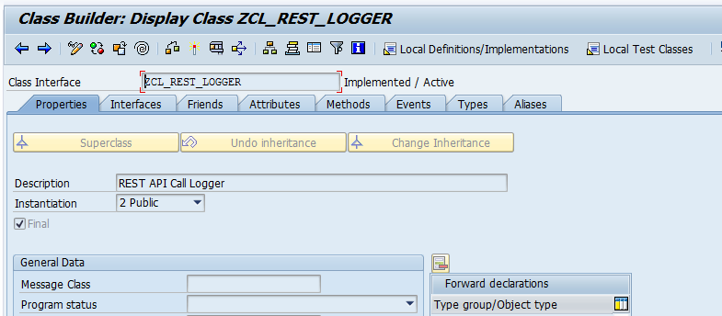

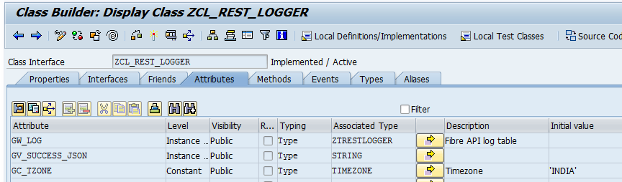

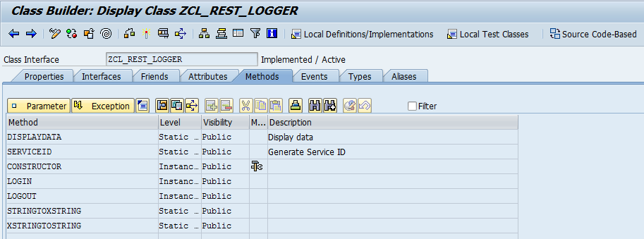

**DISPLAYDATA~Method implementations.**

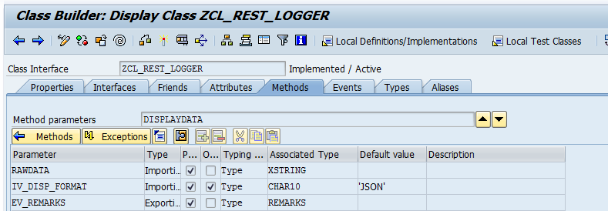

METHOD displaydata.  
  
  DATA:  
  lv_length   TYPE i,  
  lt_binary   TYPE STANDARD TABLE OF x255,  
  l_json      TYPE string,  
  l_xml       TYPE string,  
  lo_json_dsr TYPE REF TO cl_trex_json_deserializer,  
  lo_root     TYPE REF TO cx_root,  
  lo_tree     TYPE REF TO cl_salv_tree,  
  lo_nodes    TYPE REF TO cl_salv_nodes,  
  l_html      TYPE xstring.  
  
  FIELD-SYMBOLS: <lfs_data> TYPE any,  
                 <lfs_datatab> TYPE table.  
  
  
  
  IF rawdata IS NOT INITIAL.  
  
    CALL FUNCTION 'SCMS_XSTRING_TO_BINARY'  
      EXPORTING  
        buffer        = rawdata  
      IMPORTING  
        output_length = lv_length  
      TABLES  
        binary_tab    = lt_binary.  
  
    IF lt_binary IS NOT INITIAL.  
      CALL FUNCTION 'SCMS_BINARY_TO_STRING'  
        EXPORTING  
          input_length = lv_length  
        IMPORTING  
          text_buffer  = l_json  
        TABLES  
          binary_tab   = lt_binary  
        EXCEPTIONS  
          failed       = 1  
          OTHERS       = 2.  
      IF sy-subrc <> 0.  
        ev_remarks = 'Falied to convert binary ro string'.  
        RETURN.  
      ENDIF.  
      IF l_json IS NOT INITIAL.  
        TRY.  
            CASE iv_disp_format.  
              WHEN 'JSON'.  
*            cl_demo_output=>display_json( l_json ).  
  
                CALL TRANSFORMATION sjson2html SOURCE XML l_json  
                                         RESULT XML l_html.  
  
                cl_abap_browser=>show_html( html_string =  
                  cl_abap_codepage=>convert_from( l_html ) ).  
  
  
              WHEN 'XML'.  
                CALL TRANSFORMATION id SOURCE XML l_json  
                               RESULT XML l_xml.  
                cl_abap_browser=>show_xml( xml_string = l_xml ).  
*            cl_demo_output=>display_xml( l_xml ).  
  
              WHEN OTHERS.  
            ENDCASE.  
          CATCH cx_root.  
        ENDTRY.  
      ENDIF.  
    ENDIF.  
  ENDIF.  
  
ENDMETHOD.

**SERVICEID~Implementation**

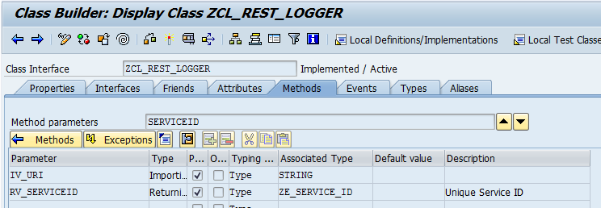

method SERVICEID.  
  
DATA: lt_string TYPE STANDARD TABLE OF string,  
      lv_service TYPE string,  
      lv_route   TYPE string,  
      lv_params   TYPE string.  
SPLIT iv_uri at '?' INTO iv_uri lv_params.  
SPLIT iv_uri at '/' INTO TABLE lt_string.  
  
READ TABLE lt_string into lv_service INDEX lines( lt_string ) - 1.  
READ TABLE lt_string into lv_route   INDEX lines( lt_string ).  
  
rv_serviceid = |/{ lv_service }/{ lv_route }|.  
  
endmethod.

**CONSTRUCTOR~Method Implementation**

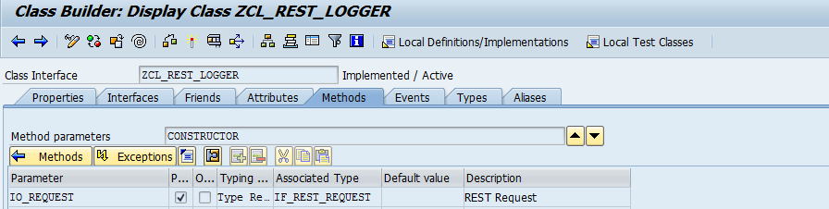

METHOD constructor.  
  TYPES:  
  BEGIN OF ty_data,  
  unique_id TYPE ze_unique_id,  
  END OF   ty_data.  
  
  DATA: lw_data     TYPE ty_data,  
        lv_json_req TYPE string,  
        lo_root     TYPE REF TO cx_root,  
        lt_log      TYPE STANDARD TABLE OF ztrestlogger,  
        lw_log      TYPE ztrestlogger.  
  
  gw_log-serviceid = serviceid( io_request->get_uri( ) ).  
  lv_json_req      = io_request->get_entity( )->get_string_data( ).  
  
  gw_log-indata = stringtoxstring( lv_json_req ).  
  
*  TRANSLATE lv_json_req TO UPPER CASE. "PWC_SHAFIQUL 29.01.2021 11:59:55  
  TRY .  
      zui_cl_json=>deserialize(  
        EXPORTING  
          json             = lv_json_req  
        CHANGING  
          data             =  lw_data  
      ).  
      gw_log-unique_id = lw_data-unique_id.  
  
  
      IF gw_log-unique_id IS NOT INITIAL.  
  
        SELECT  *  
          FROM ztrestlogger  
          INTO TABLE lt_log  
          WHERE serviceid = gw_log-serviceid  
          AND   unique_id = gw_log-unique_id.  
  
        IF sy-subrc IS INITIAL.  
  
          SORT lt_log BY outtime DESCENDING.  
          READ TABLE lt_log INTO lw_log INDEX 1.  
          IF sy-subrc IS INITIAL AND lw_log-status = 'S'.  
            gw_log = lw_log.  
            gv_success_json = xstringtostring( gw_log-outdata ).  
          ENDIF.  
        ENDIF.  
      ENDIF.  
      me->login( gw_log-unique_id ).  
    CATCH cx_root INTO lo_root.  
  
  ENDTRY.  
  
ENDMETHOD.

**LOGIN!Method Implementation**

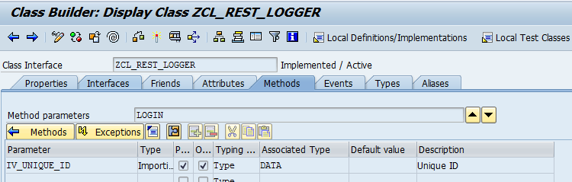

METHOD login.  
  
  gw_log-changed_by = sy-uname.  
  GET TIME STAMP FIELD gw_log-intime.  
  IF iv_unique_id IS NOT INITIAL.  
    gw_log-unique_id = iv_unique_id.  
  ELSE.  
    gw_log-unique_id = gw_log-intime.  
  ENDIF.  
  CONDENSE gw_log-unique_id.  
ENDMETHOD.

**LOGOUT~Method Implementation**

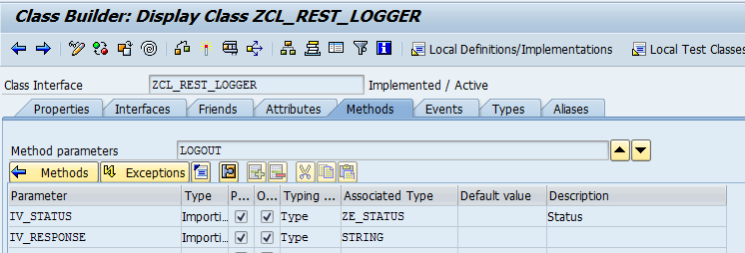

METHOD logout.  
  TYPES:  
  BEGIN OF ty_resp,  
  status TYPE ze_status,  
  END OF   ty_resp.  
  
  DATA: lw_log  TYPE ztrestlogger,  
        lw_resp TYPE ty_resp.  
  
  IF iv_status IS INITIAL.  
  
    CALL METHOD zui_cl_json=>deserialize  
      EXPORTING  
        json = iv_response  
      CHANGING  
        data = lw_resp.  
  
    gw_log-status = lw_resp-status.  
  ELSE.  
    gw_log-status = iv_status.  
  ENDIF.  
  
  gw_log-outdata = stringtoxstring( iv_response ).  
  GET TIME STAMP FIELD gw_log-outtime.  
  INSERT ztrestlogger FROM gw_log.  
  COMMIT WORK.  
  
ENDMETHOD.

**STRINGTOXSTRING~Method Implementation**

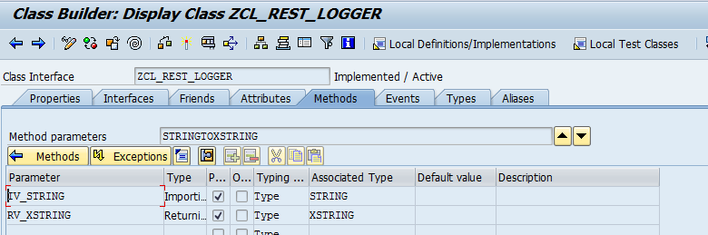

METHOD stringtoxstring.  
IF iv_string IS NOT INITIAL.  
  
  CALL FUNCTION 'SCMS_STRING_TO_XSTRING'  
    EXPORTING  
      text   = iv_string  
    IMPORTING  
      buffer = rv_xstring  
    EXCEPTIONS  
      failed = 1  
      OTHERS = 2.  
  IF sy-subrc <> 0.  
* Implement suitable error handling here  
  ENDIF.  
  
ENDIF.  
ENDMETHOD.

**XSTRINGTOSTRING~Method Implementation**

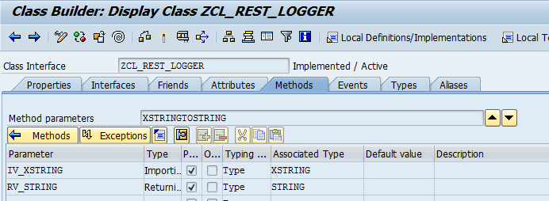

METHOD xstringtostring.  
  DATA:  
  lv_length   TYPE i,  
  lt_binary   TYPE STANDARD TABLE OF x255.  
  
  CALL FUNCTION 'SCMS_XSTRING_TO_BINARY'  
    EXPORTING  
      buffer        = iv_xstring  
    IMPORTING  
      output_length = lv_length  
    TABLES  
      binary_tab    = lt_binary.  
  
  IF lt_binary IS NOT INITIAL.  
    CALL FUNCTION 'SCMS_BINARY_TO_STRING'  
      EXPORTING  
        input_length = lv_length  
      IMPORTING  
        text_buffer  = rv_string  
      TABLES  
        binary_tab   = lt_binary  
      EXCEPTIONS  
        failed       = 1  
        OTHERS       = 2.  
    IF sy-subrc <> 0.  
    ENDIF.  
  ENDIF.  
  
ENDMETHOD.